**How to fill the WASH forms in the Integrated Refugee Health Information System (iRHIS)**

(as of 08 November 2018)

**Background:** Regular monitoring of WASH indicators is essential to track if basic needs of people in refugee settings are met and to follow progress towards more sustainable solutions. The UNHCR WASH manual specifies 16 WASH standards and indicators (<http://wash.unhcr.org/unhcr-wash-manual-for-refugee-settings/>). To monitor progress towards these indicators, information should be entered into the Integrated Refugee Health Information System (iRHIS). Access indicators should be monitored using the UNHCR monthly report card which can be directly entered into iRHIS by UNHCR WASH staff and/or implementing partners. Household indicators should be monitored on an annual basis through a KAP Survey once the results are available, the indicators measured through the survey should be entered into iRHIS.

**Log-in:** go to [his.unhcr.org](https://his.unhcr.org/home) . The username is the name of the country for which information should be entered. Passwords can be made available by HQ.

**Instructions:**

1. After logging in, click on “data” in the left menu

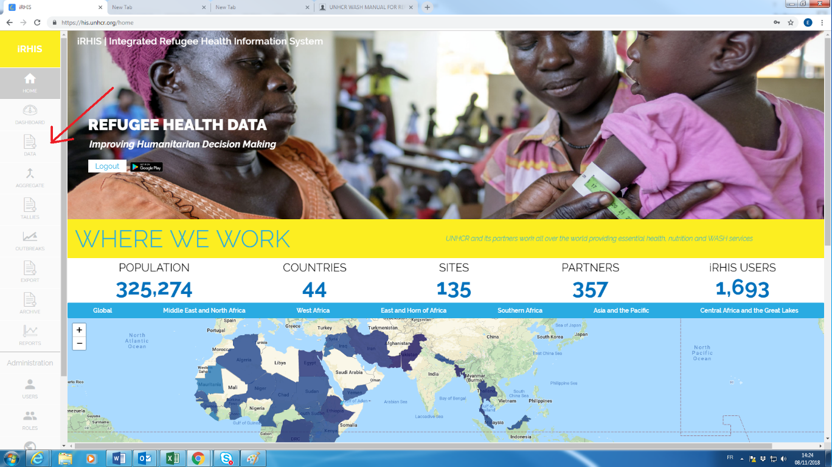

1. 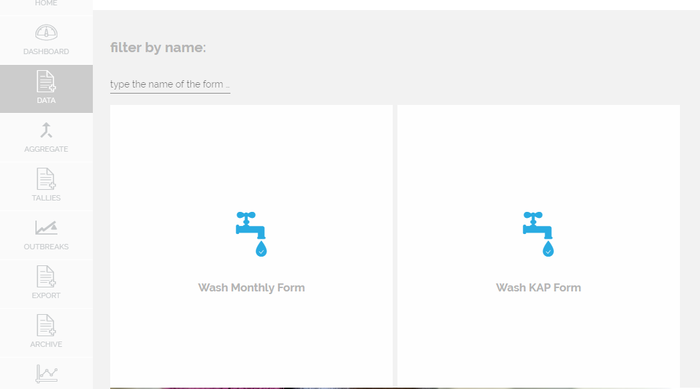Chose the relevant form
2. Create a new form by clicking on the yellow ⊕ button

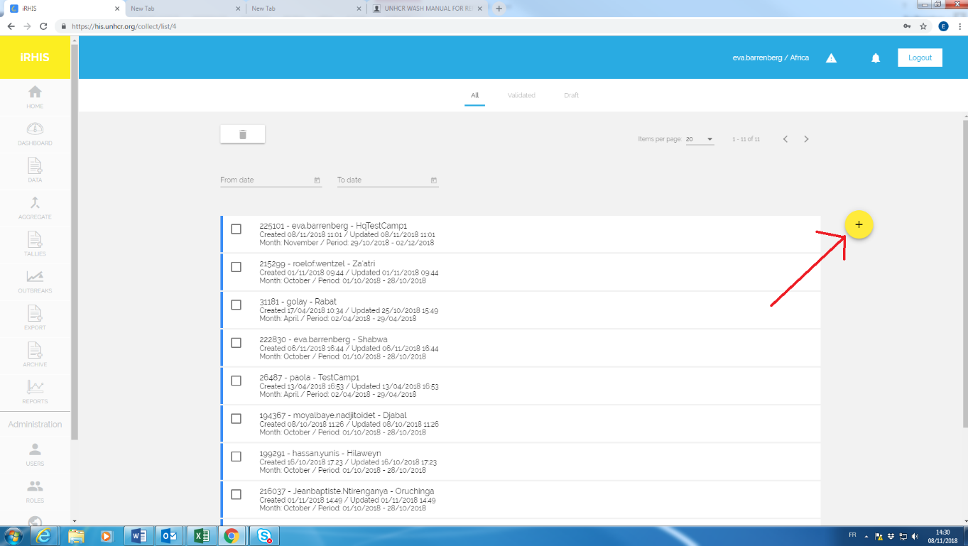

1. Select the location by clicking on

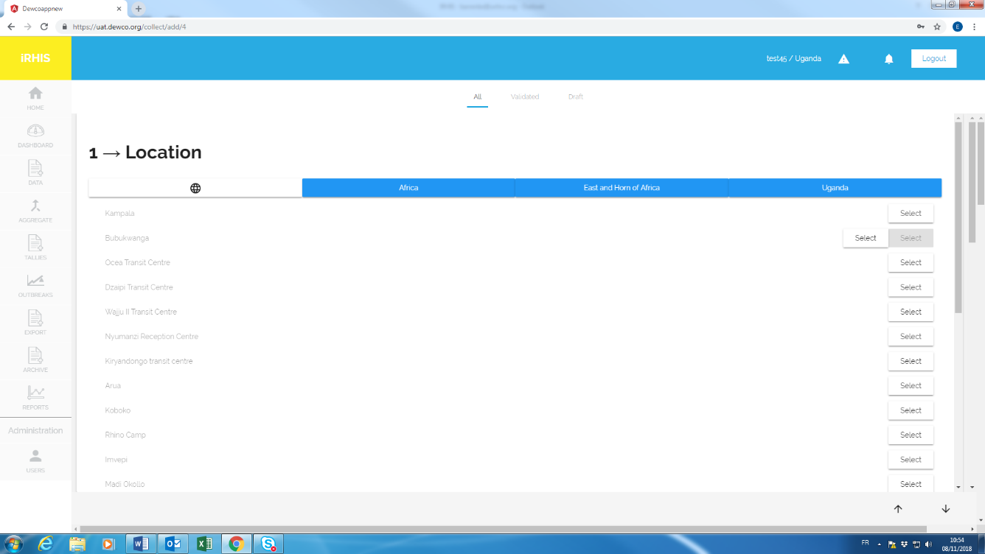Globe symbol 🡪 Region 🡪 Sub-region 🡪 Country 🡪 Camp/Site (press “select” button)

1. 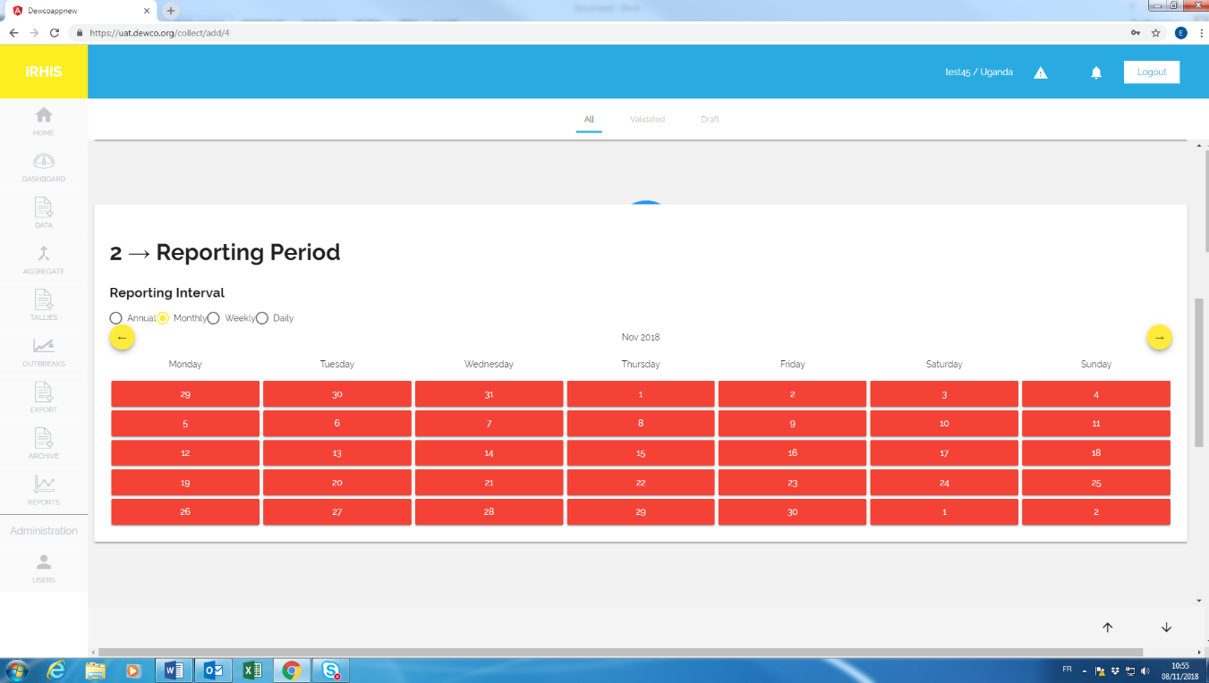Select the reporting period for which you plan to submit data. Choose between “annual” (for KAP data) and “monthly” (for the monthly report card). It is sufficient to click on any day on the desired reporting period.
2. After having selected a site and the reporting period, press “Create”

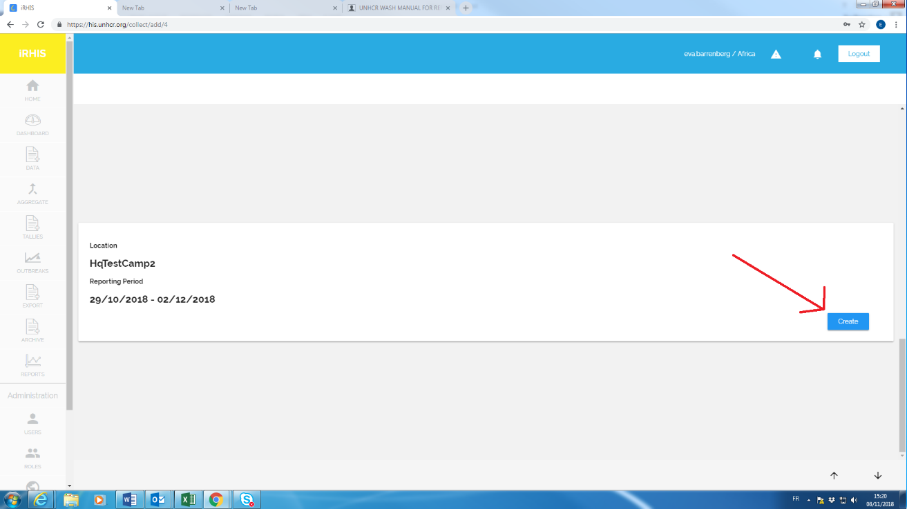

1. Choose between “Emergency “and “Post-Emergency” and then fill in the form. Once this is done, click “Save”

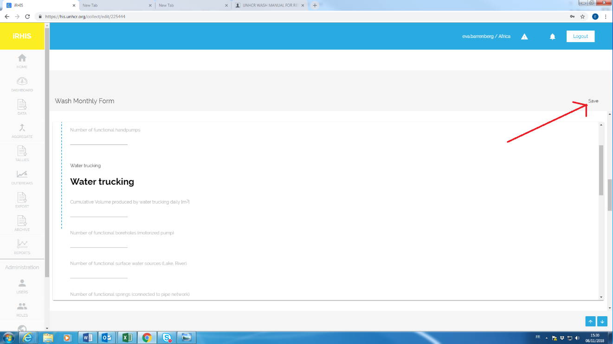

Upon submission of one or several forms:

1. Data can be seen under “Reports”. After submission of two or more monthly report cards, the software will also display trends over time.

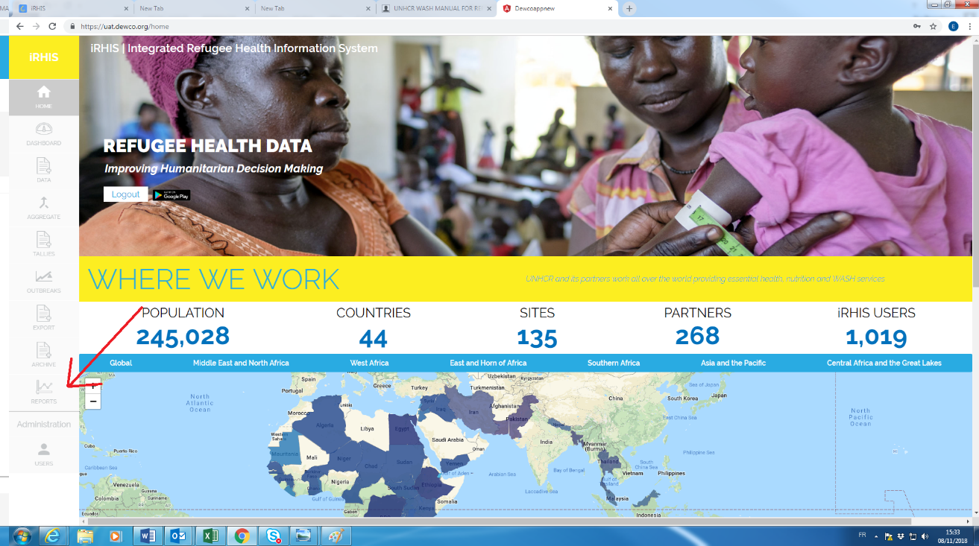

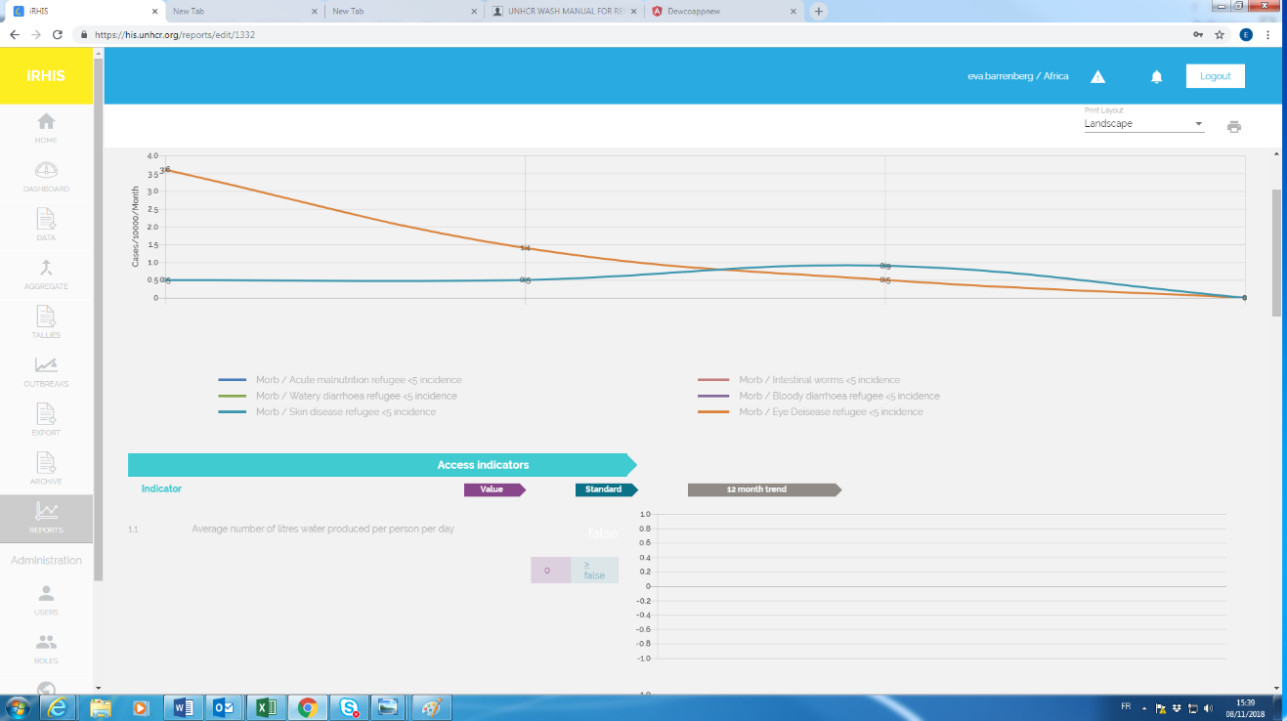

1. If you would like to export data collected over time:
2. Click the “Export” tab on the left (1),
3. Select the time frame of interest to you (2)
4. Select one or several variables of interest to you (3)
5. Click the “Export” symbol (4)

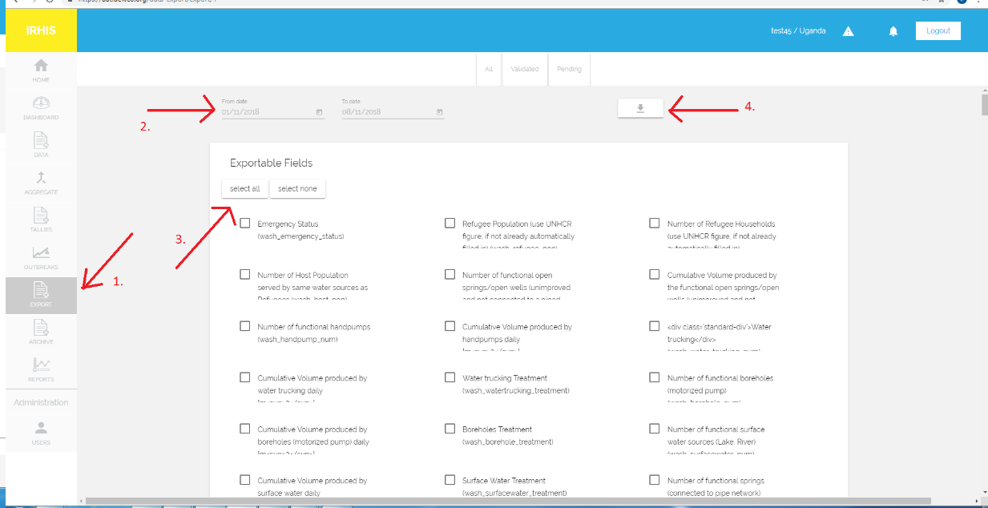

1. Information will appear on the front-end of iRHIS under the water & sanitation tab:

