Introduction
This note is intended to provide support on calculating Protection cluster, including AoRs, People in Need (PiN) for the (Humanitarian Needs Overview) HNO. The note explains the methodology with a step-by-step process for the calculation of PiN.
The HNO is designed to support the Humanitarian Country Team (HCT) in developing a shared understanding of the impact and evolution of a crisis and to inform response planning.
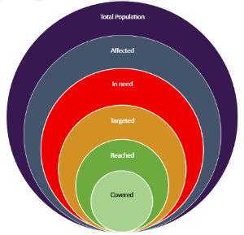
One of the requirements from the clusters/sectors during the HNO process is the provision of People in Need (PiN) figures, disaggregated by gender, age and disability. This information is used in the Humanitarian Response Plan (HRP) to decide on the total number of people to target and funding requests.
Figure 1: Humanitarian Profile

People in Need (PiN)
People in Need are a sub-set of the Population Affected. It is a sum of the number of People in Need, for each population group and geographical area and are defined as those:
- whose physical security, basic rights, dignity, living conditions or livelihoods are threatened or have been disrupted, AND
- whose current level of access to basic services, goods and social protection is inadequate to re-establish normal living conditions with their accustomed means in a timely manner without additional assistance.

Protection PiN
Protection People in Need (PiN) is the population estimates of people in need of humanitarian protection services. It is used by the cluster / sector as humanitarian planning figures and is linked to the HRP population targets and must be disaggregated by gender, age and disability.

AoR specific PiN
AoR PiN for a specific AoR is a figure calculated based on AoR specific Severity Scale. Each of the active AoRs in the country of operations should have a specific PiN estimate for humanitarian planning purposes. AoRs can make use of gender and age disaggregation for its PiN figures.

Aggregation Method for PiN calculation

Selecting data and indicators
The first step in calculating the PiN is the selection of ‘indicators’ of need for each selected population group used for the Protection analysis. This step is covered in detail within the HPC guidance module 2 on Severity Scales and its note. Please refer to the methodology section of the note.

Prepare and clean the datasets
The next step is to prepare and clean the dataset(s) from which the indicators were selected. MultiSector Needs Assessment Datasets usually come in a clean format from OCHA / or REACH, but if it require cleaning then there are numerous resources available online to guide you through the process of data cleaning in excel such as this one or the one here.
The list of potential issues with the data might include cases like incorrect formatting of values, duplication of records, matching p-codes to place names, suspicious numbers etc. Such issues with data should be resolved in order to move to the next step of the PiN calculation.
Populate the cleaned data in an excel workbook. You may use the excel template provided at the following link. Organize the data by geographical locations, using Common Operational Dataset – Admin Boundaries (CODs-AB) , population groups and indicators.

Apply severity score
Please refer to HPC guidance module 2 on Severity Scales and its note on how to apply severity scale.

Aggregation of all indicators
Once the severity score by location and population group has been calculated, the next step is to assign a percentage for each of the identified affected population group(s).
The severity scoring of each of the geographical location and population group will determine the percentage applied to each of the affected population groups present in the unit of analysis. It is important to mention that the process of assigning the percentage(s) is made during the joint analysis workshop setting at country level, jointly by the Protection cluster and AoRs once the severity scales have been agreed and endorsed.
In some situations, the Cluster/AoR Coordinators can also decide the percentages to apply to each affected population group.
Location | Population Group | Percentage - Severity Scale 5 | Percentage - Severity Scale 4
District A | IDPs | 90 – 100% | 70 – 89%
District A | Host community | 60 – 80% | 40 – 59%
Example of assigning percentages by location / population group
In the example table above, in District A for IDPs population group, 90-100% of population is considered in need for Severity Scale 5. For Severity Scale 4, 70-89% of the population of IDPs in District A is considered in need. For Host community, the percentages are 60-80% and 40-59% for Severity Scales 5 and 4 respectively.

Estimate the number of households falling under each severity phase
Once the decision about the percentages is made and endorsed, the Information Management Officer will produce the estimates of PiN, ensuring these are aligned with the severity scoring and the agreed percentages.
Simply multiply the percentages obtained in the previous step with the total population of the affected population group to obtain the number of people falling under a given severity scale.
The next step is to review, interpret and adjust these estimations as part of the joint analysis process, if required.
The AoR specific severity scales follow the same rationale as for the overarching Protection cluster scales. Once the overarching Protection PiN is produced, the AoRs will make use of their scoring for each of the unit of analysis to determine the percentage to apply to each of the affected population groups at a given geographical location.
It is important to keep in mind that AoR specific PiN cannot be higher than the overarching Protection cluster PiN. If such a situation arises Protection cluster and AoRs should revisit the methodology in order to arrive at consensus during the joint analysis workshop.

Example
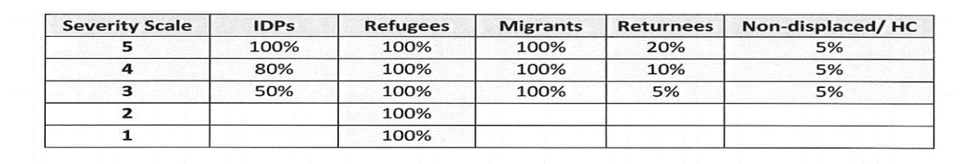
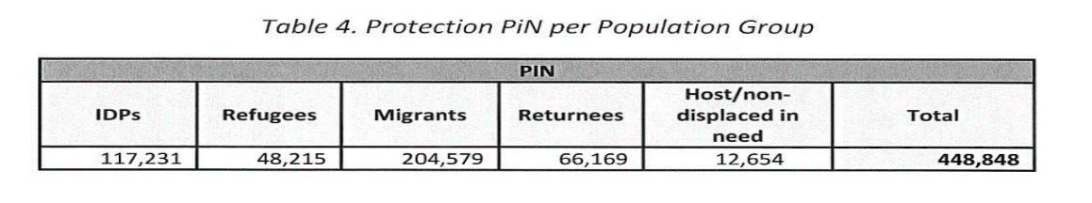
Here we see an example from 2019 Libya HNO of percentages applied for different population groups under each severity scale. For severity scale 5, 100% of the IDPs population was considered in need, for severity scale 4, 80% of the IDPs population was considered in need and so on. Similarly, for Refugees population group, 100% of the refugees' population was considered in need for all severity scales. The table at the bottom of the image shows final estimates of PiN by population groups.

Video Tutorial on PiN Calculation
The step-by-step video tutorial on how to estimate PiN is available at this link. The tutorial uses administrative locations from a fictious country called Klanndestan and the PiN estimation is done at sub-district (administrative 3) level. The estimation is done using dummy data from one Mine Action indicator. The tool used in the video is accessible through this link.

Support request
If you face any challenge or difficulty during the process, please get in touch at:
Region | HPC Regional Coordination Focal Point | HPC Regional IM Focal Point
Asia/Pacific/Europe | Julien Louis P. Marneffe, marneffe@unhcr.org | Kashif Rehman, rehmanka@unhcr.org
East & Southern Africa | Jessica Gorham, gorham@unfpa.org | Kashif Rehman, rehmanka@unhcr.org
Latin & Central America | Boris Aristin, aristing@unhcr.org | Boris Aristin, aristing@unhcr.org
MENA | Julien Louis P. Marneffe, marneffe@unhcr.org | Kashif Rehman, rehmanka@unhcr.org
West & Central Africa | Noemi Dalmonte, dozin@unhcr.org | Boris Aristin, aristing@unhcr.org

https://kmp.hpc.tools/km/humanitarian-profile-support-guidance
https://data.humdata.org/search?ext_cod=1&q=&ext_page_size=25
https://kmp.hpc.tools/km/humanitarian-profile-support-guidance

