UNHCR - Mariupol Office
UNHCR Mariupol Office and courtyard - external CCTV cameras positions
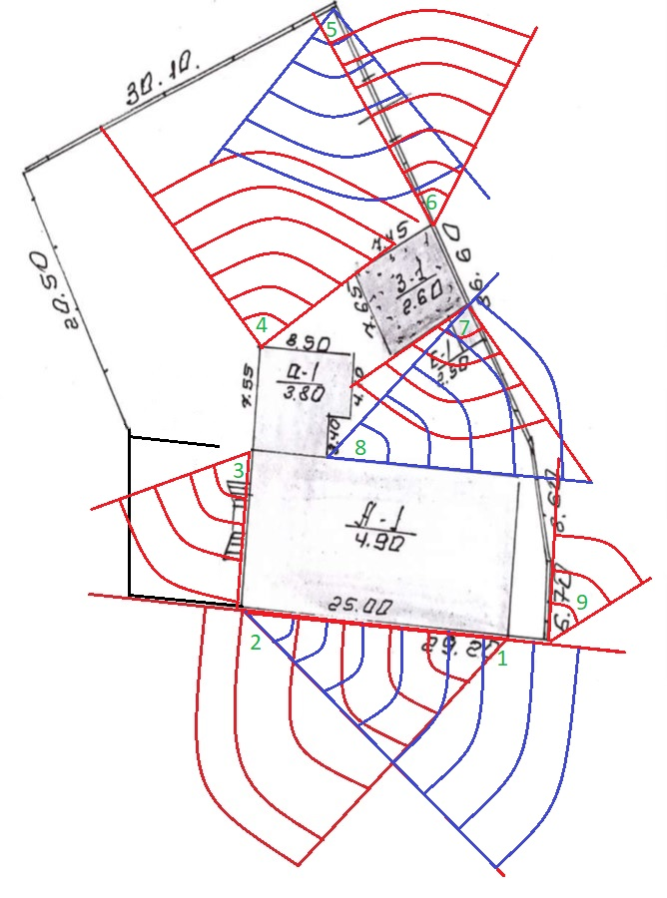

UNHCR Mariupol Office – internal CCTV cameras position

