GREECE SHELTER + NFI WORKING GROUP: TERMS OF REFERENCE

Background
Over one million refugees and migrants undertook the perilous journey across the Mediterranean to Europe in 2015, the vast majority having crossed the Aegean Sea from Turkey to Greece. Refugee and migrant inflows continued during the first quarter of 2016, with 154,491 new arrivals registered in Greece by 25 April 2016. The vast majority (90 per cent) come from the world’s top ten refugee-producing countries, primarily from Syria, Afghanistan and Iraq. The percentage of persons with specific needs amongst the arrivals has increased, with 60 per cent of women and children to date in 2016, compared to 47 per cent in 2015.
The situation in Greece considerably changed in February and March 2016, with the closure of the Greece-FYROM border on 8 March and the entry into effect of the EU-Turkey agreement on 20 March. From a response targeting people on the move, humanitarian actors reviewed their priorities to focus on a static population living in an urban context and being hosted in emergency sites or existing buildings. Refugees and migrants are now divided into two categories that are subject to different administrative treatment. Those who arrived on the islands in Greece prior to 20 March have been almost fully transferred to the mainland, and have access to asylum, family reunification and the possibility to benefit from the relocation scheme as per previous policy and standards.
Sites are managed either temporarily by the army, local authorities or the Alternate Ministry of Interior in charge of Migration Policy, with populations ranging between 200 and 4,000 persons, making it difficult to realise economies of scale as most sites need to be covered by mobile teams. The quality and scope of services offered at each site vary from one location to the other.
For those who arrived after 20 March on the islands, they have been kept in the hotspot facilities until they are registered and processed, with restricted freedom of movement. While most humanitarian partners suspended some of their activities in detention facilities, the implementation of some alternatives to detention has allowed the resumption of certain services in some facilities. Meanwhile, returns to Turkey started on 4 April 2016.

Working Group (WG) Objectives
The WG aims to ensure that refugees and migrants are provided with secure, comfortable and culturally-appropriate shelter, as well as suitable household belongings to maintain adequate protection and personal dignity for the duration of their stay in Greece. This will be achieved by:
- Validating, promoting and monitoring of the use of technical guidance across all shelter and NFI interventions in Greece, including needs assessment tools; common definition of ‘vulnerability’; range of standard NFI kits; NFI distribution tracking system (ration cards or bracelets); minimum construction/fabrication quality of locally-procured shelter and NFI materials; minimum shelter and site planning standards; SOPs for different shelter and NFI response modalities.
- Building local and national capacity of relevant actors (from government bodies to informal volunteers) to understand humanitarian needs with regard to shelter and NFIs, encouraging their use of WG technical guidance.
- Coordinating with relevant Greek Government bodies and all other sectors to ensure a synchronized response in order to benefit the PoC;
- Working in close collaboration with the Cash Working Group to pursue the transition to multi-purpose cash/voucher grants for NFI assistance, rental support and/or shelter improvements.

Geographical Coverage
National Strategic Advisory Group (SAG):
Countrywide coverage (mainland and islands) providing strategic direction and guidance to all operational level coordination hubs.
Operational WG Hubs:
Hub Location | Administrative boundaries under Hub’s coordination | Accommodation sites within Administrative boundaries  (as of 14.06.2016)
Thessaloniki | Central Macedonia; Eastern Macedonia + Thrace | Alexandria, Chalkero, Cherso, Derveni, Diavata, Drama, EKO Gas Station, Evzonoi (Hara Hotel + BP Gas Station), Fragaport, Giannitsa, Kalohori, Karamanlis, Kordelio, Lagadikia, Nea Kavala, Oreokastro, Pieria (Camping Nireas, Ktima Iraklis + Petra Olympou), Sinatex, Thessaloniki Port, Vaiohori + Veria.
Ioannina | Epirus | Doliana, Filipiada, Katsika Ioanninon, Konitsa, Tsepelovo.
Athens | Attica, Central + Western Greece | Agios Andreas, Andravidas, Elefsina, Eleonas, Elliniko (I, II + III), Larisa-Koutsochero, Lavrio, Malakasa, Oinofyta, Piraeus Port, Ritsona, Schisto, Skaramagas, Thermopiles, Victoria Square, Volos.
Lesvos | Lesvos | Kara Tepe, Moria
Chios | Chios | Diepthe, Souda, Vial
Samos | Samos | Malagari Port, Vathy
Kos | Kos, Kalymnos, Rhodes
Leros | Leros | Lepida, Poseidon

National level Coordination

SAG Objectives:
The SAG seeks to support the Shelter + NFI Sector WG in developing and, on a regular basis, reviewing the Operational Strategy, ensuring that this strategy is responsive to the changing humanitarian situation in Greece, is aligned with the Sector objectives and is operational in scope.
In addition, a key SAG objective is the establishment, validation and monitoring of context-specific technical guidance for operational WG members. This includes, but is not limited to, needs assessment tools, common vulnerability definitions, NFI kit standards and distribution tracking systems, shelter and site planning minimum standards.

SAG Tasks and Responsibilities:
Meet on needs and topic-focused basis to address the following:
- Review/revision of National Shelter + NFI Sector’s strategic priorities.
- Theme selection and management of temporary technical task forces (TTFs).
- Monitoring and evaluation of overall operational response efforts.
- Information management tools are aligned to strategy and useful for WG members.
- Contingency planning and risk mapping for the sector.
- Advocacy with key stakeholders to promote/achieve WG’s strategic priorities.
- Two-way communication and collaboration with operational WG hubs.
- Targeted capacity development of local stakeholders (authorities, NGOs, PoC and host communities).

Operational level Coordination

Tasks and Responsibilities on the MAINLAND:
- Advocate for fair and equitable humanitarian responses to all affected persons, as well as encourage beneficiary ownership of shelter/NFI outputs via sensitization campaigns and their inclusion throughout the planning cycle.
- Distribute NFIs in a participatory manner, utilizing age, gender and diversity principles.
- Identify culturally and contextually appropriate shelter solutions for all PoC, most notably those with disabilities, the socially and economically vulnerable, elderly individuals, single-headed households and unaccompanied minors.
- Liaise closely with the Cash Based Initiatives to identify best practice in NFI identification and distribution.
- Identify gaps in the needs of the PoC and coordinate means to best prioritise and address them.
- Engage informal/local NGO’s.
- Coordinate assessment of needs with other sectors and operating agencies.
- Involve local communities and businesses to provide required support and improvements to shelter needs to foster good will with host communities.
- Promote the importance of providing adequate fire safety measures at all refugee/migrant hosting sites.
- Explore appropriate shelter and site planning designs for more sustainable, longer-term housing.
- Develop
- Provide Information Management support to agencies to ensure uniform and adequate reporting.

Tasks and Responsibilities on the ISLANDS are addressed in individual ToRs.
NOTE: Lesvos have a different inter-sector WG structure; shelter is combined with WASH and NFIs stand alone.
Inter-Sector Issues
The WG will operate in close coordination with other Sectors and partners in order to actively address:
- PoC protection concerns related to Shelter and NFIs.
- SGBV Sector WG should inform the shelter programmes in order to propose adequate solutions – including adequate lighting, privacy, locks, overcrowding, and unsegregated communal accommodation.
- The modalities of all types of shelter and NFI support take into account to specific needs based on gender, age and disabilities. All items will be appropriate for the needs of women, men, girls, and boys, ensuring that the specific and increased needs of the most vulnerable (elderly, children, persons with disabilities) are met. Specific trainings should be supported by the Sector.
- Environmental impact of extensive camp-development and shelter support to out of camp contexts.
- Potential negative impact of dense refugee and migrant populations living in close proximity to local Greek communities and social-cohesion issues arising as a result.
- An integrated urban shelter strategy to promote alternatives to camps/isolated accommodation sites by capitalizing on existing building stock and reinforcing local markets/community services.
- Communal kitchens related to cash, WASH, protection, etc.

Membership and Member Responsibilities:
Government Partner to Lead Shelter NFI Working Group with Co-Lead by UNHCR.

National Strategic Advisory Group:
In lieu of a separate national WG, the SAG forms the national level coordination of the Shelter and NFI Sector Working Group. It represents key partners from the level of INGOs, NGOs, UN agencies, Inter-Governmental Organisations and Greek authorities from each area of operation (North, West, Islands and Attica) to provide strategic direction for WG through consultation with all members.
Members profile = senior technical or programme staff with national-level decision making authorities.
National Coordinators = Government Partner (TBD) and UNHCR.

Operational Hubs:
Members profile = field-based technical or program staff with field-based decision making authorities.
Members = Relevant government agencies, local and International Humanitarian Organisations, including UN, Inter-governmental, non-governmental & local volunteers, and donors.
Operational Hub Coordinators = Leading NGO agencies, sometimes in co-coordination with UNHCR, based on their coordination capacity and participation (not solely managing or attending meetings), their shelter + NFI experience/expertise and presence with response activities in the respective sub-national hubs.
Currently a ‘work in progress’ for Thessaloniki, Ioannina and Larissa to finalise operational coordinators and/or focal points.

Coordinator and co-coordinator Responsibilities
- Ensure appropriate coordination with partners in an inclusive and transparent manner, ensure decisions are taken in a participatory way and follow up on key decisions and action points;
- Promote the integration of gender into planning, policies and guidelines;
- Act as focal point for inquiries on the Shelter and NFI sector response plans and operations and represent the sector within Inter Sector and Interagency Coordination Meetings as well as in other humanitarian for a/platforms
- Encourage the use of common needs assessment and monitoring tools, and ensure timely and accurate reporting by all partners and sectors.

Transition and Handover
The WG will create a roadmap for the complete handover of responsibilities to Greek government stakeholders, primarily the municipal, governorate and regional authorities, based upon an assessment of objectives, targets and scenarios contained in this document and associated support documents.

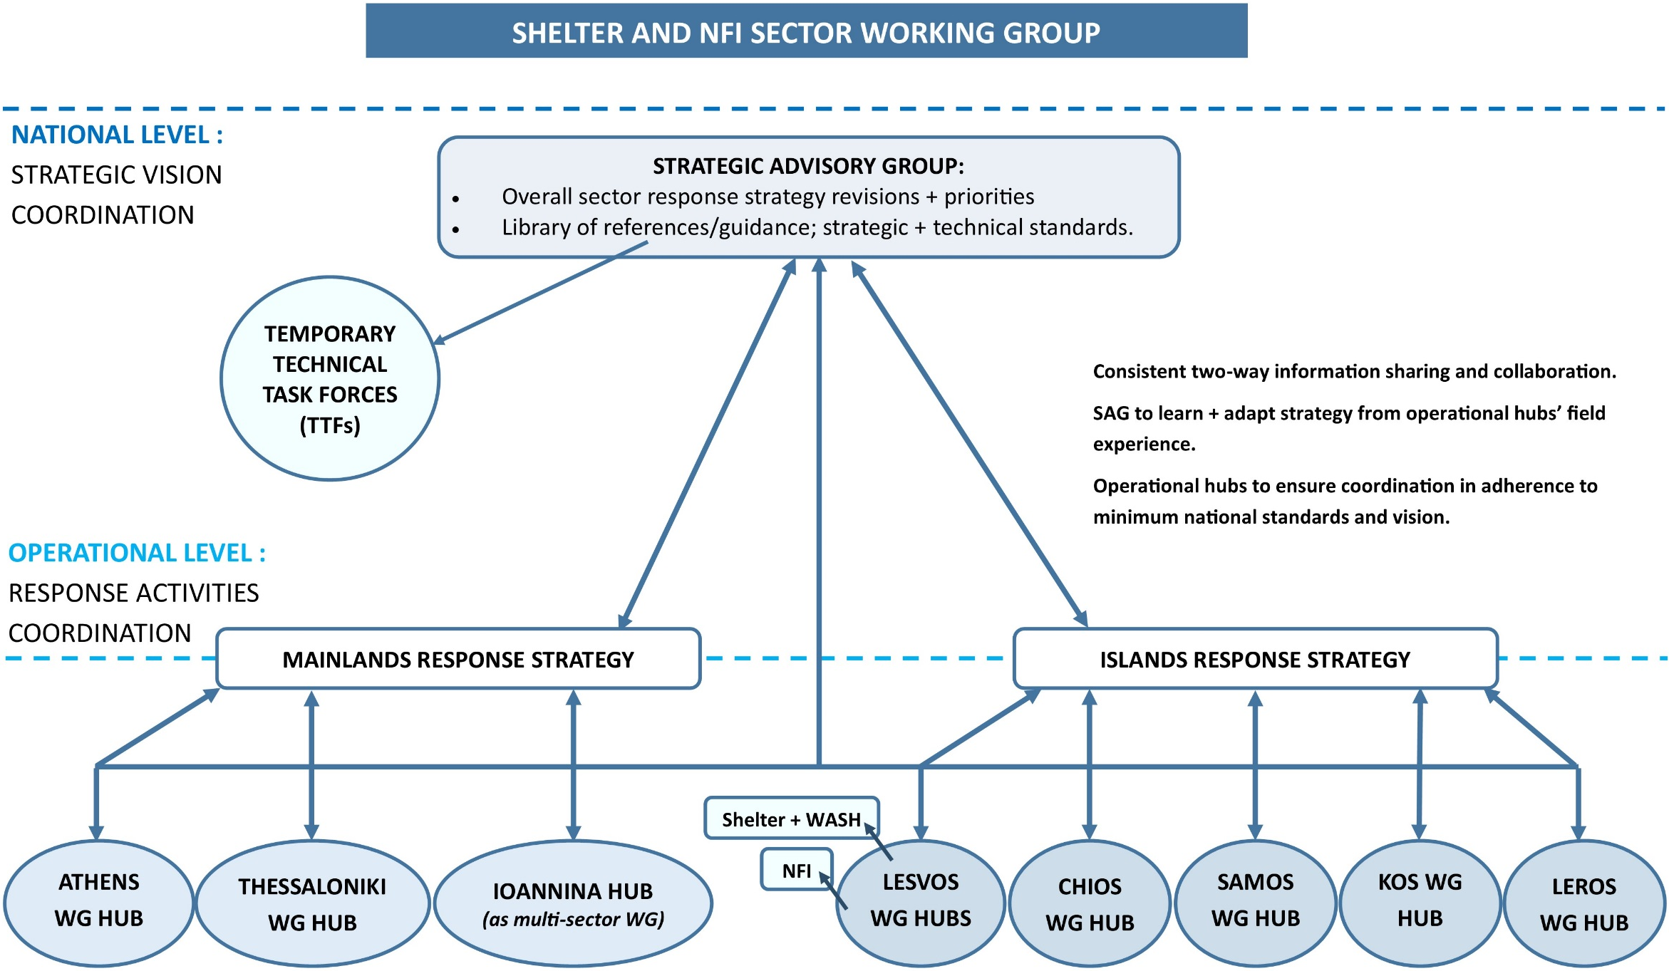
Coordination Structure

Regional Refugee and Migrant Response Plan for Europe, Jan-Dec 2016, pg.45.

