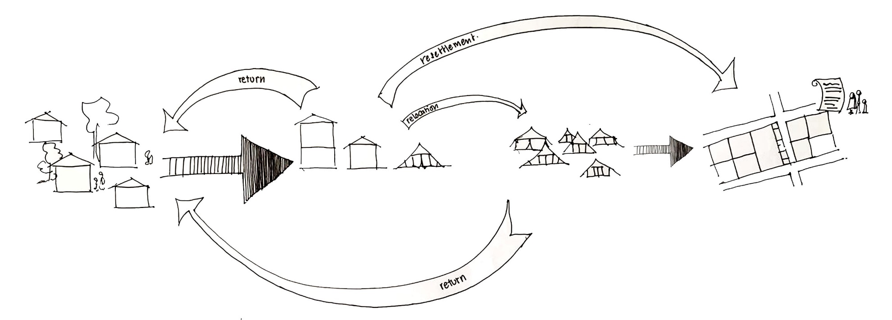
CAMP COORDINATION AND CAMP MANAGEMENT | CYCLONE IDAI RESPONSE
STRATEGY (draft)

Place of Origin
(home owners, land/home renters)
Resettlement Site
(planned site with plot allocation and land title)
Accommodation Centers (community centers, schools, tent sites, etc.)
Transitional Location (temporary setting prior to return or resettlement)

OBJECTIVES:
CCCM will works towards ensuring safety and dignity for the displaced population living in collective settings by improving their access to protection and assistance, as well as the living environments.
RESPONSE:
Place of origin | Accommodation Centers | Transitional Location | Resettlement Sites
INFORMATION
- Tracking of movement, site population, demographics, etc.
- Basic multi-sector Need assessments at site level
MONITORING AND COORDINATION
Ensure information on conditions at place of origin are available for those wishing to return. | - Support to INGC on-site focal points  Mobile Teams:  - Service Mapping,  - Monitoring of services, raising concerns and issues to the cluster where on-site referral is not viable  - Site level coordination: engagement with service providers  - Establishing and maintaining information hub, that includes: PSEA awareness, referral information, service information, etc.  - Complaint and Feedback mechanism
COMMUNITY ENGAGEMENT AND PARTICIPATION
 | - Capacity development with committees in centres/sites, ensure awareness on PSEA, referral mechanism, participation and leadership  For return and resettlement:  - Work with Community Engagement WG to conduct consultations and verification at sites planned for closure.  - Discuss and plan to get ready for movement (return and resettlement), organizing go-see visits for resettlement sites |  | - Follow up with committees after movements,  - Further capacity development as relevant/required
SITE PLANNING AND SITE IMPROVEMENT
 | - Basic site assessment and improvement such as: construction of communal cooking area, improve drainage, signage, etc.  - Establishing Site maintenance committee |  | - Technical support and capacity development for site planning to Ministry of Environment, Land and Public Works.  - Site planning support on site  - Assess, identify and support on short-term site improvement need
Decommission:
- make plan with host communities and local authorities for de-commissioning of accommodation centers that are closing,
- Organize teams to support and mobilize communities for clean-up and repairs prior to handover of the facilities

COORDINATION:
CCCM will work to coordinate with service providers at site level, coordinate with other cluster to raise issues and concerns to relevant sectors in all locations as well as active engagement and contribution to the Relocation, Return and Resettlement Working Group as part of its commitment towards durable solution for the displaced population.
MONITORING:
Contact: Moz.Coord@cccmcluster.org

