Apply to a Job Opening with UNHCR in 10 Steps

(for External applicants only)

UNHCR is pleased to announce the launch of the new MSRP Online Recruitment Tool to all applicants interested in applying for job opportunities with UNHCR. Please note that applications to our vacancies through e-mail will no longer be considered.
Step 1: Interested applicants are kindly asked to visit the link below as a first step:
https://www.unhcr.org/careers.html
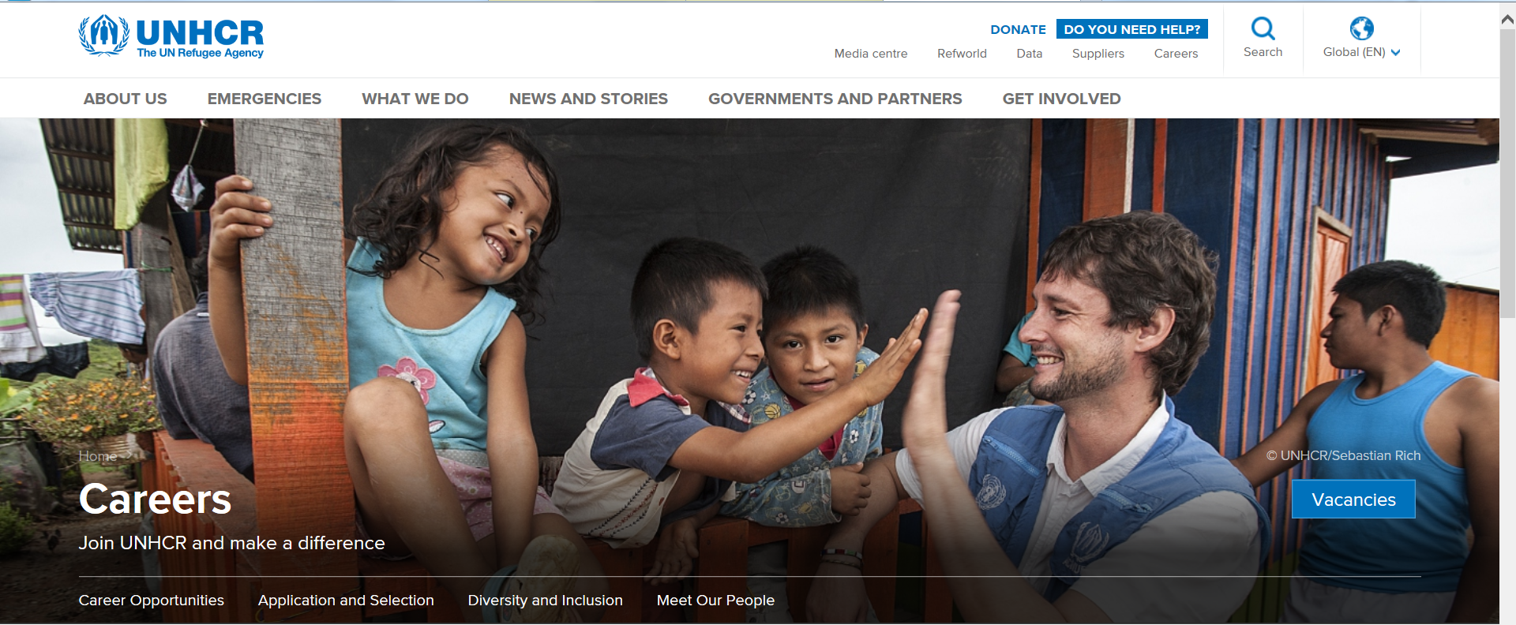

Step 2: On this main page for careers, please click on the blue button “Vacancies’.
Step 3: You will be directed to the page below, where all UNHCR vacancies all over the world are listed.
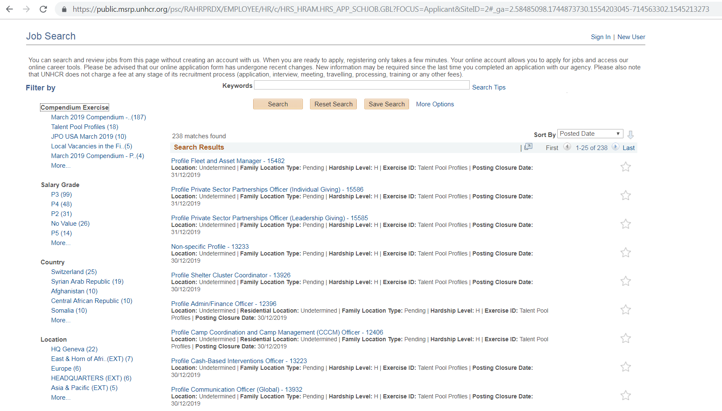

Step 4: You must “sign in” in order to apply for any vacancies listed. You must click on New User on the right corner of the screen as shown above if you are applying as an external candidate for the first time.
Step 5: For the local job openings in UNHCR Turkey, please click on ‘Local Vacancies in the Field’ link on the left column as shown above. You may use filters on the left side of the Careers page, to reduce their results for a more focused search, or enter the Job Opening number in the “Keywords” field.
Step 6: Once you select the Job Opening you wish to apply for, you will be directed to the Job Description page in the on-line application (Personal History Form) process.
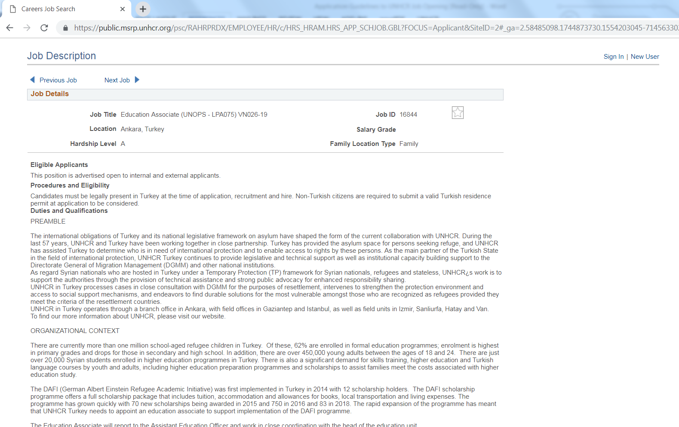

Step 7: For the vacancy you are interested in, please click on the “Apply” button, which will direct you to the page in the next image. You must fill in the required field and click on “Next” in order to move ahead in the application process.
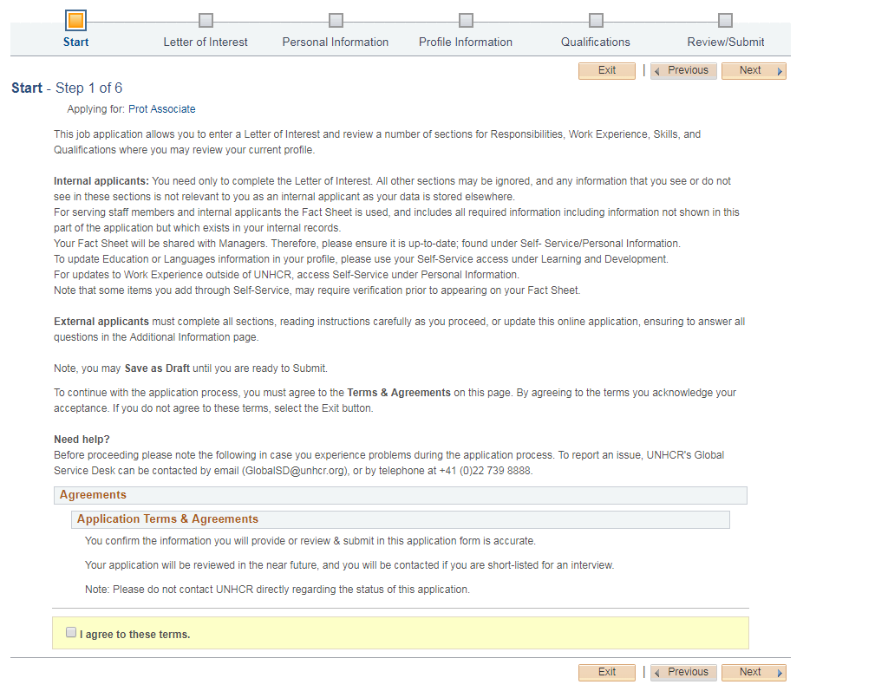

Step 8: You must agree to the terms, before reaching the Letter of Interest page of the application. They must include a Letter of Interest and completed online application including personal, profile and qualifications information.
Step 9: In the “Additional Information” section all questions must be answered. Once all is completed, you may click “Review/Submit” application. Here you may preview your application and review it by section.
Step 10: By clicking on “Confirmation and Consent”, you will submit your application and receive automatic notification by e-mail that the application has been submitted. Congratulations!

Please note that only shortlisted applicants will be notified by UNHCR.

