|  |
| --- |
| INTER-AGENCY STANDING COMMITTEE  TRANSFORMATIVE AGENDA REFERENCE DOCUMENT  **4. Reference Module for Cluster Coordination**  **at the Country Level**  November 2012 |

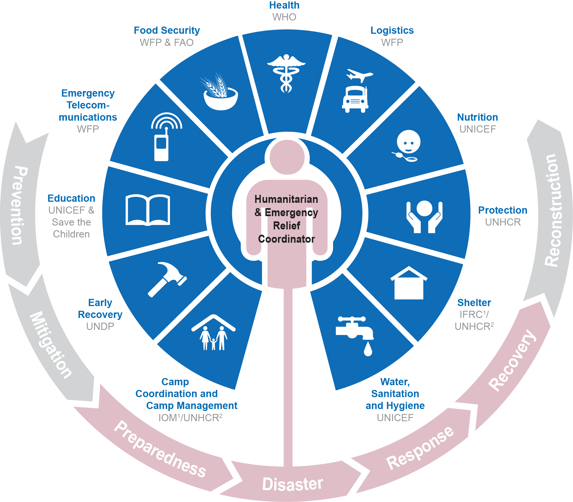

This Module will be circulated in November 2012 and field tested in the first half of 2013. The Module will be updated based on experience and use of country teams, and the revised version will be circulated by June 2013. Thereafter, it will be reviewed and updated periodically based on experience and good practice.

# Table of Contents

1. Cluster Activation 4

2 Cluster De-activation 6

3 Cluster Functions 9

4 Cluster Management Arrangements 11

5 Minimum Commitments for Participation in Clusters 14

6 Sub-National Level Coordination 16

7 Sharing Leadership within the Cluster Approach 18

8 Inter-Cluster Coordination 21

9 Coordination Performance Monitoring 23

Acronyms and Abbreviations 25

Further Reference 26

Following the recommendations of an independent Humanitarian Response Review in 2005, the cluster approach was proposed as one way of addressing gaps and strengthening the effectiveness of humanitarian response through building partnerships. The cluster approach ensures clear leadership, predictability and accountability in international responses to humanitarian emergencies by clarifying the division of labour among organizations and better defining their roles and responsibilities within the different sectors of the response. It aims to make the international humanitarian community better organised and more accountable and professional, so that it can be a better partner for the affected people, host governments, local authorities, local civil society and resourcing partners.

However, the strength of the cluster approach relies on an understanding that this approach is not the only humanitarian coordination solution. In some cases, the cluster approach may co-exist with other “non-cluster” coordination solutions – whether national or international – or an alternative sectoral approach may be preferable. An indiscriminate application of all clusters in every emergency may waste resources and reduce opportunities for governments to exercise their primary responsibility to provide humanitarian assistance to people in need.

**Prepared by:** IASC Sub-Working Group on the Cluster Approach

**Endorsed by**: IASC Working Group on 31 August 2012

Introduction

This Cluster Coordination Reference Module[1] is about the basics of cluster coordination in non-refugee situations[2]. It is compiled in response to a request by the IASC as a reference guide for practitioners to facilitate the work through which humanitarian outcomes can be improved. It outlines key concepts and draws attention to existing guidance, wherever relevant. This reference module will be reviewed periodically based on feedback from the field. This module covers both large-scale responses identified within the IASC Transformative Agenda[3] as ‘level 3’*[4]* and smaller scale (‘non-level 3’) responses.

Using clusters intelligently

Coordination is a means to an end – the ultimate aim of the humanitarian community is to serve vulnerable populations effectively[5]. Accordingly, the scale of international coordination arrangements should be tailored to the operational context, to support national efforts[6] based on existing capacity in order to direct as many resources as possible towards delivering humanitarian assistance in a timely, predictable manner. Developing complicated coordination arrangements should be avoided; not all clusters need to be activated in every response.

The IASC Transformative Agenda recognizes the need for Humanitarian Coordinators (HCs), Resident Coordinators (RCs) and Humanitarian Country Teams (HCTs) to be empowered to make decisions that are right for their own country operations. While this reference module focuses on the cluster approach as the principal tool available to the international community for coordinating and accounting for their response, it falls to the leadership of the humanitarian team at the country level to devise the most appropriate ‘coordination solutions’ taking into account the local operational situation.

# 1. Cluster Activation

Cluster activation means the establishment of clusters as part of an international emergency response, based on the HCT’s analysis of humanitarian need and coordination capacity on the ground, in consultation with national partners.

The IASC Principals agreed that the activation of clusters must be more strategic, **less automatic and time limited**. The HC should only recommend the activation of clusters when there is an identified need which is not being addressed. The ideal approach is to support *national* mechanisms for sectoral coordination. To the extent possible, any new clusters which are established should complement existing coordination mechanisms.

In a level 3 response, clusters may be activated - if they do not already exist – with the support of personnel deployed through the Inter-Agency Rapid Response Mechanism (IARRM). The IARRM ensures there are sufficient experienced people on the ground working within agreed structures to either augment or fill the core coordination functions required for an effective response. All clusters should be prepared to deploy in a level 3 response, but the decision of which clusters to activate will be taken within 72 hours from the level 3 declaration by the HCT (if existent), supported by the IASC emergency/operational directors at headquarters, and on the basis of analysis of coordination mechanisms in place. Cluster activation will be regularly reviewed thereafter (as per the table in Section 2 on cluster de-activation).

Criteria for cluster activation

The criteria for cluster activation are as follows:

1. Trigger event in the form of a new large-scale emergency or sharp deterioration and/or significant change in an existing humanitarian situation leading to coordination gaps.
2. Evaluation of existing national response and coordination capacity and/or national response shows inability to appropriately meet needs.
3. Humanitarian needs justify a multi-sectoral approach that the existing coordination and response mechanisms can no longer adequately address.
4. The size of the operational presence (the number of actors and complexity of response) requires a sector-specific coordination mechanism, if this does not already exist.

Activation procedures

The procedure for activating one or more clusters is as follows:

1. The RC/HC agrees with the HCT which clusters should be activated, based on the contingency plan and with a clear rationale for each case that takes into account national capacity and needs.
2. Global Clusters are alerted in advance of the proposed HCT meeting to discuss activation so that they ensure appropriate and informed representation at country level in this discussion.
3. The RC/HC selects Cluster Lead Agencies in consultation with the HCT based on the agencies’ coordination and response capacity, as well as the location and level of its operational presence and/or ability to increase this. The selection of Cluster Lead Agency ideally mirrors the global-level arrangements but this is not always possible, and in some cases other organizations may be better placed to take the lead.[7] Shared leadership, including using non-governmental organizations, should be considered.
4. Upon agreement within the HCT, the RC/HC sends a letter to the Emergency Relief Coordinator (ERC) outlining the recommended cluster arrangements, suggested Cluster Lead Agencies, and the rationale for the clusters selected for activation. If other coordination solutions outside of the cluster have been agreed, these should also be outlined in the letter.
5. The ERC transmits the proposal to IASC Principals and Global Cluster Lead and Co-Lead Agencies for approval within 24 hours and informs the RC/HC accordingly.
6. Once approved, the RC/HC informs relevant partners of the agreed clusters and lead agencies.

Addressing issues which cut across clusters

Decisions on the activation of clusters to fill operational gaps should take into account the protection needs of the affected population including the “areas of responsibility” of the Protection Cluster (i.e. child protection; gender-based violence; mine action; and housing, land and property). Cluster activation should also take into account needs within other cross-cutting areas such as age; environment; gender; HIV/AIDs; mental health and social well-being; and persons with disabilities. These issues should be integrated into the work of the clusters, as should early recovery and disaster risk reduction.

# 2 Cluster De-activation

The de-activation of clusters is a decision to stand-down one or several clusters because either the cluster has transferred responsibility for delivery and possibly capacities, tools, systems and resources to national and/or development partners or because humanitarian needs in a particular sector have sharply decreased or ceased (e.g. when affected people have returned, reintegrated or relocated).

It should be noted this section is presented in the context of ongoing discussions to frame a broader approach to humanitarian transition and early recovery and the outcomes of those discussions will be included in the next review of this Module.[8]

The basics of cluster de-activation

As stressed earlier, clusters are supposed to be a temporary coordination solution and the aim should be to either resume or establish national, development-oriented coordination mechanisms as soon as the humanitarian emergency phase ends. The efficient de-activation of clusters is therefore based on (a) a regular review questioning the on-going need for clusters by the RC/HC and HCT, and (b) the required planning to ensure transitional arrangements are put in place and are being supported by capacity development and preparedness efforts.

Importance of analyzing the context when deciding on de-activation

As a very general principle, the criteria for the de-activation of clusters should mirror the criteria for activation, i.e.when the criteria applied to activate a cluster no longer apply, the cluster can be de-activated. However, in deciding on de-activation, the RC/HC and HCT should consider the need to address any on-going **humanitarian needs** and **the national and local context.** Clusters do not all have to be deactivated at the same time; some may need to remain longer, while others are deactivated. Some clusters will have a more natural counterpart to ‘hand over to’ than others, making transition easier. Also, de-activation in sudden onset crises may be a more rapid process than de-activation in complex or protracted emergencies.

There are some factors that would suggest a longer transition between the emergency and recovery phases – especially in complex emergencies - including:

* A continuing requirement to address critical humanitarian needs and the violation of human rights;
* The need to maintain accountability for delivery in key sectors;
* The existence, capacity and willingness of national counterparts to lead sectoral coordination;
* The possibility of recurring or new disasters.

Additional considerations

The opportunity cost of deactivation of clusters should be considered in contexts where humanitarian need may suddenly increase again. De-activating clusters too soon could result in unnecessary costs in re-establishing them and would reduce the possibility for preparedness and transition arrangements. In deciding on de-activation, the RC/HC and HCT should take a pragmatic view of the potential for re-occurring or new disasters as determined by an updated multi-hazard contingency plan.

Transitional arrangements

Clusters have a responsibility to build the capacity of their respective national counterparts, where they exist. Good practice suggests that a strategy for transition to national structures is developed by the cluster soon after its activation, including overall and cluster-specific plans to ensure the transfer of cluster capacity to national counterparts and development partners.

Capacity-building and preparedness activities should be incorporated into the transition process where possible, while also ensuring the planning process does not create the over-extension of clusters’ roles. In implementing their exit strategies, clusters need to ensure that continued support is provided to national counterparts even after the complete phase out of the cluster approach in support of early recovery and sector coordination[9].

Separating de-activation from funding and participation

Decisions on cluster de-activation should not be linked to formulating funding requirements, determining participation in the HCT, engagement in the inter-cluster/inter-sectoral coordination fora, or other inter-agency humanitarian coordination structures which support the delivery of efficient and strategic humanitarian action.

Periodic review of clusters’ status

Clusters should be reviewed by the RC/HC and HCT periodically, as per the table below, to ensure alternative coordination mechanisms are (re-)established when appropriate, either for the overall response or for those sectors where national capacities are in place. Cluster review should include any planned provision for the handover of strategies and mechanisms established by the clusters to their national counterparts, and should also take into account any agreements for the handover of resources in accordance with the rules and regulations of the cluster lead agency.

The review by the RC/HC and HCT of the status of clusters may be complemented by the annual review of field operations by the IASC emergency/operational directors at the headquarters level[10].

Cluster-de-activation procedures

1. Under the leadership of the RC/HC, the HCT notes which clusters have successfully transferred effective coordination responsibilities to national counterparts (government or other), and recommends de-activation. The rationale for those clusters which may still be required is presented during the review process, along with a plan for their transition.
2. The RC/HC provides a summary of the review to the ERC, outlining which clusters are to transition and subsequently be de-activated, along with an indication of other sectoral coordination mechanisms in place, agency focal points engaging with these sectoral coordination mechanisms, and the implications of these decisions on contingency planning.
3. The ERC shares this note with the IASC Principals and Global Cluster Lead and Co-Lead Agencies for their approval.
4. Once approved, the RC/HC informs relevant partners of agreed arrangements.

Table 1. Review of Clusters

|  |  |  |
| --- | --- | --- |
| **Context** | **Status and review** | **Implications** |
| Level 3 response | Activation review by the HCT within three months of Principals’ level 3 decision. | Surge capacity normally withdraws based on the findings of the review. Transition plan from level 3 required by ERC. |
| **All levels of response** | Review of the need for cluster and/or national/development capacity for coordination by the HCT every 6 months; justification for clusters provided in advance of CAP or appeal process and mid-year review. | Rationale for maintaining clusters included in the strategic plan; strategic objectives include sectoral and cluster contributions. |

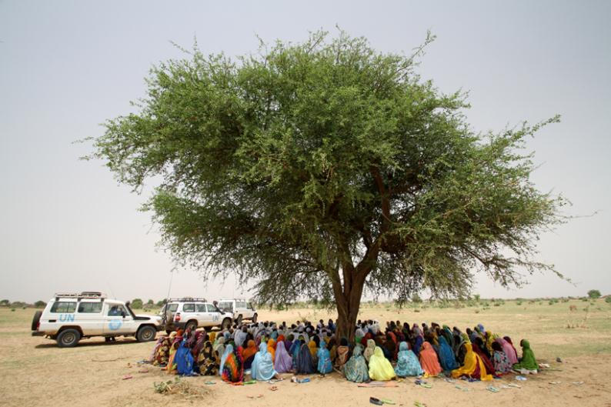

A meeting with returnees in Borota, eastern Chad. The key concern discussed was the lack of clean water. Credit: OCHA/P Peron

# 3 Cluster Functions

The IASC Principals “agreed there is a need to restate and return to the original purpose of clusters, refocusing them on strategic and operational gaps analysis, planning, assessment and results.[11]” The aim of the cluster approach, as agreed in 2006[12], is to strengthen system-wide preparedness and technical capacity to respond to humanitarian emergencies, ensuring clearly designated leadership and accountability in the main areas of humanitarian response. At the country level, the aim is to strengthen response through predictability, accountability, and partnership by ensuring better prioritization and defining roles and responsibilities of humanitarian organizations. Information management and analysis are key in this regard.

Delivering as a cluster

Consequently, the **core functions** of a cluster at the country-level are:

1. **Supporting service delivery** 
   * Provide a platform to ensure that service delivery is driven by the agreed strategic priorities
   * Develop mechanisms to eliminate duplication of service delivery
2. **Informing strategic decision-making of the HC/HCT for the humanitarian response**
   * Needs assessment and response gap analysis (across sectors and within the sector)
   * Analysis to identify and address (emerging) gaps, obstacles, duplication, and cross-cutting issues including age, gender, environment, and HIV/AIDs
   * Prioritization, grounded in response analysis
3. **Planning and strategy development**
   * Develop sectoral plans, objectives and indicators that directly support realization of the HC/HCT strategic priorities
   * Apply and adhere to existing standards and guidelines
   * Clarify funding requirements, prioritization, and cluster contributions for the HC’s overall humanitarian funding considerations (e.g. Flash Appeal, CAP, CERF, Emergency Response Fund/Common Humanitarian Fund)
4. **Advocacy** 
   * Identify advocacy concerns to contribute to HC and HCT messaging and action
   * Undertake advocacy activities on behalf of cluster participants and the affected population
5. **Monitoring and reporting** the implementation of the cluster strategy and results; recommending corrective action where necessary
6. **Contingency planning/preparedness/capacity building** in situations where there is a high risk of recurring or significant new disaster and where sufficient capacity exists within the cluster.

Early recovery

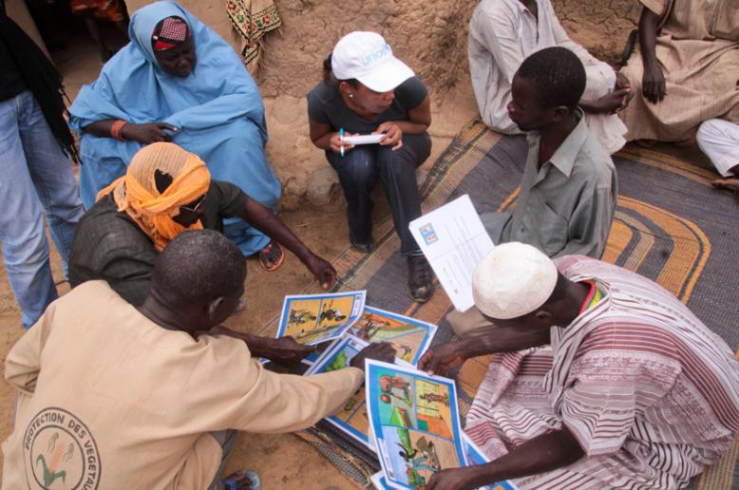Finally, each cluster is also responsible for integrating early recovery from the outset of the humanitarian response. The RC/HC has the lead responsibility for ensuring early recovery issues are adequately addressed at country level, with the support of an Early Recovery Advisor. The Advisor works on inter-cluster early recovery issues for a more effective mainstreaming of early recovery across the clusters and to ensure that multidisciplinary issues, which cannot be tackled by individual clusters alone, are addressed through an Early Recovery Network[13]. Exceptionally, where early recovery areas are not covered by existing clusters or alternative mechanisms, the RC/HC may recommend a cluster be established in addition to the network to address those specific areas.

Aid workers conducting cholera awareness campaigns to at-risk communities in Niger. In 2012, nearly 4,000 cholera cases and over 80 deaths have been reported, mostly along the Niger River which recently flooded after heavy rains in the west of the country. Credit: UNICEF/S Mebrahtu

# 4 Cluster Management Arrangements

This section covers the organization and coordination of the various cluster components – the Cluster Lead Agency, the Cluster Coordinator and all cluster participants at the national and sub-national level – in order to deliver on the core functions of the cluster. It is important to balance the need for consultation on operational concepts with the need to provide leadership of a cluster in an emergency to ensure key decisions are taken by a manageable number of partners.

Effective and efficient cluster management is a shared responsibility

A well-run cluster is a **formal deliverable** of the Cluster Lead Agency and forms a part of the agency’s work. However in practice, it has been recognized by the IASC and donors that the efficient management or functioning of clusters is the **joint responsibility** of the Cluster Lead Agency, the Cluster Coordinator, resourcing partners and all cluster participants at the national and sub-national level.

The criteria for participation in the more strategic, management work of the cluster are:

* Operational relevance in the emergency
* Technical expertise
* Demonstrated capacity to contribute strategically and to provide practical support
* Commitment to contribute consistently

Characteristics of a well-managed cluster

Efficient cluster management should encompass the following characteristics:

* Monitored performance of the six core cluster functions with regard to developing programmes – which clearly contribute to the implementation of evidence-based strategic objectives – based on the identification of good field practices and agreed international benchmarks and standards;
* Establishment and maintenance of an appropriate humanitarian coordination mechanism;
  + Strengthening pre-existing sectoral coordination through increased predictability and accountability;
  + Building complementarity of partner actions: avoiding duplication and gaps;
  + Ensuring adequate resources are mobilized and are equitably allocated for the effective functioning of the cluster and its response;
  + Effective and comprehensive integration of relevant cross-cutting issues, including age, gender, environment and HIV/AIDs;
* Maintaining flexibility within the cluster to respond to changes in the operating environment, evolving requirements, capacities and participation;
* The effective use and transfer of information to, from and between cluster members and other stakeholders;
* Interaction with other clusters (including through inter-cluster coordination fora), humanitarian actors, government counterparts, and relevant authorities for operational planning, engagement and active contribution of operational partners;
* Accountability to the affected population through effective and inclusive consultative and feedback mechanisms.

No ‘one-size fits all’ approach to cluster management

There is no ‘one-size fits all’ approach to cluster management. Due to the varying size, scope and complexity of disasters and cluster response, the choice of a management approach must be adapted to need and may change as the response evolves. However, experience has provided some models for efficient cluster management which have been approved by the IASC. In 2011, the IASC Principals agreed that “participation in clusters should be better defined and managed to enhance the ability of clusters to provide strategic direction, including through the creation of small ‘Steering Committees’ (SC) or ‘Strategic Advisory Groups’ (SAG) of key operational partners, complemented by separate forums or mechanisms to ensure broader information exchange for all cluster/sector partners”[14]. The number of SCs or SAGs formed will be context dependent and based on the need to ensure the required leadership.

Strategic Advisory Group

Chaired by the Cluster Coordinator, the SAG is responsible for developing and adjusting the strategic framework, priorities and work plan for the cluster. SAG membership **must** be representative of the overall cluster partnership. Apart from operational UN, International Organization for Migration (IOM) and NGO representatives, SAG members have included government representatives/focal points; donors; national NGO forum representatives; representatives of the International Federation of the Red Cross and Red Crescent Societies and National Societies; OCHA; cluster representatives; and where appropriate military liaison officers (see table below). However, to be efficient and effective and avoid the challenges arising from a large number of cluster partners, SAG membership should also be limited (up to a maximum of 15 partners in larger emergencies). To avoid feelings of exclusion among other cluster partners, the SAG (through the Cluster Coordinator) must interact with the broader cluster membership to ensure a regular flow of information.

Table 2. SAG Member/Invitee Options

|  |  |
| --- | --- |
| **Possible SAG Members** | |
| ***National Level*** | ***Sub-National Level*** |
| * Cluster Coordinator (supported by an information management specialist and cluster administrative support officer) * National NGO technical experts * International NGO technical experts * IFRC representatives (in natural disasters not affected by conflict) * UN technical experts * OCHA * Government representatives | The need for sub-national management should be determined by the national level SAG on a context specific basis (please also see section on sub-national coordination).  Membership does not need to directly mirror national level and often has greater representation of local authorities and NGO partners in both leadership and/or technical roles. |
| **Potential Invitees to the SAG (as appropriate)** | |
| * Sub-national cluster focal points * Donor representatives * Red Cross/Red Crescent Movement representatives * Regional focal points, in instances where agencies may have technical expertise based at a regional level * Military representatives and other authorities, as appropriate | |

Technical Working Groups

Technical Working Groups (known as ‘TWiGs’ or ‘TWGs’) are task-oriented and time-limited. They are created as needed, for example to agree minimum standards and formulate appropriate technical practices, or to find solutions to local issues and advise the SAG accordingly. TWiGs are coordinated by a focal point or technical advisor nominated by the SAG and consist of the necessary technical experts, usually not more than 15 people.

To facilitate communication with specific groups within the broader membership or outside of the cluster - such as experts in particular technical areas (including cross-cutting issues), military actors, government counterparts, and UN senior leadership - the SAG might also designate cluster partners to serve as a liaisons with these groups.

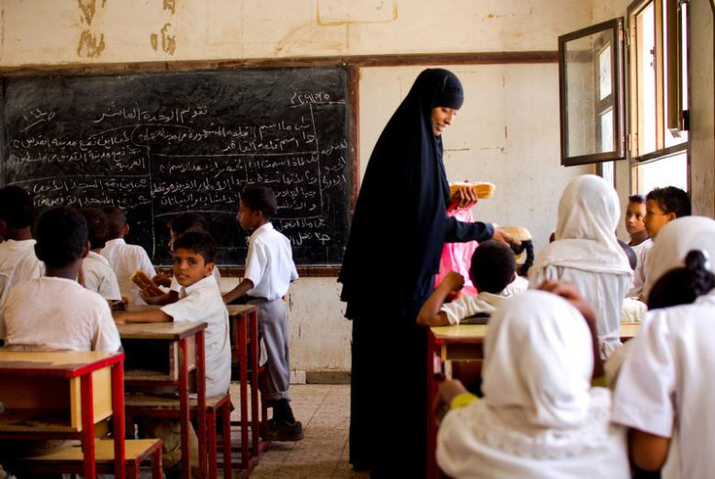

Yemeni girls stay at home to work when food is limited. With one of the greatest gender disparities in the world, school feeding programmes strive to encourage rural families to enrol their young daughters in basic and secondary education. Credit: Yemen HCT

# 5 Minimum Commitments for Participation in Clusters

Without constant commitment by cluster participants, predictable coordination will not be achieved.

The case for commitment by cluster participants

These minimum commitments for participation in country-level clusters provide a common basis of understanding of what organizations – whether local, national, or international – commit to bring to clusters at the country level through their participation. The commitments are not intended as a means to exclude organizations from participating in clusters nor should they prevent actively seeking the participation of national authorities within cluster coordination, as appropriate.

Balanced with these commitments from cluster partners, Cluster Lead Agencies have a reciprocal responsibility[15] to ensure that they lead clusters in a manner that goes beyond simply sharing information and that they provide effective coordination with their sub-national counterparts. Cluster Lead Agencies, together with the Cluster Coordinators, are responsible for providing a forum for strategic response that meets the needs of affected people and that feeds into other levels of strategic response (e.g. inter-cluster coordination at the country and global levels).

Agreeing to the commitments

All cluster partners, including Cluster Lead Agencies in their potential role as implementer alongside other agencies, have common, mutual responsibilities to reach the objective of effective and timely humanitarian response for affected people.

The minimum commitments are not prescriptive and should be adapted to actual needs and context as cluster-based responses vary greatly in size, scope and complexity. These commitments are a starting point and should be considered as an absolute minimum to which organizations may build. Country-level clusters should use this document as a basis when developing or updating their terms of reference and their own commitments.

Minimum commitments

The minimum commitments for participation in clusters include:

* A common commitment to humanitarian principles, the *Principles of Partnership*[16] through for example, cluster-specific guidance and internationally recognized programme standards, including the Secretary-General’s *Bulletin on Special Measures for Protection from Sexual Exploitation and Sexual Abuse*.
* Readiness to participate in actions that specifically improve accountability to affected populations as per the IASC *Commitments to Accountability to Affected Populations[17] and the related Operational Framework.*
* Demonstrate an understanding of the duties and responsibilities within the cluster, as defined through IASC terms of references and guidance notes[18] and any guidance specific to the cluster itself, as well as country cluster terms of reference, where available.
* Active participation within the cluster and commitment to consistently engage in the cluster’s collective work.
* Capacity and willingness to contribute to the cluster’s strategic response plan and activities, which must include inter-cluster coordination and cross-cutting issues (age, gender, environment and HIV/AIDs).
* Commitment from a relevant senior staff member to engage consistently in the cluster towards the fulfillment of its mission.
* Commitment to work cooperatively with other cluster partners to ensure an optimal and strategic use of available resources, including sharing information on organizational resources.
* Willingness to take on leadership responsibilities of sub-national and/or working groups, as needed and as capacity and mandates allow.
* Contribute to developing and disseminating advocacy and messaging targeted at various actors, including, but not limited to, affected communities, the host government, donors, the HCT, cluster lead agencies, and the media.
* 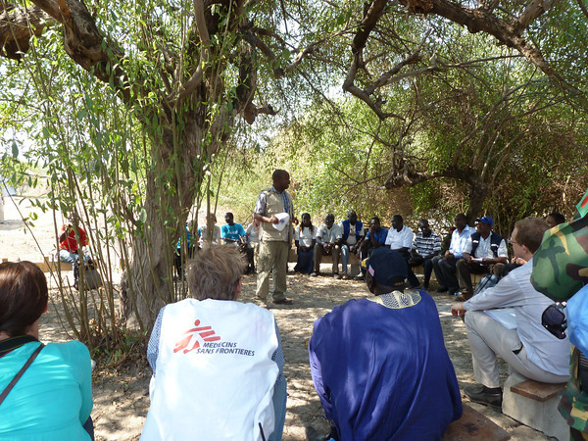Ensure interpretation and effective communication (i.e. appropriate language) in order to support diverse participation within the cluster, notably from local organizations (and national and local authorities where appropriate).

Humanitarian workers at a coordination meeting in South Sudan's Pibor coordination hub, Jonglei State, where inter-communal violence affected nearly 170,000 people. Aid organizations have recorded 165 violent incidents with humanitarian consequences in the first five months of 2012 alone. Credit: OCHA

# 6 Sub-National Level Coordination

Sub-national coordination refers to de-centralizing coordination from the national level by establishing sub-clusters/sectors in zones of particular operational importance. Structures may be established at more than one administrative level if required (e.g. provinces and districts in Pakistan), although the underlying principle of minimizing structures remains firmly in place. Sub-national coordination is critical where the response take place in remote areas (e.g. in Sudan) or over a large amount of territory (e.g. in the DRC).

Importance of sub-national coordination

Coordination structures in humanitarian operations that involve both national and sub-national level clusters have been identified as more effective than coordination models that comprise a single national level cluster. Notwithstanding resource limitations and operational context considerations, it is highly desirable to have sub-national clusters to facilitate decentralized decision-making and enhance the response time between decision-taking and implementation. In addition, sub-national level clusters are better suited to adapting existing standards to local circumstances. They are also better placed to maintain close cooperation with international, national and local NGOs and authorities in implementing the strategic plan; paying attention to cross-cutting and multidimensional issues; ensuring greater community involvement and participation; and enhancing accountability to affected populations.

However, as outlined above, sub-national clusters should only be established on the basis of the operational needs and should be de-activated as soon as those needs are met or when there is local capacity to coordinate the response in that area.

Sub-national cluster establishment

The establishment of sub-national clusters should be formalized in terms of reference outlining the key functions of the sub-national cluster and the parameters within which it will operate. The agreed terms of reference should be shared with the national Cluster Lead Agency for final endorsement.

Within the limits of available resources and operational context, sub-national clusters should have full- or part-time sub-national level Cluster Coordinators. Sub-national clusters offer ideal opportunities for UN agencies, international and national NGOs as well as national authorities to share cluster leadership.

Relationship between national and sub-national clusters

The national level clusters should provide support and policy direction to sub-national clusters. There must be a clear link between corresponding sub-national and national clusters in order to facilitate reporting, information-sharing and collaboration with national and other sub-national level clusters; to promote national programmatic cohesion and overall coordination to track trends; to identify common concerns across operational areas; and to develop more upstream advocacy and programming strategies. To ensure this coherence, the terms of reference should establish clear accountability lines between national and sub-national clusters, thus enabling the decentralization of operational decisions. There should also be a clearly understood sequencing between national and sub-national bodies: national meetings should take place after sub-national meetings and both discussions should be based on a reliable record of decisions taken and issues raised.

Types of sub-national activities

The terms of reference of sub-national clusters should follow the **core functions** of the cluster at the country-level, while at the same time being streamlined and tailored to local operational realities. Accordingly, the working methods of sub-national clusters must be light and focused on service delivery and operational activities; ensuring reporting and information sharing with the national cluster and, through that mechanism, other sub-national clusters; and promoting the involvement of the affected populations in cluster activities to ensure that humanitarian actors respond adequately to their actual needs.

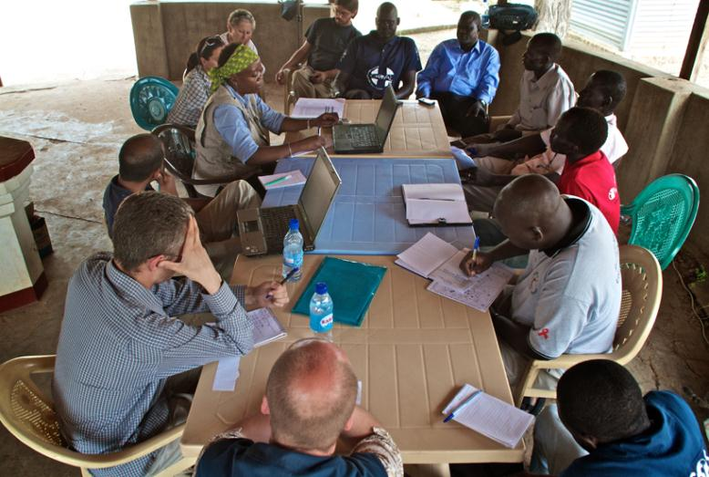

Coordination meeting at Agok in Warrap state, South Sudan. Thousands of residents of Abyei settled in Agok after being displaced by armed clashes in 2011. Credit: OCHA/D DeLorenzo

# 7 Sharing Leadership within the Cluster Approach

A number of evaluations and reports have found that clusters that share leadership between UN, NGOs, Red Cross/Red Crescent Movement[19] and other key humanitarian actors, including IOM, generally produce positive benefits by improving partnership, advocacy and information for a better response. Sharing leadership ensures stronger engagement and better coordination. This is especially true in remote field locations where a UN presence may be limited or non-existent, and where often NGOs may have a strong and consistent presence. In addition to access, NGOs can also bring technical expertise; different approaches on accountability to affected people; long-term community involvement and understanding; and an expansive partnership potential to any leadership role.

Sharing leadership

Shared leadership is an approach which allows for an equitable and meaningful distribution of either Cluster Lead Agency or cluster coordination responsibilities at the global, national and/or sub-national levels. It is accompanied by clear roles, mutual understanding and defined accountabilities. The appropriate and transparent sharing of leadership amongst different actors is a true reflection of the interdependency of the humanitarian community to ensure an effective strategic response.

While dependent on the context, sharing leadership will require actors to go beyond the norms of participation and implementation, and to define together clear and well-understood leadership roles and responsibilities. No matter what the level, an examination of the leadership role to be shared, and its accompanying responsibilities must be undertaken as part of a joint terms of reference development. This should cover the complementary roles of the Cluster Lead Agencies, the Cluster Coordinators and the cluster participants, ensuring that key aspects - such as accountabilities, strategy, representation, advocacy, fundraising and visibility - are clear to all parties[20].

Examples of shared leadership

There are several shared leadership examples. The Global Logistics Cluster embraces shared leadership through the secondment of NGO staff with specialized skills to the global cluster support cell. Seconded staff can be deployed to serve as Cluster Coordinators while working in the support cell. This shared leadership model is useful in providing training; ensuring a consistent approach to each Logistics Cluster deployment; ensuring that information management and reporting are handled consistently; applying lessons learned uniformly; and engaging secondees in preparedness missions. It also allows NGOs, which might not be in a position to take on the Provider of Last Resort responsibilities, to operate with authority at the field level as secondees of the Logistics Cluster, supported by WFP.

Another example is sharing cluster leadership across the timeframe of an operation with one Cluster Lead Agency handing over to another in a planned and agreed fashion. The model of shared leadership used by the Emergency Shelter Cluster in natural disasters since 2006 is that of "phased leadership", whereby different agencies lead the cluster for different phases of the response (e.g. agencies like IFRC with expertise in emergencies and the required surge capacity mechanisms lead during the emergency and transitional phases, handing over to agencies such as UN-Habitat with developmental expertise to lead during the recovery phase).

Parameters of shared leadership

When considering sharing leadership of the cluster, the following points should be taken into account:

* Terms of reference or memoranda of understanding must be developed to ensure a common understanding of roles and responsibilities with the leadership arrangement within a specific context, as well as common accountabilities. Examples of different terms of reference are available on *http://clusters.humanitarianresponse.info/*. *A*ctors engaged in shared leadership should jointly determine the shared leadership model that works best for their context. The terms of reference must be completed and understood in advance as taking on a shared leadership role will in most cases require actors to hire full-time staff.
* Sharing leadership amongst actors can augment and strengthen cluster leadership but should not relieve the designated in-country cluster lead agency of its core responsibilities and agreed accountabilities, including Provider of Last Resort[21].
* Terms used to describe sharing leadership vary, with co-facilitator, co-coordinator, co-steward, co-lead, sub-cluster coordination, sub-national leadership, work group membership, task force chairs and secondment all used in different contexts. Within the complex and diverse environment of response, harmonization of language should be sought; Global Cluster Lead Agencies and HCTs are encouraged to provide guidance on this during the development of terms of reference.

For further consideration

* While potentially difficult in some cases, a goal within any response is for national governments to uphold their responsibilities to their own people. Those who take on shared leadership roles should assist with national capacity building.
* There are transactional costs to sharing leadership effectively, in both workload and financial terms. Resource partners, the RC/HC and the HCT need to ensure that funding does not present a barrier to actors who would otherwise be in a position to share the leadership of cluster responses. When possible (where financial mechanisms under its authority exist) the HC/HCT should help to mobilize funds to support shared leadership and in other countries donor support should be encouraged.[22]
* Sharing leadership will not compensate for poor core leadership. The expectation is that sharing leadership will improve strong leadership by increasing capacity. It is incumbent upon the Cluster Lead Agency and its partners to ensure that qualified staff are placed in positions of leadership.
* Training opportunities in the competency areas required to ensure success within a shared leadership structure must be provided to all relevant actors.
* Not all actors are willing or able to share leadership responsibilities and, as with cluster activation, decisions to share leadership should be based on an assessment of needs and capacities on the ground.

# 8 Inter-Cluster Coordination

Whatever the coordination mechanism may be, where clusters are active it is clear that effective inter-cluster coordination is necessary to support the HC/HCT in ensuring that multidisciplinary and cross-cutting issues that cannot be tackled by individual clusters alone or that call for a concerted action are addressed appropriately and that inter-cluster duplications and gaps are eliminated. (Cluster Approach Evaluation 2, April 2010)

Levels of inter-cluster coordination

Inter-cluster coordination is a cooperative effort among clusters and between clusters and the HCT to assure coherence in achieving common objectives, avoiding duplication and ensuring all areas of need are prioritized.

At the strategic level, inter-cluster coordination is led by the HC through the HCT and at the operational level by Cluster Coordinators supported by OCHA. Inter-cluster coordination can take place at three levels:

1. The **HCT**, with Cluster Lead Agencies coming together to make decisions which provide the overall strategic direction for the response (which is usually reflected in a CAP or Flash Appeal)
2. **Groups of clusters** established by the HC, in consultation with the HCT, to coordinate the implementation of specific objectives included in the HCT’s strategic plan and to ensure complementarity and coherence in the planning and implementation of operations.
3. An **inter-cluster coordination forum** bringing together all clusters to cross-reference cluster analysis, identify inter-cluster synergies and coverage gaps, address cross-cutting issues and prepare strategic options and advocacy points for the HCT (such a group is usually facilitated by OCHA).

Responsibility for inter-cluster coordination

The HC and HCT should determine the most appropriate arrangements for inter-cluster coordination at the national and sub-national level based on the complexity of the coordination challenges, the number of clusters activated, the existence of other coordination structures and any additional criteria that the HC/HCT may wish to consider.

OCHA’s role in inter-cluster coordination

As mentioned above, the HC/HCT may request OCHA to periodically convene inter-cluster coordination meetings involving all Cluster Coordinators to link the operational level inter-cluster groups and the strategic level planning by the HCT. The establishment of an inter-cluster forum may provide a practical means to build consensus among Cluster Coordinators and develop guidance and information as requested by the HCT. It is not a forum for directing or managing the operational work of clusters.

Inter-cluster core functions

Inter-cluster core functions include the following:

* Consolidating and supporting work done by the clusters around the programme cycle, e.g. on coordinated assessments, planning and monitoring;
* Ensuring cluster strategies are in line with the overall strategic direction of the response, and that operational objectives and indicators complement each other and duplications and gaps are avoided[23];
* Facilitating the design and implementation of common approaches to information management tools;
* Supporting clusters in strengthening their accountability to affected people;
* Collectively addressing cross-cutting issues (gender, HIV/AIDs, age, environment, disabilities) and risks (mines, natural disaster hazards) according to specific needs identified locally; ensuring that the combined efforts conducted by the different clusters allow a comprehensive, coherent and effective answer to the distinct needs of girls, boys, women and men;
* Identifying core advocacy concerns and resource gaps, and preparing advocacy messages or recommendations for resource mobilization;
* Addressing specific issues related to the inter-cluster strategic planning and coordination of early recovery as a component of the humanitarian response;
* Updating contingency plans and preparedness activities and ensuring complementary roles and responsibilities between the clusters and, where appropriate, developing a coordinated approach to building the capacity of national counterparts.

# 9 Coordination Performance Monitoring[24]

Monitoring coordination performance at the national and sub-national level in both sudden onset and protracted crises is necessary to ensure that clusters are efficient and effective coordination mechanisms, fulfilling the core cluster functions outlined in this Module, meeting the needs of constituent members, and supporting delivery to affected people. It is also necessary for accountability purposes to demonstrate the added value and justify the cost of coordination.

This section elaborates on two elements to monitor coordination performance[25]: (1) the Cluster Activation Checklist and (2) the Coordination Performance Report. Both enable the identification of areas for support, improvement, and follow-up actions. The Cluster Lead Agency can also use the processes in support of its accountability to the RC/HC and national authorities. While this section focuses on monitoring the performance of clusters, consideration should be given to extending the focus to include ‘other coordination solutions’ in subsequent revisions of this Module.

Cluster Activation Checklist

* Two weeks
* One month
* Two months

The ***Cluster Activation Checklist*** is a simple tool designed to monitor progress of cluster activation and implementation after the declaration of a level 3 emergency, in line with commitments and the level 3 emergency response timeline agreed under the Transformative Agenda[26]. The checklist can also be used in all other contexts where clusters are activated.

The checklist is completed by the Cluster Coordinator in consultation with other humanitarian actors and looks at the status of the cluster activation, staffing, establishment of core functions, and deliverables. It can be used as both an ongoing performance checklist as well as a management and reporting tool. Updated checklists should be produced by each cluster at periods of **two weeks**, **one month** and **two months** after the declaration of a level 3 emergency or in other contexts after the activation of clusters.

Coordination Performance Report

* Three months
* Then every six months

The **Coordination Performance Report***[27]* is used in all humanitarian responses with activated clusters and when there is more time available for a more in-depth assessment of the *quality* of cluster operations and production of key deliverables. If clusters are activated, it is completed **three months** after the onset of an emergency and **every six months** thereafter. In protracted crises, it is used immediately and then updated every six months.

The report focuses on the IASC six cluster core functions, as outlined in this Module, with an additional component on accountability to affected people. The report is based on feedback collected through a consultative process, with inputs from the Cluster Coordinator and cluster partners. This is an opportunity for self-reflection by the cluster, identifying areas that are working well and those that require increased attention, raising awareness on support needed from the Cluster Lead Agencies, partners, and/or Global Clusters.

To facilitate the completion of the Coordination Performance Report, separate questionnaires for Cluster Coordinators and for cluster partners have been developed to monitor the performance of coordination at national and sub-national levels. These questionnaires are on-line self-assessment tools designed to monitor the performance of the cluster in achieving its six core functions including a component on accountability to affected populations. The questionnaires aim to assist clusters recording the perception of partners and of Cluster Coordinators and do not replace existing cluster performance tools based on peer review.

When there are sub-national clusters, each of the hubs should be treated as a separate entity and reported against by the partners locally present in that cluster and the sub-national Cluster Coordinator. This is a separate exercise to that performed by the national cluster as it brings additional detail and insight.

The Philippine National Red Cross distributed blanket and hygiene goods and made a tour to reassess the damages and the condition of the evacuation centers after typhoon Ondoy hit Calamba city in the province of Laguna, Philippines in 2009. Credit: IFRC/Y. Shimizu

# Acronyms and Abbreviations

**CAP** Consolidated Appeals Process

**CERF** Central Emergency Response Fund

**CLA** Cluster Lead Agency

**ECHA** Executive Committee on Humanitarian Affairs

**ERC**  Emergency Relief Coordinator

**HC** Humanitarian Coordinator

**HCT**  Humanitarian Country Team

**IARRM**  Inter-Agency Rapid Response Mechanism

**IASC** Inter-Agency Standing Committee

**IFRC** International Federation of Red Cross and Red Crescent Societies

**IOM** International Organization for Migration

**MHPSS** mental health and psychosocial support

**NGOs** non-governmental organizations

**OCHA**  Office for the Coordination of Humanitarian Affairs

**RC** Resident Coordinator

**SC** Steering Committee

**SAG** Strategic Advisory Group

**TOR** terms of reference

**TWiG** Technical Working Group

**UNDG** United Nations Development Group

**UNDP** United Nations Development Programme

**UNDOCO** UN Development Operations Coordination Office

**UN-Habitat** United Nations Human Settlements Programme

# Further Reference

* [Guidance Note on Using the Cluster Approach to Strengthen Humanitarian Response, 2006](http://clusters.humanitarianresponse.info/document/iasc-guidance-note-using-cluster-approach-strengthen-humanitarian-response)
* [Operational Guidance on Designating Sector/Cluster Leads in Major New Emergencies, May 2007](http://clusters.humanitarianresponse.info/document/iasc-operational-guidance-designating-sectorcluster-leads-major-new-emergencies)
* [Operational Guidance on Designating Sector/Cluster Leads in On-Going Emergencies, May 2007](http://clusters.humanitarianresponse.info/document/iasc-operational-guidance-ongoing-emergencies)
* [IASC Draft Guidance on the Adaptation of Clusters in Transition, March 2011](http://clusters.humanitarianresponse.info/document/iasc-draft-guidance-adaption-clusters-transition)
* [Framework on Cluster Coordination Costs at the Country Level, May 2011](http://clusters.humanitarianresponse.info/document/framework-cluster-coordination-costs-and-functions-country-level)
* [IASC Operational Guidance on Responsibilities of Cluster/Sector Leads an OCHA in Information Management](http://clusters.humanitarianresponse.info/document/iasc-operational-guidance-responsibilities-sector-cluster-leads-and-ocha-information)
* [Cluster Lead Agencies Joint Letter on Dual Responsibility, November 2009](http://clusters.humanitarianresponse.info/document/cluster-lead-agencies-joint-letter-dual-responsibility)
* [IASC Generic Terms of Reference for Cluster Leads at Country Level](http://clusters.humanitarianresponse.info/document/iasc-generic-tor-cluster-leads-country-level)
* [IASC Handbook for RCs and HCs on Emergency Preparedness and Response](http://clusters.humanitarianresponse.info/document/handbook-rcs-and-hcs-emergency-preparedness-and-response)
* [Emergency Shelter Cluster Review in Myanmar](http://clusters.humanitarianresponse.info/document/emergency-shelter-cluster-review-myanmar)
* [WASH Cluster Coordination Handbook, January 2009](http://clusters.humanitarianresponse.info/document/wash-cluster-coordinator-handbook)
* [WHO Health Cluster Guide, 2009](http://clusters.humanitarianresponse.info/document/who-health-cluster-guide)

1. This Module should be used alongside other guidance prepared under the IASC Transformative Agenda.
2. UNHCR has a mandated responsibility to lead and coordinate international action to refugee needs, and clusters are not established in this context.
3. The IASC Principals reviewed humanitarian response efforts to several major disasters in 2010 and 2011 and pinpointed a number of shortcomings. Building on the 2005 Humanitarian Reform, they agreed to a set of actions in December 2011, referred to as the IASC Transformative Agenda which focused on improving leadership, coordination and accountability of international humanitarian response, particularly in large-scale emergencies.
4. For more information on level 3 responses, please see the Level 3 Emergency Response Timeline (2012) or the IASC Transformative Agenda: How the System Responds to L3 Emergencies (2012) available on the IASC website.
5. Accountability to affected populations is the ultimate objective of the IASC Transformative Agenda. In December 2011, the IASC Principals agreed to integrate commitments to accountability to affected populations into their individual agencies' policies and operational guidelines. An Operational Framework on Accountability to Affected Populations was also endorsed to determine participation, information provision, feedback and complaints handling with affected populations at the country level.
6. For further advice on this key issue, please refer to the IASC Operational Guidance for Cluster Lead Agencies on Working with National Authorities (July 2011).
7. In the case of ‘service clusters’ (Logistics and Emergency Telecommunications) the selection of the Cluster Lead Agency normally mirrors global arrangements because they require a technical expertise to be effective and are less able to hand over to the other agencies without the necessary institutional infrastructure.

   UNHCR is the Cluster Lead Agency of the Global Protection Cluster. However, at the country level in disaster   
   situations or in complex emergencies without significant displacement, the three core protection mandated agencies (UNHCR, UNICEF and OHCHR) will consult closely and, under the overall leadership of the HC/RC, agree which agency, among the three, will assume the role of Cluster Lead Agency for protection.
8. More detailed guidance on transitional arrangements for clusters is available from the (draft) Joint Lessons Learned And Good Practice Toolkit: Transitioning Humanitarian Coordination Mechanisms to Support Longer Term Recovery and Development prepared by UNDP, DOCO and OCHA; the Transition Guidance Toolkit prepared by the UNDG/ECHA Working Group on Transition and the IASC Early Recovery Cluster Working Group; and the IASC Operational Guidance for Cluster Lead Agencies on Working with National Authorities (July 2011).
9. There is at present a clear need to develop a methodology and tool for capacity assessment to enable a defined capacity development/exit strategy and support agreement with national counterparts on the most effective approach to coordination
10. Recommendation 43, IASC Transformative Agenda: Chapeau and Compendium of Actions (January 2012).
11. Recommendation 26, IASC Transformative Agenda: Chapeau and Compendium of Actions (January 2012).
12. IASC Guidance Note on Using the Cluster Approach to Strengthen Humanitarian Response (November 2006).
13. An Early Recovery Network addresses the multi-dimensional nature of early recovery by bringing together early recovery focal points from each of the clusters/sectors to work together on the integration, mainstreaming and coordination of early recovery issues and activities across all clusters/sectors.
14. Final Summary and Action Points, IASC Principals meeting, 13 December 2011, recommendation 29.
15. The terms of Cluster Coordinator, Cluster Lead Agency and Humanitarian Country Team are used as per the IASC Guidance Note on Using the Cluster Approach to Strengthen Humanitarian Response (November 2006); the Joint letter from Cluster Lead Agencies to their Directors/Representatives at Country Level (October 2009), IASC Guidance for Humanitarian Country Teams (November 2009).
16. Equality, transparency, results-oriented approach, responsibility, and complementarity as defined in the statement of commitment available at [www.globalhumanitarianplatform.org](http://www.globalhumanitarianplatform.org)
17. These commitments refer to leadership and governance; transparency; feedback and complaints; participation; and design, monitoring and evaluation. See Revised Action Points, IASC Principals meeting, 13 December 2011.
18. This includes, but is not limited to, the Generic Terms of Reference for Sector/Cluster at the Country Level and IASC guidance on particular cross-cutting issues and information management.
19. Subject to the mandates of the three different components of the Red Cross/Red Crescent Movement.
20. Please see the good practice catalogue on the IASC website. In South Sudan, for example, there is a process of developing a generic terms of reference for NGO cluster co-coordinators.
21. The 2008 definition of Provider of Last Resort (POLR) was revised by the IASC Principals in December 2011 to read: “Where necessary, and depending on access, security and availability of funding, the cluster lead, as POLR, must be ready to ensure the provision of services required to fulfil critical gaps identified by the cluster and reflected in the HC-led HCT Strategic Response Plan.”
22. The Framework on Cluster Coordination Costs and Functions in Humanitarian Emergencies at Country Level (May 2011) highlights the value of NGOs taking on leadership roles in coordination and states that "donors will also explore mechanisms to fund NGOs directly for coordination roles.”
23. Service clusters provide feedback on the feasibility of the work plan in relation to logistical constraints and not on the programmatic content itself.
24. This section does not include cluster evaluation or system-wide humanitarian response monitoring, which will be articulated in a framework to be developed by December 2012.
25. The Cluster Activation Checklist and Coordination Performance Report formats are available on clusters.humanitarianresponse.org.
26. Please see the Level 3 Emergency Response Timeline (2012) available on the IASC website.
27. The Coordination Performance Report will be rolled out in a number of countries in November 2012, with broader implementation planned for 2013.