Instructions - Site Monitoring using GeoODK

SITE MONITORING
Site Monitoring involves the continual monitoring of sites on a weekly basis to gain an understanding of the state of each site, identifying any needs and gaps in assistance and service delivery. The information is collected on a mobile data collection application (GeoODK), which sends the information directly a UNHCR server. Data analysis is then conducted from the data collected and reports generated for dissemination. Feedback from all staff on the relevance of questions and effectiveness of the monitoring system is important for continual development of the site monitoring methodology. For assistance or technical support, contact your field based information management focal point and/or Ioannis - papachri@unhcr.org (IMO Athens).

INSTALLING GEOODK:
On the mobile phone, open a web browser and follow the link: www.unhcr.gr/unhcrsites.apk or http://goo.gl/vlk8zT
Click on the red tie of the Android icon to start to install on the phone.

CHANGING THE SETTINGS:
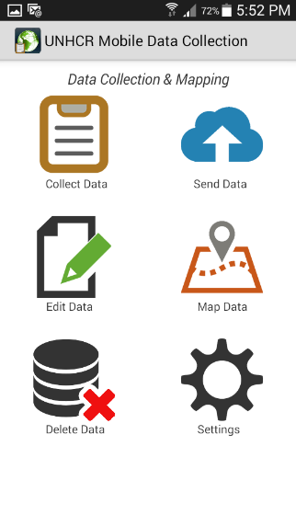
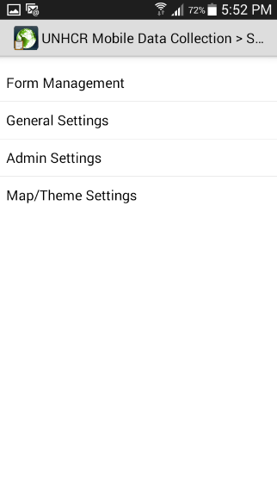
Changing Setting
(ignore these instructions if application has already been pre-configured by an IM officer)

- Open GeoODK Application
- Click on Settings in the main screen
- Click on General Settings

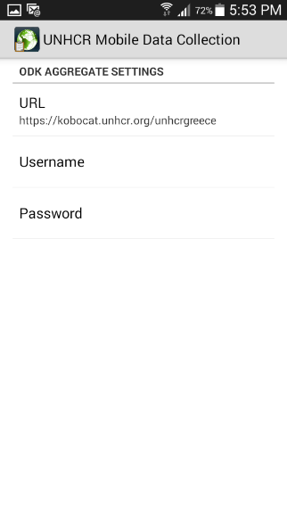
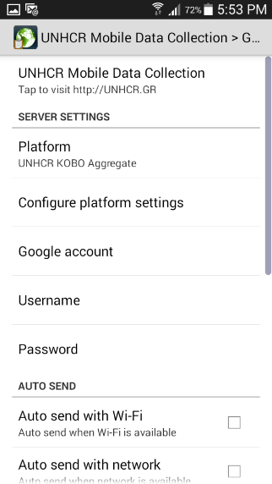
  - Click on Configure platform settings
  - Change the URL to read:
https://kobocat.unhcr.org/unhcrgreece
  - Don’t add a username or password
  - Now go back to the General Settings screen

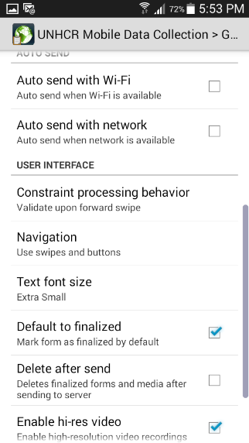
- Ensure Auto send with Wifi is unchecked
- Ensure Auto send with network is unchecked
- Constraint processing behavior is set to Validate upon forward swipe
- Navigation is set to Use swipes and buttons
- Text font size is set to Extra Small (can be small or Medium if you have trouble seeing the screen)
- Default to finalized is checked
- Delete after send is unchecked (important!)
- No go back to the Setting screen
- Click on Admin Settings
- Ensure all boxes are checked

COLLECTING DATA:
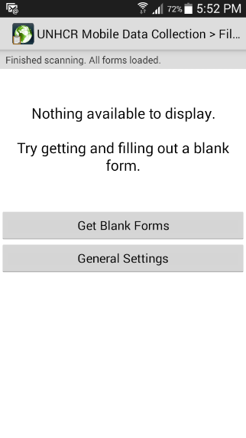
- Click on Collect Data in the main screen
- Click on Get Blank Forms,
- Choose the Site Monitoring form from the list
- Click Get Selected button
- Once the form has been downloaded, simply click on the form to start filling it in

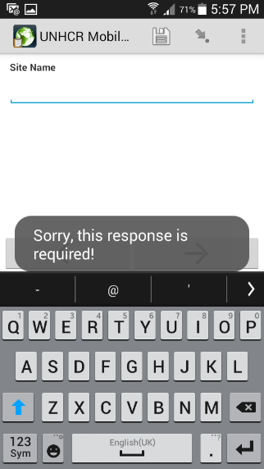
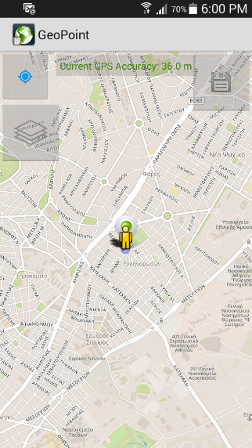
- Some questions are mandatory, therefore you may get this error message “Sorry, this response is required” appears
- Some questions on the form have calculations e.g. for percentage. An error message will appear if your total percentages are greater than 100%
- The Location question is very IMPORTANT! please ensure it is recorded. To capture the location, press the Location button and a map will appear. You should ideally be standing in a part of the camp/site when recording the location, else you will need to move the green marker to the location where the camp/site is actually located. To record the location, simply click on the little disk icon.

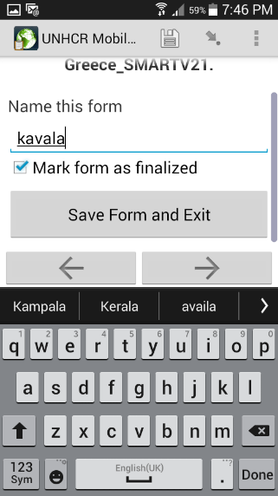
- When you finish the form you will get to finally screen, where you need to RENAME THE FILE WITH THE CAMP/SITE NAME before clicking Save Form and Exit.

- To send the collected data on the camp/site, click on Send Data from the main screen and select the form you wish to send, then click Send Selected.

EDITING & RE-SENDING DATA ON A SITE:
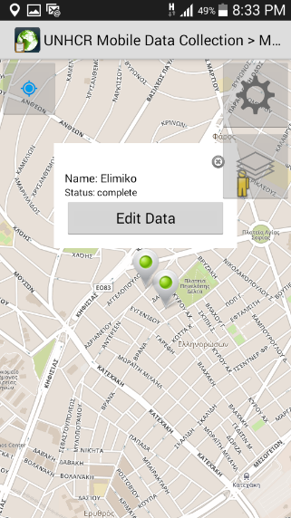
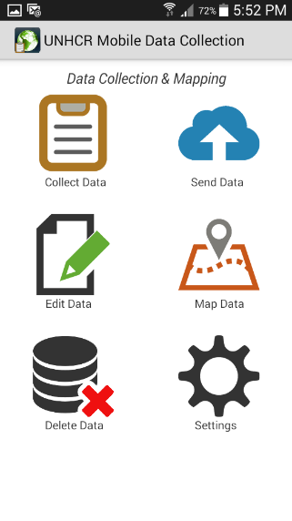
- If you are re-visiting the same camp/site, then you can simply update the previously sent information by re-edit the form.
- Click on Map Data on the main screen
- In map, locate the site you wish to edit and click on Edit Data. If you can’t find the camp/site, zoom out until it appears on the screen.
- If the camp/site you entered is not available, you may need to re-enter the whole data and carefully record the Location field.
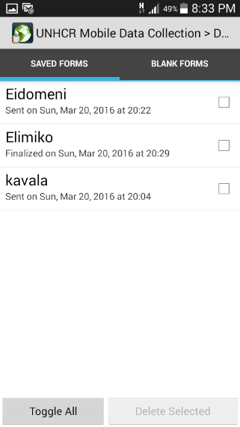
- When re-editing, make sure you go all the way to the end and Save Form and Exit (ensuring the mark as finalized box is checked).
- Send the collected data on the camp/site, click on Send Data from the main screen and select the form you wish to send, then click Send Selected.

- If you have entered incorrect data for a camp/site, you can delete it by clicking Delete Data in the main screen

- Then select the checkbox next to camp/site you wish to delete, then click the Delete Selected button.

