UNHCR Nansen Refugee Award 2017

Photo essay – DRAFT

Embargoed until 18 September 2017

Some are the orphaned children of Boko Haram members, others are the children of parents who fell victim to the insurgents – and yet they are improbable fellow classmates at The Future Prowess Islamic Foundation School, in Maiduguri, the capital of Borno State - and centre of a raging conflict in north-east Nigeria that has killed 20,000 and displaced millions more.

The school offers more than just an education for children caught up in the war. Zannah Mustapha, the lawyer and mediator, who founded the facility in 2007, provides the students with free meals, uniforms and makes sure they have access to healthcare services. Of the current 540 students, more than half are girls, which is noteworthy in a country with a large education gender gap.

Due to a growing need, Mustapha opened a second education facility situated on the banks of River Gadabul in Maiduguri. Eighty-eight children displaced by violence are now learning there.

Mustapha has also acted as a mediator between the Nigerian government and Boko Haram, a group whose name is often translated as, "Western education is sinful,” to help free some of the more than 200 Chibok schoolgirls who had been abducted by the militant group in April 2014. He hopes that future talks will result in the release of the remaining captive Chibok girls, believed to number more than 100

For these reasons, and for his dedication to widows and internally displaced persons, UNHCR, the UN Refugee Agency, is honoring Mustapha with the 2017 Nansen Refugee Award.

The widows’ association, set up by Mustapha, now numbers close to 600. It provides women whose families have often lost the breadwinners with a collective support group and advice on how to apply for grants to start small businesses. Many of their children are enrolled in Mustapha’s schools.

Photo 1:

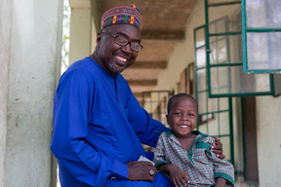

RF2106475

Zannah Mustapha, a champion for the rights of all children to have access to a quality education in war-torn north-east Nigeria, is the recipient of the 2017 Nansen Refugee Award. Mustapha pictured with his son. Future Prowess Islamic School asks all of the school’s volunteer teachers to enroll their children at the school to show their dedication to the institution. UNHCR/Rahima Gambo

Photo 2:

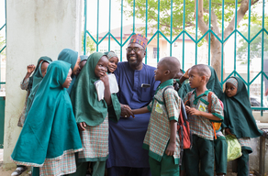

Working against the odds and operating in an extremely precarious security environment, Mustapha has managed to create a safe space for war-affected children to learn. The school enrolls children of Boko Haram fighters as well as displaced youth and children orphaned due to the terrorist organisation’s violence. UNHCR/Rahima Gamba

Photo 3:

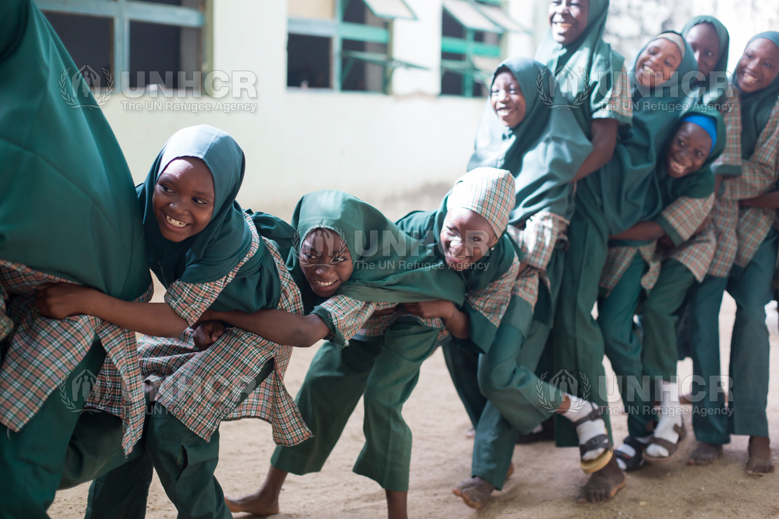

RF2106657

Many young girls in Nigeria do not have access to a suitable education. Female students of Future Prowess Islamic Foundation School, seen here during physical education class, have the same opportunity to learn and excel as boys. UNHCR/Rahima Gambo

Photo 4:

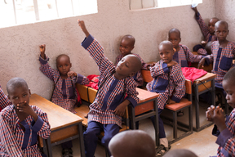

RF210636

The Future Prowess Islamic Foundation School was founded in 2007 as a single classroom with 36 children. Last year, due to a growing need, Mustapha opened up a second learning facility situation on the banks of River Gadabul in Maiduguri, Borno State, Nigeria. UNHCR/Rahima Gambo

Photo 5:

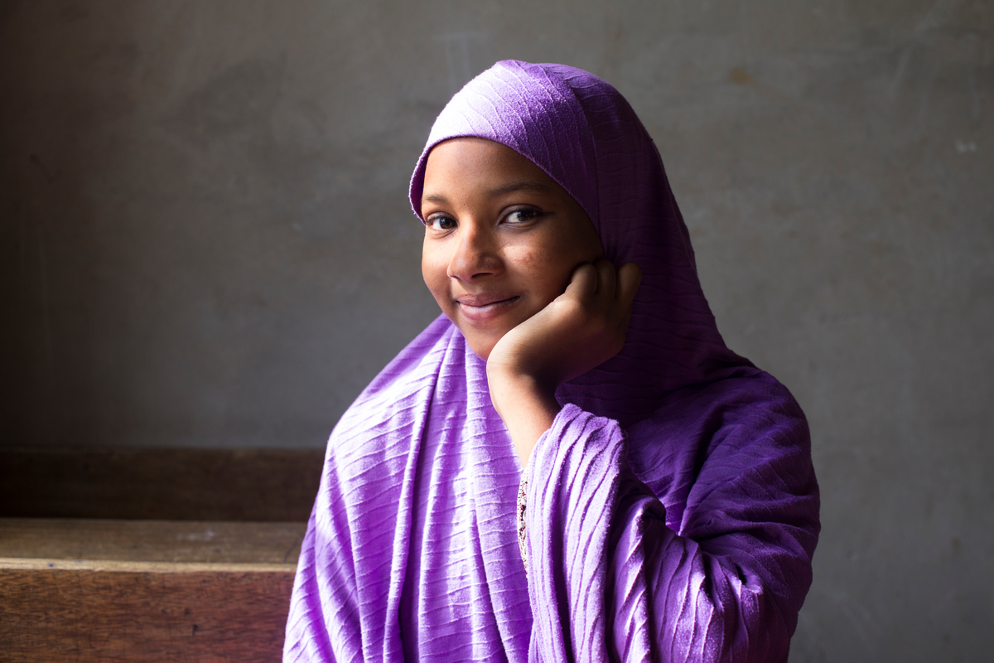  
RF2106340

Zeinab Ibrahim, 16, graduated from Mustapha’s school and received a scholarship for Treasures Richfield College, a small secondary school in Maiduguri, Borno State, Nigeria. “I owe everything to Mr Mustapha. It was such a good school and he is such a good man. He treated me like his daughter. He treats everyone the same,” she said. UNHCR/Rahima Gambo

Photo 6:

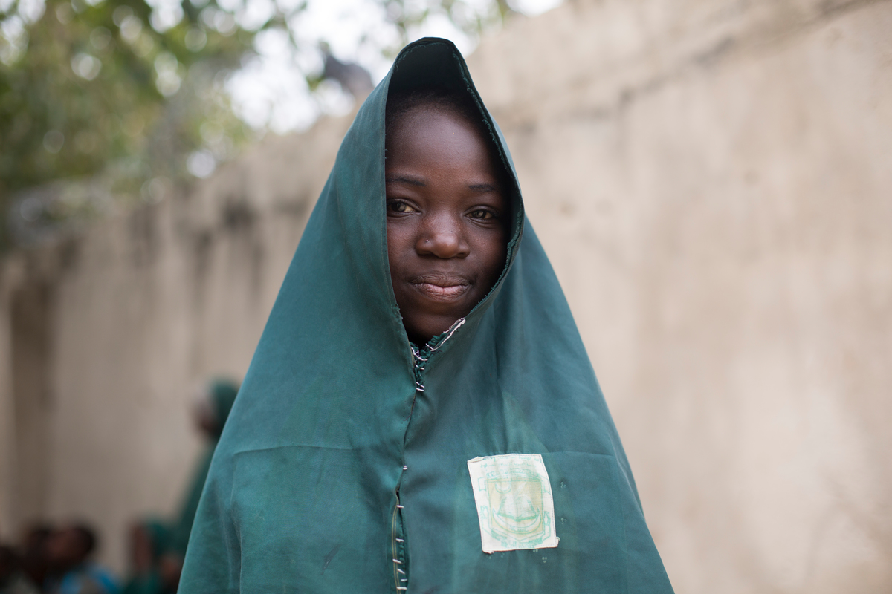

Hauwa Madu, 13, whose father was killed by Boko Haram, had to go and live with her aunt. Fortunately she was able to enroll in The Future Prowess Islamic Foundation School. “This school is really like my home now. I can think of tomorrow again because of what he has done for us here,” Hauwa said. UNHCR/Rahima Gambo

Photo 7:

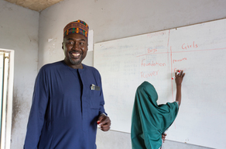

RF2106637

Mustapha, pictured in one of his classes, has also mediated between the Nigerian state and Boko Haram. He has played an instrumental role in negotiating the release of young Chibok schoolgirls who were held captive by the insurgent group. UNHCR/Rahima Gambo

Photo 8:

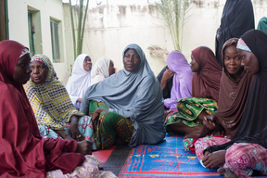

RF2106522

http://media.unhcr.org/archive/-2CZ7A2A79T_8.html

Mustapha also set up the Future Prowess Widows Association, seen gathered in the courtyard of the school. They receive free psychotherapy among other services. Many of their children also attend Mustapha’s schools. UNHCR/Rahima Gambo