UNHCR Nansen Refugee Award 2016
Photo essay – DRAFT
Embargoed until 6 September 2016

In 2015, the number of refugees and migrants arriving in Greece by sea escalated dramatically as conflicts and violence in Syria, Afghanistan and Iraq continued to uproot people from their homes.

On the island of Lesvos alone – a popular tourist destination – the numbers arriving at its shores topped 500,000. Thousands more risked the freezing waters, fake lifejackets and storms to make landfall on other Greek islands, including Chios, Samos, Leros and Kos.

For many refugees who made the often harrowing flight from danger, the heroic humanitarian efforts of Greek volunteers in 2015 went well beyond pulling survivors from the seas - they helped them to take the first steps towards a normal life.

Their efforts characterize the massive public response to the refugee and migrant emergency in Greece and across Europe, in which thousands of people stood in solidarity with those forced to flee, and the humanity and generosity of communities around the world who open their hearts and homes to refugees.

Two such volunteers have been jointly recognized for UNHCR’s Nansen Refugee Award 2016: Konstantinos Mitragas on behalf of the Hellenic Rescue Team (HRT) and Efi Latsoudi, the human rights activist behind PIKPA village on the Greek island of Lesvos.

More than 2,000 volunteers make up the HRT and have been rescuing people from the Aegean Sea and Greek mountains since 1978. In 2015, the volunteers were working 24 hours each day, responding to endless rescue calls in the middle of the night.

Over the course of the year, they undertook 1,035 rescue operations, saving 2,500 lives, and assisted more than 7,000 people to safety. In their tireless efforts to save so many people, HRT volunteers set an example to the world.

On Lesvos, PIKPA village has provided a safe and welcoming environment for refugees on the island. Efi Latsoudi was one of the initiators of the site in 2012, transforming a former children’s summer camp into a protected environment, particularly for vulnerable refugees, including women who had lost their children during the crossing and adults and children with physical or learning disabilities.

During the peak of the crisis, PIKPA was hosting around 600 refugees a day, despite a capacity of just 150, and distributing over 2,000 meals each day.

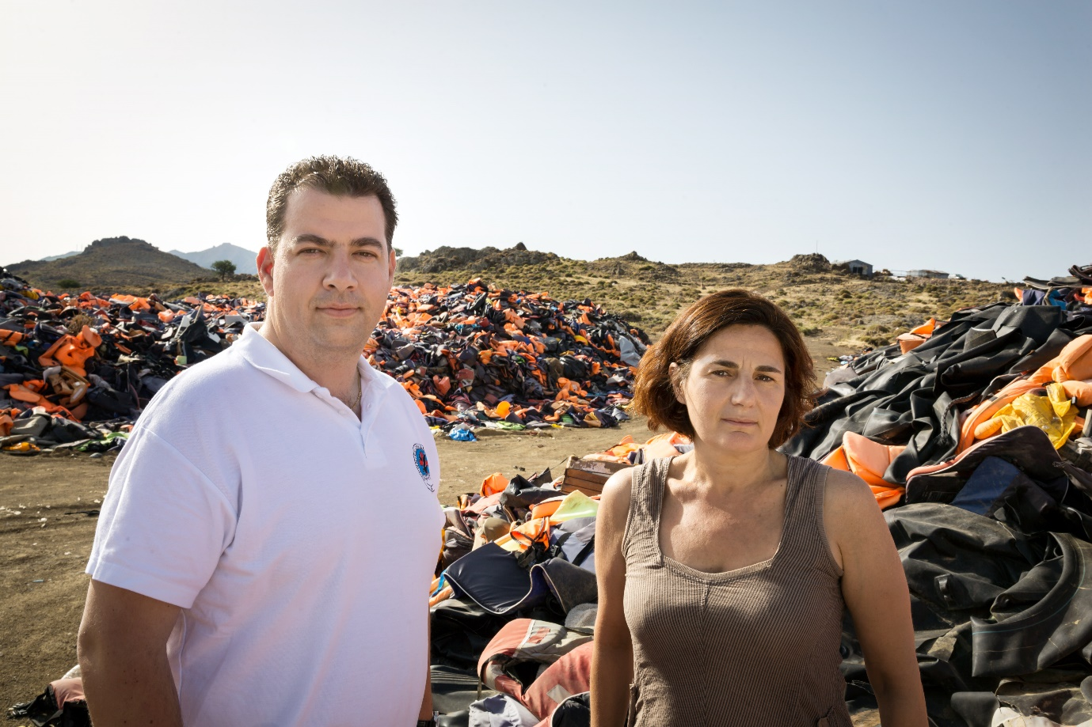
Konstantinos Mitragas on behalf of the Hellenic Rescue Team (HRT) and Efi Latsoudi, the human rights activist behind PIKPA village on the Greek island of Lesvos, are joint winners of UNHCR’s Nansen Award 2016. UNHCR/G. Welters

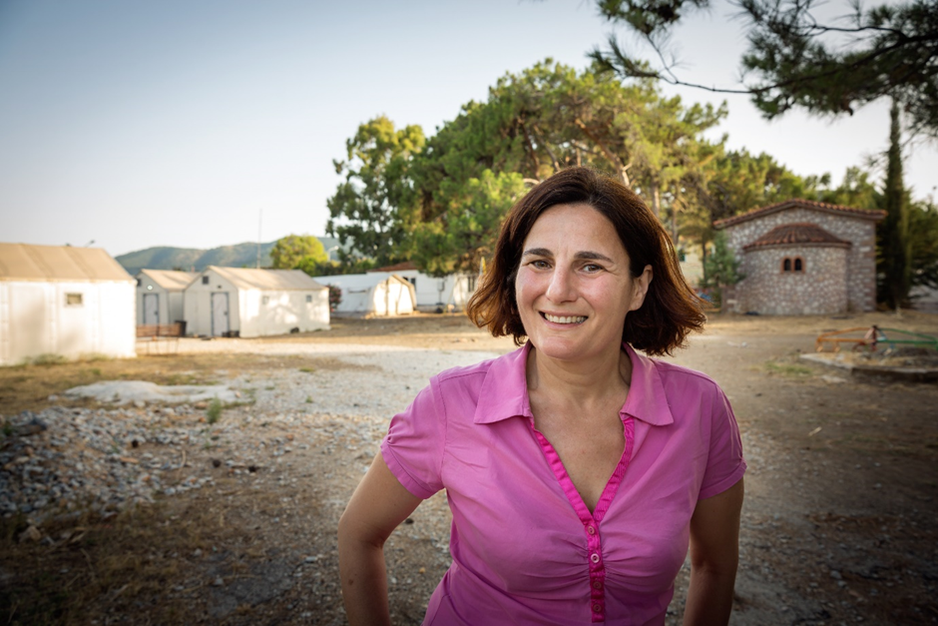
Efi Latsoudi is the softly-spoken but quietly passionate human rights supporter behind PIKPA. On Lesvos, PIKPA village has provided a safe and welcoming environment for refugees on the island. UNHCR/G. Welters

Opened in 2013 the former children’s summer camp has become a haven for some of the most vulnerable refugees on Lesvos. PIKPA takes pride in being fully independent, relying solely on donations and volunteer contributions, both locally and internationally. UNHCR/G. Welters

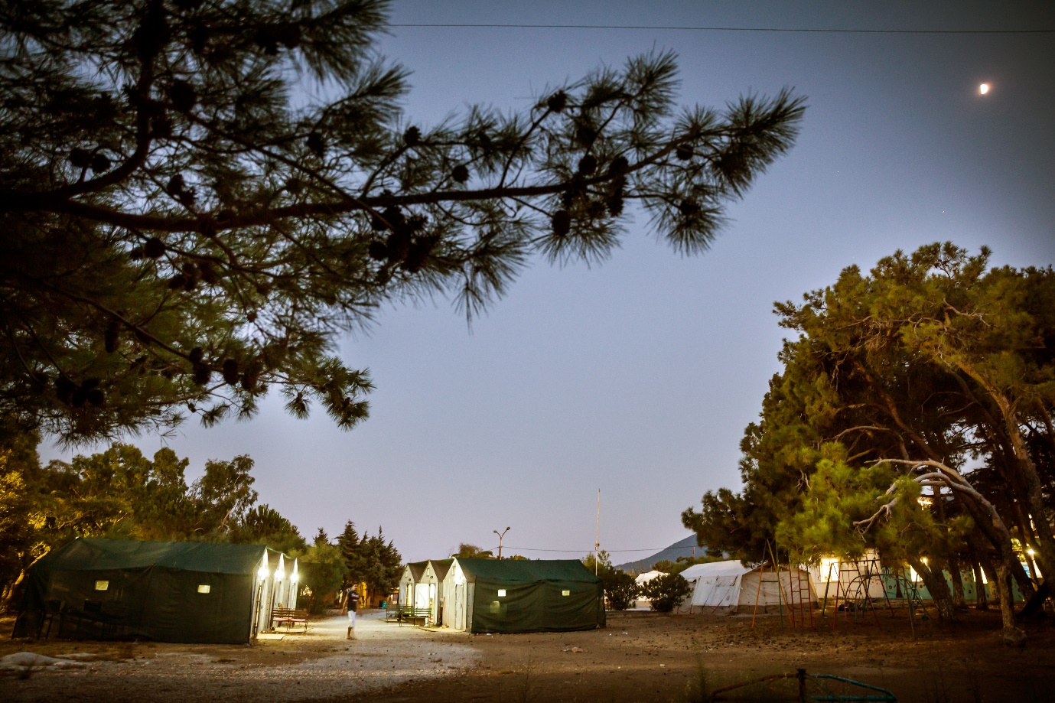
PIKPA lies in the south of Lesvos, nestled peacefully beneath a grove of pine trees. UNHCR/G. Welters

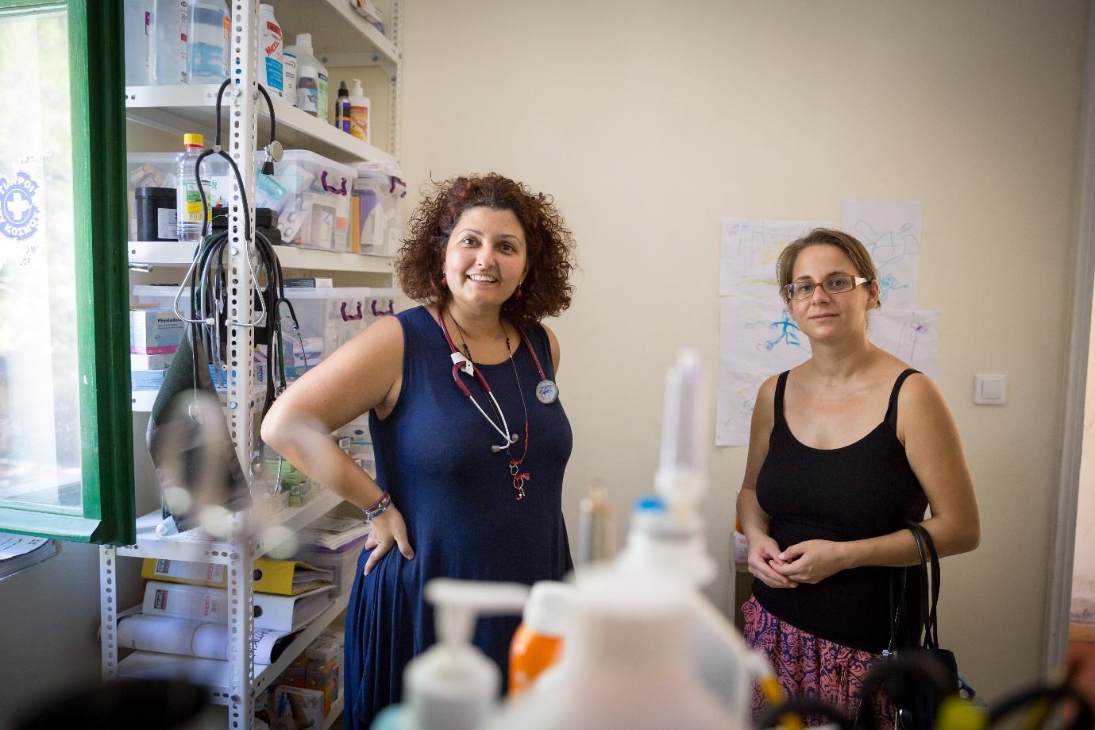
Like the hundreds of other volunteers at PIKPA, both Doctor Eirini (left) and Nurse Dimitra (right) have spent the last three years working around the clock to care for refugees on the island. Doctor Eirini also holds down a full-time job. “I’m usually running every day,” she says, laughing. “On Friday, I’m doing a 24-hour shift in the primary care unit at a local hospital.” UNHCR/G. Welters

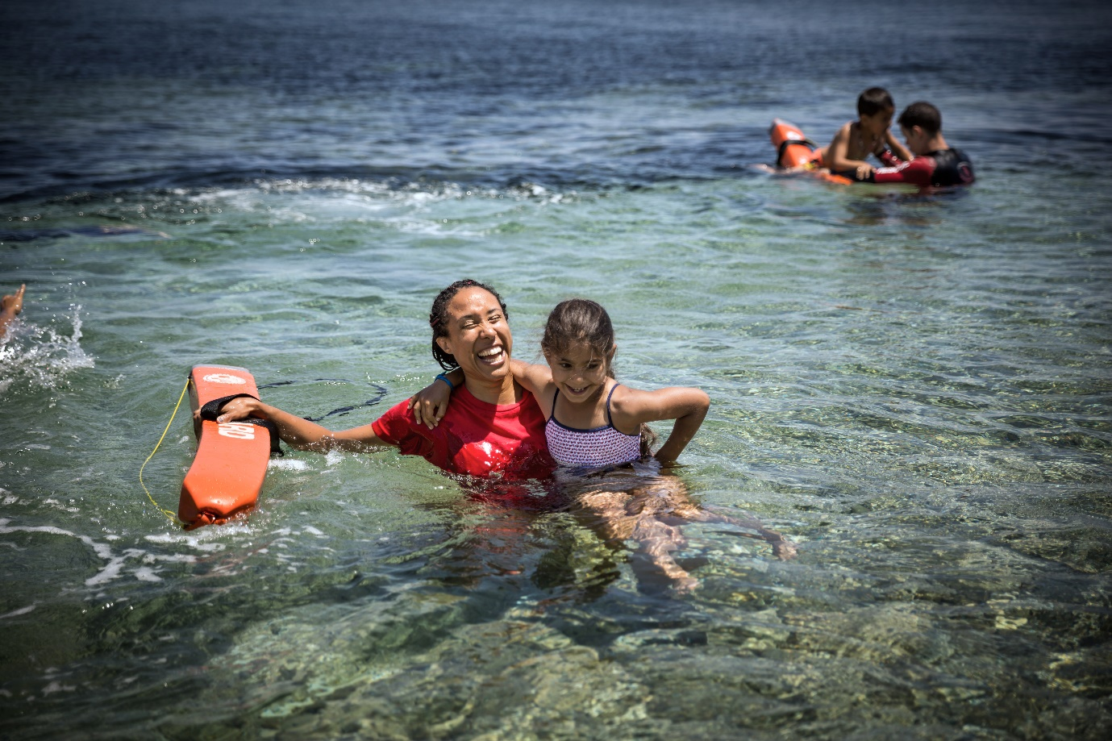
PIPKA works with Proem-Aid, a non-profit association from Spain, to bring teams of volunteer trained lifeguards from cities like Barcelona and Seville to teach swimming to refugee children. For many children the lessons have given them new confidence and self-esteem after terrifying sea crossings from Turkey. UNHCR/G. Welters

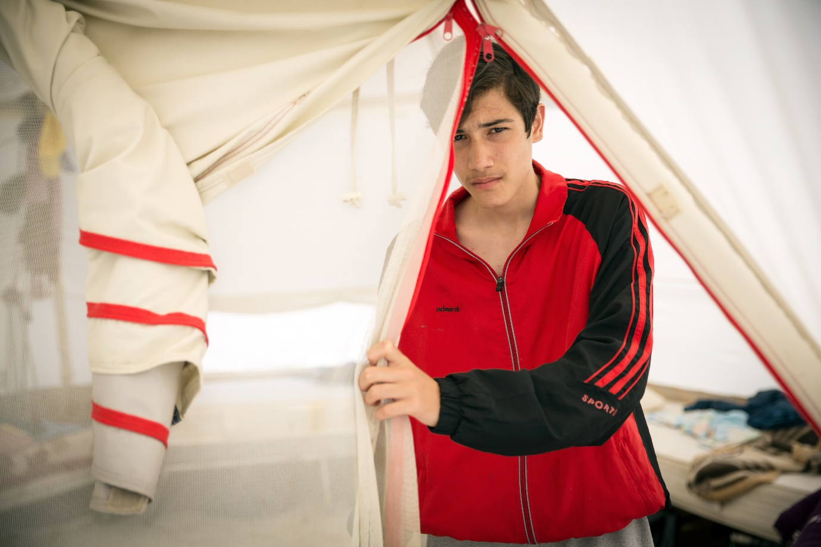
After fleeing war-torn Syria, seventeen-year-old Mohammed found safety and belonging in the PIKPA community after a harrowing arrival in Greece. UNHCR/G. Welters

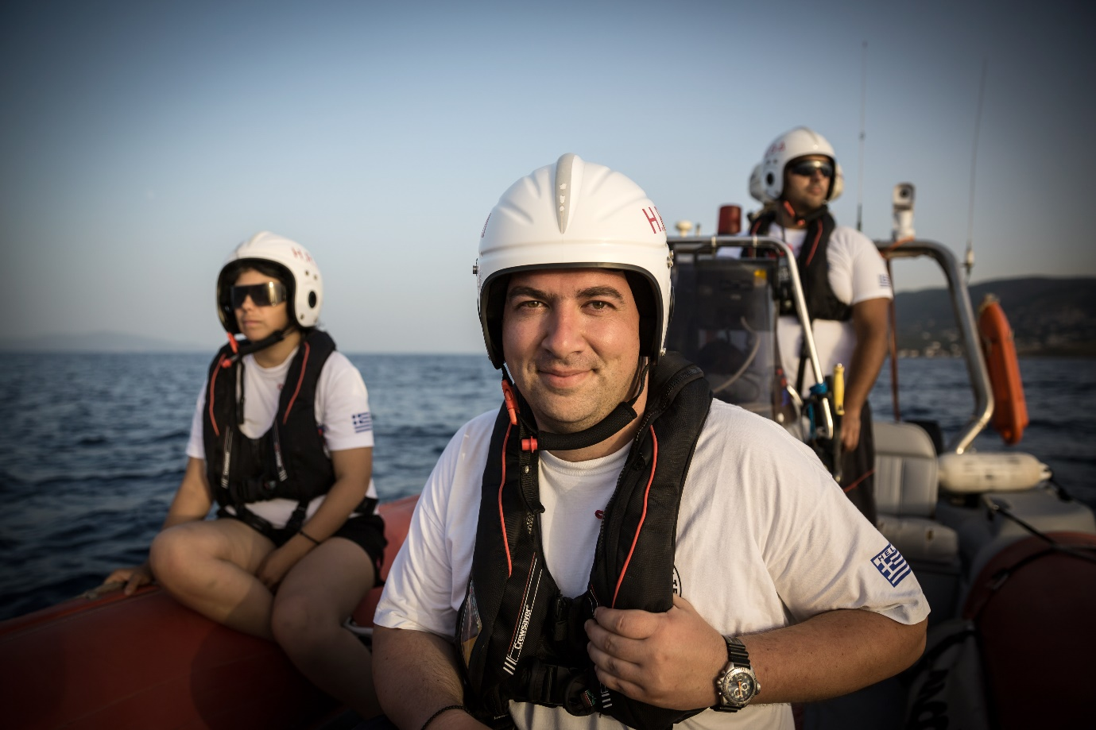
Konstantinos Mitragas, the Hellenic Rescue Team’s (HRT) secretary-general, is a sea captain and a Thessaloniki businessman by trade. Like his colleagues, he works on a voluntary basis, overseeing everything from training to media relations. UNHCR/G. Welters

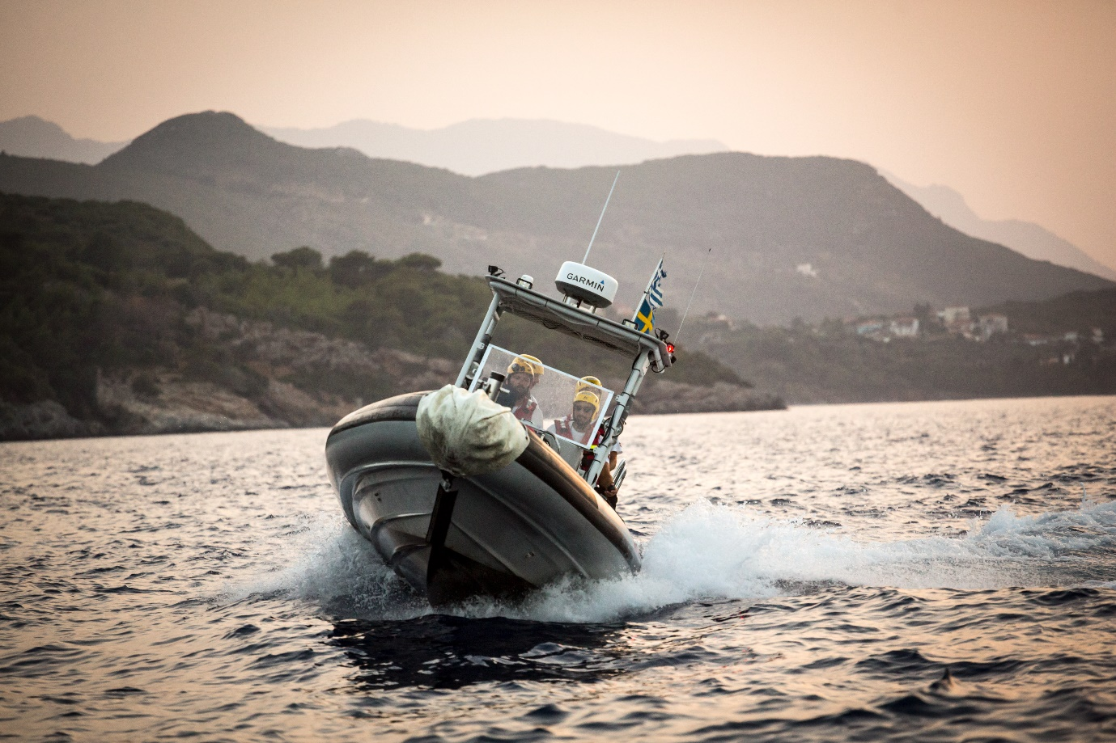
More than 2,000 volunteers make up the HRT and have been rescuing people from the Aegean Sea and Greek mountains since 1978. In 2015, the volunteers undertook 1,035 rescue operations, saving 2,500 lives and assisted more than 7,000 people to safety. In their tireless efforts to save so many people, HRT volunteers set an example to the world. UNHCR/G. Welters

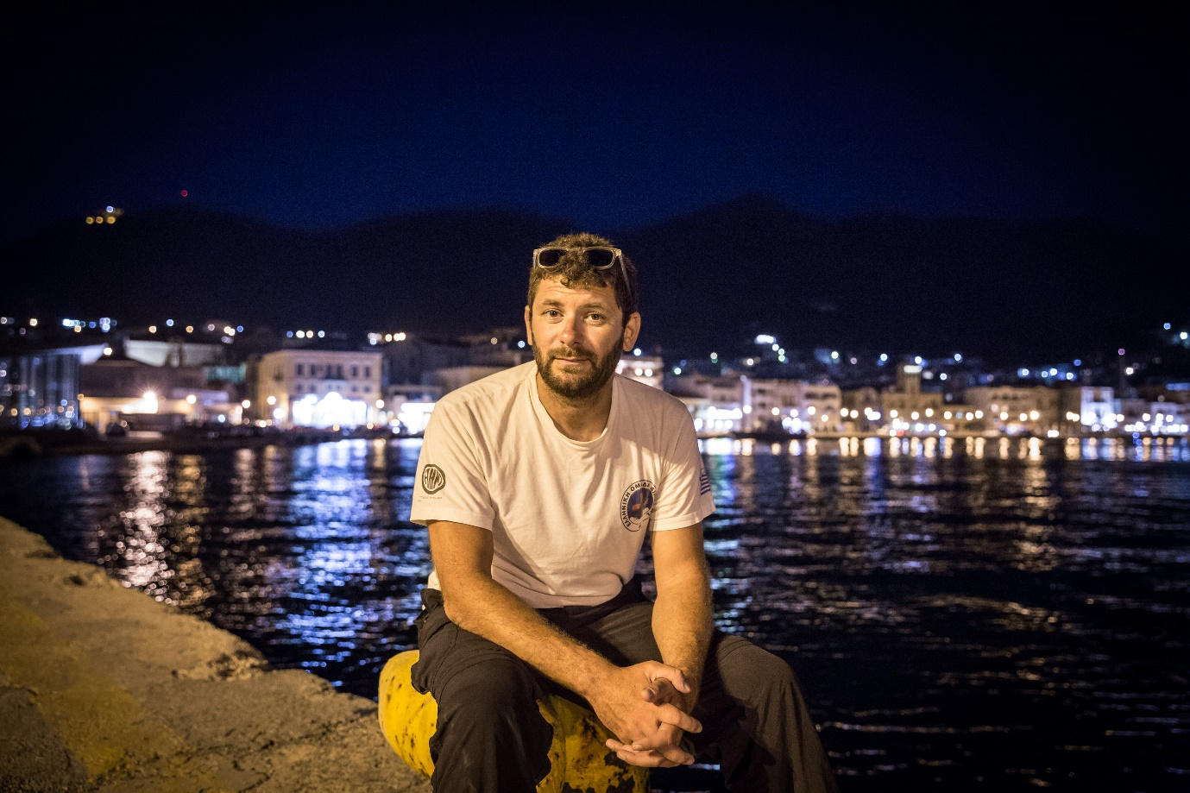
Yanis is a 33-year-old paramedic who volunteers with the HRT. For many volunteers, 2015 was traumatic but often they found strength in each another. Yanis’ lasting memory of 2015 is one of two children holding each other as they floated, having died from hypothermia before rescuers could reach them. “You do get a little emotional,” he says. “It’s very important to debrief with your team, and sit and talk, so you can see if someone has a problem.”
UNHCR/G. Welters

