Building the Evidence Base for Humanitarian Safe Water Supply

Free Residual Chlorine Decay in Azraq Refugee Camp, Jordan

Syed Imran Ali, Ph.D.

University of California, Berkeley

*Version 1 October 12, 2014*

TABLE OF CONTENTS

Abstract 1

Background 2

Methodology 4

Study Design 4

Ethics 6

Camp Background 6

Sampling Strategy and Data Coverage 7

Analytical Approach 7

FRC Decay Modelling Approach 7

Approach for Exploring Factors Driving FRC Decay 8

Results and Discussion 8

Water Quality 8

FRC Decay Models 9

Factors Driving FRC Decay 13

Phase A: Collecting Water from Tapstand into Container 14

Phase B: Transporting Water from Tapstand to Household 14

Phase C: Storage and Use of Water in the Household 15

Conclusions 17

Acknowledgments 18

References 19

# Abstract

*Objective:*

Current emergency safe water guidelines are based on little field evidence. We launched an observational study on chlorine decay in the Azraq refugee camp, Jordan in July-August 2014 in order to: i) develop evidence-based guidelines for centralized batch chlorination in humanitarian operations; and ii) identify factors affecting the safe water chain. This study builds on earlier work from South Sudan and adds to the evidence base that study initiated.

*Methods:*

We observed water quality at four points post-distribution: i) directly from tapstands; ii) after collection; iii) after transport to households; and iv) after 6 to 24 hours of household storage/use. Water quality parameters analyzed included free and total residual chlorine, turbidity, pH, oxidation reduction potential, electrical conductivity, and water temperature. We documented water handling practices via spot check and respondent self-report. Chlorine decay was modeled using MATLAB and linear regression models to identify factors linked to chlorine decay were developed in STATA.

*Findings:*

We found second order decay was a useful representation of total apparent FRC decay in the camp setting at Azraq, corroborating earlier findings from South Sudan. For initial FRC at the tapstand in the 0.2 to 1.0 mg/l range, we found a decay rate of ~3x10-3 L×mg-1×min-1 at Azraq. Regression models confirmed that initial chlorine level was strongly associated with decay, while a weaker positive correlation was found with pH. Some limited evidence emerged on the protective effect of covering household water storage containers and container cleanliness. Other water handling practices yielded weak or inconsistent evidence. Strong evidence emerged that storing household water in direct sunlight led to rapid FRC decay, a practice used by 40% of respondents to dissipate excess chlorine due to taste/odour objections.

*Conclusion:*

On the basis of data collected at Azraq, we recommend that the FRC guideline target be set to 0.8 to 0.9 mg/l at the tapstand. According to modeling, this target should maintain at least 0.2 mg/l of residual up to 24 hours post-distribution. This is in line with the range specified by ACTED in their study of pre-distribution chlorine decay. Maintaining this FRC target, preventing excessive chlorination events, and on-going hygiene promotion activities may rectify and prevent sunlight-exposure practices at Azraq. The rate of FRC decay at Azraq was found to be less than that observed in South Sudan and may be linked to lower temperatures and better ambient sanitary/WASH conditions at Azraq. These findings affirm that chlorine decay is influenced by ambient conditions underscoring the need to develop the evidence base across multiple and variable locales.

# Background

Waterborne diseases are among the most significant threats facing displaced populations in refugee/IDP camps. Ensuring access to adequate quantities and quality of water is a necessary component for their control (1–5). Centralized batch chlorination remains one of the most widely used approaches for treating water during emergencies due to its residual protection, relative ease of use, and low cost (6–8). As such, humanitarian organizations have developed a number of guidelines stipulating what free residual chlorine (FRC) levels should be at camp water distribution points (9–17). Generally speaking, guidelines recommend FRC levels be between 0.2 and 0.5 mg/l under normal circumstances and between 0.5 and 1.0 mg/l during outbreaks of diarrhoeal disease and/or when pH or turbidity is elevated—a balance between having sufficient residual protection on one hand and preventing taste/odour-driven rejection due to excessive chlorination on the other.

These FRC guidelines derive from conventions stated in the WHO Guidelines for Drinking-water Quality (GDWQ) (8), and assume that some residual chlorine will remain in the water to protect it from contamination until it is consumed. However, these conventions emerge from experience with municipal piped-water systems—that is, from conditions that are fundamentally different from those encountered in refugee/IDP camps. As the Centers for Disease Control (CDC) observe, the GDWQ definitions are appropriate only when users drink water directly from the flowing taps of a piped system. While recommended FRC levels may be able to maintain water quality through the distribution network, such levels are unlikely to provide sufficient protection when water is collected at the tap, transported to the home, and then stored for some time before being consumed (18).

Evidence of this abounds in the literature. Studies in non-emergency resource-constrained settings have shown that (re)contamination of previously safe water does occur during collection and transport from distribution points, as well as during storage and drawing of water in the home (19–22), representing a significant health risk to vulnerable populations (23,24). Post-collection (re)contamination of drinking water has also been documented in emergency settings in refugee/IDP camps in Uganda (25), and linked to the spread of diarrhoeal disease and cholera among camp populations in Malawi (26,27), Kenya (28,29) and the Darfur region of Sudan (30). Although the humanitarian guidelines also call for facilities and practices to preserve the safe water chain—notably appropriate water containers (i.e., covered, narrow-mouthed, and with a tap) and their regular cleaning, disinfection, and replacement—post-distribution recontamination in camp settings remains poorly understood and does not figure concretely into current FRC guidelines. In general, we have little documented insight into how emergency water, sanitation, and hygiene (WASH) practices actually fare in the field (31–33).

As current FRC guidelines derive from experience with municipal piped-water systems, they are inappropriate for use in refugee/IDP camps. The experience of the Maban County refugee crisis in South Sudan calls attention to this gap. Surveys conducted in the Jamam refugee camp in October-November 2012 showed that 40 to 58% of households that ostensibly collected water from chlorinated tapstand sources had no detectable FRC in their stored household water (34,35). Another study carried out in Jamam and the nearby Batil refugee camp in April 2013 demonstrated the presence of human adenoviruses in stored household water indicating faecal contamination (36). These observations, taken in light of the prolonged hepatitis E and acute watery diarrhoea outbreaks affecting the Maban County refugee camps (37), raised pressing questions about the behaviour of chlorine in the camp setting and what could be done to ensure safe water supply.

In response to these concerns a study was launched in the Jamam, Batil, and Gendrassa refugee camps of Maban County, South Sudan in March-April 2013 (38). The goal of the study was to start building the evidence base on emergency safe water supply and, from this, develop guidelines which are grounded in field realities. The study in South Sudan found that current FRC guidelines offered insufficient residual protection post-distribution; a tentative recommendation was made to increase the FRC guideline target from the current 0.2 to 0.5 mg/l range to1.0 mg/l (irrespective of water quality or outbreak conditions).

The degree to which the findings from South Sudan can be generalized to other camps around the world is unknown. Further iterations of the study in other camps globally are required to generalize the evidence base and the safe water guidelines stemming from it. Because a number of factors may influence total apparent FRC decay—climate, water source, WASH services, sanitary conditions, and local terrain/environment—further studies must be carried out in a range of settings in order to develop guidelines which are articulated to specific local conditions. This research project aims to launch a total of four studies in refugee/IDP camps around the world, of which South Sudan was the first. The project aims to improve best practices for safe water supply in refugee/IDP camps the world over and will achieve scale via promulgating evidence-based revisions to the Sphere Project, UNHCR, MSF, and other humanitarian guidelines.

As the second field phase of the research project, a study was launched in the Azraq refugee camp, Jordan in summer 2014—a collaboration between UNHCR and the University of California, Berkeley, with additional support from Médecins Sans Frontières (Holland). Two further studies in two different camps will follow in early 2015. A final guidance document integrating findings from the four field studies will provide guideline revision recommendations in summer 2015.

This report presents findings from the Azraq field study. It seeks to do two things: 1) model FRC decay in the refugee/IDP camp setting between collection at the tapstand and consumption at the household level; and 2) explore relationships between FRC decay and other water quality parameters, water handling practices, and contextual factors in order to generate insight into factors which preserve or compromise the safe water chain. The report also links to findings from the first phase in South Sudan as well as the recent ACTED report on pre-distribution FRC decay at Azraq (39).

# Methodology

## Study Design

The study sought to follow the path of water in the camp setting from the time it was distributed at the tapstand to the time it was consumed at the household level. The study was comprised of two elements: a) water quality analyses; and b) surveys of water handling practices and contextual factors.

We followed how water quality changed at four points between the tapstand and the household:

1. Initial water quality at the *point of distribution* i.e., from the tapstand directly;
2. From the collection-transport container, immediately after water had been collected from the tapstand by the water-user;
3. From the collection-transport container, once it had been transported to the household by the water-user; and
4. After several hours of storage and use in the household.

Water quality parameters analyzed included free residual chlorine (FRC), total residual chlorine (TRC), turbidity, pH, oxidation reduction potential (ORP), electrical conductivity (EC), and water temperature. FRC and TRC were analyzed via the colorimetric method using a Wagtech Photometer 7100 and Wagtech DPD1/DPD3 reagents (Palintest Ltd., Tyne & Wear, UK); turbidity via the nephelometric method using a Palintest PTH 090 compact turbimeter (Palintest Ltd., Tyne & Wear, UK); pH and ORP via the potentiometric method using an Eijkelkamp 18.21 multimeter (Eijkelkamp Agrisearch Equipment, Giesbeek, The Netherlands); and EC, air and water temperature were measured using an Hanna Instruments HI 98311 EC/TDS/temperature tester (HANNA Instruments, Woonsocket, RI, USA).

The survey element of the study collected information on water collection, transport, storage, and drawing practices, as well as contextual factors. This information was collected via spot-check observation by surveyors or respondent self-reporting. All information was recorded in the field on a data collection form. The survey element was implemented at two points:

* 1. At the tapstand in order to document water-users’ collection and transport practices (i.e., concurrent to water quality analysis event #2 above); and,
  2. During the follow-up visit to the household, in order to document water-users’ storage and drawing practices (i.e., concurrent to analysis event #4).

Figure 1 brings together the water quality and survey elements and summarizes the overall logic of the study. Each iteration of the procedure outlined in Figure 1 represented one unique sample collected. Each sample thus consisted of data from *four unique water quality* *analysis events* and *two unique* *survey events*.

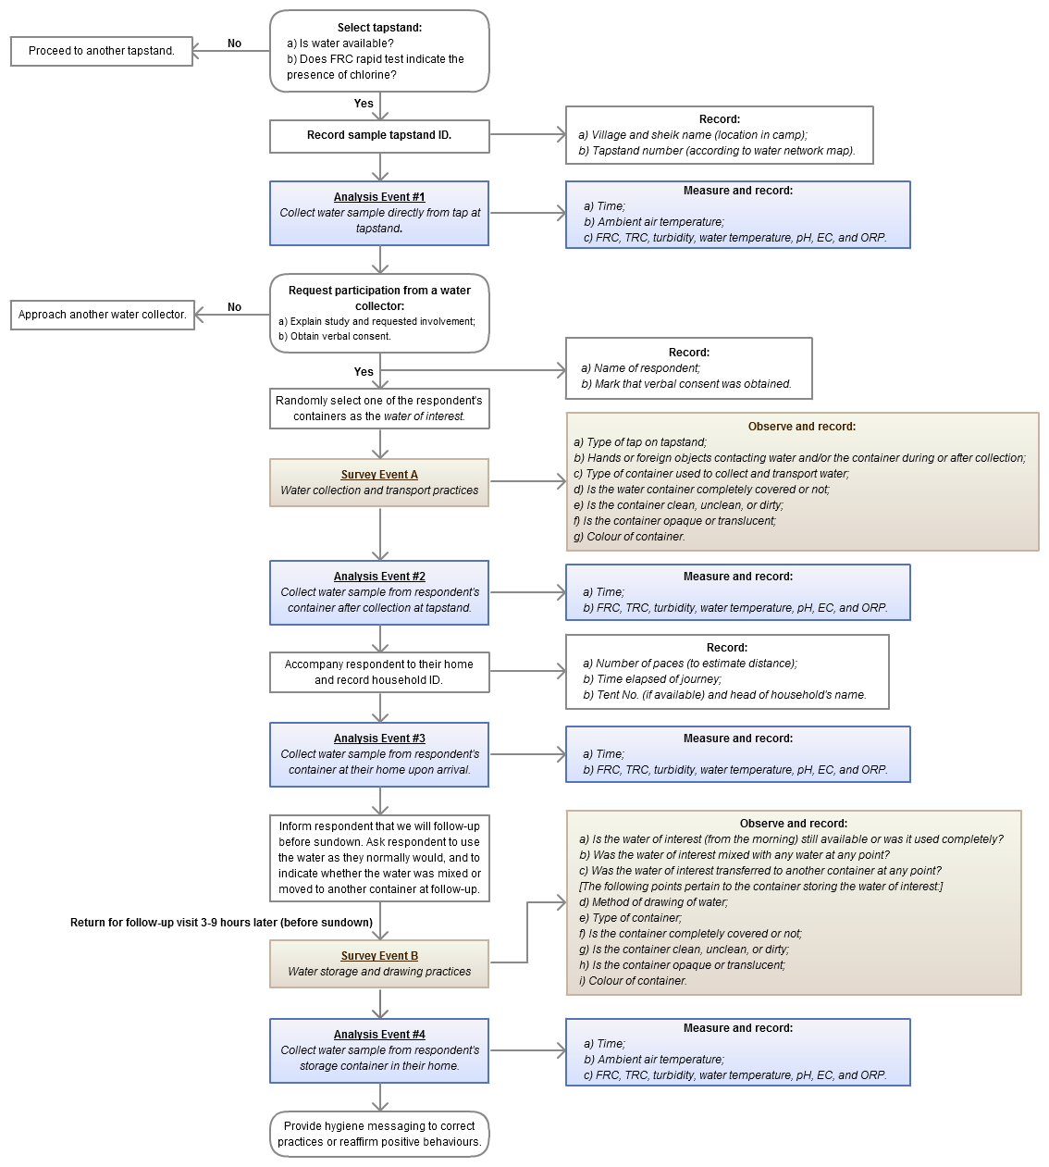

Figure 1 | Schematic of study design. Each iteration of the above procedure represented one unique sample.

During the course of the study we made a few modifications to the protocol in response to emergent observations. We stopped documenting whether people’s hands came into contact with the water because it proved impossible to accurately catch every instance this occurred or to say conclusively that it did not occur. About half way through the study, we began to document whether the water was stored indoors or outdoors and whether it was exposed to the sun, as this emerged as a factor of interest.

Generally speaking, we began data collection (i.e., analysis event #1) in the morning and returned to each enrolled household for follow-up (i.e., analysis event #4) in the afternoon (an approximate 6 hours interval between events #1 and #4). However, we also varied the data collection schedule over the course of the study in order to gather follow-up data at variable time points. At different points in the study, we modified the schedule to do analysis event #1 in the afternoon and return to collect analysis event #4 sample the next morning (approximately 18 hours interval). Alternatively, we did analysis event #1 in the morning and returned for event #4 follow-up the next morning (approximately 24 hours interval). This variation allowed us to capture follow-up data at different time points post-distribution, which would be informative for subsequent decay modelling.

During data collection, care was taken to ensure that the same water of interest was followed through all four analysis events in order to ensure validity of results. Stated another way, we sought to follow the same “unit” of water from tapstand to consumption. Each water sample drawn for analysis was collected by pouring into a clean plastic beaker, which was itself rinsed three times with the water to be sampled before drawing. Care was taken during the drawing of water samples to prevent contamination by hands or foreign objects. Additionally, care was taken to abstract only 500 ml of respondents’ water at each analysis event (including rinsing) and avoid spillage in order to limit the consumption of respondents’ water. If poor water handling or hygienic practices on the part of water-users was observed at any point during data collection, at the end of the follow-up visit, survey teams discussed specific hygiene promotion messages and/or re-affirmed positive practices. This was done at the end of follow-up in order to not influence behaviours under study during data collection.

Prior to initiating primary data collection, the two data collection teams (4 staff from the refugee population) underwent a week of training and pilot testing. The primary investigator alternately accompanied the two teams over the course of the study in order to ensure procedural adherence.

## Ethics

The study underwent ethical review and received approval from the Institutional Review Board at the University of California, Berkeley prior to the launch of data collection.

## Camp Background

The Azraq camp is a temporary home to approximately 10 to 12 thousand Syrian refugees. The camp was partially populated at the time of the study, with village 3 fully and village 6 partially populated. The camp is located in the eastern desert of Jordan. The terrain is stony desert with shallow rolling elevation. The region is extremely arid with midday temperatures during the period of the study averaging 31.2**°**C (min: 22.3**°**C; max.: 43.3**°**C). Water supply for the camp was derived from boreholes at distance. All water supply to the camp was delivered by truck. Water supply was distributed to the refugee population via tapstands dispersed throughout the camp area (in accordance with Sphere guidelines). Tankers delivered water directly to storage tank networks, which were connected to several tapstands in each of the villages. The sanitary conditions in the camp were extremely good, with sanitation and water supply facilities exceeding Sphere standards. The camp was well-planned and featured semi-permanent steel-sheet housing.

## Sampling Strategy and Data Coverage

Primary data collection ran through July-August 2014. Previous studies looking at water quality changes between source and household have been in the range of 50 to 150 samples (21,40,41), so a sample size of 200 had been selected for the first field phase in South Sudan. In the end, 220 unique samples were collected in South Sudan, with the number roughly divided between the three camps. In Jordan, a goal of 200 samples was set and 199 samples were ultimately collected, thereby approximating the data volume from South Sudan.

Samples were collected from all areas of the camp that were populated at the time of the study (villages 3 and 6), with a greater number of samples taken in those areas that had greater population. Coverage was thus 100% of the populated area of the camp. Respondents were approached randomly from among people collecting water at the tapstand following analysis event #1. Hence, with respect to both water quality and water handling behaviours, the findings of this study may be considered representative of Azraq camp at large.

## Analytical Approach

The two tasks of the study were to: a) model FRC decay; and b) explore relationships between FRC decay and other water quality parameters, water handling practices, and contextual factors. The analytical approaches used for each of these tasks are unique and are described separately in this section.

### FRC Decay Modelling Approach

With the data collected we sought to develop empirical models of the total apparent decay of FRC post-distribution. The kinetics of chlorine decay in the bulk phase have been described in the literature as first-order, second-order, or higher (42–44). Ultimately, the appropriate reaction order comes down to what fits the data: we sought to develop the nth-order model that best suited the data. Erroneous entries in the dataset were identified and removed prior to analysis.

The data were modelled as an nth-order reaction following the general integrated rate law:



where:  *Co = initial concentration*

*C = concentration at time, t*

*k = decay constant*

*n = rate order*

In MATLAB 7.12 (MathWorks Inc., Natick, MA, USA) we applied the *fminsearch* function (which utilizes unconstrained nonlinear optimization)to minimize sum of square errors and estimate parameters *k* and *n* using pooled vectors of FRC and time data. Given the nonlinearity of chlorine decay, modelling was stratified on the basis of initial FRC concentration at the tapstand ([FRC]*i*): 1) all [FRC]*i* data; and 2) [FRC]*i* in the range of 0.2 to 1.0 mg/l. The latter range was selected as this is the target range specified by Jordanian national standard JS286 (39) and hence most pertinent to local field practice. The *k* and *n* outputs generated from modelling were then applied in the general integrated rate law and used to ‘reverse-engineer’ what initial FRC levels should be at the tapstand in order to achieve a desired level of residual chlorine protection at a specified time post-distribution.

### Approach for Exploring Factors Driving FRC Decay

The second component of the study sought to explore how water quality, water handling practices, and other contextual factors were associated with FRC decay. For this purpose, linear multiple regression models were developed using STATA 13 (StataCorp, College Station, TX, USA). Returning to Figure 1 for a moment, we recall that for each sample, water quality was assessed at four points (i.e., the four analysis events). Hence, each sample can be considered as comprising of three discrete phases. Water handling practices and contextual factors relevant to each of these phases were included in the phase’s regression model.

# Results and Discussion

## Water Quality

Summary statistics on water quality, as observed directly from tapstands (i.e., analysis event #1) are given in Figure 1.

Table 1 | Summary statistics on water quality at tapstands in Azraq camp (July–August 2014).

|  |  |  |  |  |  |
| --- | --- | --- | --- | --- | --- |
| Parameter | n | Mean | Std. Dev. | Min. | Max. |
| *FRC (mg/l)* | 199 | 0.98 | 0.43 | 0.38 | 4.5 |
| *TRC (mg/l)* | 199 | 1.00 | 0.44 | 0.35 | 4.5 |
| *Turbidity (NTU)* | 197 | 2.2 | 1.2 | 0.02 | 8.74 |
| *Water temp. (˚C)* | 199 | 27.1 | 1.0 | 24.8 | 30 |
| *pH* | 194 | 7.6 | 0.2 | 6.2 | 8.2 |
| *ORP (mV)* | 129 | 655 | 73 | 381 | 768 |
| *Electrical Conductivity (ms/cm)* | 194 | 992 | 355 | 355 | 1896 |

We observe that these parameters are within generally accepted ranges. Although the mean FRC (0.98 mg/l) is within the generally accepted target range for emergency safe water supply (i.e., 0.2 to 1.0 mg/l), the standard deviation indicates a wide dispersion. Figure 2 presents a histogram of FRC at tapstands in Azraq camp through July-August 2014.

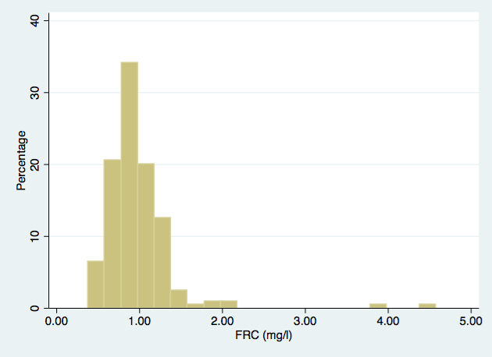

Figure 2 | Histogram of chlorine levels at the tapstand at Azraq Camp (July-August 2014).

Generally the chlorination performance was good at Azraq. The range specified by ACTED (the lead water supply agency) was 0.2 to 1.0 mg/l, which is in accordance with the emergency guidelines and this was more or less achieved. There are some instances of excessive chlorination (i.e., >1.0 mg/l) but most of these are within a reasonable range of the upper limit (i.e., <1.5 mg/l). On rare occasions, FRC was grossly excessive (around 4.0 mg/l and greater) but these were few.

## FRC Decay Models

We sought to model the data as an nth-order decay phenomenon. Output parameters *n*, *k*, *SSE*, and *R2* are reported in Table 2 along with treated data volumes. Graphs and residual plots are presented in Figure 3.

Table 2 | nth-order decay modeling outputs.

|  |  |  |  |  |  |  |  |  |  |
| --- | --- | --- | --- | --- | --- | --- | --- | --- | --- |
| Strata | Data volume | | | | Model outputs | | | | |
| Initial FRC range | n1 | n2 | n3 | n4 | k  (L·mg-1·min-1) | n | SSE | R2 | Graph |
| *All FRC* | 199 | 150 | 177 | 184 | 2.001 x 10-3 | 2.01 | 34.95 | 0.74 | 1 |
| *0.2 mg/L - 1.0 mg/L* | 126 | 91 | 109 | 120 | 2.986 x 10-3 | 2.11 | 10.87 | 0.62 | 2 |

From Table 2, we observe that the rate order, *n*, in both strata hover around 2, suggesting that a second order decay model may be an appropriate representation of chlorine decay in the camp setting. This corroborates what was observed in South Sudan as well (38).

We observe that the decay constant, *k*, is in the range of 2.0 to 3.0 x 10-3 L·mg-1·min-1. We recall from Figure 2 that there were some excessively high initial FRC concentrations at the tapstand. Once these excessive levels are removed from the model, the decay constant rises to around 3.0 x 10-3 L·mg-1·min-1. We take this value as representative as it excludes the influence of excessive FRC concentrations.

In South Sudan, we found that the decay constant was around 5.0 x 10-3 L·mg-1·min-1 (38). This indicates that the decay regime in Azraq camp is different from that encountered in South Sudan: specifically, decay is less rapid at Azraq than in South Sudan. The reduced decay may be linked to i) temperatures being lower at Azraq (average midday air temperature: 31.2**°**C) than in the South Sudan camps (average midday air temperature: 35.2**°**C); and ii) the vastly better ambient sanitary and WASH conditions at Azraq than in the South Sudan camps. Chlorine decay is likely to be affected by these two factors and indeed we do observe less decay at Azraq than in South Sudan. This affirms that chlorine decay is site-specific and is influenced by ambient conditions, underscoring the need to develop an evidence base across multiple and variable locales.

The goodness of the fit (*R2*) ranges from 0.62 to 0.74, suggesting that the second order model is a moderately good fit to the data. The graphs and residual plots in Figure 3 provide further insight into goodness of fit. We observe in both strata that the models are a relatively good fit for the data in the early periods (e.g., *t* < 400 min post-distribution). However, with greater time post-distribution, the model appears to overestimate decay (i.e., residuals are positively skewed in *t* > 1000 min). What this means is that guidelines based on these models will be conservative and offer a greater margin of protection.

Figure 3 | Graphs and residual plots of decay models.

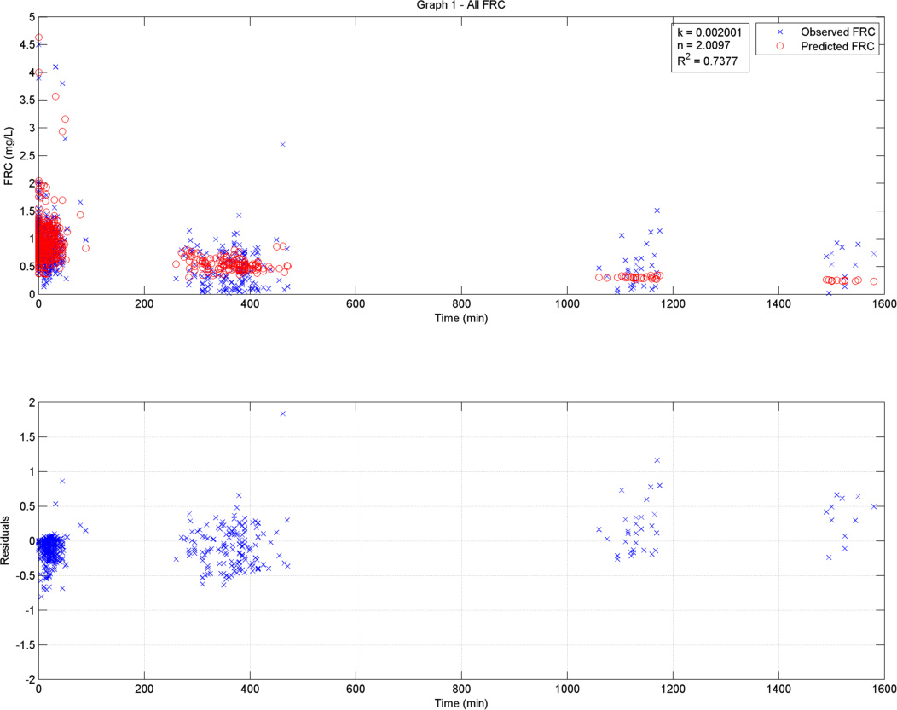

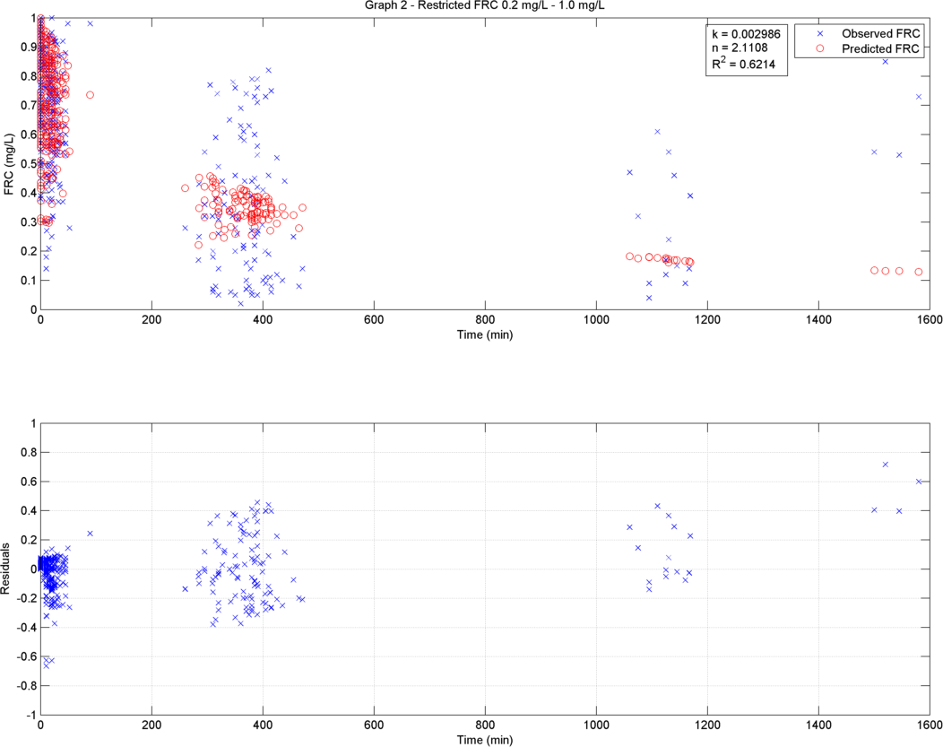

*Design of Evidence-Based FRC Guidelines*

With the *k* and *n* values generated from modeling, it is now possible to ‘reverse engineer’ using the general integrated rate law what the initial FRC should be at the tapstand (*Co*)in order to have a certain level of FRC protection (*Ct*) at a designated time post-distribution (*t*). We set as our primary target 0.2 mg/l of FRC protection 24 hours post-distribution. This is the same as the minimum level of protection designated for piped water supplies at the point of consumption.

Furthermore, ACTED has recently carried out a study in the Azraq camp to optimize chlorination of incoming water trucks and FRC levels at tapstands (39). The ACTED study thus assessed chlorine decay chlorine decay *pre-distribution*. The ACTED study complements the *post-distribution* focus of this study: together, water quality across the whole water supply chain is traversed. The conclusion of the ACTED FRC pilot was that the agency will accept 0.8 to 1.4 mg/l FRC in water tankers entering the camp, which was seen to yield FRC at the tapstand in the range of 0.4 mg/l to 1 mg/l, with 0.7 mg/l as an average. Below we will calculate the level of post-distribution FRC protection which can be expected at 24 hours if ACTED maintains this FRC range at tapstands. It should be noted that the FRC guideline of 1 mg/l at the tapstand is the same as that which was recommended from the South Sudan study so we will be able to see the impact of adopting this guideline in the context of the Azraq camp.

The general integrated rate law was built into a spreadsheet (Excel 2003, Microsoft Inc., Redmond, WA, USA) and the *goalseek* function used to solve for *Co* when *C* and *t* are set to target values, and *k* and *n* are set according to model outputs (the spreadsheet tool is available upon request from the author).

The predicted *Co* values to achieve the ideal level of protection and the *C24hr* values under the ACTED targets are presented in Table 3.

Table 3 | Design of evidence-based FRC guidelines from decay models.

|  |  |  |  |  |  |  |  |  |
| --- | --- | --- | --- | --- | --- | --- | --- | --- |
| Strata | Model Parameters | | | | To get ideal protection at 24 hrs, Co must be: | ACTED targets at tapstand yields C after 24 hours of: | | |
| Initial FRC range | k  (L·mg-1·min-1) | n | SSE | R2 | ***(i.e., to get C24hr =***  ***0.2 mg/l)*** | ***Co =***  ***0.4 mg/l*** | ***Co =***  ***1.0 mg/l*** | ***Co =***  ***0.7 mg/l*** |
| *All FRC* | 2.001 x 10-3 | 2.01 | 34.95 | 0.74 | 0.47 | 0.19 | 0.26 | 0.23 |
| *0.2 mg/L - 1.0 mg/L* | 2.986 x 10-3 | 2.11 | 10.87 | 0.62 | 0.85 | 0.16 | 0.21 | 0.19 |

Table 3 tells us several things. First off, under the observed decay regime at Azraq, it is possible to achieve an ideal level of FRC protection. This was not possible to achieve in the South Sudan camps due to the rapidness of the decay there (38). We take the the 0.2 mg/l to 1.0 mg/l initial FRC strata as representative as it is generated from the data closest to the range relevant for field practice. **In order to achieve 0.2 mg/l of FRC protection 24 hours post-distribution, a FRC guideline target at the tapstand of 0.85 mg/l should be maintained.**

With ACTED’s stated policy of achieving 0.4 mg/l at minimum, 1.0 mg/l at maximum, and 0.7 mg/l as an average, an acceptable household residual level can also be achieved (i.e., 0.16 to 0.21 mg/l). **To optimize camp water safety, it is recommended that ACTED maintain 0.8 to 0.9 mg/l at the tapstand**.This will ensure at least 0.2 mg/l of FRC protection after 24 hours of household storage and use**.** This is within the range already specified by ACTED so the agency is well-positioned to ensure safe water supply at Azraq. ACTED’s upper limit (i.e., 1.0 mg/l) is also the tentative recommendation from the South Sudan research (38). The finding here suggests that the South Sudan recommendation is slightly excessive but would still work to ensure safe water at the household level (albeit in the South Sudan camps, a guideline target of 1.0 mg/L could only ensure safe water for 12 hours).

## Factors Driving FRC Decay

In this section we explore how water quality, water handling practices, and other contextual factors were associated with FRC decay. We proceed phase by phase in order to elucidate the effects of various explanatory variables on decay within each phase. In the tables presented in this section, the *regression coefficient* is reported along with stars indicating the degree of significance (legend below each table).

### Phase A: Collecting Water from Tapstand into Container

Outputs of the linear regression models for Phase A are given in Table 4.

Table 4 | Regression table for Phase A.

|  |  |  |  |  |  |
| --- | --- | --- | --- | --- | --- |
| VARIABLES | Model 1 | Model 2 | Model 3 | Model 4 | Model 5 |
| Water Quality |  |  |  |  |  |
| [FRC]*i* | 0.103* | 0.101* | 0.101* | 0.101* | 0.102* |
| NTU*i* | 0.004 | 0.003 | 0.003 | 0.002 | 0.001 |
| Temp.*i* | 0.004 | 0.003 | -0.004 | -0.005 | -0.004 |
| EC*i* | 0 | 0 | 0 | 0 | 0 |
| pH*i* | -0.026 | -0.023 | -0.023 | -0.022 | -0.025 |
| Container Type (rigid jerrycan base level) | | | | | |
| Collapsible jerrycan | | 0.02 | 0.023 | 0.026 | 0.024 |
| Small rigid jerrycan (10L) | | -0.015 | -0.014 | -0.014 | -0.012 |
| Ambient Air Temp. | |  | 0.002 | 0.003 | 0.002 |
| Container Covered | |  |  | -0.022 | -0.021 |
| Container Cleanliness (clean base level) | | |  |  |  |
| Unclean |  |  |  |  | 0.006 |
| Dirty |  |  |  |  | 0.092 |
| Constant | 0.045 | 0.059 | 0.175 | 0.219 | 0.213 |
| R2-Adj. | 0.078 | 0.070 | 0.068 | 0.064 | 0.058 |
| N | 187 | 181 | 180 | 180 | 180 |

* p<0.05, ** p<0.01, *** p<0.001

From Table 4 we observe that with the exception of initial FRC concentration, which we would expect to be related to the magnitude of FRC decay given its nonlinearity, none of the other explanatory variables appear to be related to FRC decay during water collection. The low R2 value indicates that unknown and/or undocumented factors control much of the observed decay here.

### Phase B: Transporting Water from Tapstand to Household

Outputs of the linear regression models for Phase B are given in Table 5.

Table 5 | Regression table for Phase B.

|  |  |  |  |  |  |  |  |
| --- | --- | --- | --- | --- | --- | --- | --- |
| VARIABLES | Model 1 | Model 2 | Model 3 | Model 4 | Model 5 | Model 6 | Model 7 |
| Water Quality |  |  |  |  |  |  |  |
| [FRC]*i* | 0.246*** | 0.246*** | 0.248*** | 0.247*** | 0.247*** | 0.247*** | 0.247*** |
| NTU*i* | 0.001 | 0 | 0 | 0 | 0 | 0 | 0 |
| Temp.*i* | 0.003 | 0.002 | 0.002 | 0.002 | 0.002 | 0.002 | 0.002 |
| EC*i* | 0 | 0 | 0 | 0 | 0 | 0 | 0 |
| pH*i* | -0.014 | -0.001 | 0.001 | -0.002 | -0.001 | -0.003 | -0.003 |
| Container Type (rigid jerrycan base level) | | |  |  |  |  |  |
| Collapsible jerrycan | | 0.034 | 0.036 | 0.032 | 0.03 | 0.031 | 0.031 |
| Small rigid jerrycan (10L) | | -0.008 | -0.009 | -0.009 | -0.007 | -0.008 | -0.008 |
| Ambient Air Temp. | |  | -0.001 | -0.001 | -0.001 | -0.001 | -0.001 |
| Container Covered | |  |  | 0.024 | 0.026 | 0.025 | 0.025 |
| Container Cleanliness (clean base level) | | |  |  |  |  |  |
| Unclean |  |  |  |  | 0.012 | 0.012 | 0.012 |
| Dirty |  |  |  |  | 0.008 | 0.001 | 0.001 |
| Steps to Household | |  |  |  |  | 0 | 0 |
| Minutes to travel to Household | |  |  |  |  |  | 0 |
| Constant | -0.097 | -0.191 | -0.178 | -0.175 | -0.188 | -0.151 | -0.15 |
| R2-Adj. | 0.403 | 0.438 | 0.439 | 0.437 | 0.432 | 0.430 | 0.427 |
| N | 186 | 180 | 179 | 179 | 179 | 179 | 179 |

* p<0.05, ** p<0.01, *** p<0.001

From Table 5 we observe that with the exception of initial FRC concentration, none of the other possible explanatory variables appear to be related to FRC decay during water collection. The R2 value is greater now suggesting that these variables do account for more of the observed variability; however, whether they are positively or negatively related remains unclear.

### Phase C: Storage and Use of Water in the Household

Outputs of the linear regression models for Phase C are given in Table 6.

Table 6 | Regression table for Phase C.

|  |  |  |  |  |  |  |  |  |  |  |
| --- | --- | --- | --- | --- | --- | --- | --- | --- | --- | --- |
| VARIABLES | Model 1 | Model 2 | Model 3 | Model 4 | Model 5 | Model 6 | Model 7 | Model 8 | Model 9 | Model 10 |
| Water Quality |  |  |  |  |  |  |  |  |  |  |
| [FRC]*i* | 0.464* | 0.463* | 0.460* | 0.459* | 0.459* | 0.457* | 0.461* | 0.462* | 0.460* | 0.469*** |
| NTU*i* | -0.011 | -0.014 | -0.013 | -0.012 | -0.012 | -0.012 | -0.016 | -0.015 | -0.015 | -0.005 |
| Temp.*i* | 0.007 | 0.01 | 0.01 | 0.013 | 0.013 | 0.011 | 0.012 | 0.012 | 0.01 | -0.017 |
| EC*i* | 0 | 0 | 0 | 0 | 0 | 0 | 0 | 0 | 0 | 0 |
| pH*i* | 0.244* | 0.249* | 0.221* | 0.238* | 0.239* | 0.240* | 0.249* | 0.248* | 0.249* | 0.253 |
| Container Type (rigid jerrycan base level) | | | |  |  |  |  |  |  |  |
| Collapsible jerrycan | | -0.029 | -0.026 | -0.015 | -0.017 | -0.017 | -0.017 | -0.016 | -0.015 | 0.086* |
| Small rigid jerrycan (10L) | | -0.112 | -0.105 | -0.101 | -0.099 | -0.101 | -0.1 | -0.096 | -0.096 | -0.087 |
| Ambient Air Temp. | |  | 0.002 | 0.003 | 0.003 | 0.004 | 0.004 | 0.005 | 0.005 | -0.006 |
| Container Covered | |  |  | -0.126* | -0.125 | -0.125 | -0.126 | -0.126 | -0.124 | -0.064 |
| Container Cleanliness (clean base level) | | | |  |  |  |  |  |  |  |
| Unclean |  |  |  |  | 0.017 | 0.015 | 0.02 | 0.021 | 0.022 | 0.032 |
| Dirty |  |  |  |  | -0.042 | -0.05 | -0.043 | -0.045 | -0.044 | 0.288*** |
| Water Transferred Between Containers | | | |  |  |  | 0.145 | 0.171 | 0.161 | 0.568** |
| Water Mixed with Other Waters | | | |  |  |  |  | -0.059 | -0.065 | -0.242 |
| Water Used | |  |  |  |  |  |  |  | 0.016 | -0.047 |
| Water Stored Indoors/Out of Sun | | | |  |  |  |  |  |  | -0.330*** |
| Constant | -2.153* | -2.244* | -2.101* | -2.240* | -2.264* | 614.546 | 573.171 | 691.089 | 731.298 | 2787.781 |
| R2-Adj. | 0.270 | 0.273 | 0.264 | 0.277 | 0.269 | 0.264 | 0.261 | 0.256 | 0.252 | 0.546 |
| N | 177 | 171 | 170 | 169 | 169 | 169 | 169 | 168 | 168 | 109 |

* p<0.05, ** p<0.01, *** p<0.001

In Table 6 we see that several explanatory variables emerge as statically significant during this phase. As expected, initial FRC concentration remains positively associated with magnitude of FRC decay. In addition, pH also appears as positively related to FRC decay. This suggests that the higher pH is during household storage and use, the more rapidly FRC decay occurs. A protective effect of covering the container during household storage and use also appears but the effect weakens when other variables are introduced. A protective effect is naturally expected and corroborates what was observed during household storage and use in South Sudan (38). There is also some weak evidence to suggest that the rigid jerrycan is more protective than the collapsible jerrycan, but the effect is only observed in a single model. Furthermore, some weak evidence emerged to confirm that container uncleanliness, as well as transferring water between containers was associated, with FRC decay, but again the effects are weak and inconsistent. This is not to say that these hygienic water handling practices do not work, simply that confirmatory evidence was not found in this setting. Promotion of hygienic water handling practices remains an essential component of emergency safe water supply.

Though most are weak, one extremely strong effect emerged. Many households in Azraq (approximately 40% of respondents) are storing their water in the sun. Storing water in the sun is seen to be strongly associated with FRC decay (whereas storing the water indoors and out of the sun was protective). The R2 value shows a big jump once the sun exposure variable is introduced, suggesting that this feature is indeed an important factor for FRC decay during household storage and use. When we asked refugee households during the course of the fieldwork why they placed their water in the sun, we were told it was precisely because the sun helped to dissipate the chlorine residual which they found to be unpleasant in taste and odour.

This underscores the central tension with chlorination in humanitarian operations: balancing between having sufficient chlorine to protect against recontamination and preventing taste and odour-driven rejection. These are respectively the lower and upper limits that humanitarian FRC guidelines must exist within. Refugee households reported that when chlorine was excessive at the tapstands, they would begin keeping the water in the sun in order to remove excess chlorine taste and odour. This highlights the importance of careful management of chlorination systems, as excess FRC events may lead to shifts in water handling behaviours which may persist for a longer duration than the excessive chlorination event. Generally, chlorination performance at Azraq is good (Figure 2). Maintaining 0.8 to 0.9 mg/l FRC targets at tapstands, preventing excess events (i.e., >1.0 mg/l), along with on-going hygiene promotion activities, may rectify and prevent sun-exposure practices at Azraq. Water taste/odour acceptance studies may also be considered in Azraq camp in order to determine the precise threshold beyond which the refugee population resorts to modifying their water or seeking other sources.

# Conclusions

The evidence base underlying emergency safe water supply guidelines is almost non-existent at present. The present study sought to investigate FRC decay in the refugee/IDP camp setting—from collection at the tapstand to consumption at the household level—in order to develop evidence-based guidelines for centralized batch chlorination in humanitarian operations. The research at Azraq refugee camp, Jordan is the second of four field research phases, and builds on earlier work from South Sudan.

On the basis of data collected at Azraq, we recommend that the FRC guideline target be set to 0.8 to 0.9 mg/l at the tapstand. According to modeling, this target should be able to maintain at least 0.2 mg/l of residual up to 24 hours post-distribution. This is in line with the range specified by ACTED in their study of chlorine decay pre-distribution. This study and the ACTED study together traverse the entire water supply chain. Maintaining 0.8 to 0.9 mg/l FRC at tapstands should ensure safe water through to consumption in Azraq camp.

Although strong evidence did not emerge on the protective effects of hygienic water handling practices, this is not to say that these practices do not work, simply that confirmatory evidence was not found in this setting. Promotion of hygienic water handling practices remains an essential component of emergency safe water supply. Conversely, strong evidence did emerge on the impact of storing household water in the sun. Approximately 40% of respondents in this study were documented to follow this practice, with the stated intent of dissipating excess chlorine. Storing water in the sun was observed as being strongly linked to FRC decay. Maintaining the 0.8 to 0.9 mg/l FRC target at tapstands, preventing excess chlorination events (i.e., >1.0 mg/l), along with on-going hygiene promotion activities, may rectify and prevent this practice at Azraq.

The present study in Jordan builds on earlier work from South Sudan, and adds to the evidence base on emergency safe water supply. Modeling with the Jordan dataset indicates that a second order decay model may be an appropriate representation of chlorine decay in the camp setting, corroborating our findings from South Sudan. The rate of FRC decay at Azraq was found to be less than that observed in South Sudan (but within the same order of magnitude). The lower rate of decay may be linked to lower temperatures and vastly better ambient sanitary and WASH conditions at Azraq. These findings affirm that chlorine decay is indeed influenced by ambient conditions, underscoring the need to develop an evidence base across multiple and variable locales.

Integrating findings from Jordan and South Sudan suggests that an appropriate range for emergency FRC target guidelines may be in the range of 0.8 to 1.0 mg/l. Given the evidence of different decay regimes between the two sites, the need for further studies in varying camp settings is underscored. A number of factors may influence total apparent FRC decay including climate, water source, WASH services, sanitary conditions, and local terrain/environment. Further studies in 2015 may be best targeted at temperate and forested regions, as well as sites where surface water is the primary water source, as these conditions have not yet been investigated and would contribute to the breadth of the emerging evidence base.

# Acknowledgments

Many thanks are due to my refugee colleagues who prefer to remain unnamed. I would also like to gratefully acknowledge the financial support of the Division of Programme Support and Management, UNHCR; the Blum Center for Developing Economies; and the USAID Development Impact Lab at the University of California, Berkeley. My thanks also to Jeff Fesselet and the Public Health Department of Médecins Sans Frontières OCA for kindly lending me the research equipment to be able to do this work. I owe a tremendous debt to the many people on the ground in Amman and Azraq who helped with all the practical aspects of the research: Khaled Shapsough for his careful control at the wheel of his car on the “road of death” between Azraq and Amman, and his banter the whole way through; Bernadette Castel-Hollingsworth, UNHCR Azraq; Phillip Priestley and his field security team, UNHCR Azraq; Boutros Hijazeen, Murad Al-Shishani, and dear colleagues in the Technical Unit, UNHCR Azraq; the whole Azraq UNHCR team in fact; Amin Juzar Bhai in the Amman UNHCR office for his patient support and perseverance in getting everything sorted; Ammar Hathnawi, ACTED; and Malek Abdeen and Marten Mylius, CARE Jordan. Many thanks also to Syed Sa’ad Ali for his invaluable support with MATLAB.

***Please direct correspondence to:*** imran.ali@berkeley.edu *or* ali.s.imran@gmail.com

# References

1. Toole MJ, Waldman RJ. The public health aspects of complex emergencies and refugee situations. Annu Rev Public Health. 1997;18:283–312.

2. Connolly MA, Gayer M, Ryan MJ, Salama P, Spiegel P, Heymann DL. Communicable diseases in complex emergencies: impact and challenges. Lancet. 2004;364(9449):1974–83.

3. Salama P, Spiegel P, Talley L, Waldman R. Lessons learned from complex emergencies over past decade. Lancet. 2004;364:1801–13.

4. Cronin A, Shrestha D, Spiegel P, Gore F, Hering H. Quantifying the burden of disease associated with inadequate provision of water and sanitation in selected sub-Saharan refugee camps. J Water Health. 2009;7(4):557–68.

5. Kouadio IK, Aljunid S, Kamigaki T, Hammad K, Oshitani H. Infectious diseases following natural disasters: prevention and control measures. Expert Rev Anti Infect Ther. 2012;10(1):95–104.

6. Cairncross S, Feachem RG. Environmental Health Engineering in the Tropics: An Introductory Text. Hoboken, NJ: Wiley; 1993.

7. Reiff FM. Chlorination for International Disasters. Proc Water Environ Fed. Water Environment Federation; 2002;13:439–51.

8. WHO. Guidelines for Drinking-water Quality. 3rd Ed. Geneva: World Health Organization; 2008.

9. Médecins Sans Frontières. Refugee Health: An Approach to Emergency Situtations. Hanquet G, editor. London: Macmillan; 1997.

10. Oxfam GB. Oxfam Guidelines for Water Treatment in Emergencies [Internet]. 2001. Available from: http://reliefweb.int/report/world/guidelines-water-treatment-emergencies

11. WHO. Environmental Health in Emergencies and Disasters: A Practical Guide. Wisner B, Adams J, editors. Geneva: World Health Organization; 2002.

12. Davis J, Lambert R. Engineering in Emergencies: A Practical Guide for Relief Workers. London: ITDG Publishing; 2002.

13. UNHCR. Handbook for Emergencies. 3rd Ed. Geneva: United Nations High Commissioner for Refugees; 2007.

14. Médecins Sans Frontières. Hepatitis E outbreak control: Water, Hygiene & Sanitation aspects. Amsterdam: Médecins Sans Frontières; 2008.

15. JHSPH, IFRC. The Johns Hopkins and Red Cross Red Crescent Public Health Guide in Emergencies. 2nd Ed. Geneva: International Federation of Red Cross and Red Crescent Societies; 2008.

16. Médecins Sans Frontières. Public Health Engineering in Precarious Situations. Brussels: Médecins Sans Frontières; 2010.

17. The Sphere Project. Humanitarian Charter and Minimum Standards in Humanitarian Response. 3rd Ed. Rugby, UK: Practical Action Publishing; 2011.

18. CDC. Chlorine Residual Testing [Internet]. 2012. Available from: http://www.cdc.gov/safewater/chlorine-residual-testing.html

19. Mintz ED, Reiff FM, Tauxe R V. Safe water treatment and storage in the home: A practical new strategy to prevent waterborne disease. J Am Med Assoc. 1995;273(12):948–53.

20. Clasen TF, Bastable A. Faecal contamination of drinking water during collection and household storage: the need to extend protection to the point of use. J Water Health. 2003;1(3):109–15.

21. Trevett AF, Carter R, Tyrrel S. Water quality deterioration: A study of household drinking water quality in rural Honduras. Int J Environ Health Res. 2004;14(4):273–83.

22. Wright J, Gundry S, Conroy R. Household drinking water in developing countries: a systematic review of microbiological contamination between source and point-of-use. Trop Med Int Heal. 2004;9(1):106–17.

23. Trevett AF, Carter RC, Tyrrel SF. The importance of domestic water quality management in the context of faecal-oral disease transmission. J Water Health. 2005;3(3):259–70.

24. Gunther I, Schipper Y. Pumps, germs, and storage: The impact of improved water containers on water quality and health. Health Econ. 2013;22:757–74.

25. Steele A, Clarke B, Watkins O. Impact of jerry can disinfection in a camp environment - experiences in an IDP camp in Northern Uganda. J Water Health. 2008;6(4):559–64.

26. Swerdlow DL, Malenga G, Begkoyian G, Nyangulu D, Toole M, Waldman RJ, et al. Epidemic cholera among refugees in Malawi, Africa: treatment and transmission. Epidemiol Infect. 1997;118(03):207–14.

27. Roberts L, Chartier Y, Chartier O, Malenga G, Toole M, Rodka H. Keeping clean water clean in a Malawi refugee camp: a randomized intervention trial. Bull World Health Organ. 2001;79(4):280–7.

28. Mahamud AS, Ahmed JA, Nyoka R, Auko E, Kahi V, Ndirangu J, et al. Epidemic cholera in Kakuma Refugee Camp, Kenya, 2009: the importance of sanitation and soap. J Infect Dev Ctries. 2009;6(3):234–41.

29. Shultz A, Omollo JO, Burke H, Qassim M, Ochieng JB, Weinberg M, et al. Cholera Outbreak in Kenyan Refugee Camp: Risk Factors for Illness and Importance of Sanitation. Am J Trop Med Hyg. 2009;80(4):640–5.

30. Walden VM, Lamond E, Field SA. Container contamination as a possible source of a diarrhoea outbreak in Abou Shouk camp, Darfur province, Sudan. Disasters. 2005;29(3):213–21.

31. Cronin AA, Shrestha D, Cornier N, Abdalla F, Ezard N, Aramburu C. A review of water and sanitation provision in refugee camps in association with selected health and nutrition indicators - the need for integrated service provision. J Water Health. 2008;6(1):1–13.

32. Blanchet K, Roberts B. An evidence review of research on health interventions in humanitarian crises. London: London School of Hygiene and Tropical Medicine; 2013.

33. Bastable A, Russell L. Gap Analysis in Emergency Water, Sanitation and Hygiene Promotion. London: Humanitarian Innovation Fund; 2013.

34. Oxfam. PH Monthly Monitoring Report (Jamam Refugee Camp, November 2012). Oxford: Oxfam GB; 2012.

35. CDC. Final Report: Hepatitis E Outbreak Investigation: Results from the Knowledge, Attitudes and Practices (KAP) Survey, Environmental Investigation, and Seroprevalence Survey in Jamam and Yusuf Batil Camps, Upper Nile, South Sudan. Atlanta: Centers for Disease Control and Prevention; 2013.

36. Guerrero-Latorre L, Gonfa AH, Girones R. Environmental Investigation in Maban, South Soudan (April 2013): Preliminary Results. Barcelona: University of Barcelona WADHE Project; 2013.

37. Thomson K, Dvorzak J, List L, Mackinnon E, Ali SI, Bishop L, et al. Epidemiological characteristics of a prolonged hepatitis E outbreak in three refugee camps in South Sudan. MSF Scientific Day. London, UK; 2013.

38. Ali SI. Humanitarian Water at Risk: Chlorine Decay in Refugee Camp Water Supply in South Sudan. Amsterdam; 2013.

39. ACTED. Free Residual Chlorine Pilot, Azraq Camp - September 2014 Report. Amman, Jordan; 2014.

40. Trevett AF, Carter RC, Tyrrel SF. Mechanisms leading to post-supply water quality deterioration in rural Honduran communities. Int J Hyg Environ Health. 2005 Jan;208(3):153–61.

41. Levy K, Nelson KL, Hubbard A, Eisenberg JNS. Following the water: A controlled study of drinking water storage in northern coastal Ecuador. Environmental Health Perspectives. 2008. p. 1533–40.

42. Kumar MSM, Munavalli GR. Autocalibration of chlorine transport model for steady state distribution system by genetic algorithm. Seventh International Water Technology Conference. Egypt; 2003. p. 495–506.

43. Vuta LI, Dumitran GE. Some aspects regarding chlorine decay in water distribution networks. Conf Aerul Si Apa Compon Ale Mediu. Cluj-Napoca, Romania: Cluj University Press; 2011;253–9.

44. Walski T, Chase DV, Savic D. Water Distribution Modeling. Exton, PA: Haestad Methods; 2001.