TOILET INFRASTRUCTURE SANITARY SURVEY FORM
COMMUNAL TRENCH LATRINE
- General Information
Location: Camp __________________ Sector ____________ Block ___________ Community ______________
GPS Long: _____°_______ʹ_______ʺ GPS Lat: _____°_______ʹ_______ʺ Number of toilet cubicles: ______
Contact person: ___________________ Position: ____________________ Date of visit: ____/________/_____
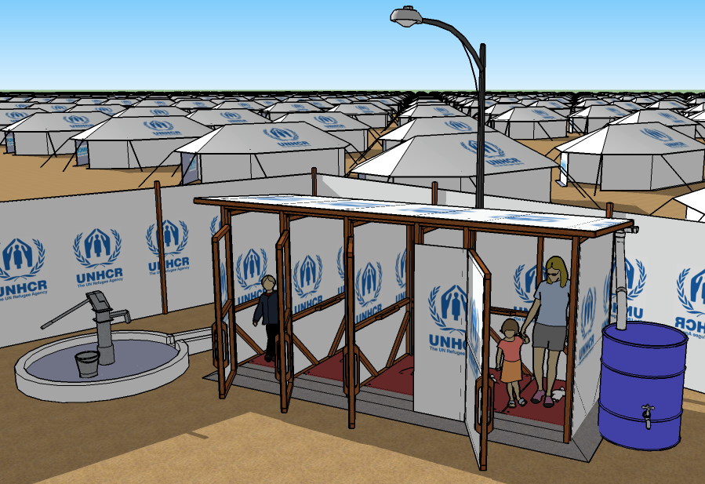
4.
11.
9.
8.
6.
5.
3.
2.
1.
12.
7.
10.
- Identification of risk factors |  | Risk
- Are the pit walls visibly cracked / broken / leaking / flooded? |  | Y / N
- Is the toilet pit full? (less than 0.5m remaining space in the pit)? |  | Y / N
- Is the toilet block unsanitary? (traces of faeces anywhere inside the toilet facilities)? |  | Y / N
- Is there any evidence of fly infestation?  (presence of one or more flies in the cubicle during the assessment period)? |  | Y / N
- Are there any drinking water sources within 10m of the toilet facility? |  | Y / N
- Is there evidence of open defecation anywhere around the toilet block? |  | Y / N
- Is there a lack of a privacy screen around the toilet block? |  | Y / N
- Is there a lack of privacy inside any of the toilet cubicles?  (for example - is any of the plastic sheeting missing or ripped)? |  | Y / N
- Are any of the toilet cubicles missing a functional security lock? |  | Y / N
- Is there a lack of adequate night-time security lighting within 3m of the toilet block?  (adequate lighting = at least 100 lumens / m²) |  | Y / N
- Is there a lack of a functional hand-washing station within 10m of the toilet?  (functional = soap + handwashing water + drainage) |  | Y / N
- Is there a lack of handrails for vulnerable groups (elderly / infirm / disabled / children)? |  | Y / N
Total score of risks |  | / 12
Signature of Inspector ………………………….….. | Community representative ……………….……………..
Note: Risk score: 9-12 = very high, 6-8 = high, 3-5 = intermediate, 0-2 = low

