WASH Country Strategy 2014 - 2018

UNHCR Template

Date:
Revision #

Note: This document will be revised and updated to reflect the changes in the operation.

This paper is intended to act as a WASH strategy framework, a ‘living’ document that will outline the framework for action.
Regular evaluation and monitoring will determine amendments to this strategy, to be undertaken through UNHCR WASH Officer in Country.

This document is intended to be part of the baselines for the development of ad-hoc Country Operational Plans.

WASH Global Strategy Overview (half page max)
Brief overview/summary of the Global WASH strategy.

Background / Context (2 pages max)
Country situation and background (geography, economical/political context/map of the country)

Overview of the WASH situation in the country (2 pages max)
Includes narrative on:
- country WASH response capacity (presence of UNHCR in country/presence of other WASH actors/stakeholders analysis/role and interaction with cluster etc)
- Areas of interventions and ongoing programmes
- Population groups / vulnerable groups
- WASH budget by objective (compared to number of refugees) in the past 3-5 yrs
- Challenges (floods/outbreaks/influx etc)
- indicators & graphs (how many camps have met the standards….. etc)

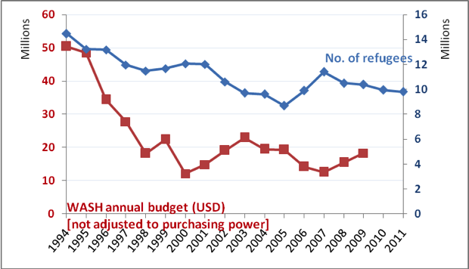

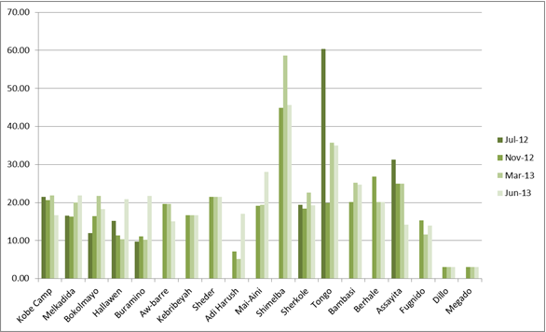

Annual Water access trend in Ethiopia camps – July 2012 – June 2013

Vision (3 pages max)

Based on the pillars at global level developed as part of the WASH strategy in HQ, outline key strategic objectives within 5 years:
- i.e. Training, capacity building & partnerships (internal training for UNHCR staff, external for IPs and local partners/government bodies/refugees)
- i.e. Sustainability (moving towards more long-term sustainable solutions such as family latrines/use of local materials/from motorized to human powered water systems/trainings)
- i.e. Monitoring (WMS / mapping of facilities / groundwater monitoring / KAP, etc)
- i.e. Coordination (with health – epidemiological data sharing / with nutrition – SENS / with environment – GW monitoring / with WASH Cluster – prepositioning of contingency stock & or secondments on HP, etc)
- i.e. Emergency Preparedness & Contingency Planning
- i.e. Cross cutting issues (environment/protection/vulnerable people, etc)
- i.e. Hygiene promotion strategy (involvement of the community/trainings/etc)
- i.e. WASH in communal places (health centers, schools, markets, mosques, etc)
- i.e. Host community programmes

Country WASH Objectives (4-5 pages max)
Set up Country-specific objectives and actions to achieve them.

i.e. Objective 1: Refugees have safe access to water of sufficient quality and quantity

Actions the country will take to achieve objectives (pls take into account that the following has been included in the Global WASH Strategy at HQ up to 2018).

i.e.
- modernization and optimization of water infrastructures,
- mapping and modeling of water supply systems,
- design of more sustainable water facilities (O&M-wise)
- Working on long-term and more sustainable water infrastructures
- Water supply systems to be designed in such a way that upgrades and enlargements of the distribution network is feasible
- Water systems to be equipped with back-up system (alternative water sources, spare generators and pumps, etc….)
- Adequate Operation and Maintenance of water infrastructures is carried out regularly and included in budget of partner and “software” components such as:

- Calculate the cost of water to evaluate early investment costs & enhance efficiency in our operation
- Camp of above 5,000 refugee would develop a water safety plan
- Regular water quality monitoring (bacteriological and chemical) at the production as well as at the household level. It will include supply of adequate materials to carry out those tests.
- Expand where appropriate groundwater monitoring systems in UNHCR operational areas (i.e. Merti Aquifer monitoring program developed in Dadaab)
- Partnerships with Research Institutes/Universities and Private companies for enhanced water infrastructures designs
- Capacity building for preventive operation and maintenance of water infrastructures
- Capacity building in water treatment and water quality monitoring and process control
- Strengthen our water response in out of camps situations and urban settings
- Strengthen our water programme in Sahel/semi-arid contexts adapted to nomadic populations

Sector Objective | Output objective | Standard
 |  | Emergency (e.g. first 6 months of a newly installed camp, major influx of refugees, outbreaks) | Post-emergency, transitional phases (protracted crisis and long term situation)
1. Refugees have safe access to water of sufficient quality and quantity | Improved water quantity | >15l/person/day | >20l/person/day
 | Improved water quality | >=70% of HHs collecting drinking water from protected water sources only | >=95% of HHs collecting drinking water from protected water sources only
 | Improved water quality at non-chlorinated water sources | >=95% of tests with 0 faecal coliforms/100ml of water | >=95% of tests with 0 faecal coliforms/100ml of water
 | Improved water quality at chlorinated water collection locations | >=95% of tests showing Free Residual Chlorine >= 0.1mg/land NTU<5 | >=95% of tests showing Free Residual Chlorine >= 0.1mg/l and NTU<5
 | Increased access to water | =< 250 persons per tap | = 80 persons per tap
 | Increased access to water | >=80% of HHs collecting >=15 liters/persons/day | >=80% of HHs collecting >=15 liters/persons/day
 | Increased access to water | =< 500m to tap | = 200m to tap
 | Increased water storage | >=80% of HHs with sufficient daily water storage capacity (50 liters for a 5 members average) | >=80% of HHs with sufficient daily water storage capacity (50 liters for a 5 members average)

i.e. Objective 2: Refugees have safe access to quality sanitation

Improving safe access to quality sanitation, involves complementary hardware and software actions. The “hardware” components include:
- More sustainable sanitation infrastructures implemented (use of local materials, family sanitation facilities in post-emergencies contexts, etc)
- Apply a more standardized design of sanitation facilities across the operations which will meet the standard in term of privacy, safety and cost effectiveness
- Equal spatial distribution of sanitation infrastructures for equal access opportunities for all refugees through GIS tools
- Wastewater, solid waste management and drainage being systematically part of the sanitation programme in all refugee camps, whereby wastewater evacuation system are handled by WASH actors/partners and the overall drainage component (runoff at cross roads) is developed in coordination with site planning
- Where appropriate work with livelihood on building business around solid waste (recycling & compost) and wastewater (biogas, gardening, water for livestock)
The “software” components for improved access to quality sanitation include:
- Involvement of refugees in all phases of sanitation infrastructures (i.e. planning, design, piloting, maintenance, etc)
- Roll out of CLTS in locations with long standing refugee settlements
- Strengthen our sanitation response in urban settings by developing specific guidelines based on field experience
- Partnerships with Research Institutes/Universities and Private companies for enhanced sanitation designs

Sector Objective | Output objective | Standard
 |  | Emergency (e.g. first 6 months of a newly installed camp, major influx of refugees, outbreaks) | Post-emergency, transitional phases (protracted crisis and long term situation)
2.Refugees have safe access to quality sanitation | Increased safe disposal of human waste | =< 50 persons per communal latrine | =< 20 persons per communal latrine aiming to 1 latrines / households
 | Increased access to sanitation | >=60% of HHs report defecating in a toilet | >=85% of HHs report defecating in a toilet
 | Increased access to sanitation | >80% of HHs have access to latrine | >80% of HHs have access to latrine
 | Increased access to sanitation | >80% of communal latrines compliant with UNHCR standards (cleanable slabs, privacy & structural safety) | >80% of communal latrines compliant with UNHCR standards (cleanable slabs, privacy & structural safety)
i.e. Objective 3: Refugees have improved hygiene

i.e. Community mobilization is key to address the determinants of poor hygiene. Therefore, particular emphasis will be put to strengthen community mobilization for enhancing monitoring and use of water and sanitation facilities, strengthen sense of ownership of water and sanitation infrastructures and for key messages dissemination.

Hygiene promotion in schools will also play a crucial role to promote safe hygiene practices as part of an educational process.

Coordination between Health, Education and WASH will be strengthened to enhance effectiveness in hygiene/public health promotion, and to enhance information sharing and optimization of resources. Capacity building for enhanced expertise in hygiene promotion and increase the number of hygiene promotion officers will also be pursued to optimize improved hygiene among refugees.

Coordination with Community Services will be strengthened to ensure enhanced water storage capacity at households level through distribution of water containers and advocacy for POC to have adequate quantity of soap and basic hygiene items (including hand-washing devices) to maintain hygienic condition and ensure dignity will also constitute a key action to improve hygiene and reach the HP objective for the sector.

In order to provide a baseline and monitoring tool for defining and adjusting the hygiene promotion strategy in each of the UNHCR’s operational area, the roll out of a standardized KAP survey will be carried out in 20 countries by 2017.

Sector Objective | Output objective | Standard
 |  | Emergency (e.g. first 6 months of a newly installed camp, major influx of refugees, outbreaks) | Post-emergency, transitional phases (protracted crisis and long term situation)
3.Refugees have improved hygiene | Improved hygiene | >=90% of HHs with (any type of) soap present in the house (presented within 1 minute) | >=90% of HHs with (any type of) soap present in the house (presented within 1 minute)
 |  | >=80% of HHs with knowledge of at least 3 of the 5 critical handwashing times | >=80% of HHs with knowledge of at least 3 of the 5 critical handwashing times

i.e. Objective 4: Coordination, Partnerships and Capacity building of WASH partners and officers

etc…….

Contingency planning (1-2 pages max)
Process and timeframe foreseen to develop a contingency plan for the Country.

Monitoring & Evaluation (1-2 pages max)
Includes indicators, process, frequency and health statistics

Budget / Resources / Staffing (2 pages max)
- Broad costs of the strategy
- Resources needed
- Organogram of staff

Coordination (2 pages max)
- Information management
- partnerships (subagreements & partnerships with research institutes/Universities
- information sharing
- standardization of designs, assessment forms, etc

Annexes

Annex A: Detailed WASH Operational Plans if available for each Camp.
Annex B: Additional References
Annex B: Maps of the camp

In case of outbreaks, the FRC at water collection locations can be raised up to 0.6-0.8 mg/l depending on the water specific characteristics and on the acceptability of the POCs
This is current Sphere standard, but UNHCR will aim to reduce this standard to 30 persons per latrine in the emergency phase during 2013 – 17.

