**The Nansen Refugee Award 2016 Winners**

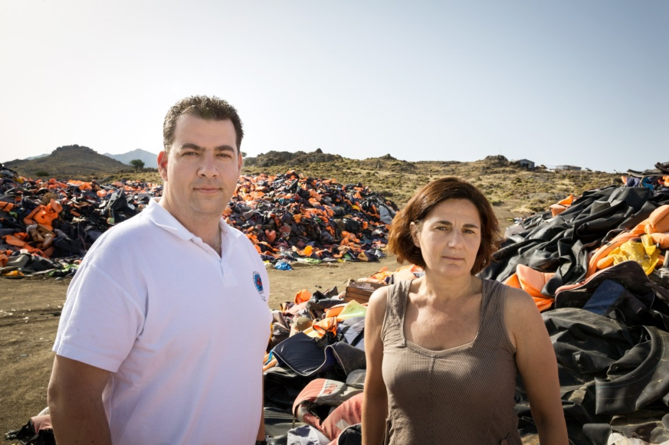

**Konstantinos Mitragas** on behalf of the Hellenic Rescue Team (HRT) and **Efi Latsoudi**, the human rights activist behind “PIKPA village” on the Greek island of Lesvos, are joint winners of UNHCR’s Nansen Refugee Award 2016. The award recognizes their tireless voluntary efforts to aid refugees arriving in Greece during 2015, and is reflective of the spirit of volunteerism that characterized the unique response to the refugee and migrant emergency in Europe.

Since 2007, Greece has been challenged by the arrival of a large number of refugees and migrants, but in 2015 sea arrivals escalated to an emergency. On the island of Lesvos alone, numbers topped 500,000 last year. In October 2015, arrivals peaked at more than 10,000 per day, as conflicts in Syria, Afghanistan and Iraq continued to uproot people from their homes. Other Greek islands, including Chios, Samos, Leros and Kos also hosted refugees as thousands more risked the freezing waters, fake lifejackets and surging storms in order to find safety.

For many refugees, the heroic humanitarian efforts of Greek volunteers in 2015 went well beyond pulling survivors from the seas, they helped them to take the first steps towards a normal life.

More than 2,000 volunteers make up the HRT and have been rescuing people from the Aegean Sea and Greek mountains since 1978. In 2015, the volunteers were working 24 hours per day, responding to endless rescue calls in the middle of the night. Over the course of the year, the volunteers undertook 1,035 rescue operations, saving 2,500 lives, and assisted more than 7,000 people to safety. In their tireless efforts to save so many people, HRT volunteers set an example to the world.

On Lesvos, “PIKPA village”, a community-run accommodation area, has provided a safe and welcoming environment on the island, since 2012. Efi Latsoudi was one of the initiators of the site, transforming a former children’s summer camp into a safe and protected environment, supported by the municipality of Lesvos. Over the years, the site was overwhelmed with particularly vulnerable refugees, including women who had lost their children during the crossing and adults and children with physical or learning disabilities. PIKPA has hosted up to 600 refugees a day, despite a capacity of just 150, and distributing over 2,000 meals each day. Efi’s commitment has been complimented by the work of hundreds of heroic volunteers.

**People helped at PIKPA camp**

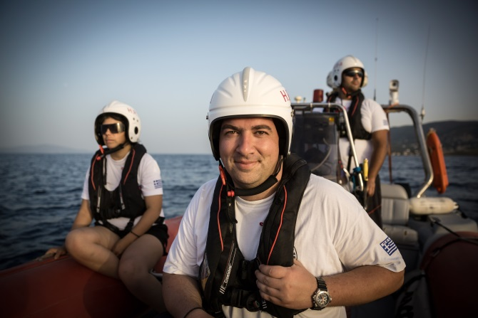

**Konstantinos Mitragas**, a sea captain and The Hellenic Rescue Team’s (HRT) secretary-general, is a Thessaloniki businessman by trade.

Like his colleagues, he works on a voluntary basis, overseeing everything from training to media relations.

“I believe it’s something in your heart that moves you and makes you volunteer,” says the father-of-two. “Of course many times we are frightened, this is what keeps us alive – if you are not frightened, you are not human.”

Over the last two years, HRT has experienced a significant increase in volunteers and has called for more, in order to expand its operation following the refugee influx of 2015.

“We have to be united in periods of crisis, as we did with our other Greek volunteers and the rest of the world who came here to assist us,” says Mitragas. “The planet will have difficult situations in the future, so we have to be together in order to assist in saving lives.”

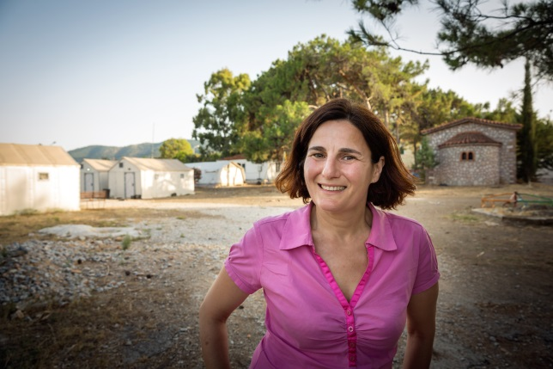

**Efi Latsoudi** is the softly-spoken but quietly powerful human rights activist from PIKPA village.

Originally from Athens she moved to Lesvos in 2001. Her unshakable compassion changes lives and restores hope to those who have already lost so much.

By 2006, not only had the number of refugees and migrants crossing to Lesvos increased, but Latsoudi watched, horrified, as so many died in their efforts to find safety. “I thought, it is not possible that this is happening next to us and we don’t know anything,” she recalls.

Efi participated in a small activist group, regularly visiting the existing hosting facilities on Lesvos and helping refugees with their daily needs. By 2012, sea arrivals had resumed.She saw the urgent need for a safe space, a refuge for the most vulnerable refugees – the disabled, sick, pregnant, young and old – whose needs were rapidly rising. Following advocacy by civil society, with Efi’s impulse and vision, the mayor supported a solution which gave hope to hundreds of refugees and shipwreck survivors thereafter.

PIKPA takes pride in being fully independent, relying solely on donations and volunteer contributions, both locally and internationally. “There is a face of Europe that is very human and it’s amazing,” says Latsoudi, who juggles the relentless demands of PIKPA with her 15-year-old son, Mihalis. “It can do miracles. And this is a miracle.”

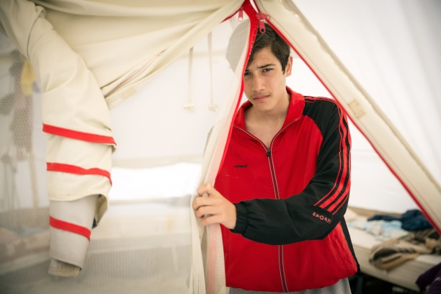

Seventeen-year-old Mohammed was shocked to find himself behind barbed wire after arriving at Moria camp on Lesvos. Although he was afraid, it was nothing compared to the terror he once felt at home.

After the Syrian army had taken his cousin and his terrified older brother had escaped to safety in the Netherlands, his mother begged him to leave Syria. Late one night he crossed the Aegean Sea to the Greek island of Lesvos. It took just an hour and a half, he had escaped.

For the 856,723 refugees like Mohammed who crossed from Turkey to Greece in 2015 – half of whom hailed from war-torn Syria – the risks of this perilous journey were nothing next to the hell they left behind at home.

Mohammed was one of the ‘lucky’ ones who made it to safer shores. But, even on Lesvos, his nightmare was not yet over.

He spent his first day in Europe in a closed and overcrowded facility at Moria where many tensions occurred. “I was scared because I was tired from the journey and I was alone” he recalls.

But his faith in humanity was restored when he was referred to PIKPA village. Over the course of four years, it has become a haven for some of the most vulnerable refugees on Lesvos. Here, Efi Latsoudi and ateam of volunteers help traumatized and vulnerable refugees feel safe again. There is a community atmosphere, a space for children to play and access to medical care, legal assistance and education.

“I felt safe,” says Mohammed, relief washing over his face at the memory. “I felt like I have a family. I felt like I have people who protect me.”

For so many refugees like him who survived the crossing to Greece in 2015, Latsoudi and PIKPA became a lifeline in a sea of uncertainty. The generosity and support that people have received here will stay with them forever.