37th WEDC International Conference, Hanoi, Vietnam, 2014

SUSTAINABLE WATER AND SANITATION SERVICES
FOR ALL IN A FAST CHANGING WORLD

Ecological sanitation in refugee camps: Implementing Urine Diversion Dry Toilets in Dollo Ado, Ethiopia

P.Ngala, M.Burt, S.Gonzaga, A.Bastable, Kenya

BRIeFING PAPER
The choice of sanitation technology in humanitarian crisis is based on various factors including the terrain, social and cultural norms and agency experience. There is the continued need for humanitarian response mechanisms to factor the environmental impact and sustainability of the technologies used in the provision of safe water supply and sanitation to affected communities. The acceptability of using ecological sanitation technologies such as Urine Diversion Dry Toilets (UDDT) in refugee contexts needs significant exploration. Using refugee camps in Dollo Ado as a case study, this paper outlines how the UDDT technology has been implemented in the context of protracted refugee camps, the successes and the areas needing further exploration to make it better able to be adopted across various refugee programmes and contexts.

Introduction
In humanitarian crisis involving mass displacement of populations, one of biggest challenges for aid agencies is the provision of adequate safe sanitation facilities for human excreta disposal. The task of setting up suitable sanitation facilities is often compounded by the fact that many of the locations identified for settlement of affected populations are marginalised and in difficult terrain. In some cases, as has been the case in many emergencies in Africa, what was anticipated to be a short term arrangement evolves into a longer term scenario. During the initial emergency stages, the go-to options are faster to build, shared sanitation solutions such as trench and pit latrines. As the situations become protracted, agencies have to deal with an increasing population, limited space, reduced funding and a pressured environment, making service delivery more difficult.
Implementation of ecological sanitation (Ecosan) technologies in humanitarian contexts is a strategy that represents a value-added and cost-effective intervention that is aligned with the global strategic goal of moving toward sustainable solutions for humanitarian responses. Mwase (2006) advocates that numerous benefits would be achieved for both the affected communities and host country if Ecosan technologies are used in emergency situations and thereon. This paper provides a review and case study of how the UDDT technology has been implemented in Hiloweyn refugee camp in Dollo Ado, Ethiopia. The UDDT technology was introduced to Hiloweyn camp, by UNHCR’s WASH Partner, Oxfam GB, when faced with a number of sanitation challenges including rocky ground and limited space.

Context
The Dollo Ado region in south eastern Ethiopia hosts one of the largest refugee operations in the world; approximately 201,100 persons as of May, 2014. The refugees are mostly of Somali origin who fled insecurity in their country in 2009 and more who came after the famine in 2011. The refugees are distributed in five camps; Bokolmanyo, Melkadida, Kobe, Hiloweyn and Buramino. While most of the camps have reached their full capacity, there are still people crossing the border from Somalia and UNHCR is progressively facing issues related to overcrowding of the camps.
The choice of latrine types in these areas has been based on a myriad of factors. Buramino and Hiloweyn refugee camps are located on hard crystalline rock. The interspersed limestone with gypsum intrusion require heavy machinery to break the ground formation. Bokolmanyo, Melkadida and Kobe stand on moderately weathered formations that allow manual excavation of pits. While construction of pit latrines is relatively easier in the latter camps, the continued refugee influx puts pressure to increase the latrine coverage in the demarcated land space. Thus far the types of latrines that exist in Dollo Ado refugee camps are trench latrines constructed mainly at the peak of the emergency, communal latrines with offset pits or a direct drop hole, composting family latrines and UDDT.

The Urine Diversion and Dry Toilets Technology
The Urine Diverting Dry Toilet operates without water and has a divider that allows the user to divert the urine away from the faeces. The urine and faeces are collected in different chambers. Drying material such as lime, ash or earth should be added to the faecal chamber after defecation. UDDTs may be constructed with two adjacent dehydration vaults or one single vault with interchangeable containers (Rieck, Munch, & Hoffman, 2012). The aim of UDDT is to evaporate and dry out the excreta. The moisture content is reduced as low as possible by different means; solar heat, ventilation and absorbent material addition. The addition of ashes (or any alkaline absorbent) also plays a significant role in the enhancement of the pathogen die off, reduction of fly breeding and odor control (Veolia Environment Foundation, 2013).
After a stabilization period, it is then possible to collect the dried excreta safely and use it as fertilizer. The World Health Organisation (WHO) has provided some guidelines (Table 1 below) on pathogen elimination that are useful in defining the stabilization period needed for faecal sludge from the UDDTs.

Table 1. WHO Recommendations for storage treatment of dry excreta and faecal sludge before use at household and municipal levels
Treatment | Criteria | Comment
Storage; ambient temperature 2-20°C | 1.5-2 years | Will eliminate bacterial pathogens; regrowth of E.Coli and Salmonella may need to be considered if rewetted; will reduce viruses and parasitic protozoa below risk levels. Some soil-borne ova may persist in low numbers
Storage; ambient temperature >20-35°C | >1 year | Substantial to inactivation of viruses, bacteria and protozoa; inactivation of schistosome eggs (<1 month); hookworm (Ancylostoma/Necator) and whipworm (Trichuris); survival of certain percentage (10-30%) of Ascaris eggs (≥ 4 months), whereas a more or less complete inactivation of Ascaris eggs will occur within 1 year.
Alkaline treatment | pH>9 during <6months | If temperature >35°C and moisture <25%, lower pH and/or wetter material will prolong the time for absolute elimination
Source:(WHO, 2006)

The advantages of the UDDT technology relate to both the potential of reuse of waste and the reduction of contaminants. Urine, properly diverted from faeces, reduces the unpleasant odours and fly breeding associated with latrines. If the faeces remain dry then pathogens are not able to migrate and easily contaminate groundwater. The major disadvantage of UDDT is that unless the users both understand how to use the UDDT and use it properly, then there is the increased risk that the intended function of the system will not be achieved (Kinstedt, 2012).
A study on the role of Ecosan in emergency situations, (Munch, Ochs, Amy , Mwase , & Francois Fesselet, 2006) proposed that UDDT be considered especially in situations where there is need for alternatives to pit latrines for example in places which have a high groundwater table, are prone to flooding or are hard to excavate.

The Project

Background
Oxfam GB has been UNHCR’s partner in charge of sanitation in the Hiloweyn camp ever since it’s set up in 2011. Due to the rocky terrain, jack hammers and excavators were used to dig pits up to 3 m deep for latrines. The cost for hiring the excavators and digging was inhibitive and as such limited the numbers set up so that these were constructed into a block of latrines shared between 16 families. The low permeability of the ground also limited how long a latrine would be in use to about 2 years from a possible 4 year if the terrain was different. It is with these issues in mind that WASH actors in the region explored other sanitation options and use of the Urine Diversion Dry Toilet technology was introduced (Oxfam, 2012).

Implementation
The UDDT was first piloted at household level in Hiloweyn camp in 2012. A demand survey conducted after the pilot provided useful feedback for the roll out of UDDT in the camp. The users shared that the stairs on the original UDDT model were too high for the elderly and children and this was adjusted in the subsequent models. While plastic or ceramic molded slabs are available for UDDT, the agencies involved agreed that replication in remote set ups like Hiloweyn would make it difficult to implement and as such precast concrete urine pots were designed proving more cost effective.
The UDDT is constructed on the surface of the ground, with an elevated platform consisting of two chambers. Urine is collected in one chamber where it is partially infiltrated in the ground and partly evaporated. Faecal sludge is collected in another chamber with ashes added through the drop hole after each defecation. A ventilation pipe supports the drying process in addition to controlling odor in the toilet.
The following aspects are an important part of how UDDT is implemented in the Hiloweyn camp:
- Ashes are added after each defecation to support the drying effect and maintain alkaline conditions
- The temperature of the pit is not controlled, but is likely to be above 20°C all year long due to the geographical location of the camp
- Having two chambers allows adequate time for proper maturation of the faecal sludge.

These pH, moisture and temperature conditions should facilitate the stabilization of faecal sludge by alkaline treatment and within a period of 1 year, allow for the dry sludge to be safe for handling.

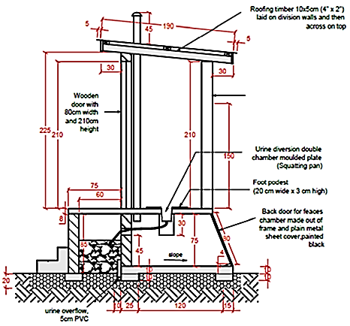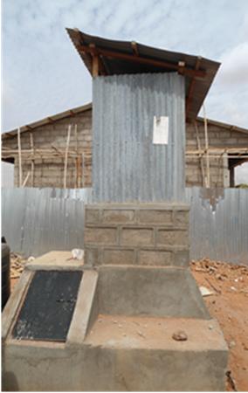

Figure 1. Schematic view of a UDDT Photograph 1: Side view of a UDDT in Hiloweyn camp
Source: Oxfam, 2012

Findings

It is not implicit in this approach that the users would use the compost in their gardens, since in many countries refugees are not permitted to plant their own crops. The primary rationale here is to enable users to empty their own latrines once sludge is safe to handle. In this way, it increases the ownership of the families for their latrine and eliminates the costly and time consuming activity of having to regularly desludge the latrine. While the operation and maintenance of the UDDT is simple, the design needs to drive the correct use of the toilets by only enabling one squat hole to be used at a time and for easy vault emptying.

Successes
To date, 700 family UDDTs have been constructed and are in use. Some of the things that work in favour of the UDDT include:
- User acceptance: according to a demand survey (Oxfam, 2012), the community prefer the UDDTs because they have reduced smell and fly menace, are easier to clean and offer more privacy than other sanitation options. This takes cognizance of the additional satisfaction related to the fact that they are family rather than communal facilities.
- Longevity of use: while the filling time for the UDDT in Hiloweyn is approximately 1.2 years as compared to 2 years for the shared pit latrines (Veolia, 2013), the UDDT model allows for continuous use without having to construct a new sanitation structure. This is because it equipped with two chambers and once one is full, it is sealed off to allow for adequate stabilisation of the sludge as the other chamber is used. At a later stage, the dried sludge is removed from the chamber allowing for further ‘re-use’.
- Environmental impact: the ecological footprint of sanitation solutions in Hiloweyn is reduced as with the use of the UDDT, there is reduced risk of contaminating the already high ground water level.
- Cost: due to the rocky terrain, the total cost of construction of pit latrines used to be approximately 730USD and would still need to be replaced when full, while the UDDT option is at a cheaper 400USD and does not need to be replaced when full.
- Space efficiency: there is no need to dig additional pit latrines or build additional superstructures with the UDDT. It only needs to be emptied once a year (Oxfam, 2012).

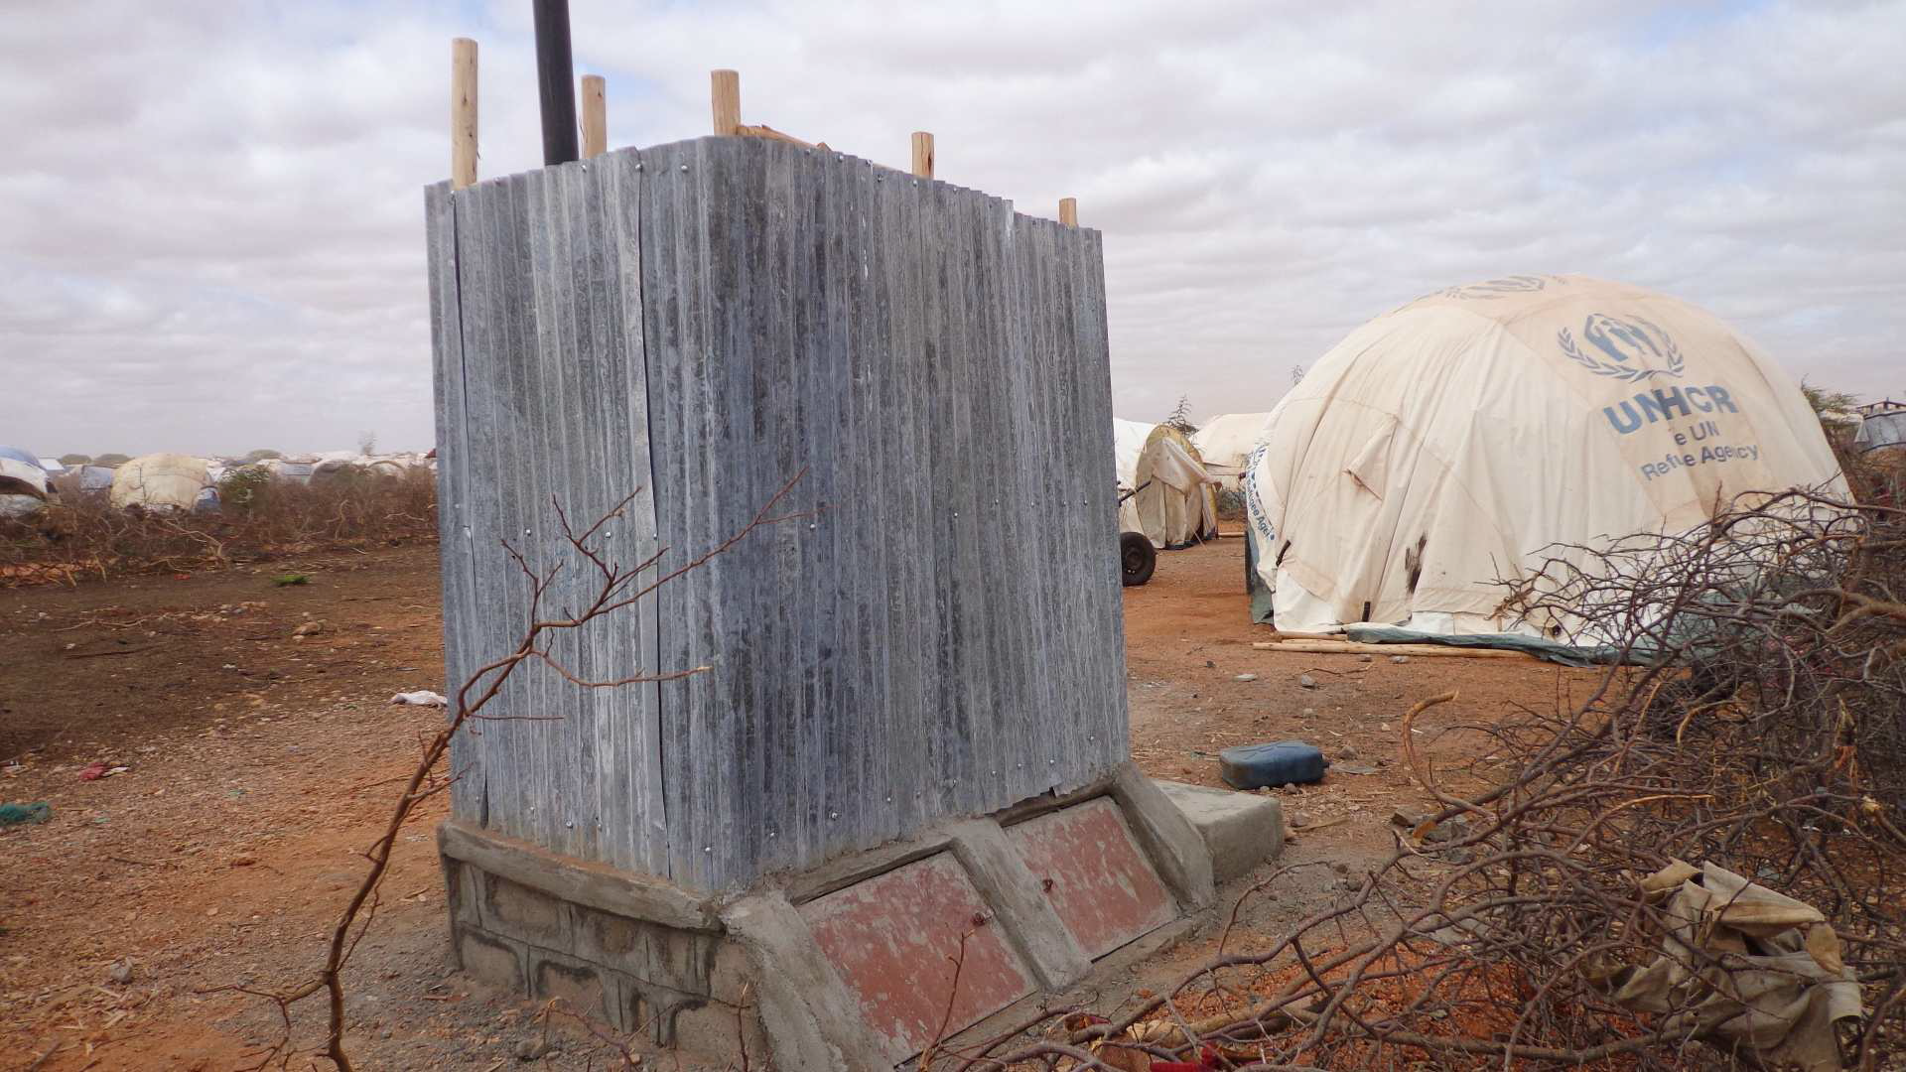 |  | 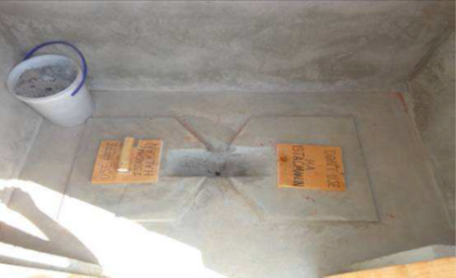
Photograph 2. UDDT Superstructure  Source: Oxfam, 2012 |  | Photograph 3. Inside a UDDT with signs indicating which side is in use  Source: Oxfam, 2012

Challenges and areas of further research
An assessment conducted by Veolia (2013) in the Dollo Ado camps highlighted some technological aspects on the use of UDDT that still need to be addressed:
- Viability of use of the dried sludge as fertilizer: to be a good fertilizer the pH of the sludge needs to be alkaline and if the addition of ash has not been performed on a regular basis then the pH is likely to be low and the handling of the sludge after the stabilisation period cannot be guaranteed.
- The stabilisation period for the sludge: the assumption in this case is that users are diligent in ensuring that liquid does not enter the drying chamber and as such the moisture level is below 25%. If the moisture level is higher then, a longer stabilisation period or an oven would be needed to dry the sludge.
In order to facilitate replication of this technology in various humanitarian crisis settings; UNHCR in conjunction with Centre for Disease Control (CDC) and Oxfam, are proposing to undertake further research in the following areas:
- Assessment of socio-cultural considerations that are likely to influence acceptability and other factors required for effective use of the design
- Identification of appropriate methods to improve pathogen inactivation to ensure the safe and hygienic disposal of human waste.

Conclusion
There is a lot of scope for the use of ecological sanitation technologies in humanitarian operations whether at the initial response stage or in long term situations. The emphasis continues to be on the promotion of sustainable sanitation options, which in addition to meeting the needs of the population for safe sanitation also reduces the pollution threat to the environment they rely on. While there are still gaps encountered in the appropriate use of UDDT in limited settings such as refugee camps, further exploration can serve to address these issues and increase the variety of sanitation options available to humanitarian actors.

Acknowledgements
The authors would like to acknowledge Oxfam GB, UNHCR’s partner agency, responsible for the implementation of Urine Diversion Dry Toilets in Dollo Ado, Ethiopia with initial funding from the Oxfam Innovation Fund. Thank you also to the UNHCR staff in Ethiopia for their support in providing information on this project.

References

Kinstedt, K. (2012). The Application of Ecological Sanitation for Excreta Disposal in Disaster Relief. Retrieved April 2014, from http://www.susana.org/lang-en/library/library?view=ccbktypeitem&type=2&id=1506
Munch, E. V., Ochs, A., Amy , G., Mwase , H., & Francois Fesselet, J. (2006). Provision of Sustainable sanitation in emergency situations: role of ecosan. Sustainable Development of Water resources, Water Supply and Environmental Sanitation (pp. 506-509). Colombo, Sri Lanka: WEDC.
Oxfam. (2012). Hiloweyn Urine Diversion & Dry Toilet Demand Survey.
Oxfam. (2012). Introduction of Urine Diversion and Drying Toilet in Hiloweyn Refugee Camp, Dollo Ado, Ethiopia. Oxfam.
Rieck, C., Munch, E. v., & Hoffman, H. (2012, December). Technology Review of UDDTs. Retrieved from Sustainable Sanitation Alliance: http://www.susana.org/docs_ccbk/susana_download/2-874-technology-review-of-uddts-18-june-2013.pdf
Tilley, E., Luthi, C., Morel, A., Zurbrugg, C., & Schetenleib, R. (2008). Compedium of Sanitation Systems and Technologies. Retrieved from EAWAG: http://www.eawag.ch/forschung/sandec/publikationen/sesp/dl/compendium_high.pdf
Veolia Environment Foundation. (2013). WASH Consultancy Assesment Report, Dollo Ado Refugee Camps.
WHO. (2006). Guidelines for the Safe use of Wastewater, Excreta and Greywater. Retrieved February 13, 2014, from www.whqlibdoc.who.int/publications/2006/9241546824_eng.pdf

Contact details

UNHCR (P.Ngala, M.Burt, S.Gonzaga)  P. O. Box 43801-00100  Nairobi, Kenya  Tel:+254706524361  Email: ngala@unhcr.org  www.unhcr.org | Oxfam (A.Bastable)  Tel:+441865473858  Email: abastable@oxfam.org.uk  www.oxfam.org.uk

