UNHCR
STANDARDISED EXPANDED
NUTRITION SURVEY (sens) GUIDELINES
FOR REFuGEE POPULATIONS

MODULE 1:
ANthropometry and health

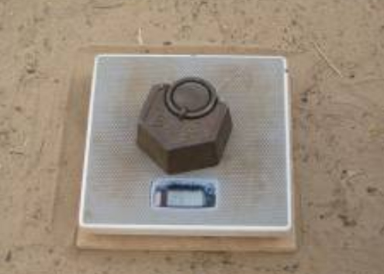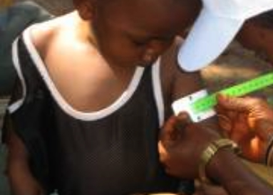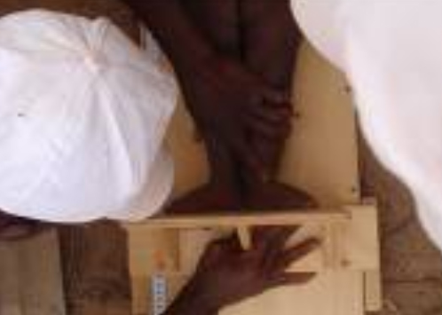
A PRACTICAL STEP-BY-STEP GUIDE VERSION 2 (2013)

Table of Contents

Key messages 5

Definition of some key terms 6

Objectives and target groups 8

Data collection 10
Measurement methods 10
Material needed 13
Case definitions and calculations 14
Ethical considerations 17
Standard procedure and quality assurance 18

Training 19
Common errors and challenges in training and data collection 20

Data entry 23

Data cleaning 30
Daily questionnaire check 30
Database check 31
SMART plausibility check on anthropometric data 36

Presentation of results 37
Result tables and figures 38

Data analysis 54
Analysis procedures 54
Common errors and challenges in data analysis 56

Use of results 57
Classification of public health problem and targets 57
Recommendations 59

Annex 1- EventS calendar 62
Annex 2- Ordering information 63
Annex 3- SENS Children 6-59 questionnaire 64
Annex 4- Referral form 65
Annex 5- Anthropometry quality assurance logsheet 66
Annex 6- Pictures of anthropometric measurements 67
Annex 7- Interpreting flags in ENA for SMART 69
Annex 8- Plausibility checks on anthropometric data 70
Annex 9- Presentation of combined camp results 84
Annex 10- Epi info Analysis 86

Key messages

- Data on the prevalence of acute malnutrition (based on weight-for-height and / or oedema) and stunting (based on height-for-age) among children aged 6–59 months is essential to collect in refugee settings for monitoring purposes. When justified, other age groups are sometimes also included.

- Data on the coverage of measles vaccination, the coverage of vitamin A supplementation in the last six months and the two-week period prevalence of diarrhoea in young children is essential to collect in refugee settings for monitoring purposes.

- A standard questionnaire should be used for the collection of anthropometric, measles vaccination, vitamin A supplementation and diarrhoea data.

- Providing good quality training to survey teams, supervising them well and checking the quality of the data they are collecting on a daily basis will help ensure that data are reliable.

- Standard methods have been developed for collecting, analysing and presenting anthropometric data in reports (refer to SMART initiative documentation). Standardising this process helps to maintain the quality, reliability and usability of nutrition survey data.

- The prevalence of stunting (height-for-age) and underweight (weight-for-age) should be presented as part of the survey report but should be interpreted with caution where reliable age data is not available (as is the case in many refugee situations).

- There are standard ways of reporting anthropometric, measles vaccination, vitamin A supplementation and diarrhoea results that should be followed in all nutrition survey reports produced in refugee contexts.

Definition of some key terms

Acute malnutrition: acute malnutrition is a form of undernutrition. It is caused by a decrease in food consumption and / or illness resulting in bilateral pitting oedema or sudden weight loss. It is defined by the presence of bilateral pitting oedema or wasting (low MUAC or low weight-for-height z-score).

Anthropometry: anthropometry is the study and technique of human body measurement. It is used to measure and monitor the nutritional status of an individual or population group.

Diarrhoea: diarrhoea is defined as having 3 or more loose or watery stools per day. The loss of fluids through diarrhoea can cause dehydration and electrolyte imbalance.

Stunting (chronic malnutrition): stunting, or chronic malnutrition, is a form of undernutrition. It is defined by a height-for-age z-score (HAZ) below two standard deviations of the median reference population. Stunting is a result of prolonged or repeated episodes of undernutrition starting before birth. This type of undernutrition is best addressed through preventive maternal health programmes aimed at pregnant women, infants, and children under age 2. Programme responses to stunting require longer-term planning and policy development.

Global Acute Malnutrition (GAM): GAM is a population-level indicator referring to overall acute malnutrition defined by the presence of bilateral pitting oedema and / or wasting defined by weight-for-height z-score (WHZ) below two standard deviations of the median reference population. GAM is divided into moderate and severe acute malnutrition (GAM=MAM + SAM).

Kwashiorkor: a form of severe undernutrition referred to alternatively as oedematous malnutrition. Symptoms may include oedema; thin, sparse or discoloured hair; and skin with discoloured patches that may crack and peel. See Bilateral Pitting Oedema.

Bilateral Pitting Oedema: bilateral pitting oedema, also known as nutritional oedema, kwashiorkor or oedematous malnutrition, is a sign of severe acute malnutrition (SAM). It is defined by bilateral pitting oedema of the feet and verified when thumb pressure applied on top of both feet for three seconds leaves a pit (indentation) in the foot after the thumb is lifted. It is an abnormal infiltration and excess accumulation of serous fluid in connective tissue or in a serous cavity.

Severe Acute Malnutrition (SAM): SAM is defined by the presence of bilateral pitting oedema or severe wasting (MUAC < 115 mm or a WHZ < -3 z-score). A child with SAM is highly vulnerable and has a high mortality risk. SAM can also be used as a population-based indicator defined by the presence of bilateral pitting oedema or severe wasting (WHZ < -3 z-score).

Wasting: wasting is a form of acute malnutrition. It is defined by MUAC < 125 mm or a WHZ < -2 z-score.

Measles: an acute, contagious viral disease, usually occurring in childhood and characterised by eruption of red spots on the skin, fever and catarrhal symptoms.

Reference Population: the NCHS Growth Reference (1977) and WHO Growth Standards (2006) reference values are based on two large surveys of healthy children, whose measurements represent an international reference for deriving an individual’s anthropometric status.

Vitamin A: a fat-soluble vitamin important for normal vision, tissue growth, and healthy skin. It is found in fish-liver oils, milk, green leafy vegetables, and red, orange, and yellow vegetables and fruits. A deficiency of vitamin A in humans causes poor vision at night and damage to the skin and mucous membranes.

Z-score: a score that indicates how far a measurement is from the median – also known as standard deviation (SD) score. The reference lines on the growth charts (labelled 1, 2, 3, -1, -2, -3) are called z-score lines; they indicate how far points are above or below the median (z-score 0).

Supplementary feeding: provision of an additional food ration for moderately
malnourished children or adults ‘targeted supplementary feeding’; or to the most
nutritionally vulnerable groups ‘blanket supplementary feeding’.

Therapeutic feeding: provision of medical and dietary treatment to children with
SAM.

Objectives and target groups

- The standard target group to routinely include in an anthropometric assessment in refugee contexts is children aged 6-59 months. When justified, other age groups are sometimes also included.

- All children aged 6-59 months will be assessed for measles vaccination although data will only be analysed for the 9-59 months age group (or other context-specific target group e.g. 9-23 months); and

- All children aged 6-59 months will be assessed for vitamin A supplementation in the last six months and diarrhoea in the last two weeks.

Objectives should be worded as follows in the survey protocol and report:

Primary objectives:

- To measure the prevalence of acute malnutrition in children aged 6-59 months.

- To measure the prevalence of stunting in children aged 6-59 months.

- To determine the coverage of measles vaccination among children aged 9-59 months (or context-specific target group e.g. 9-23 months).

- To determine the coverage of vitamin A supplementation in the last six months among children aged 6-59 months.

- To determine the two-week period prevalence of diarrhoea among children aged 6-59 months.

Secondary objective:

- To determine the coverage of targeted supplementary and therapeutic feeding programmes for children aged 6-59 months.

Things to note:

- There will be therapeutic and targeted supplementary feeding programmes in most refugee settings to take care of acutely malnourished children. A nutrition survey is a good opportunity to ask about enrolment of the surveyed children into the feeding programmes running in the area for the treatment of acute malnutrition. This will only provide a rough estimation of the coverage of such programmes but may point out to some major problems that can be addressed following the survey. However coverage surveys as opposed to nutrition surveys are the best way to determine the coverage of these types of feeding programmes due to the small sample size of acutely malnourished children found during nutrition surveys. This is why this objective should always be worded as a secondary objective.

- The systematic inclusion of infants aged 0-5 months in anthropometric survey is not currently recommended by UNHCR for the following main reasons: (1) The accurate weight measurement of infants 0-5 months requires an infant scale with a higher precision (+/-10g) than those most commonly used on the field (+/- 100g); (2) If a meaningful, precise estimate of infant malnutrition is needed for programmatic purposes, sample size requirements can be difficult to meet; (3) Interpretation of malnutrition results among children aged 6-59 months and 0-59 months are often wrongly used interchangeably and compared; and (4) Reporting malnutrition results among children aged 6-59 months is currently the norm in refugee settings and emergencies. However, in certain circumstances, where there may be particular concerns over the nutritional status of infants 0 – 5 months old, these infants may also be included in the anthropometric assessment if proper scales are used, specialised training is provided for measuring infants’ length (e.g. a cloth needs to be used below the knees of infants during length measurement) and sample size requirements are met. Note that prevalence of severe acute malnutrition calculated using the WHO Growth Standards (2006) will be much higher than when using NCHS Growth Reference (1977) in infants aged 0-5 months.

Data collection

Measurement methods

Sex: gender is recorded as male or female.

Birth date or age in months: the exact date of birth (day, month, year) is recorded from either an EPI card, child health card or birth notification if available. Note that the ‘UNHCR Manifest’ should never be used for recording the age of a child. If no reliable proof of age is available, age is estimated in months using a local event calendar or by comparing the selected child with a sibling or the child of a neighbour whose ages are known, and is recorded in months on the questionnaire. If the child’s age can absolutely not be determined by using a local events calendar or by probing, the child’s height can be used for inclusion; the child must measure between 65/67 cm and 110 cm (note that no stunting and underweight data will be calculated for these children recruited on the basis of height only and with no age data). In the final report, the proportion of children with age documentation should be recorded as well as the proportion of children recruited on the basis of height (if any). The latter should be minimal (<15%). For an example of a local events calendar to use and adapt to the refugee setting being surveyed, see Annex 1 or see SENS Anthropometry and Health Module tool: [Tool 1-Local Events Calendar].


Figure 1 Flow chart for collecting age data during a survey

No
Reliable age documentation is available

or slow on et?
Start here
Yes

Record exact date of birth from the age documentation.

Note that you should record the proportion of children having an exact birth date in the final survey report. See Presentation of Results section for more details.
Age can be estimated using an events calendar
Yes

No

Probe using the local events calendar and record the age in months on the questionnaire.

Note that the mother may remember the exact date of birth of her child; in this case, only write down the age in months on the questionnaire. Do not write down the date of birth as the recalled date of birth is considered to be less reliable than a date of birth from age documentation.
The child’s height is between 65/67 cm and 110 cm

or slow on et?
No

Yes

Exclude the chid from the survey.
Include the child in the survey and leave the age cells on the questionnaire blank.
Note that you should record the proportion of children recruited on the basis of height in the final report (if any). See Presentation of Results section for more details.

Weight: children are weighed without clothes using either a Salter scale or an electronic scale. The use of the electronic scale is highly recommended as opposed to the use of the Salter scale to increase quality of weight data. Leaving very light underwear on is acceptable if it is not possible to remove all clothing. Measurements are taken to the closest 100 grams. There may be contexts where removal of clothes is not acceptable at all. If the clothes worn are fairly standard, e.g. a simple pair of trousers, then a sample of the items can be weighed, and that weight subtracted from the weight of each child wearing similar clothes. For more details on how to adjust for weight of clothes, refer to the SMART manual (note that ENA for SMART software can do this subtraction automatically).

Height/Length: children’s height or length is taken to the closest millimetre using a wooden height board. It is preferable to use boards with two tape measures attached, one on each side, marked out in 0.1cm increments. The board should be easily set upright to measure height with the head piece of the length board becoming the base when the board is set upright. Age or height can be used to decide on whether a child should be measured lying down (length) or standing up (height). It must be ensured that all teams in the same survey use the same criteria and that the same criterion is used from year to year in the same refugee settings. Below are the recommendations to follow:

- In a context where official age documentation is available for most children, age should be used to decide how to measure a child. Children less than 24 months should be measured lying down while those 24 months or older should be measured standing up.
- In a context where age of children is mainly estimated from a local events calendar or by recall, height should be used to find out how to measure a child. When reporting the main survey results using the new WHO Growth Standards, children less than 87cm are measured lying down, while those greater than or equal to 87cm are measured standing up. When reporting the main survey results using the old NCHS Growth Reference, children less than 85cm are measured lying down, while those greater than or equal to 85cm are measured standing up. A screening stick labelled at 85/87cm may be used for helping to decide on the measurement method.

Oedema: bilateral oedema, also known as nutritional oedema, is assessed by applying gentle thumb pressure onto the tops of both feet of the child for a period of three seconds and thereafter observing for the presence or absence of an indent. All oedema cases reported by the survey teams should be verified by the survey coordinator and need immediate referral (see Ethical Considerations section below).

MUAC: MUAC is measured at the mid-point of the left upper arm between the elbow and the shoulder and taken to the closest millimetre using a standard tape.

Child enrolment in supplementary or therapeutic feeding programmes: if there are feeding programmes in place, coverage should be assessed for the supplementary and therapeutic feeding programmes running in the survey area for acutely malnourished children.

Measles vaccination: measles vaccination is assessed by checking for the measles vaccine on the EPI card if available or by asking the caregiver to recall if no EPI card is available. The location on the body where measles vaccination is usually given in the refugee context or in the place of origin of the refugees should be investigated. This may help the caregiver to recall which vaccine the child has received. Measles vaccination is assessed for all children aged 6-59 months to make data collection easier, however analysis is only done on the target age group (9-59 months or other context-specific target group).

Vitamin A supplementation in last 6 months: whether the child received a high-dose vitamin A capsule over the past six months is recorded from the EPI card or health card if available or by asking the caregiver to recall if no card is available. A vitamin A capsule should be shown to the caregiver when asked to recall.

Diarrhoea in last 2 weeks: caregivers are asked if their child had suffered from diarrhoea in the past two weeks.
Material needed

- A supplies planning tool is provided to help in calculating the amount of equipment and supplies needed and to estimate the overall cost. See SENS Pre-Module tool: [Tool 8-Supplies Planning Tool].

- A list of international suppliers is provided in Annex 2.
- The SENS questionnaire for children 6-59 months is shown in Annex 3 or see SENS Pre-Module tool: [Tool 9-Full SENS questionnaire].

Anthropometric measurements

- Wooden height board
- Weighing scale: Electronic scale (Uniscale) or Salter scale (25kg) with hanging pants and cord
- A wooden board slightly larger that the electronic scale to stabilise it on the ground
- Weighing scale carry bag
- A stick to screen children’s height (labelled at 65/67, 85/87 and 110cm)
- MUAC tape
- Questionnaires (always carry extra copies)
- Weight/Height reference table (WHO Growth Standards 2006 or NCHS Growth Reference 1977)
- Referral forms for moderately and severely acutely malnourished children found during the survey who are not already enrolled into a feeding programme

Measles vaccination

- Questionnaire

Vitamin A supplementation

- Vitamin A capsule to show to the caregiver to help them recall accurately
- Questionnaire

Diarrhoea

- Questionnaire

Case definitions and calculations

Acute malnutrition

Weight-for-Height (WHZ) is the nutritional index that reflects short term growth failure (acute malnutrition, e.g. wasting) and is defined by a child’s weight (kg) and height or length (cm) in relation to a standard or reference population of the same height. Acute malnutrition is defined using WHZ index values or the presence of oedema. The WHZ indices are expressed in z-scores according to both NCHS Growth Reference and WHO Growth Standards and percentage of the median according to NCHS Growth Reference only. Acute malnutrition is classified as severe or moderate based on the cut-offs shown below. It is also used in the classification of global acute, moderate acute and severe acute malnutrition (GAM, MAM, SAM).

Table 1 Definitions of acute malnutrition using weight-for-height and/or oedema in children 6–59 months

Categories of acute malnutrition | Percentage of median (NCHS Growth Reference 1977 only) | Z-scores (NCHS Growth Reference 1977 and WHO Growth Standards 2006) | Bilateral oedema
Global acute malnutrition | <80% | < -2 z-scores | Yes/No
Moderate acute malnutrition | <80% to ≥70% | < -2 z-scores and ≥ -3 z-scores | No
Severe acute malnutrition | >70% | > -3 z-scores | Yes
Severe acute malnutrition | <70% | < -3 z-scores | Yes/No

Mid Upper Arm Circumference (MUAC) is considered to be an effective predictor of the risk of death when below 115mm in children aged 6-59 months (or >65cm in height). Low MUAC is also a widely used criterion for admitting children to selective feeding programmes. However, the weight-for-height index remains the most common index to quantify wasting in surveys amongst refugees and other emergency affected populations.

MUAC and weight-for-height measurements do not necessarily identify the same children as being malnourished. Because children can be admitted to selective feeding programmes using either low weight-for-height or low MUAC, it is important to include both indicators in nutrition surveys. This will allow the accurate estimation of the number of children who are eligible for admission to feeding programmes. MUAC should be classified according to the following cut-offs:
Table 2 MUAC MALNUTRITION cut-offs in children 6-59 months

Categories of low MUAC values
<125 mm
≥ 115 mm and <125 mm
< 115 mm

Stunting

Height-for-Age (HAZ) is the nutrition index that reflects longer term growth failure (stunting) and is defined by a child’s height (cm) and age (days or months) in relation to a standard or reference population of the same age. Stunting, also known as chronic malnutrition, is classified as severe or moderate based on the cut-offs shown below. Stunting is defined using height-for-age index values.

Table 3 Definitions of stunting using height-for-age
in children 6–59 months

Categories of stunting | Z-scores (WHO Growth Standards 2006 and NCHS Growth Reference 1977)
Stunting | <-2 z-scores
Moderate stunting | <-2 z-score and >=-3 z-score
Severe stunting | <-3 z-scores

Underweight

Weight-for-Age (WAZ) is the nutrition index that reflects a combination of both chronic and acute growth failure. It is termed underweight and defined as a child’s weight (kg) and age (days or months) in relation to a standard or reference population of the same age. Underweight is classified as severe or moderate based on the following cut-offs. Underweight is defined using the weight-for-age index values

Table 4 Definitions of underweight using weight-for-age
in children 6–59 months

Categories of underweight | Z-scores (WHO Growth Standards 2006 and NCHS Growth Reference 1977)
Underweight | <-2 z-scores
Moderate underweight | <-2 z-scores and >=-3 z-scores
Severe underweight | <-3 z-scores

Diarrhoea

Diarrhoea is defined as three or more loose or watery stools in a 24-hour period.

Child enrolment in supplementary and therapeutic feeding programme

Feeding programme coverage is estimated during the nutrition survey using the direct method as follows (reference: Emergency Nutrition Assessment: Guidelines for field workers. Save the Children. 2004):

Coverage of SFP programme (%) =

100 x
No. of surveyed children with MAM according to SFP criteria who reported being registered in SFP
No. of surveyed children with MAM according to SFP admission criteria

Coverage of TFP programme (%) =
100 x
No. of surveyed children with SAM according to TFP criteria who reported being registered in TFP
No. of surveyed children with SAM according to TFP admission criteria

Ethical considerations

Referral process for malnourished children should be done as follows:

- If not already enrolled in a feeding programme, children found to be moderately or severely acutely malnourished should be referred for treatment according to the local treatment standards (if treatment facilities are available).

- If referring patients, the agreement of the health facilities or nutrition centres should be obtained before the survey starts; and

- The caregivers of malnourished children should be given a paper referral slip to take with them to the health facility or nutrition centre and a replicate of the referral slip should be given to the facility or nutrient centre for follow-up (SAM cases need urgent follow-up). See Annex 4 for a referral slip to use during the survey.

- If a child is reported to be enrolled in a treatment facility / programme, the programme type should be verified with the card or bracelet and noted on the questionnaire.

Things to watch out for:

- When referring children, use the local treatment standards, i.e. what reference population is used for admission (WHO Growth Standards 2006 versus NCHS Growth Reference 1977)? Is MUAC used for admission?

- When referring children with MAM, ensure to refer them to a service where they can be registered for supplementary feeding programme (SFP) and make sure to specify the time when the SFP is running (teams should have the schedule of SFP days).

Standard procedure and quality assurance

- Refer to the SMART Standardised Training Package for the best-practice recommendation on collecting anthropometric data.

Things to note:

- Always measure the weight before the height as children often get agitated with height measurements.

- If there is more than one eligible child in the household, measure the less ‘difficult’ child first.

- Explain the procedure to the mother and ask the mother’s authorisation to undress the child.

- It is highly recommended to use the electronic scales as this will provide better results. To avoid the scales wobbling when placed on uneven ground, they should be stood on a flat wooden board.
- Measuring equipment should be tested regularly during the survey and the results recorded on a form. For an example of a form to use for this purpose see Annex 5 or see SENS Anthropometry and Health tool: [Tool 2-Anthropometry Quality Assurance Log sheet]). Faulty equipment must be replaced. The following should be checked on a daily basis:

  - Test each scale with a standard weight of at least 5kg.
  - Test each height board with a stick that is cut at 110cm and check the quality of the measuring tape glued onto the board.
  - Test the MUAC tapes with a plastic pipe or glass bottle with a circumference of about 15-20cm and check quality of MUAC tape.
Training

- Refer to the SMART Standardised Training Package for recommendations on training surveyors in anthropometric measurements.

- Refer to Annex 6 for illustrations depicting the standard procedures for anthropometric measurements that can be used while training.

- The training on anthropometric measurements will last at least one full day with half a day on theory and practice, and half a day on the standardisation exercise.

Things to watch out for:

- Table 5 describes the most common errors experienced by survey coordinators that should be considered and avoided.

- Table 6 describes the most common errors experienced by survey workers in data collection. These should be emphasized during the training and the survey coordinator should focus on these when assessing the teams’ performance during supervision visits throughout the survey.

Common errors and challenges in training and data collection

Table 5 Common errors experienced by survey coordinators

Common errors | Examples | Solution
Not using quality assured equipment | Using measuring equipment without testing their calibration. For example, using a MUAC tape that is damaged; Using an electronic scale that is malfunctioning; Using a wooden height board with bad quality tapes. | Test the calibration of the equipment at the beginning of the survey and regularly during the survey; Ensure you have spare equipment so you can replace faulty or broken items during the survey.
Not enough time spent on practising anthropometric measurements and assessment of oedema | Starting the survey when the surveyors are not adequately trained. This will cause faulty measurements. | Include a practical training on anthropometric measurements in the field during the training.
Not training surveyors because they are experienced | Experienced surveyors are not provided with refresher training and measurement accuracy is compromised. | Always conduct refresher training as knowledge and practical skills can be lost over time. Bad habits can also be replicated.
Not evaluating skills of surveyors at end of training | Not evaluating surveyors at the end of the training and assuming that all of the concepts have been understood. | Always evaluate surveyors at the end of the training. If not enough time is left for a written test, direct observations of the surveyors during the pilot test can be conducted.

Table 6 Common errors experienced in data collection

Common errors | Examples | Solution
Oedema is not well assessed | Surveyors have been known to mistake a fat child for a child with oedema. | The coordinator should double-check the oedema cases, particularly when team members are inexperienced; The coordinator should pay close attention to see if oedema cases are spread evenly between teams or whether they are all found by one team. The latter may be suspicious and it is advisable to check the team’s oedema assessment technique.
Faulty weight measurement | The standard procedure to measure weight is not followed well, resulting in inaccurate results. For example, heavy clothing (>50–100g) is left on the child during the weight measurement without reporting it on the questionnaire;  Scale not calibrated to zero (Salter scale);  Child moving;  Weight measurements are rounded to the nearest 0.0 or 0.5kg rather than 0.1kg. | Reinforce standard procedures during training and do practical exercises with real children.  Note that rounding weight can have serious implications when calculating z-scores and may result in children being wrongly classified.
Faulty length/height measurement | The standard procedure to measure length / height is not followed well, resulting in inaccurate results. For example, knees bent, feet extended, not removing footwear or headgear, head badly positioned and not in correct plane, child not lying straight along board, sliding board not firmly against heels / head, measuring a child standing up when the measurement should be taken lying down; Height / length measurements are rounded to the nearest 0.0 or 0.5cm rather than 0.1cm. | Reinforce standard procedures during training and do practical exercises with real children.  Note that rounding height can have serious implication when calculating z-scores and may result in children being wrongly classified.
Faulty MUAC measurement | The standard procedure to measure MUAC is not followed well, resulting in inaccurate results. For example, tightening or loosening the MUAC tape too much, not measuring from the ‘middle’ the arm or measuring the right arm rather than the left. | Reinforce standard procedures during training and do practical exercises with real children.
Imprecise age estimation or inaccurate recording | When a document with the date of birth (such as vaccination card) is not available, age is not estimated well with a local events calendar. For example, the wrong birth year (errors of + or – 12 months) is recorded; Surveyors overestimate multiples of 12 (12, 24, 36, 48 months) due to the conversion of age in full years without refining the estimation; Surveyors do not include older children between 3.5 and 5 years of age because parents tell them that their child is over 5 years of age. | Include a practical training on age estimation and recording.  Note that z-scores for height-for-age or weight-for-age require accurate ages to within two weeks.
Not calibrating the survey equipment regularly | Checking the calibration of anthropometric equipment is not done daily and faulty equipment is used. | Ensure a log sheet is used to record information during the survey.
Not properly recording the enrolment of the child into a feeding programme | The surveyors do not ask about the card of the feeding programme and rely on the recall of the caregiver. | Ensure that surveyors confirm the enrolment of the children into feeding programmes for the treatment of acute malnutrition with a card or bracelet where available.
Referral for malnutrition not done | The weight-for-height index (or MUAC) is not cross-checked and surveyors fail to refer a child with moderate acute malnutrition (children with severe acute malnutrition are more easily recognisable while those with moderate acute malnutrition can sometimes be difficult to identify visually). | Provide training on the referral process using local standards for referral.
Recording of weight as height or vice versa | When the team leader writes down the measurements on the questionnaire, s/he writes down the weight and height measurements in the wrong cells. | Always double-check the questionnaire completeness and plausibility of responses / measurements before leaving the household by scanning the questionnaire.
Recording that a vitamin A capsule was given in the last 6 months when in fact the child received it more than 6 months ago | When a health record is available, the surveyor ignores the date the vitamin A supplement was given.  When no health record is available, the surveyor does not ask the caregiver to recall over the past six months only. | Ensure to record vitamin A supplementation received over the past six months only.
Not clearly telling the caregiver which type of vaccine the question is referring to | When no EPI/health card is available, the caregiver is asked to recall whether the child was vaccinated against measles but this is not explained clearly (note that children under-5 get different types of vaccination).  When a health record is available, the wrong vaccine is recorded. | Ensure to use the local term for measles vaccination and find out where on the body measles vaccination is typically given.  Ensure to train teams well on the different types of health records available and where to read the vaccination history.
Using the wrong definition of diarrhoea and not asking specifically about the 2 weeks preceding the survey | The surveyor does not explain well what is meant by ‘diarrhoea’ and does not explain well the 2-week recall period.  The caregiver thinks that one loose stool in a 24-hour period represents diarrhoea.  The caregiver reports the child as having had diarrhoea even though the episode happened more than one month ago. | Ensure to train the surveyors well on the proper case definition of diarrhoea and the 2-week recall period.

Data entry

- The recommended names and descriptions of the standard variables (as shown in UNHCR SENS Child 6-59 Questionnaire), and the range of correct values and correct codes are shown in Table 7.

Table 7 Data dictionary for questionnaire children 6-59 months of age
(with instructions on the use of ENA for SMART)

Question number | Suggested variable name | Description | Conditions | Special instructions
CH1 | ID | Child number in the household | As many eligible children there are in the surveyed household | This standard variable is already created in ENA for SMART software (see Figures 2-3 below).
CH2 | HH | Household number | The number of households should equal to the total number of households surveyed | This standard variable is already created in ENA for SMART software (see Figures 2-3 below).
CH3 | CHCONST | Consent given by the caregiver for the child measurements | Valid values are:  1=Yes  2=No  3=Absent  (this variable does not necessarily need to be entered into ENA for SMART) | For consent, follow instructions described in SENS Pre-Module Step 13.  An individual will be marked as ‘absent’ only after at least two re-visits to the household have been made.  This variable is not automatically created by ENA for SMART software and does not necessarily need to be entered onto database.  This column is to ensure that consent is asked and obtained; and that absent individuals are recorded and followed-up on.
CH4 | SEX | Sex of child | Valid values are:  ‘m’ for male  ‘f’ for female  (automatically created in ENA for SMART Variable View) | This standard variable is already created in ENA for SMART software (see Figures 2-3 below).
CH5 | BIRTHDAT | Exact birth date of child  dd/mm/yyyy | Valid values are:  59 months before the exact survey date up until 6 months prior to the first day of the survey. | This standard variable is already created in ENA for SMART software (see Figures 2-3 below).  The exact birth date should only be taken from an age documentation showing day, month and year of birth.  The date cannot be after survey date.  It is only recorded if an official age documentation is available; if the mother recalls the exact date, this is not considered to be reliable enough.  Leave blank if no official age documentation is available.  The proportion of children with no exact birthdates that is provided in the Plausibility report of ENA for SMART software should be reported in the main results. See Presentation of Results section for more details.
CH6 | MONTHS | Age of child in completed months | Ranges from 6 to 59.99 months  (automatically created and ranges set in ENA for SMART Variable View) | This standard variable is already created in ENA for SMART software (see Figures 2-3 below)  If no age documentation is available, estimate age using local events calendar.  Refer to Figure 1 above (age data decision tree).  If an official age documentation is available, record the age in months from the date of birth on the questionnaire.  When the date of birth is entered into ENA for SMART, the software will automatically calculate the exact age in months from the day of the survey.  The range 6-59.99 months is used in ENA for SMART software and is automatically set in the Variable View sheet of Data Entry Anthropometry screen.  If any entered value is outside of the set range, the value will turn pink in the Data View sheet of Data Entry Anthropometry, showing a flag.
CH7 | WEIGHT | Weight of child in kg | Ranges from 3 to 31 kg  (automatically created and ranges set in ENA for SMART Variable View) | This standard variable is already created in ENA for SMART software (see Figures 2-3 below).  The range 3-31 is used in ENA for SMART software and is automatically set in the Variable View sheet of Data Entry Anthropometry screen. If any entered value is outside of the set range, the value will turn pink in the Data View sheet of Data Entry Anthropometry, showing a flag.
CH8 | HEIGHT | Height/length of child in cm | Ranges from 54 to 124 cm  (automatically created and ranges set in ENA for SMART Variable View) | This standard variable is already created in ENA for SMART software (see Figures 2-3 below).  The range 54-124 is used in ENA for SMART software and automatically set in the Variable View sheet of Data Entry Anthropometry screen. If any entered value is outside of the set range, the value will turn pink in the Data View sheet of Data Entry Anthropometry, showing a flag.
CH9 | EDEMA | Presence of bilateral oedema | Valid values are:  ‘y’ for yes  ‘n’ for no  (automatically created in ENA for SMART) | This standard variable is already created in ENA for SMART software (see Figures 2-3 below).
CH10 | MUAC | MUAC of child in mm | Ranges from 75 to 230 mm  (automatically created by ENA for SMART but users need to set the range values in Variable View) | This standard variable is already created in ENA for SMART software (see Figures 2-3 below).  Note that MUAC is sometimes recorded in cm. ENA for SMART automatically analyses MUAC values entered in mm only. For standardisation purpose, the final results should always be reported in mm and not cm.
CH11 | ENROL | Child enrolled in feeding programme | Valid values are:  1=SFP  2=TFP  3=None  (users need to add variable in ENA for SMART Data View and set range values in Variable View) | This variable needs to be created in ENA for SMART software (see Figures 2-3 below).
CH12 | MEASLES | Measles vaccination received | Valid values are:  1=Yes card  2=Yes recall  3=No or don’t know  (users need to add variable in ENA for SMART Data View and set range values in Variable View) | This variable needs to be created in ENA for SMART software (see Figures 2-3 below).  Ask this question to all children 6-59 months to simplify the process of data collection.  Make sure to exclude children <9 months in final analysis.  Make sure not to confuse with other vaccines.
CH13 | VITA | Vitamin A supplementa-tion received in the past six months | Valid values are:  1=Yes with card  2=Yes with recall  3=No or don’t know  (users need to add variable in ENA for SMART Data View and set range values in Variable View) | This variable needs to be created in ENA for SMART software (see Figures 2-3 below).  A vitamin A capsule should be shown to the caregiver to help in the recall if there is no documentation available.  The same capsules as are used locally should be shown.  If there were no vitamin A supplementation campaign six months prior to the survey, do not include this question and make sure to advocate for a campaign to take place following the survey (this should be written as a recommendation in the final survey report).
CH14 | DIAR | Diarrhoea in last two weeks | Valid values are:  1=Yes  2=No  3=Don’t know  (users need to add variable in ENA for SMART Data View and set range values in Variable View) | This variable needs to be created in ENA for SMART software (see Figures 2-3 below).  Make sure to use the proper case definition of three or more loose or watery stools in a 24-hour period.

Figure 2 Setting up the ENA for SMART data entry screen
These additional variables need to be added manually by the users.
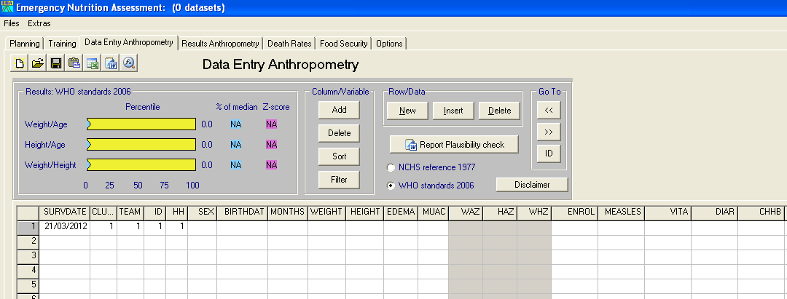
Some of the anthropometric variables are automatically created by ENA for SMART software.

Figure 3 Setting up the ENA for SMART variables ranges to detect data entry errors and flags

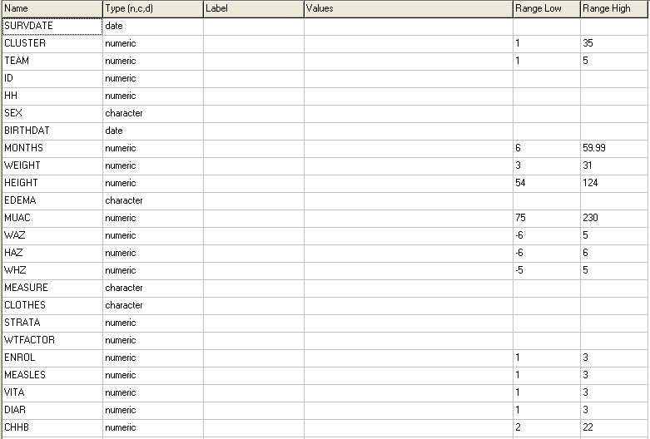
The ranges of some the variables are automatically set by ENA for SMART. Any entered values in the Data Entry Anthropometry screen (Data View screen) that is outside of these ranges will turn pink.
The ranges set for WAZ, HAZ and WHZ are the ones recommended by WHO when using the WHO Growth Standards 2006. When using the NCHS Reference 1977, these ranges need to be changed. Refer to Table 29 in Annex 8.
The users need to manually set the ranges for the CLUSTER, TEAM and MUAC variables, as well as for the additional variables manually added: ENROL, MEASLES, VITA, DIAR, CHHB.

- The Options screen of ENA for SMART software needs to be adapted for Data Entry. Refer to Figure 4 for the recommended options to select.

- During data entry, pink flags will appear when the values entered are out of the defined variable ranges entered in the Variable View screen. Refer to Annex 7 for a detailed explanation on the flags shown in Figure 5.

- The following steps should be followed when a flag is detected:

    - Step 1: Check the original data collection form to ensure that this was not a data entry error.

    - Step 2: If it is not a data entry error and if the WAZ, HAZ or WHZ pink flag are also a ‘SMART flag’, the value will need to be excluded during final analysis (refer to analysis section below). Note that this can be done automatically in the Results Anthropometry screen.
Figure 4 Setting up the ENA for SMART option screen for data entry
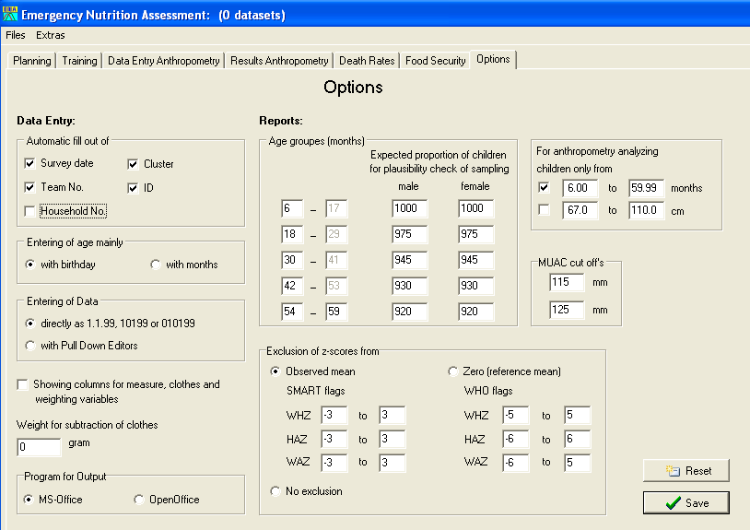
The users need to manually unselect the Household No. button. This is because there may be more than one eligible child per HH and when entering data it is easier if the HH number is not automatically filled out by the software.
Refer to the SMART guidance for more details on the use of these options. They are not commonly used in refugee contexts.

Figure 5 Understanding flags
Pink flags for WAZ, HAZ and WHZ values are called ‘WHO flags’ in the Results Anthropometry screen and in the Plausibility Report.

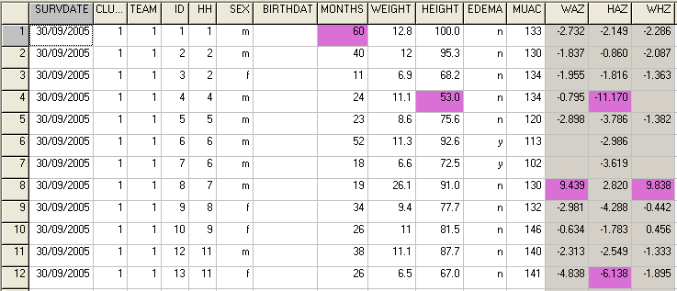

Data cleaning

Daily questionnaire check- for consistency, completeness and readability

At the end of each field work day, look at the filled questionnaires from each team and follow the procedure described below:

- Check that consent was given for the measurements (question CH3). If consent was not given, ask the surveyors if they know the reasons. If there are many refusals, knowing this information will help clarify any misunderstandings, concerns or misconceptions with the community being surveyed.
- Check that the age is between 6 and 59 months for children (questions CH5-CH6). Eye ball the data forms and see if there is an over-representation of ages ending in whole years such as 12, 24, 36 and 48 (this can also be assessed with the SMART Plausibility Check by teams).
- Check that the weight, height and MUAC values (questions CH7-CH10) can be read clearly and are recorded with the correct units and decimal points.
- Check that surveyors are not rounding weight, height and MUAC measurements to .0 / 0 or .5 / 5. Eye ball the data forms and see if there is an over-representation of values ending in .0 / 0 and .5 / 5 (this can also be assessed with the SMART Plausibility Check by teams). Note that, if an electronic scale is used, there is no need to check for rounding of weight values.
- Check that the oedema, feeding programme, measles vaccination, vitamin A supplementation and diarrhoea answers are written clearly (questions CH9 and CH 11-CH14)
- Check that oedema is not being over-reported by certain teams. Note that it is recommended that supervisors / coordinators double-check all oedema cases seen during the survey.
- Check that referral was done appropriately in case acute malnutrition was detected (check data collection control sheet for that information).

Database check- for data entry errors, data out of required range
and missing data

Figure 6 Data cleaning with ENA

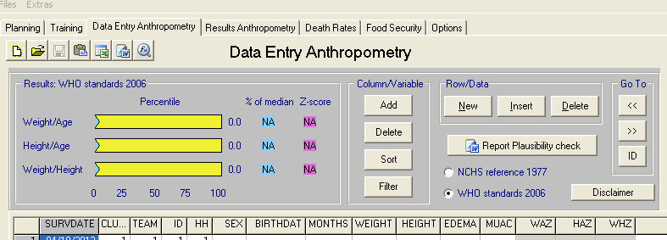
These buttons can be used to sort and filter the dataset during the cleaning process.

- Brief guidance on the data cleaning process is provided below. Refer to Annex 10 for standard data cleaning commands using Epi Info (version 3.5.4 July 2012). Free guidance on the use of Epi Info for Windows and training material on Epi Info can be found at the following site: http://www.cdc.gov/EpiInfo

Sex

- Perform frequency of or sort the sex variable column in your dataset (variable SEX).
- Screen for errors. Check for invalid values for sex (i.e. anything other than ‘m’ or ‘1’ for male and ‘f’ or ‘2’ for female as defined in the data dictionary, Table 7): if there are no invalid values then you can assume that the data has been correctly entered. If there are incorrect values, find out the corresponding child(ren) and check the value with the original questionnaire. If it was a data entry error, correct it. If it was not a data entry error, delete the invalid value and consider that the child will have a missing value for sex.
- Screen for missing sex values and check with the original questionnaire to ensure that this was not a data entry oversight.
- If sex is missing, the child cannot be included in the anthropometric analysis because the reference population information on height and weight is sex specific and no nutritional indices can be derived. The child can still be included in the analysis for oedema (because any child with oedema is severely malnourished) and in the other analyses not requiring sex (e.g. MUAC, measles vaccination, vitamin A supplementation, diarrhoea).

Age

- Look at mean age or sort the age variable in your dataset (variable MONTHS).
- Screen for errors. Check that the ‘minimum’ and ‘maximum’ values are not outside of the correct ranges for the data as defined in the data dictionary, Table 7 (not less than 6.0 and more than 59.99): if there are no values outside the range then you can assume that the data has been correctly entered. If there are incorrect values, find out the corresponding child(ren) and check the value with the original questionnaire. If it was a data entry error, correct it. If it was not a data entry error, delete the subject from the dataset.
- Screen for missing age values and check with the original questionnaire to ensure that this was not a data entry oversight.
- If age is missing, the child cannot be included in the assessment of stunting (height-for-age), underweight (weight-for-age) or measles vaccination. However, the child can still be included in the analysis for wasting (weight-for-height), oedema and other indicators not requiring age (e.g. MUAC, vitamin A supplementation, diarrhoea). You will need to ensure the child is eligible to be in the survey based on the height / length (i.e. in the required height range of 65/67-110cm).

Weight

- Look at mean weight or sort the weight variable in your dataset (variable WEIGHT)
- Screen for outliers³. Check that the ‘minimum’ and ‘maximum’ values are not outside of the plausible ranges for the data as defined in the data dictionary, Table 7 (not less than 3kg and more than 31kg): if there are no invalid values for weight then you can assume that the data has been correctly entered. If there are invalid values, find out the corresponding child(ren) and check the value with the original questionnaire. If it was a data entry error, correct it. If it was not a data entry error, delete the weight value and consider that the child will have a missing value for weight.
- Screen for missing weight values and check with the original questionnaire to ensure that this was not a data entry oversight.
- If weight is missing, the child cannot be included in the assessment of wasting (weight-for-height) or underweight (weight-for-age). However, the child can still be included in the analysis for oedema, stunting (height-for-age) and other indicators (e.g. MUAC, measles vaccination, vitamin A supplementation, diarrhoea) because these do not require weight.

Height

- Look at mean height or sort the height variable in your dataset (variable HEIGHT).
- Screen for outliers. Check that the ‘minimum’ and ‘maximum’ values are not outside of the plausible ranges for the data as defined in the data dictionary, Table 7 (not less than 54cm and more than 124cm): if there are no invalid values for height then you can assume that the data has been correctly entered. If there are invalid values, find out the corresponding child(ren) and check the value with the original questionnaire. If it was a data entry error, correct it. If it was not a data entry error, delete the height value and consider that the child will have a missing value for height.
- Screen for missing height values and check with the original questionnaire to ensure that this was not a data entry oversight.
- If height is missing, the child cannot be included in the assessment of wasting (weight-for-height) or stunting (height-for-age). However, the child can still be included in the analysis for oedema, underweight (weight-for-age) and other indicators (e.g. MUAC, measles vaccination, vitamin A supplementation, diarrhoea) because these do not require height.

Oedema

- Perform frequency of or sort the oedema variable column in your dataset (variable EDEMA).
- Screen for errors. Check for invalid values for oedema as defined in the data dictionary, Table 7 (i.e. anything other than ‘yes’, ‘y’ or ‘1’ for presence of oedema and ‘no’, ‘n’ or ‘2’ for no oedema): if there are no invalid values then you can assume that the data has been correctly entered. If there are incorrect values, find out the corresponding child(ren) and check the value with the original questionnaire. If it was a data entry error, correct it. If it was not a data entry error, delete the invalid value and consider that the child will have a missing value for oedema.
- Screen for missing oedema values and check with the original questionnaire to ensure that this was not a data entry oversight.
- If oedema is missing, the child should still be included in the anthropometric analysis based on the assumption that surveyors are likely not to forget to write down an oedema case considering that it is quite a rare event and urgent referral is needed.

MUAC

- Look at mean MUAC or sort the MUAC variable in your dataset (variable MUAC).
- Screen for outliers. Check that the ‘minimum’ and ‘maximum’ values are not outside of the plausible ranges for the data as defined in the data dictionary, Table 7 (not less than 75 mm and more than 230 mm): if there are no invalid values for MUAC then you can assume that the data has been correctly entered. If there are invalid values, find out the corresponding child(ren) and check the value with the original questionnaire. If it was a data entry error, correct it. If it was not a data entry error, delete the MUAC value and consider that the child will have a missing value for MUAC.
- Screen for missing MUAC values and check with the original questionnaire to ensure that this was not a data entry oversight.
- If MUAC is missing, the child cannot be included in the MUAC analysis.

Child enrolment in feeding programme

- Perform frequency of or sort the child enrolment in feeding programme variable column in your dataset (variable ENROL).
- Screen for errors. Check for invalid values for the child enrolment in feeding programme variable (i.e. anything other than ‘1’ for already enrolled in supplementary feeding programme, ‘2’ for already enrolled in therapeutic feeding programme, ‘3’ for not enrolled in feeding programme Table 7): if there are no invalid values then you can assume that the data has been correctly entered. If there are incorrect values, find out the corresponding child(ren) and check the value with the original questionnaire. If it was a data entry error, correct it. If it was not a data entry error, delete the invalid value and consider that the child will have a missing value for measles vaccination.
- Screen for missing values and check with the original questionnaire to ensure that this was not a data entry oversight.
- If the child enrolment in feeding programme variable is missing, the child cannot be included in the feeding programme coverage analysis.

Measles vaccination

- Perform frequency of or sort the measles vaccination variable column in your dataset (variable MEASLE).
- Screen for errors. Check for invalid values for measles vaccination (i.e. anything other than ‘1’ for yes vaccinated with card proof, ‘2’ for yes vaccinated according to recall or confirmation by mother, ‘3’ for not vaccinated or don’t know as defined in the data dictionary, Table 7): if there are no invalid values then you can assume that the data has been correctly entered. If there are incorrect values, find out the corresponding subject(s) and check the value with the original questionnaire. If it was a data entry error, correct it. If it was not a data entry error, delete the invalid value and consider that the child will have a missing value for measles vaccination.
- Screen for missing measles vaccination values and check with the original questionnaire to ensure that this was not a data entry oversight.
- If measles vaccination is missing, the child cannot be included in the measles vaccination analysis.

Vitamin A supplementation in last 6 months

- Perform frequency of or sort the vitamin A supplementation variable column in your dataset (variable VITA).
- Screen for errors. Check for invalid values for vitamin A supplementation (e.g. anything other than ‘1’ for yes received vitamin A supplement with card proof, ‘2’ for yes received vitamin A supplement according to recall or confirmation by mother, or ‘3’ for did not receive the vitamin A supplement as defined in the data dictionary, Table 7): if there are no invalid values then you can assume that the data has been correctly entered. If there are incorrect values, find out the corresponding subject(s) and check the value with the original questionnaire. If it was a data entry error, correct it. If it was not a data entry error, delete the invalid value and consider that the child will have a missing value for vitamin A supplementation.
- Screen for missing vitamin A supplementation values and check with the original questionnaire to ensure that this was not a data entry oversight.
- If vitamin A supplementation is missing, the child cannot be included in the vitamin A supplementation analysis.

Diarrhoea in last 2 weeks

- Perform frequency of or sort the diarrhoea variable column in your dataset (variable DIAR).
- Screen for errors. Check for invalid values for diarrhoea (e.g. anything other than ‘1’ for yes, ‘2’ for no or ‘3’ for don’t know, Table 7): if there are no invalid values then you can assume that the data has been correctly entered. If there are incorrect values, find out the corresponding subject(s) and check the value with the original questionnaire. If it was a data entry error, correct it. If it was not a data entry error, delete the invalid value and consider that the child will have a missing value for diarrhoea.
- Screen for missing diarrhoea values and check with the original questionnaire to ensure that this was not a data entry oversight.
- If diarrhoea is missing, the child cannot be included in the diarrhoea analysis.

SMART plausibility check on anthropometric data- for flags/extreme nutritional index values and measurement bias

- Refer to Annex 8.

Presentation of results

- Results from anthropometric measurements, feeding programmes, measles vaccination, vitamin A supplementation and diarrhoea should be descriptive and presented as proportions (with 95% CI) and means for the overall sample and according to sex- and age-specific criteria where applicable.

- When presenting the results from several camps with a representative sample drawn from each camp into one report, it is recommended to present results from each camp separately. See SENS Pre-Module tools: [Tool 4b-Dolo SENS Survey Report 2013] and [Tool 5-Dadaab Survey Report 2011].

- When several camps are surveyed with a representative sample drawn from each camp, it is not necessary to report combined results for each indicator; see Annex 9 for the recommended combined indicators to report. See the SENS Pre-Module tool that will automatically generate weighed prevalence results: [Tool 14-Weighting Data Tool].

- The main anthropometric results should be reported using WHO Growth Standards 2006 (z-scores only). Results using the NCHS Growth Reference 1977 (z-scores and percentage of the median) should be presented in the Appendix of the report. Even if the WHO Growth Standards have been adopted, results should be presented using the NCHS Growth Reference if you are attempting to look at trends over time compared to a previous survey which included only results based on the NCHS Growth Reference.

- All survey reports should present results the tables and figures shown below.

- Where an exhaustive methodology is used, confidence intervals should not be presented.

Result tables and figures

Sample size and clusters

Table 8 Target and actual number captured

 | Target (No.) | Total surveyed (No.) | % of the target
Children 6-59 months | See footnote 1 | See footnote 2
Clusters (where applicable) | See footnote 3 | See footnote 4
1. This number is taken from ENA for SMART planning screen (see Figure 7 below)
2. This number is taken from ENA for SMART by looking at the Data Entry screen of ENA for SMART and scrolling down to the last entered child (see Figure 8 below).
3. This number is taken from ENA for SMART planning screen as shown in the image below:
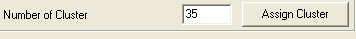

4. This number is taken from ENA for SMART Data Entry screen (CLUSTER column).

Figure 7 Total number of children aged 6-59 months planned to be surveyed (target sample size)

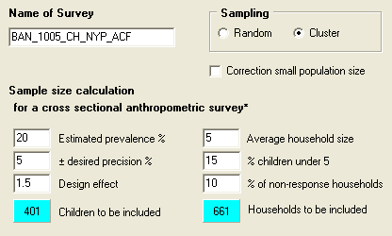
The target sample size was N=401 in this example.

Figure 8 Total number of children aged 6-59 months surveyed

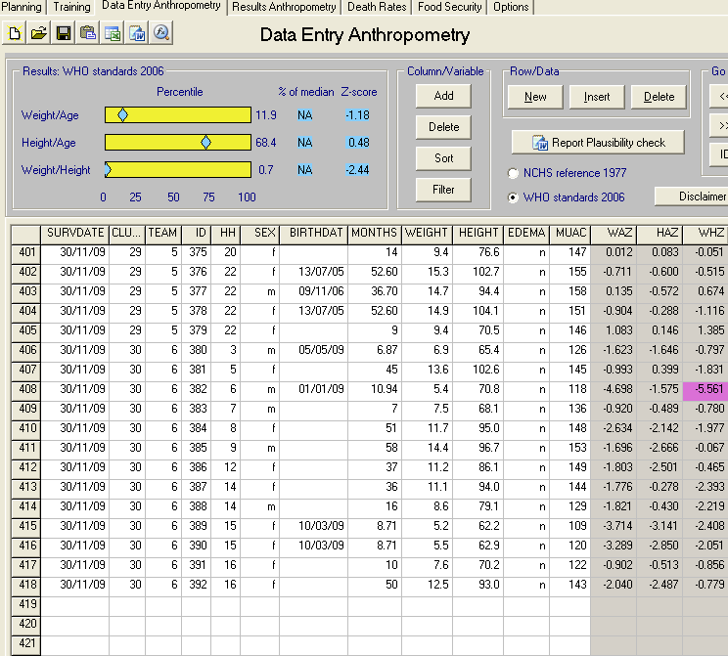
The total number of children surveyed was N=418 in this example.

Sample size of children 6-59 months

- Usually, the sample size reached in total number of children aged 6-59 months should be equal to or exceed the target sample size. If this is not the case, follow the procedure provided below for additional sampling.

Total number of clusters

- Usually, the total number of clusters surveyed should be equal to the total number of clusters planned. If this is not the case, follow the procedure provided below for additional sampling.

Additional sampling

- Additional sampling may need to be done when the target sample size has not been reached or when the target number of clusters has not been reached. The survey coordinator should make sure to mention the procedure used in the final report:

  - Procedure to follow when the target sample size has not been reached: If less than 80% of the target sample size of children aged 6-59 months was achieved by the end of the survey, the following should be done. Otherwise, no additional sampling is needed:

      - For simple or systematic random sampling surveys, another sample of households from the whole population should be taken to boost the sample size of children. This sample should be 25% of the original sample size. For example if 350 children aged 6-59 months were sampled but the target sample size was 500 children (hence you achieved 70% of the target sample size), this means that you would need to randomly select an additional 125 children (25% of 500 children).

      - For cluster sampling surveys, the replacement clusters (RCs) automatically selected by ENA software should be sampled.

  - Procedure to follow when the target number of clusters has not been reached: All of the replacement clusters (RCs) automatically selected by ENA for SMART in the planning stage should be sampled if 10% or more of your original clusters were not completed for various reasons (including security, refusal or problems with access). Otherwise, no additional sampling is needed. For example, if you were supposed to survey 30 clusters but were only able to survey 26, you then need to sample the RCs selected by ENA at the end of the survey. If you surveyed 28 clusters instead of 30, then no additional sampling is needed.

  - When conducting additional sampling, if the same household or individual is re-selected by chance from the list or within the cluster area, they should be skipped and not surveyed twice. They should not be replaced. Note that it is possible that a replacement cluster (RC) is sampled from the same area as an original cluster and that this is acceptable.

Automatic SMART report

- ENA for SMART automatically generates a nutrition survey report with some tables (see Figure 9 and Figure 10 below).

- There are several figures that are recommended to be included in the final SENS report that are not automatically generated by ENA for SMART. Refer to SENS Pre-Module Step 15 for a description on constructing graphs and on how to interpret trends and differences. For a tool that will automatically generate trend graphs, see SENS Pre-Module tool: [Tool 12-Trends and Graphs].

- Showing the recommended figures will allow for the assessment of trends. Note that, to identify a trend, it is advised that prevalence data from at least three time points are obtained from nutrition surveys carried out at similar times of the year.

Figure 9 Generating a nutrition survey report template containing completed, standard results tables
Where there is oedema, the total number of children with wasting will differ from the total number of children with acute malnutrition.

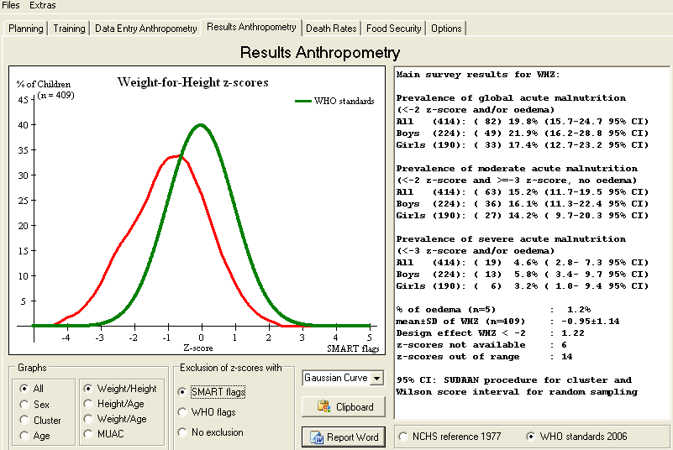
Make sure to exclude SMART flags from final analysis.
Figure 10 Setting up the ENA for SMART option screen for data analysis

Make sure to analyse children aged 6-59 months only and to exclude from analysis SMART flags.

Demographic data

Table 9 Children 6-59 months - Distribution of age and sex of sample
(this table is automatically generated by ENA for SMART software)

 | Boys |  | Girls |  | Total |  | Ratio
AGE (mo) | no. | % | no. | % | no. | % | Boy:Girl
6-17 months
18-29 months
30-41 months
42-53 months
54-59 months
Total

Things to note:

- The proportion of children with no exact birthdates that is provided in the SMART Plausibility report of ENA for SMART software should be reported at the bottom of Table 9 in the final SENS report. This is useful for example to interpret the reliability of stunting and underweight data (both indicators use age).

- The percentage of children recruited on the basis of height (where applicable) should also be reported in the SENS survey report at the bottom of Table 9.

Anthropometric data

Table 10 Prevalence of acute malnutrition based on weight-for-height
z-scores (and/or oedema) and by sex (this table is automatically generated by ENA for SMART software)

 | All  n = | Boys  n = | Girls  n =
Prevalence of global malnutrition  (<-2 z-score and/or oedema) | (n) %  (95% CI) | (n) %  (95% CI) | (n) %  (95% CI)
Prevalence of moderate malnutrition  (<-2 z-score and >=-3 z-score, no oedema) | (n) %  (95% CI) | (n) %  (95% CI) | (n) %  (95% CI)
Prevalence of severe malnutrition  (<-3 z-score and/or oedema) | (n) %  (95% CI) | (n) %  (95% CI) | (n) %  (95% CI)

The prevalence of oedema is %

Things to watch out for:

- Often people disaggregate the main survey results by children’s age, nationality, resident status or even cluster to conduct statistical analyses and compare results without considering the limitations of doing so. These analyses need to be interpreted with caution since sample size may not be large enough to detect differences if they exist or differences may be identified when there are none in reality. However, major differences in results between different groups should be looked into and warrant an in depth investigation following the nutrition survey to try to understand if the difference is real and if it is, why there is a difference.

- GAM and SAM prevalence results from year to year should be presented as shown in the example figure below.

Figure 11 Trends in the prevalence of global and severe acute malnutrition based on WHO Growth Standards in children 6-59 months from 2009-2011. Note that a trend can only be identified when there are at least three time points. It is advised that prevalence data BE obtained from nutrition surveys carried out at similar times of the year (this FIGURE CAN BE automatically GENERATED BY USING sENS PRE-MODULE TOOL 12 – TRENDS AND GRAPHS)

Table 11 Prevalence of acute malnutrition by age, based on weight-for-height z-scores and/or oedema (this table is automatically generated by ENA for SMART software)

 |  | Severe wasting  (<-3 z-score) |  | Moderate wasting  (>= -3 and <-2 z-score ) |  | Normal  (> = -2 z score) |  | Oedema
Age (mo) | Total no. | No. | % | No. | % | No. | % | No. | %
6-17
18-29
30-41
42-53
54-59
Total

- Wasting prevalence trend by age shown in Table 11 should also be presented in a figure as shown in the example below.

Figure 12 Trend in the prevalence of wasting by age in children 6-59 months (this FIGURE CAN BE automatically GENERATED BY USING sENS PRE-MODULE TOOL 12 – TRENDS AND GRAPHS)

Table 12 Distribution of severe acute malnutrition and oedema based on weight-for-height z-scores (this table is automatically generated by ENA for SMART software)

 | <-3 z-score | >=-3 z-score
Oedema present | Marasmic kwashiorkor  No.  (%) | Kwashiorkor  No.  (%)
Oedema absent | Marasmic  No.  (%) | Not severely malnourished  No.  (%)

Figure 13 Distribution of weight-for-height z-scores (based on WHO Growth Standards; the reference population is shown in green and the surveyed population is shown in red) of survey population compared to reference population (this FIGURE is automatically generated by ENA for SMART software)

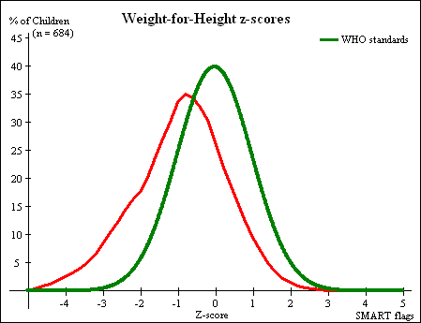

- This Gaussian Curve figure is generated automatically by ENA for SMART software in the Results Anthropometry screen and can be copied by clicking on the following buttons and icon:

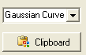
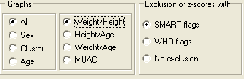
and pasting it directly in the Word Report.

Table 13 Prevalence of acute malnutrition based on the percentage of the median and/or oedema (using the NCHS Growth Reference) (this table is automatically generated by ENA for SMART software and should be shown in annex of the final report only)

 | n =
Prevalence of global acute malnutrition  (<80% and/or oedema) | (n) %  (95% CI)
Prevalence of moderate acute malnutrition  (<80% and >= 70%, no oedema) | (n) %  (95% CI)
Prevalence of severe acute malnutrition  (<70% and/or oedema) | (n) %  (95% CI)
Table 14 Prevalence of malnutrition by age, based on weight-for-height percentage of the median and oedema (using the NCHS Growth Reference) (this table is automatically generateD by ENA for SMART software and should be shown in annex of the final report only)

 |  | Severe wasting  (<70% median) |  | Moderate wasting  (>=70% and <80% median) |  | Normal  (> =80% median) |  | Oedema
Age (mo) | Total no. | No. | % | No. | % | No. | % | No. | %
6-17
18-29
30-41
42-53
54-59
Total

Table 15 Prevalence of MUAC MALNUTRITION (thESE RESULTS ARE automatically generated by ENA for SMART software HOWEVER YOU NEED TO CHANGE THE CUT-OFF DESCRIPTIONS ACCORDING TO uNHCR’S DEFINITIONS AS SHOWN BELOW)

 | All  n = | Boys  n = | Girls  n =
Prevalence of MUAC < 125 mm and/or oedema | (n) %  (95% CI) | (n) %  (95% CI) | (n) %  (95% CI)
Prevalence of MUAC < 125 mm and >= 115 mm, no oedema | (n) %  (95% CI) | (n) %  (95% CI) | (n) %  (95% CI)
Prevalence MUAC < 115 mm and/or oedema | (n) %  (95% CI) | (n) %  (95% CI) | (n) %  (95% CI)

Table 16 PREVALENCE OF MUAC MALNUTRITION by age, based on MUAC cut off's and/or oedema (thESE RESULTS ARE automatically generated by ENA for SMART software HOWEVER YOU NEED TO CHANGE THE CUT-OFF DESCRIPTIONS ACCORDING TO uNHCR’S DEFINITIONS AS SHOWN BELOW)

 |  | MUAC < 115 mm |  | MUAC >= 115 mm and < 125 mm |  | MUAC > = 125 mm |  | Oedema
Age (mo) | Total no. | No. | % | No. | % | No. | % | No. | %
6-17
18-29
30-41
42-53
54-59
Total

Table 17 Prevalence of underweight based on weight-for-age z-scores by sex (this table is automatically generated by ENA for SMART software)

 | All  n = | Boys  n = | Girls  n =
Prevalence of underweight  (<-2 z-score) | (n) %  (95% CI) | (n) %  (95% CI) | (n) %  (95% CI)
Prevalence of moderate underweight  (<-2 z-score and >=-3 z-score) | (n) %  (95% CI) | (n) %  (95% CI) | (n) %  (95% CI)
Prevalence of severe underweight  (<-3 z-score) | (n) %  (95% CI) | (n) %  (95% CI) | (n) %  (95% CI)

Table 18 Prevalence of stunting based on height-for-age z-scores and by sex (this table is automatically generated by ENA for SMART software)

 | All  n = | Boys  n = | Girls  n =
Prevalence of stunting  (<-2 z-score) | (n) %  (95% CI) | (n) %  (95% CI) | (n) %  (95% CI)
Prevalence of moderate stunting  (<-2 z-score and >=-3 z-score) | (n) %  (95% CI) | (n) %  (95% CI) | (n) %  (95% CI)
Prevalence of severe stunting  (<-3 z-score) | (n) %  (95% CI) | (n) %  (95% CI) | (n) %  (95% CI)

Figure 14 Trends in the prevalence of global and severe stunting based on WHO Growth Standards in children 6-59 months from 2007-2011. Note that a trend can only be identified when there are at least three time points. It is advised that prevalence data are obtained from nutrition surveys carried out at similar times of the year (this FIGURE CAN BE automatically GENERATED BY USING sENS PRE-MODULE TOOL 12 – TRENDS AND GRAPHS)

Table 19 Prevalence of stunting by age based on height-for-age z-scores (this table is automatically generated by ENA for SMART software)

 |  | Severe stunting  (<-3 z-score) |  | Moderate stunting  (>= -3 and <-2 z-score ) |  | Normal  (> = -2 z score)
Age (mo) | Total no. | No. | % | No. | % | No. | %
6-17
18-29
30-41
42-53
54-59
Total

- Stunting prevalence trend by age shown in Table 19 should also be presented in a figure as shown in the example below.

Figure 15 Trends in the prevalence of stunting by age in children
6-59 months (this FIGURE CAN BE automatically GENERATED BY USING sENS PRE-MODULE TOOL 12 – TRENDS AND GRAPHS)

Figure 16 Distribution of height-for-age z-scores (based on WHO Growth Standards; the reference population is shown in green and the surveyed population is shown in red) of survey population compared to reference population (this FIGURE is automatically generated by ENA for SMART software)

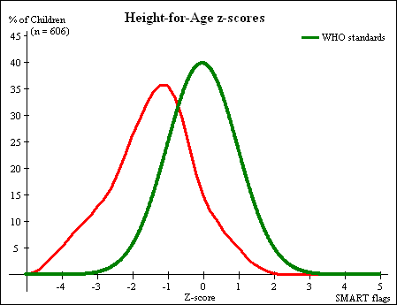

- This Gaussian Curve figure is generated automatically by ENA for SMART software in the Results Anthropometry screen and can be copied by clicking on the following buttons and icon:
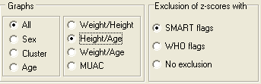
and pasting it directly in the Word Report.

Table 20 Mean z-scores, Design Effects and excluded subjects (this table is automatically generated by ENA for SMART software; no design effect should be presented if simple or systematic random sampling wAS used)

Indicator | n | Mean z-scores ± SD | Design Effect (z-score < -2) | z-scores not available* | z-scores out of range
Weight-for-Height | mean±SD of WHZ
Weight-for-Age | mean±SD of WAZ
Height-for-Age | mean±SD of HAZ

* contains for WHZ and WAZ the children with oedema.

- The flagging criteria used for anthropometric indices should be added to analysis section of the final report. (e.g. SMART flags and ranges used like -/+3 from the observed mean).

- The numbers shown in Table 20 above can also be seen on the Results screen of ENA for SMART as indicated in the Figure below.

Figure 17 Mean z-scores, Design Effects and excluded subjects by ENA
for SMART

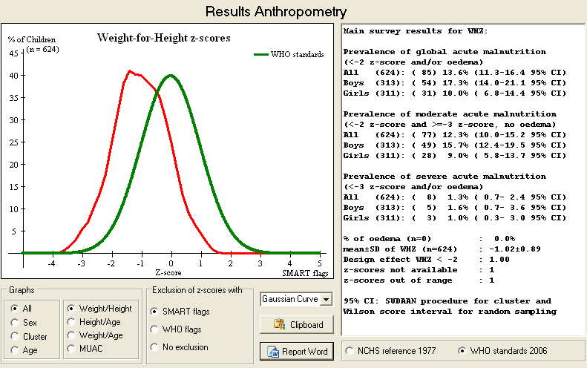
The mean WHZ is -1.02 with SD of ± 0.89.
The WHZ design effect was equal to 1.0.
There was 1 weight-for-height z-score value not available and there was 1 WHZ SMART flag in the survey dataset. The exact SMART flag values are shown in the Plausibility Report.

Feeding programme coverage

Table 21 Programme coverage for acutely malnourished children

 | Number/total | % (95% CI)
Supplementary feeding programme coverage

Therapeutic feeding programme coverage

- It is calculated based on the admission criteria used in the survey setting. Where admission is based on MUAC, WHZ and / or oedema, you may show two tables of results, one table showing the programme coverage based on MUAC and / or oedema only, and one table showing the programme coverage based on all three admission criteria.

- Children with WHZ flags should be excluded from the coverage analysis.

Measles vaccination coverage

Table 22 Measles vaccination coverage for children aged 9-59 months (or other context-specific target group) (n= )

 | Measles  (with card)  n= | Measles  (with card or confirmation from mother)  n=
YES | %  (95% CI) | %  (95% CI)

Vitamin A supplementation coverage

Table 23 Vitamin A supplementation for children aged 6-59 months within past 6 months (or other context-specific target group) (n= )

 | Vitamin A capsule (with card)  n= | Vitamin A capsule  (with card or confirmation from mother)  n=
YES | %  (95% CI) | %  (95% CI)

- Measles and vitamin A supplementation in last 6 months coverage results from year to year should be presented as shown in the example figure below.
Figure 18 Trends in the coverage of measles vaccination and vitamin A supplementation IN LAST 6 MONTHS in children 6-59 months from 2009-2011 Note that a trend can only be identified when there are at least three time points (this FIGURE CAN BE automatically GENERATED BY USING sENS PRE-MODULE TOOL 12 – TRENDS AND GRAPHS)

Diarrhoea

Table 24 Period prevalence of diarrhoea

 | Number/total | % (95% CI)
Diarrhoea in the last two weeks

Data analysis

Analysis procedures

- Make sure that the data has been cleaned before starting the analysis process.

Anthropometric data (age, sex, weight, height/length, oedema, MUAC)

- Use ENA for SMART software or ENA / Epi Info hybrid software to perform an automated, standard analysis of the anthropometric data using WHO Growth Standards 2006 and NHCS Reference 1977 to fill out Tables 9-20.
- Case definitions and calculations shown in Tables 1-4 should be used and shown in the final report.
- Refer to SMART initiative documentation for detailed guidance.

Additional variables

- For some of these additional analyses, the ENA for SMART statistical calculator may be used. Refer to SMART initiative documentation for detailed guidance.

- Brief guidance on using Epi Info software for analysis is provided below for the additional variables not automatically analysed by ENA for SMART. Refer to Annex 10 for standard analysis commands using Epi Info (version 3.5.4 July 2012). Free guidance on the use of Epi Info for Windows and training material on Epi Info can be found at the following site: http://www.cdc.gov/EpiInfo

Measles vaccination and vitamin A supplementation

- Define and recode a new variable for measles vaccination and vitamin A supplementation with card or confirmation from mother, i.e. MSL_cc (card or confirmation).
- Define and recode a new variable for the age group 9-59 months, or use the ‘Select’ command in Epi Info to proceed with analysis of children aged 9-59 months. e.g.: Select age group equal to ‘9-59.99’.
- If survey design was simple random sampling, use Epi Info ‘Frequencies’ command to fill out Tables 22-23.
- If the survey design was cluster sampling, use Epi Info ‘Complex Sample Frequencies’ command (PSU is the CLUSTER variable) to fill out Tables 22-23.
Diarrhoea

- Exclude from analysis children with answer ‘3’ (‘no or don’t know’).
- If the survey design was simple or systematic random sampling, use Epi Info ‘Frequencies’ command to fill out Table 24.
- If the survey design was cluster sampling, use Epi Info ‘Complex Sample Frequencies’ command (PSU is the CLUSTER variable) to fill out Table 24.

Feeding Programme Coverage

- Note that admission to feeding programmes may be based on more than one admission criteria, e.g. weight-for-height, MUAC and / or oedema. In this case, define a new variable for eligibility to the targeted supplementary feeding programme and one for eligibility to the therapeutic feeding programme for calculating child eligibility according to the context-specific admission criteria, i.e. SFPE for a child who is eligible for the targeted supplementary feeding programme and TFPE for a child who is eligible for the therapeutic feeding programme.
- Then, proceed to calculating coverage following the calculation previously mentioned and analyse using the procedure described in Annex 10.

Common errors and challenges in data analysis

Table 25 describes the most common errors experienced by survey coordinators when conducting the final data analysis.

Table 25 Common errors experienced in data analysis

Common errors | Examples | Solution
Oedema not measured and/or not correctly taken into account in calculation of malnutrition prevalence | Reporting global acute malnutrition prevalence by only including wasted children (weight-for-height z-score < -2) | Always measure oedema and ensure that oedematous children are correctly included in calculation of the prevalence of malnutrition.
Not taking into consideration a weighting factor when combining malnutrition prevalence estimates from several camps | When surveying several camps with a representative sample drawn from each camp, combining the samples from all camps to calculate the overall prevalence without taking into consideration a weighting factor. | For a tool that will automatically generate weighed prevalence results, see SENS Pre-Module tool: [Tool 14-Weighting Data Tool].
Reporting malnutrition results according to certain aggregates of clusters | Reporting the malnutrition results per groups of cluster or per camp section / block. | Do not disaggregate cluster surveys according to clusters in the presentation of results. All clusters merged together from all section / blocks of the camp are representative of the camp as a whole and should not be disaggregated.
Reporting a change in the malnutrition situation without any evaluation of whether the observed change is statistically significant or real | Using the point estimate results of two surveys (e.g. 10.1% vs. 12.5%) and concluding that there has been a change in GAM prevalence without looking at the confidence intervals or conducting a statistical test. | Assess whether the confidence intervals overlap and conduct a statistical test using the CDC IERHB calculator. See SENS Pre-Module tool: [Tool 13-CDC Calculator twosurveys].
Not reporting confidence intervals around the measles vaccination, vitamin A supplementation coverage estimates or diarrhoea results | Only reporting the point estimates in the final report. Often, this is because the procedure for the analysis function that takes into account cluster sampling to adjust for confidence intervals is not known by the user. | If cluster sampling is used, use the Complex Sample module in Epi Info (Advanced statistics) for analysis of measles vaccination, vitamin A supplementation and diarrhoea results.
Use of results

Classification of public health problem and targets

Anthropometric data

- UNHCR’s target for the prevalence of global acute malnutrition (GAM) for children 6-59 months of age by camp, country and region is < 10% and the target for the prevalence of severe acute malnutrition (SAM) is <2%.

- Table 26 shows the classification of public health significance of the anthropometric results for children under-5 years of age.

Table 26 Classification of public health significance for children
under 5 years of age

Prevalence % | Critical | Serious | Poor | Acceptable
Low weight-for-height | ≥15 | 10-14 | 5-9 | <5
Low height-for-age | ≥40 | 30-39 | 20-29 | <20
Low weight-for-age | ≥30 | 20-29 | 10-19 | <10

Sources: WHO (1995) Physical Status: The Use and Interpretation of Anthropometry and WHO (2000) The Management of Nutrition in Major Emergencies

Things to watch out for:

  - Although the use of this classification system is useful for decision makers, the thresholds should be interpreted with caution and in context.
  - A poor or an acceptable situation does not mean that there is no need for intervention, the population size is also an important factor in determining whether services are required e.g. A refugee population of 300 000 with a GAM prevalence of 4% will have approximately 2400 children who require treatment at any one time. Conversely, the number of children requiring treatment in a refugee situation with 20 000 people and a 20% GAM prevalence would be 800.
  - A single prevalence figure does not inform whether the malnutrition is increasing, is stable or is decreasing. It is important to look at trends as well as the current survey prevalence e.g. if a survey falls into the poor category at 8% GAM, but has increased from 5.5%, this may indicate a deteriorating situation and the need for intervention at varying levels. A trend can only be established where there are at least three points of data.
  - The classification refers to wasting and does not technically include oedema. Comparison of the GAM (including oedema) against the classification thresholds is often done. Care must be taken in the interpretation of this.
  - If any aggravating factors exist (e.g. including but not limited to high morbidity rates, measles outbreak, poor health or sanitation infrastructure, fragile access or availability of food, poor or deteriorating infant feeding practices), consider that the situation may be more serious.

Feeding programme coverage

- Note that feeding programme coverage results should be interpreted with caution due to the small survey sample size. Table 27 shows the performance indicators for malnutrition treatment programmes according to UNHCR Strategic Plan for Nutrition and Food Security 2008-2012 (same as Sphere Standards).

Table 27 Performance indicators for selective feeding programmes (UNHCR Strategic Plan for Nutrition and Food Security 2008-2012)*

 | Recovery | Case fatality | Defaulter rate | Coverage
 |  |  |  | Rural areas | Urban areas | Camps
SFP | >75% | <3% | <15% | >50% | >70% | >90%
TFP | >75% | <10% | <15% | >50% | >70% | >90%

* Also meet SPHERE standards for performance

Measles vaccination coverage

- UNHCR recommends target coverage of 95% (same as Sphere Standards).

Vitamin A supplementation in last 6 months coverage

- UNHCR Strategic Plan for Nutrition and Food Security (2008-2012) states that the target for vitamin A supplementation coverage for children aged 6-59 months by camp, country and region should be >90%.

Diarrhoea

- The diarrhoea results from the survey should not be directly compared to the data on diarrhoea from HIS since HIS data is the clinic based data whereas the survey results are household-based data.

Recommendations

- The anthropometric, feeding programme, measles vaccination, vitamin A supplementation and diarrhoea assessment results are to assist public health partners working in refugee settings to better plan their nutrition programming. For example, the results can assist in:

  - Improving the general food ration and / or implementing blanket feeding programmes;
  - Improving the selective feeding programmes and screening at the community level;
  - Improving measles and vitamin A campaigns;
  - Improving supply and retention of health record cards, and enhancing the recording of key information;
  - Strengthening training of health staff in nutrition programmes;
  - Implementing Behaviour Change and Communication activities on prevention of malnutrition.
Where can the SMART manual and training material be found?

SMART (2006) Measuring Mortality, Nutritional Status, and Food Security in Crisis Situations - SMART Methodology version 1 April 2006
- A manual detailing a basic integrated method for assessing nutritional status and mortality rate in emergency situations. It includes details of how to use the ENA Software for analysing data. The manual is aimed at host government partners and humanitarian organisations as part of the SMART initiative enhancing capacity and draws from core elements of several existing methods and best practice. It includes an optional chapter of food security which is based on a simplified version of the Household Economy Approach.
- Availability: Free, downloadable in pdf form in English.
- Contact: www.smartmethodology.org

Standardised Training Package: SMART Methodology- ACF-Canada, 2010
- The Standardised Training Package (STP) is a modular based training package for individuals and organisations interested in using SMART with a user-friendly and comprehensive tool when building capacity of survey teams. Following the survey process from start to finish, the STP provides the following information:
- Application to different contexts and different participant competency levels, allowing you to structure your training accordingly.
- Pedagogical approach with easy-to-follow presentations and trainer’s tips
- Adult-education tools such as case studies, videos demonstrating practical techniques and helpful assessment tools.
  - The annexes to these modules provide useful tools and guidance to teams when planning training events.
  - Availability: free, package downloadable in English, French, Spanish.
  - Contact: www.smartmethodology.org

ANNEXES

Annex 1 - Events calendar
See SENS Anthropometry and Health Tool 1 for instructions on how to use the calendar.
Seasons | Religious Holidays | Other Events | Local Events | Months / Years | Age (M)
Rainy season (sowing) |  |  |  | June 2007 | 0
First Rains |  |  |  | May 2007 | 1
Heat |  |  |  | April 2007 | 2
Start of heat | Mouloud 30/03/2007 |  |  | March 2007 | 3
End of cold |  |  |  | February 2007 | 4
Cold | Tabaski 31/12/2006 |  |  | January 2007 | 5
Cold |  | Republic Day 18 December |  | December 2006 | 6
Start of cold |  |  |  | November 2006 | 7
End of harvest | End of Ramadan 23/10/06 |  |  | October 2006 | 8
Start of harvest | Start of Ramadan 24/9/06 |  |  | September 2006 | 9
Long rains |  |  |  | August 2006 | 10
Long rains |  |  |  | July 2006 | 11
Rainy season (sowing) |  |  |  | June 2006 | 12
First rains |  | Labour day |  | May 2006 | 13
Heat |  | Concord Day |  | April 2006 | 14
Start of heat | Mouloud 21/03/2006 | Solar eclipse 29/03/06 |  | March 2006 | 15
End of cold |  |  |  | February 2006 | 16
Cold | Tabaski 10/01/2006 |  |  | January 2006 | 17
Cold |  | Francophonie 7–17/12/05 |  | December 2005 | 18
Start of cold | End of Ramadan 03/11/05 |  |  | November 2005 | 19
End of harvest | Start of Ramadan 2/10/05 |  |  | October 2005 | 20
Start of harvest |  |  |  | September 2005 | 21
Long rains |  | Koffi Annan visit |  | August 2005 | 22
Long rains |  | King of Morocco visit |  | July 2005 | 23
Rainy season (sowing) |  |  |  | June 2005 | 24
First rains |  | Labour day |  | May 2005 | 25
Heat | Mouloud 21/04/2005 | Katako market fire |  | April 2005 | 26
Start of heat |  |  |  | March 2005 | 27
End of cold |  |  |  | February 2005 | 28
Cold | Tabaski 24/01/2005 |  |  | January 2005 | 29
Cold |  | Presidential elections |  | December 2004 | 30
Start of cold | End of Ramadan 15/11/04 |  |  | November 2004 | 31
End of harvest | Start of Ramadan | Locust infestation |  | October 2004 | 32
Start of harvest |  |  |  | September 2004 | 33
Long rains |  | Tree festival |  | August 2004 | 34
Long rains |  | Local elections |  | July 2004 | 35
Rainy season (sowing) |  |  |  | June 2004 | 36
First rains | Mouloud 03/05/2004 | Labour day |  | May 2004 | 37
Heat |  | Concord Day |  | April 2004 | 38
Start of heat |  |  |  | March 2004 | 39
End of cold | Tabaski 02/02/2004 |  |  | February 2004 | 40
Cold |  |  |  | January 2004 | 41
Cold |  |  |  | December 2003 | 42
Start of cold | End of Ramadan 25/11/03 |  |  | November 2003 | 43
End of harvest | Start of Ramadan |  |  | October 2003 | 44
Start of harvest |  |  |  | September 2003 | 45
Long rains |  | Tree festival |  | August 2003 | 46
Long rains |  |  |  | July 2003 | 47
Rainy season (sowing) |  |  |  | June 2003 | 48
First rains | Mouloud 25/05/2003 | Labour day |  | May 2003 | 49
Heat |  | Concord Day |  | April 2003 | 50
Start of heat |  |  |  | March 2003 | 51
End of cold | Tabaski 23/02/2002 |  |  | February 2003 | 52
Cold |  |  |  | January 2003 | 53
Cold | End of Ramadan 6/12/2002 |  |  | December 2002 | 54
Start of cold | Start of Ramadan 6/11/02 |  |  | November 2002 | 55
End of harvest |  |  |  | October 2002 | 56
Start of harvest |  |  |  | September 2002 | 57
Long rains |  | Tree festival |  | August 2002 | 58
Long rains |  |  |  | July 2002 | 59
Rainy season (sowing) |  |  |  | June 2002 | 60

Annex 2 - Ordering information
Refer to SENS Pre-Module Tool 06 (Survey Supplies Planning Sheet) for more details on quantity to be ordered based on the number of teams included in the survey.

Anthropometric equipment

UNICEF supply division (for electronic scales, MUAC tapes and wooden height measuring boards)
UNICEF plads, Freeports
DK-2100 Copenhagen
Denmark
Tel: +45 35 27 35 27
Fax: +45 35 26 94 21
E-mail: supply@unicef.org
Website: www.supply.unicef.dk

Shorr Productions (for electronic scales and wooden height measuring boards)
17802 Shotley Bridge Place
Olney, Maryland 20832
USA
Tel: +301-774-9006
Fax: +301-774-0436
E-mail: ijshorr@shorrproductions.com

TALC
PO Box 49,
St Albans,
Herts
AL1 5TX
UK
Tel: +44 1727 853869
Email: info@talcuk.org
Website: www.talcuk.org/accessories/small-insertion-tape.htm
Annex 3 - SENS Children 6-59 questionnaire

See SENS Pre-Module Tool 9 for the full SENS Questionnaire.

Date of interview (dd/mm/yyyy):  |___|___|/|___|___|/|___|___||___|___|  SURVDATE |  |  |  |  |  | Cluster Number (in cluster survey only)  |___|___|  CLUSTER |  |  |  |  |  | Team number  |___|  TEAM
CH1 | CH2 | CH3 | CH4 | CH5 | CH6 |  | CH7 | CH8 | CH9 | CH10 | CH11 |  | CH12 | CH13 | CH14 | CH15
ID | HH | Consent given  1=Yes  2=No  3=Absent | Sex  (m/f) | Birthdate*  dd/mm/yyyy | Age**  (months) |  | Weight (kg)  ±100g | Height (cm)  ±0.1cm | Oedema  (y/n) | MUAC (mm) | Child enrolled  1=SFP  2=TFP  3=None |  | Measles  1=Yes card  2=Yes recall  3=No or don’t know | Vit. A in past 6 months  (SHOW CAPSULE)  1=Yes card  2=Yes recall  3=No or don’t know | Diarrhoea in past 2 weeks  1=Yes  2=No  3=Don’t know | Hb  (g/L or g/dL)
ID | HH | CHCONST | SEX | BIRTHDAT | MONTHS |  | WEIGHT | HEIGHT | EDEMA | MUAC | ENROL |  | MEASLES | VITA | DIAR | CHHB
01 |  |  |  | / /
02 |  |  |  | / /
03 |  |  |  | / /
04 |  |  |  | / /
… |  |  |  | / /
*The exact birth date should only be taken from an age documentation showing day, month and year of birth. It is only recorded if an official age documentation is available; if the mother recalls the exact date, this is not considered to be reliable enough. Leave blank if no official age documentation is available.
**If no age documentation is available, estimate age using local event calendar. If an official age documentation is available, record the age in months from the date of birth.

Annex 4 - Referral form

Referral Form (CAREGIVER) | Referral Form  (duplicate for HEALTH FACILITY)
Woman ◻ Child 6-59 mo ◻ | Woman ◻ Child 6-59 mo ◻
Woman Full Name : _____________________________ | Woman Full Name : _____________________________
Child Full Name (if applicable):_____________________ | Child Full Name (if applicable):_____________________
Block number: ___________  Age: ____________ Months ◻ Years ◻ | Block number: ___________  Age: ____________ Months ◻ Years ◻
Sex: Female ◻ Male ◻ | Sex: Female ◻ Male ◻
Referred for:  Malnutrition ◻ Severe anaemia ◻  Malnutrition | Referred for:  Malnutrition ◻ Severe anaemia ◻  Malnutrition
MUAC: _________ mm  WHZ: __________ | MUAC: _________ mm  WHZ:___________
Oedema: ◻ Yes ◻ No | Oedema: ◻ Yes ◻ No
Severe anaemia  Hb: _________g/dL | Severe anaemia  Hb: _________g/dL
Nutrition Survey team number:______________  Date:_____________________  Signature of team leader:___________________ | Nutrition Survey team number:______________  Date:_____________________  Signature of team leader:___________________

Annex 5 - Anthropometry quality assurance logsheet

This is also available in SENS Anthropometry and Health tool: [Tool 2-Anthropometry Quality Assurance Logsheet].

Team Number: _____

Date (dd/mm/year) | No. Scale | Weight  (±100g) | No. Measuring board | Length (±0.1cm) | Tape ok  Yes/no | No. MUAC tape | MUAC tape  (±1mm) | Remarks on equipment condition

Annex 6 - Pictures of anthropometric measurements

Measurement of height for children 85/87 cm and above

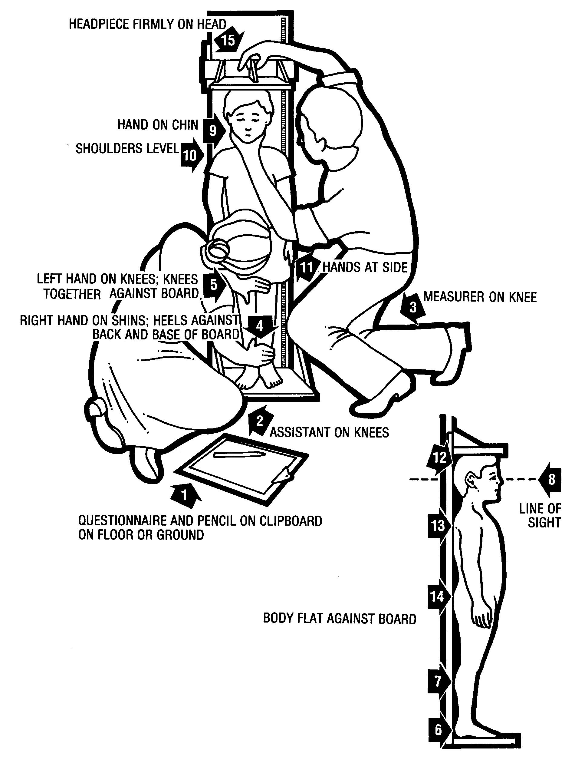
Measurement of length for children <85/87 cm
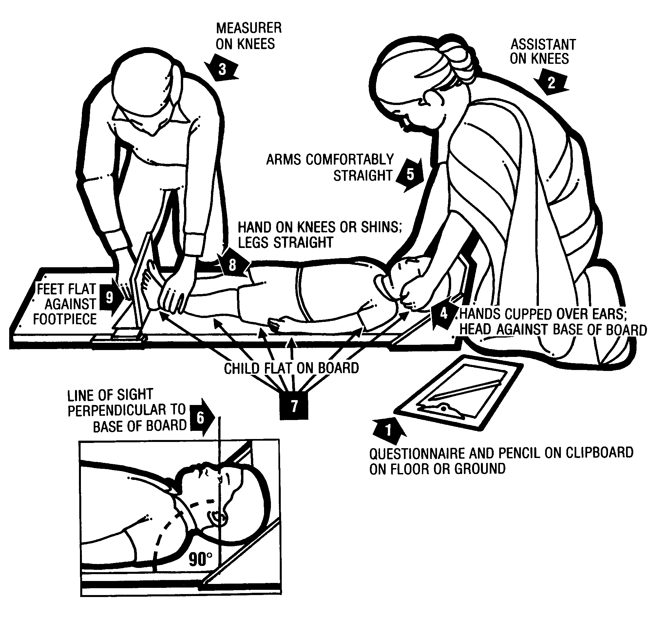
Oedema diagnostic test
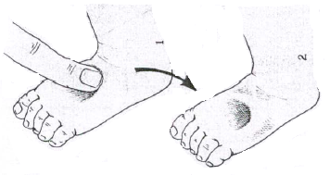
Measurement of weight with the electronic scale
(mother-child function)

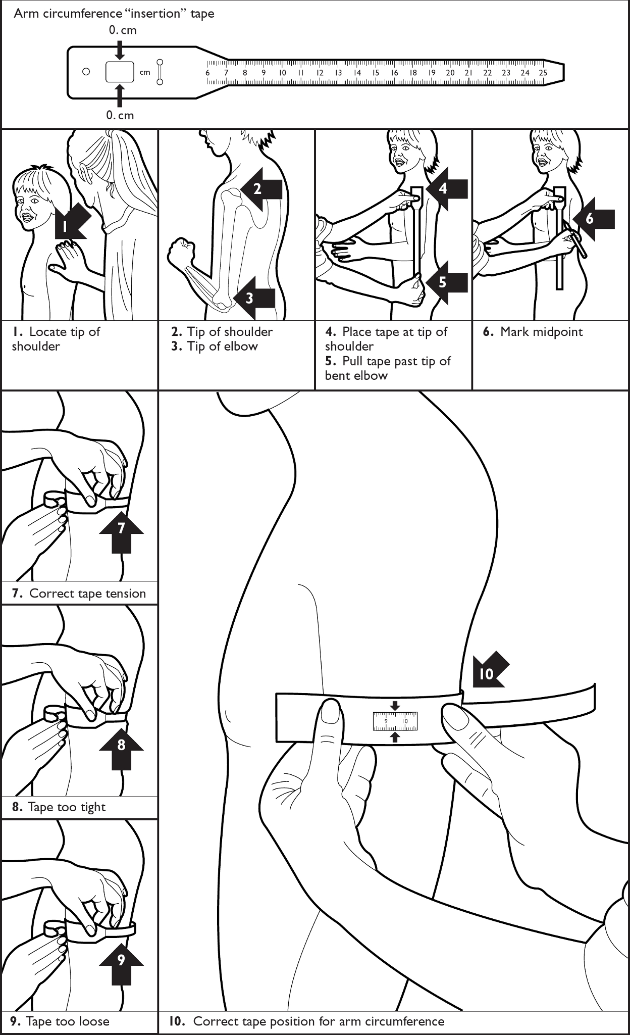

Measurement of MUAC

Annex 7 - Interpreting flags in ENA for SMART

The pink flags can be interpreted as follows:

Line 1: There is a pink flag in the age field. The child is 60 months old. First check the original data collection form to ensure that it is not a data entry error (check all of the anthropometric data entered for that child). If it is not a data entry error, this child is therefore not eligible for the survey. The eligible age range is 6-59 months of age (as shown on the Variable View screen). You need to remind the concerned team (Team 1 in this example) that they need to be more careful with assessing children’s eligibility for the survey.

Line 4: There are 2 pink flags: one in the height field and the other in the height-for-age z-score field. This means that there was probably an error with the height measurement of the child. Indeed, the child is 24 months old and measures 53cm (53cm could be the length of a new born baby!). First check the original data collection form to ensure that it is not a data entry error (check all of the anthropometric data entered for that child). If it is not a data entry error, the child will need to be excluded from final analysis for the variables including height. Note that a WHZ was not even calculated by the software because of the extreme height value. The WAZ may still be included in the final analysis because the height variable is not taken into consideration in the calculation of that index.

Line 8: There are 2 flags: one in the weight-for-age z-score field and one in the weight-for-height z-score field. This means that there was probably an error in the weight measurement of the child. Indeed, the child is 19 months old and weighs 26.1kg. First check the original data collection form to ensure that it is not a data entry error (check all of the anthropometric data entered for that child). If it is not a data entry error, the child will need to be excluded from final analysis for the variables including weight.

Line 12: There is one flag in the height-for-age field. In this case, age was probably incorrect. Indeed, the child is 26 months old and only measures 67 cm and weighs 6.5 kg (height and weight of a 6-7 months old child). First check the original data collection form to ensure that it is not a data entry error (check all of the anthropometric data entered for that child). If it is not a data entry error, the child will need to be excluded from analysis for the HAZ variable.
Annex 8 - Plausibility checks on anthropometric data proposed by the SMART Initiative: Identification of extreme nutritional values, selection bias and measurement bias

What are the challenges when collecting survey data on the field?

- No matter how well a nutrition survey is planned and coordinated, the following challenges are often encountered:

  - Surveys are done very rapidly because of limited time and budget available.
  - Limited time is available for training survey teams before the start of data collection.
  - Available staff has limited experience in data collection and are not aware of the correct way to assess the information.
  - Supervision of teams can be quite complex at times because of problems with security or access.
  - The survey coordinator cannot control what happens in the field when the teams are left alone, unsupervised.
  - Problems with team dynamics that affect work output.

- These challenges, amongst others, can impact on the quality and reliability of anthropometric data derived from nutrition surveys. If the quality of the anthropometric data is questionable, this means that the malnutrition results may not be a good representation of reality. This in turn means that interpretation of contextual information on potential risk factors for malnutrition, such as food security, feeding practices or WASH could be flawed. Programme planning and resources can therefore be less efficient and communities may not be provided with the best possible programmes.

- These challenges have promoted an extensive amount of work to develop methods for doing nutrition surveys, which ensure that the most reliable data are produced with the greatest ease and at the least cost. The SMART (Standardised Monitoring and Assessment of Relief and Transition) initiative is one of the best known initiatives in this area of work.

What is SMART?

- SMART is an initiative, launched in 2002, which promotes best practices in survey methodology and aims to contribute to:

- Standardisation of anthropometric and mortality survey methods conducted in emergencies (collected simultaneously or separately);
- Improving the quality of the anthropometric and mortality surveys; and
- Providing users with easy-to-use tools i.e. manual, software, questionnaires, a plausibility report for assessing data quality (see section below) and standard template for the final report.

Things to watch out for:

- Does a SMART survey use new methods?
- Using the term ‘SMART survey’ leads some people to mistakenly think that it is ‘something’ new and that it is totally different from a nutritional survey. SMART is not considered to be a ‘new’ methodology but rather an approach which adds to the already established and tested methods. It builds on the ‘traditional’ 30x30 nutrition cluster survey method, which was in fact first adopted as part of efforts to improve the quality of survey data.
- Is a SMART survey always a good survey?
- Some users believe that if their survey is ‘SMART’, then the survey is automatically good; which is not necessarily the case!
- Does the SMART Initiative provide a complete survey package?
- So far, the SMART initiative has focused only on methods and tools for collecting anthropometric, mortality and food security data. Some surveys will collect additional data on standard indicators such as vaccination coverage, vitamin A supplementation coverage, infant and young child feeding practices or mosquito net coverage. Therefore, SMART does not, by itself, provide a complete survey package; rather, it provides materials and tools to help improve data collection for some of the key indicators.
- Should we use the Food Security module in SMART?
- At the current time the food security assessment module has not been field tested and is not recommended for use in standard surveys. The SMART initiative method for food security assessment is based on the Household Food Economy Approach. The methods that are more widely used in surveys are based on the calculation of diet diversity scores.
What is the plausibility check?

- The plausibility check is one of the key tools in SMART for data cleaning of the anthropometric data. It allows evaluation of the quality of the anthropometric data and identification of specific types of errors, such as digit preference. If data entry is being done during the survey fieldwork, rather than at the end, the plausibility check results can be used to identify and correct mistakes as they happen.

- The plausibility report focuses on the analysis of acute malnutrition because this is the primary outcome in most nutrition surveys conducted in emergencies and because age data is often not precise enough to provide reliable estimates of stunting or underweight prevalence among children under-5.

- As more countries are moving towards integrating the new WHO Growth Standards (2006), the plausibility check is generated based on these standards only.

- The plausibility check analyses the characteristics of the anthropometric data using some previously published statistical approaches, but also uses some innovative and unpublished statistical approaches. It uses the results from these various statistical tests to provide an evaluation of the anthropometric data based on different criteria, for each individual survey team and also provides an overall score for the survey. Detailed information on the criteria used in the plausibility check is provided in the SMART initiative documentation.

How to use the plausibility check?

- Some sections of the plausibility report need to be looked at regularly and on a daily basis during survey implementation in order to target the teams to supervise and improve the way anthropometric data is being collected. Other sections need to be looked at only after data collection is complete for data cleaning, final analysis and interpretation.

- All tests done by the plausibility check should be considered in their entirety, taking into account the context and interpretation of the results before decisions on the validity of the data are made. The different tests are meant to draw attention to areas where there may be possible problems but, by themselves, should not be used to accept or reject data. The higher the score, the more problematic the survey may be. A ‘problematic’ score above 15% should lead to a careful examination of the anthropometric data for all teams and by team but, by itself, does not necessarily mean that the data is of poor quality. Further details are provided in Table 28 below.

- When the quality of the anthropometric data is not sufficient at the end of the survey, SMART provides recommendations for the reporting of malnutrition results to ensure the data can be used and results are not rejected.

  - More specifically, when the anthropometric data quality is problematic, SMART recommends using the calculated prevalence of wasting (from the observed mean with an SD of 1; this is provided in the plausibility check and cannot easily be calculated by hand) as opposed to the counted prevalence of wasting (these are the most frequently reported results calculated by simply dividing the number of cases by the total number of children surveyed × 100). As an alternative, SMART also recommends excluding results from problematic team(s) to derive the overall acute malnutrition prevalence estimate to base intervention planning. SMART suggests that these results, although still associated with a degree of uncertainty, are most likely to be a better representation of reality on which programme activities could be planned. When excluding survey teams with low quality anthropometric results, the resulting sample size should be large enough to get precise results and, if cluster sampling is used, the minimum number of clusters should be at least 25. Detailed information is provided in the SMART initiative documentation.

Things to watch out for:

- Experience has shown that there has been some ‘misuse’ of the plausibility check because of misunderstanding of how to use the results appropriately:
- Example 1: in country A, a survey coordinator sent teams back to the individual clusters which had a SD out of range for WHZ because the overall WHZ SD of the survey was below 0.8 and they thought that they did something wrong: it does not mean anything to look at the WHZ SD per cluster as several clusters have to be grouped for a meaningful analysis to be done!
- Example 2: in country B, a survey coordinator sent teams back to the field to re-measure the flagged children at the end of the survey even though there were very few of them: Some of the villages were 3-4 hours drive away and there was therefore an important waste of fuel and other resources. There will always be flagged children and this is accounted for by inflating the minimum calculated sample size by the non-response rate!
- Example 3: in country C, a survey coordinator looked at the flags shown in the Plausibility Check for one cluster and sent teams back to the field for re-measurements: the flags described in the Plausibility Check (also known as ‘SMART flags’) should only be checked at the end of the survey once sample size is large enough for a meaningful analysis to be conducted! SMART flags should not be assessed for one cluster alone.
- Example 4: in country D, the survey data was made up to fit the criteria of the plausibility check perfectly! Obviously, this must never be done as it requires falsifying information and reporting untrue information.

What are the quality criteria to check during the survey and include in the final nutrition survey report?

- The SMART quality criteria shown in Table 28 should be carefully assessed and presented in the final SENS nutrition survey report. They have been selected for the UNHCR SENS report because they are the most frequently used ones to date and are the easiest ones to interpret. Because nutrition survey reports are used by multiple stakeholders who need to use the malnutrition prevalence results, it is important that they see an assessment of the quality of the results to help them in decision making for their programmes.

- Instructions for presentation of the SMART quality criteria from the Plausibility Report in the final SENS report are as follows:

  - If Plausibility Check overall score ≤ 15%, only show the overall data quality summary table in the Appendix of the SENS report.

  - If Plausibility Check overall score >15%, carefully examine the anthropometric data for all teams and by teams; and show the details of the problematic areas in the Appendix of the SENS report along with a short interpretation. UNHCR HQ / Regional Offices should be contacted for assistance in analysing problematic scores from the SMART Plausibility Check reports.

Things to note:

  - Although every survey coordinator should strive for the best quality results to ensure programme planning can be done well, no survey is expected to be ‘perfect’ because of the many challenges encountered in reality (see above).
  - Survey coordinators should be transparent about the quality of the anthropometric data collected. Of course, when the survey is finished, little can be done about the identified problem(s), if any, that occurred and it should be made sure that the coordinator learns from this for his or her own professional development and teams do not repeat similar mistakes in future assessments. Efforts should be made to train the teams well, structure the teams appropriately, choose the right people, use good quality equipment that is regularly tested during the survey and perform regular supervision visits to provide support to the ‘weakest’ teams.
Table 28 Quality criteria used by SMART

SMART quality criteria and recommendations (detailed information is provided in the SMART initiative documentation) |  |  | When to check | Things to watch out for
Quality criteria | Acceptable range or cut-off | Description | When to check | Things to watch out for
Missing values and flagged data (refer to SENS Pre-Module Step 14 for more details) | Missing or flagged values for nutritional indices should not exceed 5-10% of the sample size. | Flags are used to identify children with data out of the usual range that are likely to be incorrect because of unlikely combinations of weight, height, age and sex data.  Besides excluding data from children who have missing information or are out of the required range, it is also important to exclude data from children who have improbable nutrition index values during data cleaning.  If there are a large number of flagged values or missing data for nutritional indices, the reliability of the survey data can be questionable.  The flagged values should be reviewed and checked against the original data collection questionnaire. Check weights, heights, ages and sex of all children listed with a flag.  Any error in data entry should be corrected. If there are still some flagged values after checking, you must assume that there was an error during measurement or recording in the field. You cannot correct these types of errors so you should exclude the remaining flagged values before further analysis (this is automatically done in the ENA for SMART software or ENA Epi Info hybrid software).  Refer to Table 29 shown below regarding the different types of flagging criteria used. | At end of survey, after data collection is complete for all teams. | It should be borne in mind that the sample size for this type of survey is calculated to provide a precise estimate of GAM. The estimate of SAM prevalence will not be as precise and, at times, may therefore be affected quite significantly by deleting some extreme / flagged values.
Sex ratio | Sex ratio should be between 0.8 and 1.2. | The sex ratio (number of male divided by number of female) should be around 1. This verifies that both sexes are equally distributed, and hence that no selection bias has occurred and confirms the representativeness of the sample.  If there is a sex bias, this needs to be explained in the report.  Reasons for possible sex bias:  1) During the survey, one sex (either boys or girls) who are out playing is less likely to be measured: this is often due to lack of communication with communities on the survey dates.  2) Faulty selection procedure: this kind of scenario can happen if a population believes that a certain sex should not be shown to strangers, or if one sex is hidden. Surveyors may not be aware of this and the coordinator should investigate while the survey is still on-going why the sex ratio is unbalanced to be able to fix any misunderstanding with the community.  3) Sampling not being done randomly: when the methodology was not strictly adhered to by survey teams or when the survey coordinator did not use a random method for sample selection. | 1. As the survey is being implemented and a reasonable number of children have been surveyed, individual teams can be checked for sex ratio. Target supervision to the ‘weakest’ teams!  2. At end of survey, after data collection is complete for all teams. | Be aware that if the sex ratio is out of range it may not necessarily be due to a failure in the sampling methods.  If sampling and selection of eligible children was done appropriately, the obtained ratio should be similar to that of the population the sample of children was drawn from. Therefore, it is possible to get an imbalance in the proportion of males / females when there is a high sex-related mortality. This can happen if either boys or girls suffered a higher mortality rates in the past.
Age distribution | Different age groups should be equally represented.  There should not be any obvious peaks of certain ages. | Similarly to sex, if age distribution is ok, then there is no selection bias of children. This confirms the representativeness of the sample and makes sure the sample is representative of the age group originally targeted for the survey.  A distribution according to age will show whether or not the sample under or over represents any particular age group (for example, too many young children because the older children were playing outside the house and were not measured).  Age bias in particular can be a serious problem for anthropometric data because younger children (6-29 months) are likely to be more malnourished than older children (30-59 months). This means that if the sample has too many young children (this often happens because it is difficult to estimate age for older children), there is an over-representation of younger children and the prevalence of malnutrition is likely to be artificially raised compared with the actual prevalence of malnutrition. On the contrary, if the sample has too many older children (this is a rarer situation), this may give a lower prevalence of malnutrition than the reality.  If there is an age bias, this needs to be explained in the report.  Reasons for possible age bias:  1) Errors (imprecision in age estimation);  2) Inadvertent exclusion of certain children (especially older children);  3) Faulty selection procedure: this kind of scenario can happen if a population believes that a certain age group should not be shown to strangers. Surveyors may not be aware of this and the coordinator should investigate while the survey is still on-going why the age distribution is unbalanced to be able to fix any misunderstanding with the community;  4) Sampling not being done randomly: when the methodology was not strictly adhered to.  Often there are peaks biasing age estimates towards whole years. Peaks are frequently seen at the 12, 24, 36 and 48 months because the age of the child is rounded: this suggests insufficient probing by the surveyors who are not estimating ages well with a local events calendar.  If there are no obvious peaks, it can be concluded that the age data is of good quality. This will often be the case in surveys where there is a high proportion of age documentation available for children.  Age heaping affects the quality of the age data but the age distribution is not necessarily affected by age heaping. Age heaping will not affect the quality of the weight-for-height outcomes however it can significantly affect height-for-age and weight-for-age outcomes (see below information on standard deviation). | 1. As the survey is being implemented and a reasonable number of children have been surveyed, individual teams can be checked for age distribution and peaks in ages. Target supervision to the ‘weakest’ teams!  2. At end of survey, after data collection is complete for all teams. | Be aware that if the age distribution is not as expected it may not necessarily be due to a failure in the sampling methods or age estimation.  If sampling and assessment of age was done appropriately, the obtained age distribution should be similar to that of the population the sample of children was drawn from. Therefore, it is possible to get an imbalance in the age group distribution when children of a specific age group are affected by higher mortality or when there was an important change in birth rates.  Be aware that the default age distribution used in analysis in the Plausibility Check is based on typical demographic data assumptions for children aged 6-59 months in developing countries. For example, if there is a significant decrease in birth rate in your context, it can be expected to have less younger children than the ‘norm’. If the nutrition survey is conducted in settings with unique, uncommon age distribution, these context-specific demographic data should be used in analysis if available and reliable.  Watch for teams reporting ages at adjacent numbers such as 11/13, 23/25, 35/37 and 47/49 months because they know you are checking for digit preference at 12, 24, 36, and 48! This type of heaping will also affect the quality of the age data.
Digit preference for weight and height | There should not be any obvious peaks of certain digit for weight and height.  The digit preference scores should be <20. | Digit preference informs about the precision of weight and height measurements. Assessing the distribution of the final decimal for height and weight will tell if the survey workers are rounding weight and / or height measurements to the nearest kilogram or centimetre, respectively and thereby taking inaccurate measures.  This can be eyeballed quickly by reviewing the questionnaire and seeing if there is over-representation of values ending in .0 and.5. This can also be assessed easily with the Plausibility Report by teams; there may be one team that is ‘cutting corners’ or has been improperly trained or supervised. | 1. As the survey is being implemented and a reasonable number of children have been surveyed, individual teams can be checked for digit preferences in weight and height measurements. Target supervision to the ‘weakest’ teams!  2. At end of survey, after data collection is complete for all teams. | Watch for teams rounding measurements at adjacent number such as .1, .4/.6, .9 because they know you are checking for digit preference at .0 and .5! This type of heaping will affect the quality of the anthropometric data.  Be aware that there is no digit preference possible for weight measurements when using an electronic scale! Therefore, do not go on to interpret this data for digit preference. Any ‘peaks’ observed will be due to chance alone.
Standard deviation of WHZ (weight-for-height z-score) | SD should be below 1.2 z-scores. | The standard deviation for WHZ explains the dispersion of z-score values around the mean. If SD>1, the distribution is more dispersed than the standard population. If SD<1.0, the distribution is less dispersed than the standard population.  This is the most common test done to assess the quality of the anthropometric data. The dispersion should be close to 1.0.  If the SD is >1.2, it is likely that there was a lot of imprecision in measuring height and weight, which results in “noisy” data that creates “fuzzy” wide distributions. Note, that if data are imprecise it will not necessarily result in extreme values that will be flagged and excluded. “Noisy” imprecise data will result in wider than expected SD even after flags (extreme values) are excluded. If the SD is wider than expected, this will result in overestimation of prevalence of MAM and SAM. If the SD for WHZ is >1.2 then SMART recommends that the calculated prevalence of malnutrition (from the mean with an SD of 1) should be reported. Furthermore, the data should be analysed by disaggregating the analysis by survey teams, and the standard deviations should be calculated for each of the indices and teams. This might reveal that one team made poor quality measurements (also look at the other quality criteria per team). | End of survey, after data collection is complete for all teams. | Surveys with a WHZ SD>1.2 require closer examination for possible problems related to age assessment and anthropometric measurements. This does not mean that the survey results need to be rejected and ignored!
Standard deviation of HAZ (height-for-age z-score) and WAZ (weight-for-age) | Same as above. | If there is a problem with the quality of age data, then HAZ and WAZ outcomes can be problematic.  With accurate age estimates and anthropometric measurements, the SD of the observed HFA and WFA z-score distribution should be relatively constant and close to the expected value of 1.0 for the reference distribution. If age data are not very good, SD can be as high as 1.7. Prevalence of stunting and underweight in these situations can be either underestimated (if mean z-score <-2) or overestimated (if mean z-score > -2). | End of survey, after data collection is complete for all teams. | The prevalence of stunting (based on height-for-age) and underweight (based on weight-for-age) need to be reported in the final survey report but should be interpreted with caution as the accuracy of age data is often poor!  Make sure to report the proportion of age documentation found in the survey.

What are the most frequently used flagging criteria for nutritional indices?

- Different approaches are taken to dealing with ‘flagged’ or potentially implausible nutritional index data in the analysis. There is no consensus regarding this issue at present and different organisations conducting nutrition surveys use different cleaning criteria. Table 29 summarises the different flagging criteria used in nutrition surveys conducted in emergencies. UNHCR currently recommends following the SMART recommendations for the exclusion of flags and hence excluding SMART flags from final analysis.

- The ENA for SMART and ENA / Epi Info hybrid software have an option to manually specify exclusion criteria for flags and the programmes automatically conduct the final analysis after excluding the corresponding flags. When using these software, note that flags are not deleted from the database permanently; they are only excluded temporarily from final analysis of the specific variable. For example, if a child has a flag for WHZ, s/he can still be included for the analysis of the other indicators, e.g. measles vaccination, vitamin A supplementation, age and sex. If there are SMART flags detected in your dataset, find out the corresponding child(ren) and check the anthropometric data values with the original questionnaire. If it was a data entry error, correct it.

- It is important to mention in the final SENS report if any data were excluded from the analyses and why the data were excluded (see Table 20 in Results section which provides this information).

Things to note:

- It is essential to bear in mind that one of the most important elements is comparison of the data between surveys (e.g. comparisons of a baseline survey with subsequent surveys in the same area to monitor programmes). Therefore, the more standardised the method is, the more comparable results will be, provided that the surveys are done according to protocol.

- In the same refugee operations and across regions, it is important that nutritional surveys conducted follow the same methodology and use the same quality criteria to clean and evaluate their data. Accordingly, the same cleaning criteria should be applied in nutrition surveys conducted in the same populations to allow comparisons.
Table 29 Flagging criteria used for nutritional indices in nutrition surveys conducted in emergencies

Index | WHO 2006 Growth Standards | SMART flags* | NCHS Growth Reference (cleaning in ANTHRO or  Epi Info) | NCHS Growth Reference  (fixed exclusion range) (suitable when the observed mean z-score is above -1.5) | NCHS Growth Reference  (flexible exclusion range)
HAZ | -6 to +6 | -3 to +3 | -6 to +6 | -5 to +3 | 4 z-score units from the observed mean z-score, with a maximum HAZ of +3.0
WHZ | -5 to +5 | -3 to +3 | -4 to +6 | -4 to +5
WAZ | -6 to +5 | -3 to +3 | -6 to +6 | -5 to +5
Reference point | 0 z-score | observed mean | 0 z-score | 0 z-score | observed mean
Remarks | To be used when WHO Growth Standards population is used for analysis.  These represent the ‘pink’ flags that appear in the Data Entry Anthropometry screen of ENA for SMART software and are defined in the Variable View screen. These flags are currently being referred to as ‘WHO flags’, ‘Epi Info flags’ or ‘pink flags’. | These are flags are recommended by SMART.  Can be used when either NCHS Reference or WHO Growth Standards populations is used for analysis.  These are the flags that appear in the Plausibility Check and are currently being referred to as ‘SMART flags’. | To be used when NCHS Reference population is used for analysis. Note that two additional criteria for flagging a record are combinations of indices in Epi Info: (HAZ>3.09 and WHZ<3.09) or (HAZ<3.09 and WHZ>3.09) | To be used when NCHS Reference population is used for analysis. | To be used when NCHS Reference population is used for analysis.
Reference | WHO 2006 Growth Standards and WHO ANTHRO software | SMART Initiative | WHO ANTHRO software and Epi Info (Epi Nut) software | WHO Technical Report Series. Physical status: the use and interpretation of anthropometry. Report of a WHO Expert Committee. Geneva, 1995. | WHO Technical Report Series. Physical status: the use and interpretation of anthropometry. Report of a WHO Expert Committee. Geneva, 1995.
Source: Adapted from Concern Worldwide Nutrition Survey Guidelines, Version 1 December 2008. Health Support Unit, Dublin.
*The range is flexible. Users can change the ranges e.g. +/- 3.5 or +/-4 but there is currently no guidance on deciding on the range to use. Most users use +/- 3 as this is used as a default in the ENA for SMART software.
Annex 9 - Presentation of combined camp results

- Weighting the data will need to be done if you have conducted surveys in a number of different camps or areas, and need to combine the results for reporting or planning purposes.

- It is not required to report the combined results for all indicators or to report the confidence intervals for the combined estimates. The tables below outline the indicators that should be reported during a combined analysis and included in the survey report.
- For a tool that will automatically generate weighed prevalence results, see SENS Pre-Module tool: [Tool 14-Weighting Data Tool].

Anthropometric data

Combined prevalence of acute malnutrition based on weight-for-height z-scores (and/or oedema)

Prevalence of global malnutrition (<-2 z-score and/or oedema) | %
Prevalence of severe malnutrition (<-3 z-score and/or oedema) | %

The prevalence of oedema is %

Combined prevalence of MUAC MALNUTRITION

Prevalence of MUAC <125mm or oedema | %
Prevalence of MUAC < 125 mm and >= 115 mm, no oedema | %
Prevalence of MUAC < 115mm and/or oedema | %

Combined prevalence of underweight based on weight-for-age z-scores

Prevalence of underweight (<-2 z-score) | %

Combined prevalence of stunting based on height-for-age z-scores

Prevalence of stunting (<-2 z-score) | %

Measles vaccination coverage

Combined measles vaccination coverage for children aged 9-59 months (or other context-specific target group)

 | Measles  (with card) | Measles  (with card or confirmation from mother)
YES | % | %

Vitamin A supplementation coverage

Combined vitamin A supplementation for children aged 6-59 months within past 6 months (or other context-specific target group)

 | Vitamin A capsule (with card) | Vitamin A capsule  (with card or confirmation from mother)
YES | % | %

Diarrhoea

Combined two-week period prevalence of diarrhoea in children aged 6-59 months

Diarrhoea in the last two weeks | %

Annex 10 - Epi info Analysis

Below are the standard Epi Info codes to use for analysis of the additional variables that are not automatically analysed by ENA for SMART. The standard PGM files containing these Epi Info codes can be found in the Epi Info mdb file entitled HUN1207CHBUDA in the SENS Anthropometry and Health tool: [Tool 3-CH Data]. To access the PGM files, go to Program Editor window and open the corresponding PGM file needed for the analysis.

Refer to the fictitious dataset available for practical purposes; Go to SENS Anthropometry and Health Tool 3, and see the Excel database HUN_1207_CH_BUDA.

The practical Excel database HUN_1207_CH_BUDA is from a nutrition survey using simple random sampling.

Data cleaning

Run these commands (together or separately; regardless of the survey design) and make sure that the ranges of the variables entered in the database match the standard codes shown in Table 7 above. The other standard SENS variables (SEX, MONTHS, WEIGHT, HEIGHT, EDEMA, MUAC) can be cleaned using ENA for SMART before analysis with ENA for SMART software.

FREQ ENROL
FREQ VITA
FREQ MEASLES
FREQ DIAR

You should check the missing data in your database and double-check that this was not a data entry oversight. The commands below need to be run separately, one by one. After selecting the variable using the code shown below, use the LIST command to view the specific records with missing data and double-check with the original data collection questionnaire. Then cancel the selected variable by typing SELECT and proceed with checking another variable.

SELECT ENROL=(.)
SELECT (this will cancel the selected variable)

SELECT VITA=(.)

SELECT MEASLES=(.)

SELECT DIAR=(.)

Data analysis

Results from the practical survey dataset are illustrated below.

Measles vaccination analysis

Measles vaccination coverage for children aged 9-59 months
(n=599)

 | Measles  (with card)  n=64 | Measles  (with card or confirmation from mother)  n=437
YES | 10.7%  (8.4-13.5 95% CI) | 73.0 %  (69.2-76.4 95% CI)

Measles vaccination coverage with card

SELECT MONTHS>=9

FREQ MEASLES

If you are analysing a cluster survey, you need to use the C-Sample commands and the code is as follows:

FREQ MEASLES PSUVAR=CLUSTER

SELECT (this will cancel the selected variable(s); only to be executed after the analysis is done and the results recorded)

MEASLES | Frequency | Percent | Cum Percent
1 | 64 | 10.7% | 10.7%
2 | 373 | 62.3% | 73.0%
3 | 162 | 27.0% | 100.0%
Total | 599 | 100.0% | 100.0%

95% Conf Limits
1 | 8.4% | 13.5%
2 | 58.2% | 66.1%
3 | 23.6% | 30.8%

Measles vaccination coverage with card or confirmation from mother
SELECT MONTHS>=9

DEFINE MSL_cc

RECODE MEASLES TO MSL_cc
1 = "YES"
2 = "YES"
3 = "NO"
END

FREQ MSL_cc

If you are analysing a cluster survey, you need to use the C-Sample commands and the code is as follows:

FREQ MSL_cc PSUVAR=CLUSTER

SELECT (this will cancel the selected variable(s); only to be executed after the analysis is done and the results recorded)

MSL_cc | Frequency | Percent | Cum Percent
NO | 162 | 27.0% | 27.0%
YES | 437 | 73.0% | 100.0%
Total | 599 | 100.0% | 100.0%

95% Conf Limits
NO | 23.6% | 30.8%
YES | 69.2% | 76.4%

Vitamin A supplementation analysis

Vitamin A supplementation for children aged 6-59 months in past 6 months (n=632)

 | Vitamin A capsule (with card)  n=63 | Vitamin A capsule  (with card or confirmation from mother)  n=401
YES | 10.0%  (7.8-12.6 95% CI) | 63.4 %  (59.5-67.2 95% CI)
Vitamin A capsule coverage with card
FREQ VITA
If you are analysing a cluster survey, you need to use the C-Sample commands and the code is as follows:

FREQ VITA PSUVAR=CLUSTER

VITA | Frequency | Percent | Cum Percent
1 | 63 | 10.0% | 10.0%
2 | 338 | 53.5% | 63.4%
3 | 231 | 36.6% | 100.0%
Total | 632 | 100.0% | 100.0%

95% Conf Limits
1 | 7.8% | 12.6%
2 | 49.5% | 57.4%
3 | 32.8% | 40.5%

Vitamin A capsule coverage with card or confirmation from mother

DEFINE VITA_cc

RECODE VITA TO VITA_cc
1 = "YES"
2 = "YES"
3 = "NO"
END

FREQ VITA_cc

If you are analysing a cluster survey, you need to use the C-Sample commands and the code is as follows:

FREQ VITA_cc PSUVAR=CLUSTER

VITA_cc | Frequency | Percent | Cum Percent
NO | 231 | 36.6% | 36.6%
YES | 401 | 63.4% | 100.0%
Total | 632 | 100.0% | 100.0%

95% Conf Limits
NO | 32.8% | 40.5%
YES | 59.5% | 67.2%

Diarrhoea analysis

Period prevalence of diarrhoea

 | Number/total | % (95% CI)
Diarrhoea in the last two weeks | 84/615 | 13.7 (11.1-16.7)

Two week period prevalence of diarrhoea

SELECT DIAR <>3

FREQ DIAR

SELECT (this will cancel the selected variable(s); only to be executed after the analysis is done and the results recorded)

DIAR | Frequency | Percent | Cum Percent
1 | 84 | 13.7% | 13.7%
2 | 531 | 86.3% | 100.0%
Total | 615 | 100.0% | 100.0%

95% Conf Limits
1 | 11.1% | 16.7%
2 | 83.3% | 88.9%

Nutrition programme coverage analysis

Programme coverage for acutely malnourished children based on all admission criteria (MUAC, WHZ and/or oedema)

 | Number/total | % (95% CI)
Supplementary feeding programme coverage | 62/164 | 37.8 (30.4-45.7)
Therapeutic feeding programme coverage | 26/84 | 31.0 (21.3-42.0)

Programme coverage for acutely malnourished children based on MUAC and/or oedema only

 | Number/total | % (95% CI)
Supplementary feeding programme coverage | 30/53 | 56.6 (42.3-70.2)
Therapeutic feeding programme coverage | 8/14 | 57.1 (28.9-82.3)

The WHZ (SMART) flags need to be excluded from the WHZ analyses by using the following PGM codes:

DEFINE Flag_WHZ_WHO

IF Flag_WHO="WHZ" THEN
Flag_WHZ_WHO="YES"
END

IF Flag_WHO="WAZ, WHZ" THEN
Flag_WHZ_WHO="YES"
END

IF Flag_WHO="HAZ, WHZ" THEN
Flag_WHZ_WHO="YES"
END

IF Flag_WHO="WAZ, HAZ, WHZ" THEN
Flag_WHZ_WHO="YES"
END

Supplementary feeding programme coverage

Based on all admission criteria (MUAC, WHZ)

Supplementary feeding programme eligibility

DEFINE SFPE

IF WHZ_WHO>=-3.000 AND WHZ_WHO<-2.000 OR MUAC>=115 AND MUAC<125 THEN
SFPE="YES"
ELSE
SFPE="NO"
END

IF WHZ_WHO= (.) AND MUAC= (.) THEN
SFPE=(.)
END

Supplementary feeding programme coverage

Use the newly generated variable named ‘Flag WHZ WHO’ defined above for to conduct the following analysis.

SELECT SFPE="YES" AND Flag_WHZ_WHO=(.)

FREQ ENROL

If you are analysing a cluster survey, you need to use the C-Sample commands and the code is as follows:

FREQ ENROL PSUVAR=CLUSTER
SELECT (this will cancel the selected variable(s); only to be executed after the analysis is done and the results recorded)

ENROL | Frequency | Percent | Cum Percent
1 | 62 | 37.8% | 37.8%
2 | 5 | 3.0% | 40.9%
3 | 97 | 59.1% | 100.0%
Total | 164 | 100.0% | 100.0%

95% Conf Limits
1 | 30.4% | 45.7%
2 | 1.0% | 7.0%
3 | 51.2% | 66.7%

Based on MUAC only

Supplementary feeding programme eligibility

DEFINE SFPE_MUAC

IF MUAC>=115 AND MUAC<125 THEN
SFPE_MUAC="YES"
ELSE
SFPE_MUAC="NO"
END

IF MUAC= (.) THEN
SFPE_MUAC=(.)
END

Supplementary feeding programme coverage

SELECT SFPE_MUAC="YES"

FREQ ENROL

If you are analysing a cluster survey, you need to use the C-Sample commands and the code is as follows:

FREQ ENROL PSUVAR=CLUSTER

SELECT (this will cancel the selected variable(s); only to be executed after the analysis is done and the results recorded)

ENROL | Frequency | Percent | Cum Percent
1 | 30 | 56.6% | 56.6%
2 | 1 | 1.9% | 58.5%
3 | 22 | 41.5% | 100.0%
Total | 53 | 100.0% | 100.0%

95% Conf Limits
1 | 42.3% | 70.2%
2 | 0.0% | 10.1%
3 | 28.1% | 55.9%

Therapeutic feeding programme coverage

Based on all admission criteria (MUAC, WHZ, oedema)

Therapeutic feeding programme eligibility

DEFINE TFPE

IF EDEMA="y" OR MUAC<115 OR WHZ_WHO<-3.000 THEN
TFPE="YES"
ELSE
TFPE="NO"
END

IF EDEMA= (.) AND MUAC= (.) AND WHZ_WHO= (.) THEN
TFPE=(.)
END

Therapeutic feeding programme coverage

Use the newly generated variable named ‘Flag WHZ WHO’ defined above for to conduct the following analysis.

SELECT TFPE="YES" AND Flag_WHZ_WHO=(.)

FREQ ENROL

If you are analysing a cluster survey, you need to use the C-Sample commands and the code is as follows:

FREQ ENROL PSUVAR=CLUSTER
SELECT (this will cancel the selected variable(s); only to be executed after the analysis is done and the results recorded)

ENROL | Frequency | Percent | Cum Percent
1 | 7 | 8.3% | 8.3%
2 | 26 | 31.0% | 39.3%
3 | 51 | 60.7% | 100.0%
Total | 84 | 100.0% | 100.0%

95% Conf Limits
1 | 3.4% | 16.4%
2 | 21.3% | 42.0%
3 | 49.5% | 71.2%

Based on MUAC and/or oedema only

Therapeutic feeding programme eligibility

DEFINE TFPE_MUAC

IF MUAC<115 OR EDEMA="y" THEN
TFPE_MUAC="YES"
ELSE
TFPE_MUAC="NO"
END

IF EDEMA= (.) AND MUAC= (.) THEN
TFPE_MUAC=(.)
END

Therapeutic feeding programme coverage

SELECT TFPE_MUAC="YES"

FREQ ENROL

If you are analysing a cluster survey, you need to use the C-Sample commands and the code is as follows:

FREQ ENROL PSUVAR=CLUSTER

SELECT (this will cancel the selected variable(s); only to be executed after the analysis is done and the results recorded)

ENROL | Frequency | Percent | Cum Percent
1 | 1 | 7.1% | 7.1%
2 | 8 | 57.1% | 64.3%
3 | 5 | 35.7% | 100.0%
Total | 14 | 100.0% | 100.0%

95% Conf Limits
1 | 0.2% | 33.9%
2 | 28.9% | 82.3%
3 | 12.8% | 64.9%

NCHS: National Center for Health Statistics (1977) NCHS growth curves for children birth-18 years. United States. Vital Health Statistics.
WHO Growth Standards, 2006
Note that ENA for SMART software will flag such an error in pink on the Data Anthropometry Entry screen.
Note that ENA for SMART software will flag such an error in pink on the Data Anthropometry Entry screen.
If the value is outside of the range or beyond the cut-off, the data may be problematic and survey coordinators should be able to assess where the problem(s) comes from by looking at the entire plausibility report. Detailed information is provided in the SMART initiative documentation.

