JOINT NUTRITION AND HEALTH SURVEYS

DOLLO ADO REFUGEE CAMPS

Bokolmanyo, Melkadida, Kobe, Hilaweyn and Buramino camps

Surveys conducted: March 2013

Report finalised: June 2013

UNHCR, ARRA, WFP, UNICEF, SC-I, ACF, IMC, GOAL




TABLE OF CONTENTS

ACRONYMS AND ABBREVIATIONS 4
ACKNOWLEDGMENTS 5
EXECUTIVE SUMMARY 6
Introduction 16
Background 16
Food Security 16
Health situation 17
Nutrition Situation 18
Water and sanitation situation 19
Survey Objectives 21
Methodology 21
Sample size 21
Sampling procedure: selecting households and individuals 23
Questionnaires 23
Measurement methods 24
Case definitions and calculations 26
Classification of public health problems and targets 28
Training, coordination and supervision 29
Data collection,entry and analysis 30
RESULTS FROM BOKOLMANYO 32
RESULTS FROM MELKADIDA 48
RESULTS FROM KOBE 65
RESULTS FROM HILAWEYN 82
RESULTS FROM BURAMINO 100
LIMITATIONS 117
DISCUSSION 118
CONCLUSION 124
RECOMMENDATIONS 125
Appendix 1 - Names of contributors 127
Appendix 2 - Summary of overall quality of anthropometric data 130
Appendix 3 – Survey Questionnaires 133
Appendix 4 – Result Tables for NCHS growth of anthropometric data 143
Appendix 5 – Events Calender 147
Appendix 6 – Map of Dollo Ado camps 148

ACRONYMS AND ABBREVIATIONS
ACF Action Contra Faim
ANC Ante Natal Care
ARRA Administration for Refugee and Returnee Affairs
BSFP Blanket Supplementary Feeding Program
CMR Crude Mortality Rate
CI Confidence Interval
CHWs Community Health Workers
CSB Corn-Soya Blend
CTC Community-based Therapeutic Care
DEFF Design effect
ENA Emergency Nutrition Assessment
EPI Expanded Programme on Immunization
Epi Info Name of CDC software for epidemiological investigations
FSNAU Food Security and Nutrition Analysis Unit
GAM Global Acute Malnutrition
GFR General Food Ration
HAZ Height-for-Age z-score
Hb Haemoglobin
HDDS Household Dietary Diversity Score
HH Household
HIS Health Information System
IMC International Medical Corps
IPs Implementing Partners
IYCF Infant and Young Child Feeding
KCAL Kilocalorie
LNS Lipid-based Nutrient Supplement
L/P/D Litre per person per day
MAM Moderate Acute Malnutrition
MCH Maternal and Child Heath
MOH Ministry of Health
MSF Médecins sans Frontières
MUAC Middle Upper Arm circumference
NCHS National Centre for Health Statistics
NFI Non food items
NPW Non Pregnant Women
OTP Out-patient Therapeutic Programme
PDM Post Distribution Monitoring
ProGres UNHCR registration database for refugees
SAM Severe Acute Malnutrition
SC Stabilization Centre
SCI Save the Children International
SD Standard Deviation
SENS Standardised Expanded Nutrition survey
SFP Supplementary Feeding Programme
SMART Standardised Monitoring & Assessment of Relief & Transitions
TFP Therapeutic Feeding Programme
U3 Children under 3 years old
U5 Children under 5 years old
U5MR Under-5 Mortality Rate
UNHCR United Nations High Commissioner for Refugees
UNICEF United Nations Children’s Funds
WASH Water Sanitation and Hygiene
WAZ Weight-for-Age z-score
WFH Weight-for-height
WHZ Weight-for-Height z-score
WFP World Food Programme
WHO World Health Organization

ACKNOWLEDGMENTS

UNHCR and ARRA commissioned and coordinated the surveys. We gratefully acknowledge the important contributions made by so many that made these surveys possible.

We would like to acknowledge all agencies involved in planning and executing the surveys. Our sincere appreciation is extended to ARRA, SC-I, IMC, ACF and GOAL for providing staff during the entire duration of the exercise. Our gratitude also goes to GOAL for providing data entry capacity WFP and UNICEF for training, supervision and logistics support and to all the drivers who worked tirelessly. A complete list of the names of all those individuals involved can be found at Appendix 1.

Finally, we sincerely thank the refugee population who gave up their time to participate and allowed us to measure their children and, most importantly, to the children themselves.

EXECUTIVE SUMMARY

The nutrition situation in the Dollo Ado camps has remained at, or above, the WHO emergency threshold for the past three years. In 2011 the situation escalated to a crisis level due to the rapid influx of refugees from Somalia fleeing famine due to drought and conflict. Collaborative efforts from all sectors in 2012 and 2013 saw the acute malnutrition prevalence reduce from an average of 41.9% in 2011 to 17.2 % in 2013.

UNHCR and ARRA with WFP, UNICEF, and implementing partners, SC-I, IMC, ACF and GOAL carried out nutrition surveys in Bokolmanyo, Melkadida, Kobe, Hilaweyn and Buramino Dollo Ado camps. The five surveys took place between the 4th to 31st March 2013, with the overall aim being to determine the extent and severity of malnutrition and mortality in different age groups and to monitor selected indicators of programme performance.

The survey objectives were as follows:

Specific primary objectives of the survey:
  - To determine the prevalence of acute malnutrition among children 6-59 months
  - To determine the prevalence of stunting among children 6-59 months
  - To assess the two-week period prevalence of diarrhoea among children 6-59 months
  - To assess crude and under-five mortality rates in the camps in the last three months
  - To assess the prevalence of anaemia among children 6-59 months and women of reproductive age (non-pregnant, 15-49 years)
  - To determine the coverage of measles vaccination among children 9-59 months
  - To determine the coverage of vitamin A supplementation in the last six months among children 6-59 months and postnatal women
  - To determine the coverage of deworming in the last six months among children 12-59 months
  - To investigate IYCF practices among children 0-23 months
  - To assess the coverage of blanket feeding programs for children 6-59 months
  - To assess the proportion of households those use an adequate quantity of water per person per day
  - To assess the proportion of households who say they are satisfied with their water supply
  - To determine the coverage of ration cards and the duration the GFD ration lasts for recipient households
  - To determine the extent to which negative coping strategies are used by households
  - To assess household dietary diversity
  - To establish recommendations on actions to be taken to address the situation

Secondary objectives:
- To determine the coverage of selective feeding programs for children 6-59 months
- To determine enrolment into Antenatal Care clinic and coverage of iron-folic acid supplementation in pregnant women
The Standardized Monitoring and Assessment of Relief and Transitions (SMART) methodology (Version 1 April 2006) was used to collect and analyse data on child anthropometry and mortality in the whole population. UNHCR’s updated Standardised Expanded Nutrition Survey Guidelines for Refugee Populations (Version 1.3, March 2012) was used to collect information on anaemia in children, anaemia in women, food security and infant and young child feeding indicators. UNHCR population figures from ProGres were used to determine the population while the 2012 nutrition survey results were used to derive the percentage of children 6-59, the average household size and adjustment for population movements.

Five independent samples were included in each survey. Three population groups: children 6-59 months , children 0-23 months and women of reproductive age 15-49 years were included. Indicators on food security, WASH, and mortality were measured in a sample of households .Systematic random sampling was used. Houses/tents were physically labelled with unique numbers per block/zone in each camp.

A total of six survey teams composed of six members each were included in each survey. A pre-survey training orientation with the supervisors was carried out for two days followed by a standardised training lasting four days and one-day of pre-test for the enumerators. The survey teams were supported by a team of supervisors and a coordinator throughout the duration of data collection. Data for children 6-59 months and mortality was entered using ENA for SMART software (November 24 2012 version) while all other data was entered using Epi Info Software (Centres for Disease Control, version 3.5.4) by a GOAL data clerk. All entries were double checked to ensure accuracy. Data analysis was undertaken with ENA for SMART and Epi Info software.

 | % (95% CI) | % (95% CI) |  | % (95% CI) | % (95% CI) | % (95% CI) |  | Classification of public health significance / target (where applicable)
 | Bokolmanyo | Melkadida |  | Kobe | Hilaweyn | Buramino
CHILDREN (6-59 months) % (95% CI)
Acute Malnutrition (WHO 2006 Growth Standards)
Global Acute Malnutrition (GAM) | 13.8 (10.8 - 17.5) | 16.9 (13.5 - 21.0) |  | 17.0 (13.3 - 21.4) | 19.2 (15.6 - 23.3) | 19.6 (16.3 - 23.4) |  | Critical if ≥ 15%
Moderate Acute Malnutrition (MAM) | 12.6 (9.7 - 16.2) | 15.3 (12.1 - 19.3) |  | 14.2 (10.8 - 18.4) | 15.7 (12.5 - 19.6) | 15.0 (12.0 - 18.5)
Severe Acute Malnutrition (SAM) | 1.2 (0.5 - 2.9) | 1.6 % (0.7 - 3.4) |  | 2.8 (1.5 - 5.2 ) | 3.4 (2.1 - 5.7) | 4.6 % (3.1 - 6.9)
Oedema | 0 | 0 |  | 0 | 0 | 0
Stunting (WHO 2006 Growth Standards)
Total Stunting | 12.0 (9.2 - 15.6) | 11.4 (8.6 - 15.1) |  | 6.5 (4.3 - 9.7) | 12.9 (10.0 - 16.5) | 11.9 (9.3 - 15.2) |  | Critical if ≥ 40%
Severe Stunting | 3.7 (2.2 - 6.0) | 1.9 (0.9 - 3.8) |  | 0.9 (0.3 - 2.7) | 2.5 (1.3 - 4.5) | 2.1 (1.2 - 3.9)
MUAC
MUAC 125-134 mm | 13.9 (10.8 -17.7) | 13.2 (10.2 -17.2 ) |  | 19.8 (15.7 - 24.6) | 16.9 (13.5 - 21.0) | 20.3 (16.8 - 24.2)
MUAC 115-124 mm | 3.2 (1.9 – 5.3) | 4.0 (2.4 – 6.4) |  | 2.8 (1.5 – 5.1) | 4.4 (2.8 – 6.9) | 2.7 (1.6 – 4.6)
MUAC <115 mm and/or oedema | 1.2 (0.5 – 2.8) | 0 |  | 0.6 (0.2 - 2.2) | 1.7 (0.8 – 3.5) | 1.9 (1.0 – 3.6)
Anaemia (6-59 months)
Total Anaemia (Hb <11 g/dl) | 46.7 (41.8-51.7) | 47.7(47.1-57.4) |  | 38.0 (32.8-43.6) | 49.5 (44.5-54.5) | 58.0(53.4-62.4) |  | High if ≥ 40%
Mild (Hb 10-10.9 g/dl) | 23.5 (19.5-27.5) | 24.7(20.5-29.4) |  | 22.7 (18.3-27.7) | 27.4 (23.1-32.1) | 29.3(25.3-33.7)
Moderate (Hb 7-9.9 g/dl) | 22.5 (18.6-26.9) | 22.5(18.5-27.2) |  | 15.0 (11.4-19.5) | 21.3 (17.4-25.8) | 28.0(24.1-32.4)
Severe (Hb<7.0 g/dl) | 0.7 (0.2-2.3) | 0.5(0.1-2.1) |  | 0.3 (0.2.0) | 0.8 (0.2-2.4) | 0.6(0.2-2.0)
Anaemia (6-23 months)
Total Anaemia (Hb <11 g/dl) | 66.4 (57.4-74.6) | 67.9 (59.3-75.7) |  | 53.3 (43.4-63.0) | 70.0 (61.7-77.4) | 75.8 (68.9-81.9)
Mild (Hb 10-10.9) | 27.2 (19.6-35.9) | 29.1 (21.6-37.6) |  | 22.4 (14.9-31.5) | 28.6 (21.3 - 36.8) | 37.6 (30.5-45.2)
Moderate (Hb 7-9.9) | 36.8 (28.4-45.9) | 38.1 (29.8-46.8) |  | 29.9 (21.4-39.5) | 40.7 (32.5-49.3) | 38.2 (31.0-45.8)
Severe (Hb<7.0) | 2.4 (0.5-6.9) | 0.7 (0-4.1) |  | 0.9 (0-5.1) | 0.7 (0-3.9) | 0
Programme Coverage
Therapeutic program (based on all admission criteria WHZ,Oedema and MUAC) | 42.9 (9.9-81.6) | 0% |  | 22.2 (2.8-60.0) | 58.8 (32.9-81.6) | 41.4 (23.5-61.1)
Therapeutic program (based on MUAC/Oedema only) | 50 (6.8-93.2) | - |  | 100 | 85.7 (42.1-99.6) | 100
SFP (based on all admission criteria WHZ and MUAC) | 28.6(17.3-42.2) | 7.9(2.6-17.6) |  | 10%(3.3-21.8) | 30.3 (19.6-42.9) | 32.9(22.3-44.9)
SFP(based on MUAC only) | 38.5 (13.9-68.4) | 26.7(7.8-55.1) |  | 11.1 (0.3-48.2) | 42.1 (20.3-66.5 | 23.1 (5.0-53.8)
Currently receiving (CSB+/CSB++) | 88.1 (84.5-91.0) | 87.3 (83.5-90.5) |  | 93.0 (89.5-95.4 | 90.0 (86.6-92.7) | 87.8 (84.4-90.5)
Measles vaccination with card (9-59 months) | 29.0 (24.6-33.8) | 16.0 (12.4-20.3) |  | 7.6 (5.0-11.4) | 5.7 (3.7-8.7) | 0.7 (0.2-2.1)
Measles vaccination with card or recall (9-59 months) | 91.0 (87.7-93.7) | 95.8 (93.0-97.5) |  | 94.7 (91.4-96.8) | 85.9 (81.9-89.3) | 80.0 (75.9-83.5) |  | Target of ≥ 95%
Vitamin A supplementation coverage with card, within past 6 months (6-59 months) | 19.8 (16.1 24.0) | 15.6 (12.2-19.8) |  | 3.7(2.0- 6.5) | 5.9(3.9-8.7) | 0.6 (0.2- 2.0)
Vitamin A supplementation coverage with card or recall, within past 6 months (6-59 months) | 95.4 (92.7-97.1) | 92.1(88.7-94.5) |  | 94.5 (91.3-96.6) | 86.8 (83.1-89.9) | 89.0 (85.8-91.6) |  | Target of ≥ 90%
Deworming coverage within the past 6 months(12-59 months) | 98.1 (95.9-99.1) | 92.5 (89.0-95.0) |  | 94.4(91.1-96.8) | 82.1 (77.6-86.0) | 83.5 (79.4-86.8)
Morbidity
Diarrhoea in the past 2 weeks | 5.8 (3.9 – 8.7) | 9.8(7.1 – 13.3) |  | 8.5(5.8– 12.2) | 15.7(12.4– 19.7) | 13.3(10.4– 16.8)
CHILDREN (0-23 months) %(95% CI)
Infant and Young children Feeding Practices
Child ever breastfed | 97.1 (93.3-99.0) | 99.4 (97.0-00.0) |  | 98.2 (94.7-99.6) | 89.6 (84.5-93.4) | 99.6 (97.7-100.0)
Timely initiation of breastfeeding | 80.2 (72.2-85.0) | 84.9 (78.8-89.8) |  | 87.6 (81.5-92.2) | 81.0 (74.5-86.5) | 78.8 (73.0-83.7)
Exclusive breastfeeding under 6months | 42.0 (28.2-56.8) | 69.1 (55.2-80.9) |  | 77.0 (64.5-86.8) | 52.3 (39.5-64.9) | 37.5 (26.4-49.7)
Continued breastfeeding at 1 year | 81.0 (58.1-94.6) | 63.6 (47.8-77.6) |  | 42.9 (17.7-71.1) | 70.8 (48.9-87.4) | 56.7 (37.4-74.5)
Continued breastfeeding at 2 years | 55.2 (35.7-73.6) | 40 (21.1-61.3) |  | 27.8 (9.7-53.5) | 0 | 18.6 (8.4-33.4)
Introduction of solid, semi-solid or soft foods | 35.7 (18.6-55.9) | 29.2 (12.6-51.1) |  | 18.5 (6.3-38.1) | 39.5 (24.0-56.6) | 44.8 (26.4-64.3)
Children bottle fed | 20.9 (15.1-27.8) | 12.7 (8.2-18.5) |  | 12.2 (7.6-18.2) | 11..8 (7.7-17.1) | 6.2 (3.5-10.1)
Children given infant formula | 11.1(6.8-16.8) | 15.5(10.5-21.6) |  | 22.5(14.9-31.9) | 21.2(15.8-27.5) | 16.7(12.2-22.0)
Consumption of iron or iron fortified foods | 80.9 (72.5-87.6) | 82.2 (74.1-88.6) |  | 77.2 (67.8-85.0) | 94.1 (88.7-97.4) | 97.0 (93.1-99)
WOMEN 15-49 years % (95% CI)
Anaemia (non-pregnant) (UNHCR SENS / WHO cut offs)
Total Anaemia (Hb <12.0 g/dl) | 34.1(26.2 – 42.6) | 23.7(15.7 – 33.4) |  | 36.6(26.2 - 48.0) | 29.8 (20.8 - 40.1) | 48.0(39.1 – 57.1) |  | High if ≥ 40%
Mild (Hb 11.0-11.9) | 15.2(9.7 – 22.3) | 13.4(7.3 – 21.8) |  | 13.4 (6.9 - 22.7) | 20.2 (12.6 - 29.8) | 22.0(15.2 – 30.3)
Moderate (Hb 8.0-10.9) | 16.7(10.9 – 24.0) | 8.2(3.6 – 15.6) |  | 20.7 (12.6 – 31.1) | 8.5 (3.7 - 16.7) | 24.4(17.2 – 32.8)
Severe (Hb<8.0) | 2.2(0.5 – 6.2) | 2.1(0.3 – 7.3) |  | 2.4 (0.3 – 8.5) | 1.1 (0.0 - 5.8) | 1.6(0.2 – 5.6)
Programme coverage , pregnant and lacating
Pregnant women currently enrolled in the ANC | 88.2 (72.5-96.7) | 89.7 (75.8-97.1) |  | 90.0 (76.3-97.2) | 71.4 (53.7-85.4) | 70.2 (55.1-82.7)
Pregnant women currently receiving Iron-folic acid pills | 76.5 (58.8-89.3) | 74.4 (57.9-87.0) |  | 64.1 (47.2-78.8) | 51.4 (34.0-68.6) | 66.0 (50.7-79.1)
Women who received post-natal vitamin A supplementation since delivery | 82.1 (63.1-93.9) | 93.8 (79.2-99.2) |  | 97.1 (85.1-99.9) | 44.4 (38.1-72.1) | 94.1 (80.3-99.0)
WATER QUANTITY % (95% CI)
Proportion of households that use: |  |  |  |  |  |  |  | UNHCR target is ≥20 lpppd
≥20lpppd | 33.7 (26.8 – 41.2) | 38.5 (31.2 – 46.2) |  | 29.4 (22.6 – 37.1) | 37.6 (30.3 – 45.2) | 49.8 (42.8 – 56.7) |  | UNHCR target is ≥20 lpppd
15- <20lpppd | 19.7 (14.1 – 26.3) | 15.5 (10.5 – 21.8) |  | 17.2 (11.7 – 23.9) | 19.1 (13.5 – 25.7) | 19.1 (14.0 – 25.1) |  | UNHCR target is ≥20 lpppd
<15lpppd | 46.6 (39.1 – 54.2) | 46.0 (38.4 – 53.7) |  | 53.4 (45.5 – 61.2) | 43.4 (35.9 – 51.1) | 31.1 (24.9 – 37.9) |  | UNHCR target is ≥20 lpppd
Average consumption, mean ( Litres per person per day) | 18.3 | 21.9 |  | 16.7 | 20.9 | 21.7 |  | UNHCR target is ≥20 lpppd
FOOD SECURITY % (95% CI)
Proportion of HH with a ration card | 100 | 99.4 |  | 100 | 100 |  | 100
Average number of days GFD lasts out of 30 days, mean | 18.4 | 17.6 |  | 17.5 | 19.9 |  | 18.5
Proportion if households where the diet consists entirely of staples, pulses and oil/fat from food aid ration(no other food sources) | 1.0 (0.1-3.7) | 0.6 (0-3.0) |  | 0 | 5.2 (2.4-9.6) |  | 5.4 (2.7-9.4)
Proportion of households not consuming any vegetables, fruits, meat, eggs, fish/seafood and milk/milk products | 34.9 (28.2-42.1) | 24.3 (18.3-31.2) |  | 26.8 (20.5-33.9) | 65.9 (58.5-72.8) |  | 19.1 (14.0-25.2)
HDDS {Mean (sd)} | 5.7 (1.4) | 6.1 (1.4) |  | 6.2 (1.5) | 5.8 (1.8) |  | 5.9 (1.9)
RETROSPECTIVE MORTALITY OCCURRING WITHIN THE CAMPS(~ 3 MONTHS RECALL)
Crude mortality rate (CDR)  Deaths/10000/day (95% CI) | 0.39 (0.20-0.77) | 0.16 (0.05 - 0.46) | 0.10 (0.03 - 0.37) |  | 0.32 (0.14 - 0.74) |  | 0.05 (0.01- 0.27) | Very serious if o if ≥1
Under five mortality rate  Deaths/10000/day (95% CI) | 1.11 (0.47 - 2.57) | 0.24 (0.04 - 1.32) | 0.26 (0.05 -1.44) |  | 1.08 (0.42 - 2.76) |  | 0.19 (0.03 -1.08) | Very serious if o if ≥2

Interpretation

- The overall nutrition situation across all Dollo Ado camps remained the same as the 2012 nutrition surveys, with the exception of Buramino, where the acute malnutrition reduced significantly. The prevalence of acute malnutrition in children aged 6-59 months remained above the WHO emergency threshold of 15%.

- Crude mortality and under five mortality rates remained within the acceptable standard of <1 death per 10,000 persons per day and <2 deaths per 10,000 persons per day respectively in all camps. The rates tend to be lower in 2013 compared to 2012 but there was no statistically significant change in crude mortality across all the camps.

- The prevalence of global stunting was within the acceptable standard but this should be interpreted with caution due to the age estimation limitation where only a small percentage, ranging from 6% to 25%, produced reliable age documentation.

- The coverage of SFP and OTP programmes was below the 90% sphere standards target but results should be interpreted with caution due to the small sample size involved in nutrition surveys. Coverage surveys are the best method to use to estimate precise coverage results.

- The coverage of measles vaccination and vitamin A supplements ranged from 80.1% to 95.8%, which has improved significantly in all camps since last year’s surveys.

- Anaemia levels in children aged 6-59 months and non-pregnant women of reproductive age (15-49 years) remained the same, except in Melkadida, where the level among the child category increased significantly compared to the 2012 results. The anaemia levels in children aged 6-59 months in all camps are still above the WHO threshold of 40%, indicating a problem of high public health significance. In non-pregnant women of reproductive age (15-49 years) the levels are below 40% but are still above the acceptable level of below 20%. It is worth noting that for the latter (except for Melkadida) the upper confidence interval for the anaemia levels was above 40%, thus is also critical. Children aged 6-23 months tend to be much more affected by anaemia.

- The infant and young child nutrition indicators in Dollo Ado improved in 2013 compared to 2012. Despite the improvement, most indicators remain poor and indicate the need for sustained and expanded programming in this area.

- Approximately 70.1% to 87.2% of the households in the camps reported that the food ration from the cycle prior to the survey had lasted less than three-quarters of the expected duration. The most important negative coping strategy that was reported to be used was borrowing of food/cash/other items with/without interest and a reduction in the quantity or frequency of meals.

- The household dietary diversity score was found to be at an average range of 5.7 to 6.2 out of the 12 food groups used to measure household dietary diversity.

- Less than 50% of the house holds reported to use more than 20 litres per person per day in all camps. UNHCR recommends that a person receives 20 litres per day.

Recommendations and Priorities

Nutrition related

- Strengthen and continue to provide all the components of the community management of malnutrition in all camps (including the efficacy of the community outreach screening) to ensure maximum coverage is attained. (UNHCR, UNICEF,WFP,ARRA,IPs)

- Ensure community screening referral for all 6-59 months children identified with a MUAC less than 125mm get enrolled into the management of acute malnutrition programs through community outreach follow up at household level. Children with a MUAC ≥125mm should be referred to the blanket supplementary feeding for enrollment and growth monitoring. (ARRA,IPs)

- Conduct the two step MUAC and WHZ scores (for children with MUAC at risk) screening monthly at the BSFP sites in all camps to ensure both high MUAC and WHZ score coverage.(IPs)

- WFP to continue the blanket supplementary feeding programme for children 6-59 months using a fortified blended food or lipid based supplement until the prevalence of malnutrition decreases to the acceptable level of <10%. Awareness and sensitization for proper use of the supplementary foods for the target group should also be continued.

- WFP to continue complementary feeding for all pregnant and lactating women with children less than six months using corn soya blend, sugar and oil premix.

- UNHCR,UNICEF, WFP, ARRA and partners to implement the Dollo Ado specific anaemia and IYCF strategy with packaged set of interventions targeting children under two years of age and pregnant and non-pregnant women of reproductive age to reduce anemia and improve caring practices.

- Ensure regular monitoring, quartely joint monitoring and yearly program perfomance evaluations in all camps to assess performance progress and formulate recommendations for any identified gaps. (UNHCR,WFP,UNICEF, ARRA, IPs)

- Undertake annual joint nutrition surveys in all camps to analyze trends and facilitate program impact evaluation. Integrate the use of computerized data collection to decrease data entry time and data check with the increased number of annual surveys in five camps within the same time frame. (UNHCR, ARRA, WFP, UNICEF and IPs)

Food security related

- WFP to continue the 100% general food ration provision in all camps.

- WFP, UNHCR and ARRA to ensure that all camps have at least one permanent distribution site, with two distribution chutes that allow for a proper distribution flow including dissemination of key messages on the utilization of the GFD at the household level.

- UNHCR to urgently provide scooping materials to all camps to facilitate accurate ration provision.

- Continue routine food basket monitoring on site and post distribution monitoring with monthly and quarterly reports in all camps to ensure that refugees receive their entitlement and problems are addressed in a timely manner (UNHCR, ARRA and WFP).

- Expand the coverage of sustainable food security and livelihood solutions in the refugee context in all camps to complement the general food distribution (UNHCR, WFP, ARRA and IPs).

Health related

- Maintain and strengthen the provision of comprehensive community based primary health programme for refugee and host populations in Dollo Ado. (UNHCR, ARRA and IPs)

- Decentralise health services and establish refugee health committee to cater for the increasing camp population. (UNHCR, ARRA, Partners)

- Develop a strategy to ensure a periodic de-worming (5-10 years, adolescents and adults) campaign of at least two times in the year for refugees and host population, to curb the high morbidity caseload with intestinal worms. This can include a school health programme with a provision for de-worming and hygiene promotion to the 5-10 years and adolescents. ( Woreda, UNHCR, ARRA, IPs)

- UNICEF, ARRA and UNHCR to ensure procurement, delivery, and coldchain management of vaccines is maintained and strengthened to facilitate efficient routine vaccinations at the health centres in all camps.

WASH related

- To curb water inequity issues, it is necessary to ensure systematic distribution of water storage/collection facilities, ensure optimal performance of the water systems and an enhanced back up system. This is a critical need and should be prioritized urgently. (UNHCR,UNICEF, WASH IPs)

Other recommendations gathered from secondary data as an inter-displinary approach to ensuring optimum food and nutrition security

Environment and livelihoods

- Develop, fund and implement a coordinated alternative fuel strategy for the refugees (including, as appropriate, firewood purchased from the local community, fuel-efficient stoves, kerosene stoves, heat-saving devices). (UNHCR)

Shelter

- Preposition emergency shelter stock for new arrivals to ensure that the length of stay at the reception centre is kept to a maximum of 3 days. The length of stay in the communal shelter should be limited to a maximum of one week. This should be followed up by the provision of a family emergency shelter for a maximum of three months and finally to a transitional shelter as a more sustainable shelter solution. (UNHCR)

Non- food items

- Regularly provide core relief items as per set standards/guidelines and increase transparency by providing refugees information on their entitlements to core relief items including their replacement period (UNHCR)

Education

- The Education sector should be used as an essential avenue to facilitate cross-sectoral message dissemination. The education sector to coordinate the development of key messages for each sector. These messages and practices should then be consistently passed throughout the camp. (UNHCR,UNICEF,ARRA,IPs)

Introduction

This report presents five nutrition surveys conducted in Bokolmanyo, Melkadida, Kobe, Hilaweyn and Buramino; Dollo Ado camps. The surveys were carried out from March 4 to 31 2013.

This report is divided into the following sections:

- The Background: This section sets out background information related to the health, nutrition and food security situation for the Dollo Ado Camps as a whole.
- The methodology: the methodology used for the surveys was similar in all camps.
- The results: presents the findings, and are reported separately for each camp survey.
- The discussion: refers to all camp surveys and highlights similarities and differences between the camps and trend monitoring over previous surveys.
- The Recommendations: are made for all camps as a whole because of the limited variation in the findings between the camps.

Background
Dollo Ado is one of 47 woredas (districts) in the Liben Zone, Somali Region of Ethiopia. it is located in the angle formed by the confluence of the Ganale Dorya and the Dawa Rivers. Dollo Ado has been hosting Somali refugees since 2009. There are five refugee camps; Bokolmanyo and Melkadida were established in 2009 and 2010 respectively. Kobe, Hillaweyn and Buramino camps were opened in June, August and November 2011, in response to an influx of Somali refugees, which was the result of the combination of drought and increased insecurity inside Somalia.Bokolmayo and Melkadida hosted a population of 40,479 at December 31, 2010. In 2011 there was a high influx into Ethiopia which was associated with famine and insecurity in Somalia and by end 2011 the Dollo Ado camps hosted a population of 142,306 individuals, being a 352% increase from 2010. Refugees continued to arrive in 2012 at an average of 2966 individuals per month totalling 35,594 at end December 2012 bringing the total population at the end of 2012 to180, 611. At the end of January 2013 the population reached 184,307 (source: UNHCR ProGres).

A number of humanitarian organisations work in Dollo Ado refugee camps to ensure delivery of essential services and supplies to the refugees. These include UNHCR, WFP, UNICEF, ARRA and several partners including ACF, IMC, SCI, GOAL, and MSF-Holland among others. UNHCR is mainly involved in coordinating services offered to the refugees through the partners. WFP’s main role is to ensure that the refugee’s food security is adequately addressed through the provision of the general food ration (GFR) once per month, blanket supplementary feeding for all children 6 to 59 months and targeted supplementary feeding for moderately malnourished children. UNICEF provides technical assistance support to health, nutrition and IYCF programmes. ARRA, apart from the coordination role, also implements the health programmes while the other partners provide both health and nutrition services in the camps and the reception centre.

Food Security

Refugees in the Dollo Ado camps are mainly dependant on the WFP provided GFR and have limited access to additional sources of food/income. At the time of the survey, the General Food Distribution (GFD) provided to all registered refugees was comprised of 600 grams/person/day being slightly above 2100 kcal/day. A further 20% top up to the cereal ration was added to compensate for milling costs and food losses during the milling process. The ration remained the same from 2011 to June 2012 with an option of wheat grain only as the diet’s staple. In July 2012 this was changed to include part rice and part wheat grain in terms of content and portion. The ration provided 133% protein requirement and 100% fat requirement. Provision of calcium, iron, iodine, vitamin A and Vitamin C micronutrients from the ration was above 100% except for calcium which was 78%.

Table 1 Contents of the current general food ration – Dollo Ado refugee camps
RATION CONTENTS | DAILY
 | RATION | ENERGY | PROTEIN | FAT | CALCIUM | IRON | IODINE | VIT. A | VIT B1 | VIT B2 | VIT B3 | VIT. C
 | g/p/d | kcal | g | g | mg | mg | µg | µg RE | mg | mg | mg | mg
Rice | 133 | 479 | 9.3 | 0.7 | 12 | 2.3 | 0 | 0 | 0.13 | 0.04 | 7.4 | 0
Wheat grain | 317 | 1,043 | 38.9 | 4.7 | 114 | 12.6 | 0 | 0 | 0.95 | 0.22 | 28.2 | 0
Pulses | 50 | 169 | 14.1 | 0.5 | 26 | 4.5 | 0 | 6 | 0.24 | 0.13 | 3.4 | 3
CSB+ | 50 | 188 | 7.6 | 4.0 | 198 | 4.7 | 20 | 277 | 0.30 | 0.36 | 5.5 | 50
Oil | 30 | 266 | 0.0 | 30.0 | 0 | 0.0 | 0 | 270 | 0.00 | 0.00 | 0.0 | 0
Salt | 5 | 0 | 0.0 | 0.0 | 0 | 0.0 | 300 | 0 | 0.00 | 0.00 | 0.0 | 0
Sugar | 15 | 60 | 0.0 | 0.0 | 0 | 0.0 | 0 | 0 | 0.00 | 0.00 | 0.0 | 0
Ration total | 599 | 2,204 | 69.9 | 39.9 | 349 | 24.1 | 320 | 553 | 1.62 | 0.74 | 44.5 | 53
Requirements |  | 2,100 | 52.5 | 40.0 | 450 | 22 | 150 | 500 | 0.90 | 1.40 | 13.9 | 28
% of requirements supplied by ration |  | 105% | 133% | 100% | 78% | 110% | 213% | 111% | 180% | 53% | 321% | 191%
% of energy supplied by protein or fat |  | 71% | 12.7% | 16.3%
Recommended daily minimum kcal is 2,100

Health situation

Heath services are centralized with a health centre in each camp except for Melkadida camp which has an additional health post.

The overall mean crude mortality rate for all the Dollo Ado camps from the UNHCR health information system (March 2012 to March 2013) was 0.3/10,000/day while under-five mortality rate was 0.6/10,000/day which is below the emergency threshold and indicates a stable population.

The main causes of illness in 2012 were respiratory tract infections, intestinal worms, watery diarrhoea, and skin diseases.

Figure 1: Under-five proportional morbidity from March 2012-March 2013; Dollo Ado camps (UNHCR HIS)
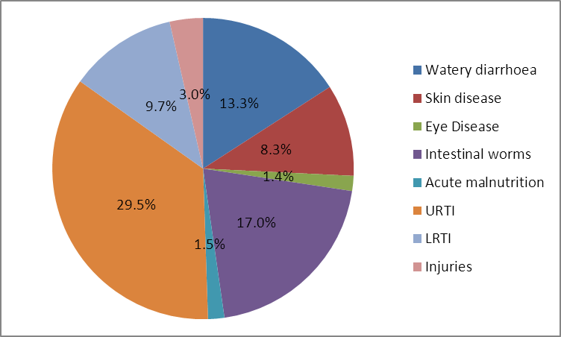

Nutrition Situation

The nutrition situation in the Dollo Ado camps has remained at or above the WHO emergency threshold for the past three years. In 2011 the situation escalated to a crisis level due to the rapid influx of refugees from Somalia fleeing famine due to drought and conflict. In 2012/3 collaborative efforts from all sectors saw the acute malnutrition prevalence reduce from an average of 41.9% in 2011 to 17.2 % in 2013. In 2013 however the change was not significant which indicates a fragile nutrition situation with possible further deterioration.

The anaemia level has remained high in the refugee camps without any significant improvement since their establishment. The level of anaemia among the children 6 to 59 months remained higher than 40% while that among women remained above 20%.

The current nutrition services and activities in the camps include:

- Targeted supplementary feeding programmes for moderately malnourished 6-59 months, pregnant and lactating women and patients with chronic illnesses such as TB and HIV
- Outpatient and inpatient therapeutic feeding programmes for severely malnourished children
- Blanket supplementary feeding programme for all children 6-59 months and pregnant and lactating women
- Infant and young child feeding support and promotion programme
- Periodic mass MUAC screening of children 6-59 months using a two step screening which includes weight for height measurements for children found at risk of acute malnutrition

From March 2012 to March 2013, the selective feeding in the programmes recorded a total of 15,565 admissions among children 6-59 months across the camps. As shown below, admissions to the selective feeding programmes showed a notable decrease in the second and third quarter of 2012, after which there was an increase in the third quarter. This could be attributed to an increased number of new arrivals and the second stage screening using weigh for height z- scores for children found at risk of being acutely malnourished.

Figure 2: Admissions to the selective feeding program (SC, OTP &TSFP) March 2012- March 2013 (Health Information System)
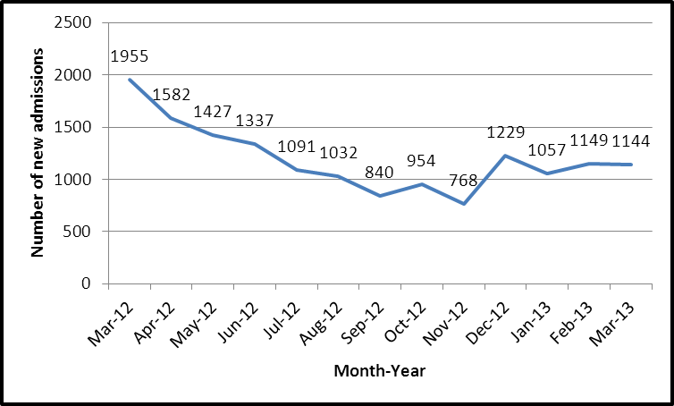

Water and sanitation situation

Dollo Ado is considered a ground water scarcity area. The quality and quantity of water is consistently affected by seasonal fluctuation and salinity issues. All camps except Melkadida were served by temporary water systems. Since March 2012, two permanent water systems have been completed which equates to a total of three permanent water systems. This has translated into a predictable water supply of reasonable quantity and quality that meets UNHCR standard. Hilaweyn and Buramino are still supplied with emergency water services. Since inception, Hilaweyn has received water through jet wells. The jet wells have been clogged and many are discontinued. Shallow wells along river banks now supply water to Hilaweyn Camp. Buramino water supply is via water trucking. A permanent water system for the two camps is under way.

Sanitation is a challenge in Dollo Ado Camps but most challenged in Buramino and Hilaweynas both camps are located on hard crystalline rock that makes pit excavation a very difficult task. Utilising heavy earth equipment, latrines have been excavated across all camps. UNHCR, in collaboration with partners, developed an innovative Urine Diversion and Dry toilet (UDDT) which reduces the cost of pit excavation and re-useability over time. This also represented a strategic shift from communal to household latrines. Urine diversion and dry toilets (UDDT) fall under the broader family of ecological sanitation where the main tenets are reuse recycle and reduce. A UDDT is a toilet that operates without water and has a divider so that with little effort, the user can divert the urine away from the faeces. The diverted urine is drained into the ground and atmosphere through an evapo-infiltration chamber with zero-human contact.

Hygiene promotion varies in the camps, with Bokolmanyo representing refugees from a cosmopolitan/ urban setting while the general hygiene promotion in other camps can generally be described as basic. The hygiene promotion team has documented many lessons on key hygiene practices and behavioural change. An example iswith handwashing after using a latrine as hand washing stations adjacent to a latrine were found to be ineffective across all the camps. Refugees preferred simple portable hand washing facilities owned by households. The general hygiene across camps has greatly improved but more time and resources is required for behavioural change.

The graph below shows the water supply trend since January 2012.
Figure 3: Trend in water supply in Dollo Ado camps

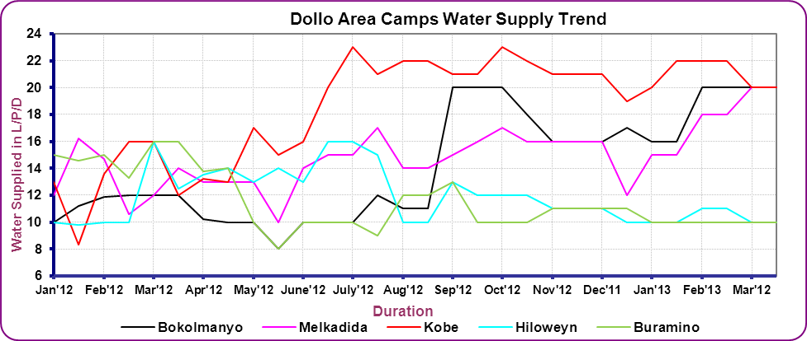

Sanitation continues to improve towared the UNHCR standard of twenty people per latrine. See figure 4 below with the trend of the latrine coverage across the months in 2012/3.
Figure 4: Trends of latrine coverage in Kobe and Hilaweyn, Dollo Ado camps

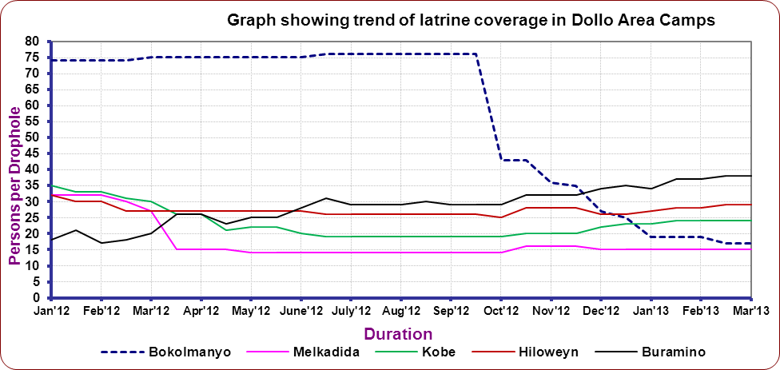

Survey Objectives
Specific primary objectives of the survey:
- To determine the prevalence of acute malnutrition among children 6-59 months
- To determine the prevalence of stunting among children 6-59 months
- To assess the two-week period prevalence of diarrhoea among children 6-59 months
- To assess crude and under-five mortality rates in the camps in the last three months
- To assess the prevalence of anaemia among children 6-59 months and women of reproductive age (non-pregnant, 15-49 years).
- To determine the coverage of measles vaccination among children 9-59 months
- To determine the coverage of vitamin A supplementation in the last six months among children 6-59 months and postnatal women
- To determine the coverage of deworming in the last six months among children 12-59 months
- To investigate IYCF practices among children 0-23 months
- To assess the coverage of blanket feeding programs for children 6-59 months
- To assess the proportion of households those use an adequate quantity of water per person per day
- To assess the proportion of households who say they are satisfied with their water supply
- To determine the coverage of ration cards and the duration the GFD ration lasts for recipient households
- To determine the extent to which negative coping strategies are used by households
- To assess household dietary diversity
- To establish recommendations on actions to be taken to address the situation
Secondary objectives:
- To determine the coverage of selective feeding programs for children 6-59 months
- To determine enrolment into Antenatal Care clinic and coverage of iron-folic acid supplementation in pregnant women

Methodology

Sample size

The sample size was calculated using the Standardized Monitoring and Assessment of Relief and Transitions (ENA for SMART) software following UNHCR SENS methodology. In each camp, the sample size was calculated based on the expected GAM prevalence and mortality rate. An estimated GAM prevalence figure of 15% was used in Bokolmanyo, 18% in Melkadida and Kobe, 21% in Hilaweyn, and 37% in Buramino. These were based on the 2012 survey results where the higher confidence interval range was considered as little was known about progress made since the last surveys. The same rationale was used to calculate the mortality sample size for all camps using 2012 survey results. The percentage of under-5 and average household size was also derived from the 2012 survey results that were considered to better reflect reality. The total population surveyed was derived from the ProGres database. A non-response rate of 10% was used in all camps expect Buramino where a non-response rate of 15% was used as the population is known to be quite mobile. A systematic random sampling methodology was used for all camps.

Table 2: Sample size calculation: Anthropometry and Mortality for the various Dollo Ado Camps
 |  | Bolkomanyo | Melkadida | Kobe |  | Hilaweyn |  |  |  | Buramino
Estimated prevalence (%) (survey 2012) |  | 15 | 18 | 18 |  | 21 |  |  |  | 37
± Desired precision (%) (UNHCR SENS guidelines) |  | 3.5 | 4 | 4 |  | 4 |  |  |  | 5
Average household size (surveys 2012) |  | 5.1 | 5.2 | 4.4 |  | 4.9 |  |  |  | 4.4
<5 population (%) (survey 2012) |  | 24 | 23 | 26 |  | 25 |  |  |  | 22
Non response households (NRR) (%) |  | 10 | 10 | 10 |  | 10 |  |  |  | 15
Total camp population (ProGres) |  | 40703 | 42575 | 32726 |  | 32075 |  |  |  | 36228
Children to be included |  | 382 | 341 | 339 |  | 378 |  |  |  | 341
Households to be included for Anthropometry and Health module (ENA for SMART) Including NRR |  | 386 | 352 | 366 |  | 380 |  |  |  | 461
Sample size calculation: Mortality
 | Bolkomanyo |  | Melkadida | Kobe |  |  | Hilaweyn |  | Buramino
Estimated rate (deaths/10,000/day) | 1 |  | 0.7 | 1 |  |  | 1.3 |  | 0.8
± Desired precision (deaths/10,000/day) (SMART guidelines) | 0.50 |  | 0.40 | 0.50 |  |  | 0.65 |  | 0.45
Average household size | 5.1 |  | 5.2 | 4.4 |  |  | 4.9 |  | 4.4
Recall period | 100 |  | 104 | 108 |  |  | 86 |  | 89
Non response households (%) | 10 |  | 10 | 10 |  |  | 10 |  | 15
Population to be included | 1481 |  | 1557 | 1364 |  |  | 1318 |  | 1629
Households to be included | 323 |  | 333 | 344 |  |  | 299 |  | 435

Final sample size for all modules:
Households to be included for Anthropometry and Health module and mortality (ENA for SMART) | 386 | 352 | 366 | 380 | 461
Households to be included for children Anaemia module (UNHCR SENS guidelines) | 386 | 352 | 366 | 380 | 461
Households to be included for IYCF module (UNHCR SENS Guidelines) | 386 | 352 | 366 | 380 | 461
Households to be included for women Anaemia module (UNHCR SENS guidelines) | 193 | 176 | 183 | 190 | 230
Households to be included for Food Security module (UNHCR SENS Guidelines) | 193 | 176 | 183 | 190 | 230
Households to be included for WASH module (UNHCR SENS Guidelines) | 193 | 176 | 183 | 190 | 230

Following SMART recommendations and little differences found between the anthropometric and mortality household sample sizes (<50 households difference), the values were compared and the higher value was chosen as the final sample size for the survey.

Sampling procedure

In each camp, a cross-sectional survey was conducted using systematic random sampling. Houses/tents were physically labeled with unique numbers per zone/block in each camp. To reduce the non-response rate and ensure results were representative of people actually living in the camps at the time of the survey, empty tents or shelter, as verified through neighbors were labeled but not included in the sampling frame. The sample size was estimated based on UNHCR registration ProGress data base for population data and the 2012 survey reports along with the current, known contextual information. The sampling interval per camp was calculated based on actual number of households/tents that were physically verified before the survey and the sample size.

Selecting households and sample subjects

Using the list generated from the physical counting and labeling of tents/ houses in the camps, a sampling interval for each camp was determined by dividing the total number of verified tents/houses by the estimated sample. The first household was thereafter determined randomly using the lottery method by drawing a random number within the sampling interval. The interval was applied across the sampling frame to generate a list of households to be surveyed in the field.

Each team was provided with a list of households to be surveyed on a daily basis. If an individual or an entire household was absent the teams were instructed to return to the household or revisit the absent individual up to two times on the same survey day. If they were unsuccessful after this, the individual or the household was recorded as absent and they were not replaced with another household or individual.

If the individual or an entire household refused to participate then it was considered a refusal and the individual or the household were not replaced with another.

If a selected child was living with a disability or a physical deformity preventing certain anthropometric measurements, the child was still included in the assessment of the other indicators.

If it was determined that a selected household did not have any eligible children, the relevant questionnaires were administered to the household.

If a selected child was found to be in the nutrition or health centre, the team went to the centre to take the measurements and the child’s information. If it is impossible to visit the centre, the child was given an ID number and considered as absent and not replaced. A note was made that the child was in a nutrition/health centre at the time of the survey. This recommendation differs from the standard SMART recommendation which considers nutrition surveys that are usually conducted in large geographic areas and where it is often not possible to go to the nutrition or health centre for measurement of the admitted child (ren).

Questionnaires

The questionnaires are attached in Appendix 3.

The questionnaires were prepared in English language and administered in Somali language via translators with pre-testing before the full survey.

Six module questionnaires were designed to provide information on the relevant indicators of the different target groups as indicated in the survey objectives. The six module questionnaires covered the following areas and the following measurements:

Module 1: Mortality- This included questions related to mortality in the last three months among the whole population.

Module 2: Food Security- This included questions on access and use of the GFD ration, us of negative coping mechanisms and household dietary diversity.

Module 3: Water- This included questions on the quantity of water used per household and the satisfaction with the drinking water supply.

Module 4: Women 15-49 years- This included questions and measures for women aged 15 – 49 years. Information relating to women’s pregnancy status, enrolment in ANC, coverage of iron-folic acid pills and post-natal vitamin A supplement and haemoglobin assessment for non-pregnant women was collected.

Module 5: Children 6-59 months- This included questions and measures for children aged 6-59 months. Information was collected on anthropometric status, oedema, enrolment in selective feeding programmes and blanket programmes (CSB++; CSB+), immunisation (measles), vitamin A supplementation in the last six months, morbidity from diarrhoea in past two weeks, morbidity from other causes in the past 2 weeks, and haemoglobin assessment.

Module 6: Children 0-23 months- This included questions on infant and feeding practices for children aged 0-23 months.

Measurement methods

Household-level indicators

Mortality: An individual-level mortality form similar to the 2012 nutrition survey was used. Data entry and analysis was done in ENA for SMART with the household-level summary data derived from the form.

Food security: The questionnaire adopted was the UNHCR’s Standardized Expanded Nutrition Survey Guidelines for Refugee Populations (Version 2; 2013)

Water: The questionnaire adopted was the UNHCR’s Standardized Expanded Nutrition Survey Guidelines for Refugee Populations (Version 1.3 March 2012)

Individual-level indicators

Sex of children: sex was recorded as male or female.

Birth date or age in months for children 0-59 months: the exact date of birth (day, month, and year) was recorded from birth certificates. Either an EPI card or child health card were used to determine the age in case there was no birth certificate. If no reliable proof of age was available, age was estimated in months using a local event calendar and was recorded in months on the questionnaire. If the child’s age could absolutely not be determined by using a local events calendar or by probing, the child’s length/height was used for inclusion; the child had to measure between 65 cm and 110 cm.

Age of women 15-49 years: unlike small children, the exact date of birth of women was not recorded. The reported age was recorded in years.

Weight of children 6-59 months: measurements were taken to the closest 100 grams using an electronic scale (SECA scale) with a wooden board to stabilise it on the ground. All children were weighed without clothes.

Height/Length of children 6-59 months: children’s height or length was taken to the closest millimetre using a wooden height board (Shorr Productions). Height was used to decide on whether a child should be measured lying down (length) or standing up (height). Children less than 87cm were measured lying down, while those greater than or equal to 87cm were measured standing up.

Oedema in children 6-59 months: bilateral oedema was assessed by applying gentle thumb pressure on to the tops of both feet of the child for a period of three seconds and thereafter observing for the presence or absence of an indent.

MUAC of children 6-59 months: MUAC was measured at the mid-point of the left upper arm between the elbow and the shoulder and taken to the closest millimetre using a standard tape. MUAC was recorded in millimetres.

Child enrolment in selective feeding programme for children 6-59 months: selective feeding programme coverage was assessed for the outpatient therapeutic programme and for the supplementary feeding programme.This was verified by card or by showing images of the products given at the different programs

Measles vaccination in children 6-59 months: measles vaccination was assessed by checking for the measles vaccine on the EPI card if available or by asking the caregiver to recall if no EPI card was available. For ease of data collection, results were recorded on all children but were only analysed for children aged 9-59 months

Vitamin A supplementation in last 6 months in children 6-59 months: whether the child received a vitamin A capsule over the past six months was recorded from the EPI card or health card if available or by asking the caregiver to recall if no card is available. A vitamin A capsule was shown to the caregiver when asked to recall.

Deworming: whether the child received a deworming tablet over the past six months was recorded from the EPI card or health card, if available, or by asking the caregiver to recall if no card is available. A deworming tablet image was shown to the caregiver when asked to recall.

Haemoglobin concentration in children 6-59 months and women 15-49 years: Hb concentration was taken from a capillary blood sample from the fingertip and recorded to the closest gram per decilitre by using the portable HemoCue Hb 301 Analyser (HemoCue, Sweden). If severe anaemia was detected, the child or the woman was referred for treatment immediately.

Diarrhoea in last 2 weeks in children 6-59 months: an episode of diarrhoea was defined as three loose stools or more in 24 hours. Caregivers were asked if their child had suffered episodes of diarrhoea in the past two weeks.

Other sickness rather than diarrhoea in last 2 weeks in children 6-59 months: whether the child was sick for any cause rather than diarrhoea; caregivers were asked if the child had suffered of any illness in the past two weeks.

ANC enrolment and iron and folic acid pills coverage: if the surveyed woman was pregnant, it was assessed by card or recall whether she was enrolled in the ANC programme and was receiving iron-folic acid pills.

Post-natal vitamin A supplementation: if the surveyed woman delivered a baby in the last six months, it was assessed by card or recall whether she had received vitamin A supplementation after delivery.

Infant and young child feeding practices in children 0-23 months: infant and young child feeding practices were assessed based on the UNHCR’s Standardized Expanded Nutrition Survey Guidelines for Refugee Populations (2013)

Referrals: Children aged 6-59 months were referred to health centre/post for treatment when MUAC was < 12.5 cm, when oedema was present, or when haemoglobin was < 7.0 g/dL. Women of reproductive age were referred to the hospital for treatment when haemoglobin was < 8.0 g/dL.

Case definitions and calculations

Mortality: The crude death rate (CMR) was expressed as the number of deaths per 10,000 persons per day. The formula below was applied:

Crude Death Rate (CMR) = 10,000/a*f/ (b+f/2-e/2+d/2-c/2)
Where:
a = Number of recall days
b = Number of current household residents
c = Number of people who joined household during recall period
d = Number of people who left household during recall period
e = Number of births during recall period
f = Number of deaths during recall period

Malnutrition in children 6-59 months: Acute malnutrition was defined using weight-for-height index values or the presence of oedema and classified as show in the table below. Main results are reported after analysis using the WHO 2006 Growth Standards. Results using the NCHS 1977 Growth Reference are reported in Appendix 4.

Table 3: Definitions of acute malnutrition using weight-for-height and/or oedema in children 6–59 months
Categories of acute malnutrition | Percentage of median (NCHS Growth Reference 1977 only) | Z-scores (NCHS Growth Reference 1977 and WHO Growth Standards 2006) | Bilateral oedema
Global acute malnutrition | <80% | < -2 z-scores | Yes/No
Moderate acute malnutrition | <80% to ≥70% | < -2 z-scores and ≥ -3 z-scores | No
Severe acute malnutrition | >70% | > -3 z-scores | Yes
Severe acute malnutrition | <70% | < -3 z-scores | Yes/No

Stunting, also known as chronic malnutrition was defined using height-for-age index values and was classified as severe or moderate based on the cut-offs shown below. Main results are reported according to the WHO Growth Standards 2006. Results using the NCHS Growth Reference 1977 are reported in Appendix 4.

Table 4: Definitions of stunting using height-for-age in children 6–59 months
Categories of stunting | Z-scores (WHO Growth Standards 2006 and NCHS Growth Reference 1977)
Stunting | <-2 z-scores
Moderate stunting | <-2 z-score and >=-3 z-score
Severe stunting | <-3 z-scores

Underweight was defined using the weight-for-age index values and was classified as severe or moderate based on the following cut-offs. Main results are reported according to the WHO Growth Standards 2006. Results using the NCHS Growth Reference 1977 are reported in Appendix 4.

Table 5: Definitions of underweight using weight-for-age in children 6–59 months
Categories of underweight | Z-scores (WHO Growth Standards 2006 and NCHS Growth Reference 1977)
Underweight | <-2 z-scores
Moderate underweight | <-2 z-scores and >=-3 z-scores
Severe underweight | <-3 z-scores

Mid Upper Arm Circumference (MUAC) values were used to define malnutrition according to the following cut-offs in children 6-59 months:

Table 6: MUAC malnutrition cut-offs in children 6-59 months
Categories of MUAC values
<125 mm
≥ 115 mm and <125 mm
< 115 mm

Child enrolment in selective feeding programme for children 6-59 months: Feeding programme coverage is estimated during the nutrition survey using the direct method as follows (reference: Emergency Nutrition Assessment: Guidelines for field workers. (Save the Children 2004):

Coverage of SFP programme (%) =
100 x
No. of surveyed children with MAM according to SFP admission criteria who reported being registered in SFP
No. of surveyed children with MAM according to SFP admission criteria

Coverage of TFP programme (%) =
100 x
No. of surveyed children with SAM according to OTP admission criteria who reported being registered in OTP
No. of surveyed children with SAM according to OTP admission criteria

Infant and young child feeding practices in children 0-23 months
Infant and young child feeding practices were assessed as follows based on the UNHCR SENS IYCF module (Version 1.3 (March 2012).

Timely initiation of breastfeeding in children aged 0-23 months:
Proportion of children 0-23 months who were put to the breast within one hour of birth
Children 0-23 months who were put to the breast within one hour of birth
Children 0-23 months of age

Exclusive breastfeeding under 6 months:
Proportion of infants 0–5 months of age who are fed exclusively with breast milk: (including expressed breast milk or from a wet nurse, ORS, drops or syrups (vitamins, breastfeeding minerals, medicines)
Infants 0–5 months of age who received only breast milk during the previous day
Infants 0–5 months of age

Continued breastfeeding at 1 year:
Proportion of children 12–15 months of age who are fed breast milk
Children 12–15 months of age who received breast milk during the previous day
Children 12–15 months of age

Introduction of solid, semi-solid or soft foods:
Proportion of infants 6–8 months of age who receive solid, semi-solid or soft foods
Infants 6–8 months of age who received solid, semi-solid or soft foods during the previous day
Infants 6–8 months of age

Children ever breastfed:
Proportion of children born in the last 24 months who were ever breastfed
Children born in the last 24 months who were ever breastfed
Children born in the last 24 months

Continued breastfeeding at 2 years:
Proportion of children 20–23 months of age who are fed breast milk
Children 20–23 months of age who received breast milk during the previous day
Children 20–23 months of age

Consumption of iron rich or iron fortified foods in children aged 6-23 months:
Proportion of children 6–23 months of age who receive an iron-rich or iron-fortified food that is specially designed for infants and young children, or that is fortified in the home.
Children 6–23 months of age who received an iron-rich food or a food that was specially designed for infants and young children and was fortified with iron, or a food that was
Fortified in the home with a product that included iron during the previous day
Children 6–23 months of age

Bottle feeding:
Proportion of children 0-23 months of age who are fed with a bottle
Children 0–23 months of age who were fed with a bottle during the previous day
Children 0–23 months of age

Anaemia in children 6-59 months and women of reproductive age: Anaemia was classified according to the following cut-offs in children 6-59 months and non-pregnant women of reproductive age. Pregnant women were not included in this surveys for the assessment of anaemia as recommended by UNHCR {pregnant women are not to be included in routine nutrition surveys for the assessment of anaemia due sample size issues, (usually a small number of pregnant women are found) as well as the difficulties in assessing gestational age in pregnant women)}.

Table 7: Definition of anaemia (WHO 2000)
Age/Sex groups | Categories of Anaemia (Hb g/dL)
Age/Sex groups | Total | Mild | Moderate | Severe
Children 6 - 59 months | <11.0 | 10.9 - 10.0 | 9.9 - 7.0 | < 7.0
Non-pregnant adult females 15-49 years | <12.0 | 11.9 - 11.0 | 10.9 - 8.0 | < 8.0

Classification of public health problems and targets

Mortality: The following thresholds were used for mortality.

Table 8: Mortality benchmarks for defining crisis situations (NICS, 2010)
Emergency threshold
CDR > 1/10,000 / day: ‘very serious’
CDR > 2 /10,000 /day: ‘out of control’
CDR > 5 /10,000 /day: ‘major catastrophe’
(double for U5MR thresholds)

Anthropometric data: The target for the prevalence of global acute malnutrition (GAM) for children 6-59 months of age by camp, country and region should be < 10% and the target for the prevalence of severe acute malnutrition (SAM) should be <2%. The table below shows the classification of public health significance of the anthropometric results for children under-5 years of age according to WHO:

Table 9: Classification of public health significance for children under 5 years of age
Prevalence % | Critical | Serious | Poor | Acceptable
Low weight-for-height | ≥20 | 15-19 | 10-14 | <10
Low height-for-age | ≥40 | 30-39 | 20-29 | <20
Low weight-for-age | ≥30 | 20-29 | 10-19 | <10

Selective feeding programmes:

UNHCR Strategic Plan for Nutrition and Food Security 2008-2012 includes the following indicators. The table below shows the targeted performance indicators for malnutrition treatment programmes according to UNHCR Strategic Plan for Nutrition and Food Security 2008-2012 (same as Sphere Standards).

Table 10: Performance indicators for selective feeding programmes (UNHCR Strategic Plan for Nutrition and Food Security 2008-2012)*
 | Recovery | Case fatality | Defaulter rate | Coverage
 |  |  |  | Rural areas | Urban areas | Camps
SFP | >75% | <3% | <15% | >50% | >70% | >90%
TFP | >75% | <10% | <15% | >50% | >70% | >90%
* Also meet SPHERE standards for performance

Measles vaccination coverage: UNHCR recommends target coverage of 95% (same as Sphere Standards).

Vitamin A supplementation coverage: UNHCR Strategic Plan for Nutrition and Food Security (2008-2012) states that the target for vitamin A supplementation coverage for children aged 6-59 months by camp, country and region should be >90%.

Anaemia data: UNHCR Strategic Plan for Nutrition and Food Security (2008-2010) states that the targets for the prevalence of anaemia in children 6-59 months of age and in women 15-49 years of age should be low i.e. <20%. The severity of the public health situation should be classified according to WHO criteria as shown in Table 13 below.

Table 11: Classification of public health significance (WHO 2000)
Prevalence % | High | Medium | Low
Anaemia | ≥40 | 20-39 | 5-19

WASH: Diarrhoea caused by poor water, sanitation and hygiene accounts for the annual deaths of over two million children under five years old globally. Diarrhoea contributes to the rate of malnutrition which subsequently leads to high infant and child morbidity and mortality. Refugee populations are often more vulnerable to public health risks and reduced funding can mean that long term refugee camps often struggle to ensure the provision of essential services, such as water, sanitation and hygiene. Hygienic conditions and adequate access to safe water and sanitation services is a matter of ensuring human dignity and is recognised as a fundamental human right. The following standards (amongst others) apply to UNHCR WASH programmes:

Table 12: UNHCR WASH Programme Standards
UNHCR Standard | Indicator
Average quantity of water available per person/day | > or = 20 litres

Training, coordination and supervision

The surveys were coordinated by three nutritionists (Terry Theuri (UNHCR), Mohammed Diaaeldin (UNICEF) and Daniel Takea (IMC) with supervision assistance from the health and nutrition managers from all the camps.

The surveys were undertaken by six teams for all camps with each team composed of six members: one mortality questionnaire enumerator, one IYCF/food security/water questionnaires enumerator, one anthropometric measurer, one hemoglobin (HB) measurer, one anthropometric measurement assistant and one HB measurement assistant. One of the six team members was also designated as the team leader. Outreach workers who were involved in labeling the tents/shelters to facilitate sampling acted as guides. The enumerators and measurers were qualified staff, while the HB assistants and the guides were incentive refugee staff. The teams were supervised on a daily basis.

A pre survey training orientation with the supervisors was carried out for two days to facilitate standardized enumerator trainings for all camps. The supervisor training was carried out on February 27 and 28, 2013. There were two enumerator trainings carried out on March 4 to 8 2013 in Bokolmanyo for the Bokolmanyo, Melkadida and Kobe surveys and in Dollo Ado on March 20 to 23 2013 for the Hilaweyn and Buramino surveys. The training lasted three days followed by a one day pre-test. The training focused on: the purpose and objectives of the survey, roles and responsibilities of each team member, familiarization with the questionnaires by reviewing the purpose of each question; interviewing skills and recording of data; interpretation of calendar of events and age determination; how to take anthropometric measurements and haemoglobin measurements and common errors; and finally a practical session on sampling procedures. The practical session on anthropometric measurements involved volunteer children for practice as well as a standardisation test. The practical session on haemoglobin measurements involved the trainees and trainers themselves as well as a standardisation test.

For the pre-test, three households were selected for each of the teams who administered the questionnaires and took the required measurements. The data collection tools were then reviewed based on the feedback from the field pre-test.

Data collection, entry and analysis

Data collection lasted for 17 days days from March 9 to 18 and March 24 to 30 2013, with three to four days spent in each camp. Each survey team explained the purpose of the survey and issues of confidentiality and obtained verbal consent before proceeding with the survey in the selected households. The informed consent form is shown in Appendix 3.

Data entry was completed at UNHCR sub-office in Dollo Ado for Buramino, Hilaweyn and Kobe camp surveys and at the Bokolmayo field office for the Bokolmanyo and Melkadida camp surveys. All questionnaires were manually checked for completeness, consistency and range before data entry by the supervisors and the coordination team. This check was also used to provide feedback to the teams to improve data collection as the survey progressed.

Data for children 6-59 months and mortality were entered using ENA for SMART software (November 24 2012 version). Data for children 0-23 months, women 15-49 years, food security indicators was entered using Epi Info Software (Centres for Disease Control, version 3.5.4). This was done by a GOAL data clerk specialist. After completion of the survey data entry, all entries were double checked one by one with the original questionnaire to ensure there were no data entry errors.

All data files were cleaned before analysis. Analysis was performed using ENA for SMART and Epi Info software.

The nutritional indices were cleaned using the flexible cleaning criteria from the observed mean (also known as SMART flags in the ENA for SMART software). This flexible cleaning approach is one that is recommended in the UNHCR Standardised Nutrition Survey Guidelines (Version 2013) in accordance with SMART recommendations. For the weight-for-height index, a cleaning window of +/- 3 SD value contained in the SMART for ENA software was used.

RESULTS FROM BOKOLMANYO

INDIVIDUAL-LEVEL INDICATORS-CHILDREN 6-59 MONTHS, 0-23 MONTHS, AND WOMEN OF REPRODUCTIVE AGE 15-49 YEARS - BOKOLMANYO CAMP, DOLLO ADO (MARCH 2013)

Table 13 shows the different population groups and the total number of individuals who were sampled within each group.

Table 13: Target sample size and actual number captured during the survey Bokolmanyo camp, Dollo Ado (March 2013)
Target group | Target  sample size | Subjects measured/interviewed during the survey | % of the target
Children 6-59 months | 382 | 405 | 106%
Children 0-23 months | 153 | 172 | 112.4%
Women 15-49 years | 193* | 192* | 99.5%
*Households

Anthropometric results (based on WHO Growth Standards 2006)
The coverage of age documentation was 25% (children having an exact birth date). This means that the stunting and the underweight data should be interpreted with caution owing to the age unreliability

Table 14: Distribution of age and sex of sample-Bokolmanyo camp, Dollo Ado (March 2013)
 | Boys |  | Girls |  | Total |  | Ratio
AGE (mo) | no. | % | no. | % | no. | % | Boy:girl
6-17 | 33 | 39.8 | 50 | 60.2 | 83 | 20.2 | 0.7
18-29 | 52 | 55.3 | 42 | 44.7 | 94 | 22.9 | 1.2
30-41 | 43 | 53.8 | 37 | 46.3 | 80 | 19.5 | 1.2
42-53 | 46 | 43.8 | 59 | 56.2 | 105 | 25.5 | 0.8
54-59 | 25 | 51.0 | 24 | 49.0 | 49 | 11.9 | 1.0
Total | 199 | 48.4 | 212 | 51.6 | 411 | 100.0 | 0.9

The overall sex ratio was 0.9 (sex ratio should be between 0.8-1.2), which confirms that both sexes were equally distributed.

Table 15: Prevalence of acute malnutrition based on weight-for-height z-scores (and/or oedema) and by sex- Bokolmanyo camp, Dollo Ado (March 2013)
 | All  n = 405 | Boys  n = 196 | Girls  n = 209
Prevalence of global malnutrition  (<-2 z-score and/or oedema) | (56) 13.8 %  (10.8 - 17.5 95% C.I.) | (26) 13.3 %  (9.2 - 18.7 95% C.I.) | (30) 14.4 %  (10.2 - 19.8 95% C.I.)
Prevalence of moderate malnutrition  (<-2 z-score and >=-3 z-score, no oedema) | (51) 12.6 %  (9.7 - 16.2 95% C.I.) | (23) 11.7 %  (7.9 - 17.0 95% C.I.) | (28) 13.4 %  (9.4 - 18.7 95% C.I.)
Prevalence of severe malnutrition  (<-3 z-score and/or oedema) | (5) 1.2 %  (0.5 - 2.9 95% C.I.) | (3) 1.5 %  (0.5 - 4.4 95% C.I.) | (2) 1.0 %  (0.3 - 3.4 95% C.I.)
The prevalence of oedema is 0.0%
There was no difference between boys and girls in the prevalence of acute malnutrition.

Figure 5: Nutrition survey (GAM, SAM) results since 2010- Bokolmanyo camp, Dollo Ado (March 2013)
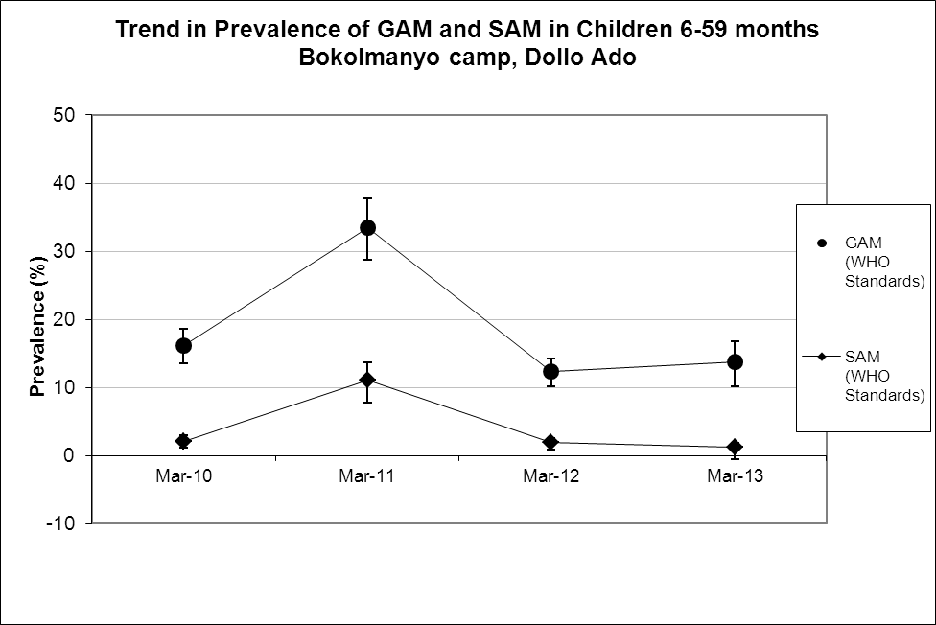
Comparison of the 2013 results with 2012 shows no statististically significant change in GAM and SAM among children 6-59 months (p>0.05).

Table 16: Prevalence of acute malnutrition by age, based on weight-for-height z-scores and/or oedema- Bokolmanyo camp, Dollo Ado (March 2013)
 |  | Severe wasting  (<-3 z-score) |  | Moderate wasting  (>= -3 and <-2 z-score ) |  | Normal  (> = -2 z score) |  | Oedema
Age (mo) | Total no. | No. | % | No. | % | No. | % | No. | %
6-17 | 79 | 4 | 5.1 | 10 | 12.7 | 65 | 82.2 | 0 | 0.0
18-29 | 93 | 1 | 1.1 | 13 | 14.0 | 79 | 84.9 | 0 | 0.0
30-41 | 80 | 0 | 0.0 | 4 | 5.0 | 76 | 95.0 | 0 | 0.0
42-53 | 104 | 0 | 0.0 | 11 | 10.6 | 93 | 89.4 | 0 | 0.0
54-59 | 49 | 0 | 0.0 | 13 | 26.5 | 36 | 73.5 | 0 | 0.0
Total | 405 | 5 | 1.2 | 51 | 12.6 | 349 | 86.2 | 0 | 0.0

Figure 6: Trends in the prevalence of wasting by age in children 6-59 months- Bokolmanyo camp, Dollo Ado (March 2013)
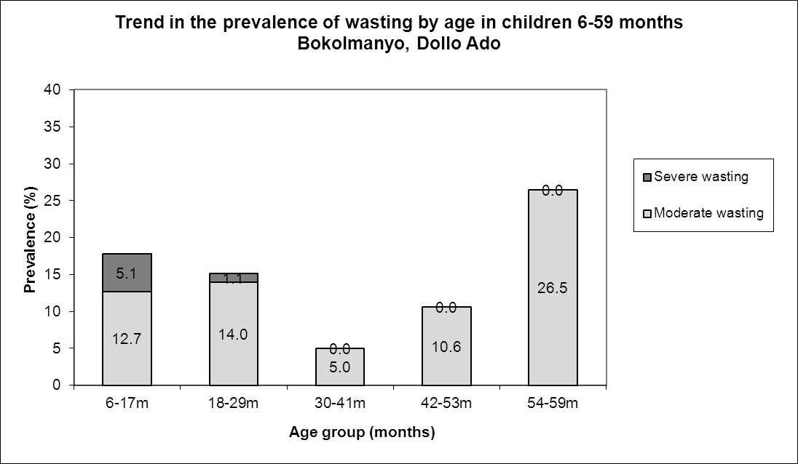

Children in age group 6-17 months and 54-59 tend to be most affected by wasting in Bokolmanyo.

Table 17: Distribution of severe acute malnutrition and oedema based on weight-for-height z-scores- Bokolmanyo camp, Dollo Ado (March 2013)
 | <-3 z-score* | >=-3 z-score
Oedema present | Marasmic kwashiorkor  No. 0  (0.0 %) | Kwashiorkor  No. 0  (0.0 %)
Oedema absent | Marasmic  No. 7  (1.7 %) | Not severely malnourished  No. 403  (98.3 %)
*Includes Flags

The figure shows that the weight-for-height z-score distribution is shifted to the left, illustrating a poorer status than the international WHO Standard population of children aged 6-59 months.

Figure 7: Distribution of weight-for-height z-scores (based on WHO Growth Standards; the reference population is shown in green) of survey population compared to reference population-
Bokolmanyo camp, Dollo Ado (March 2013)

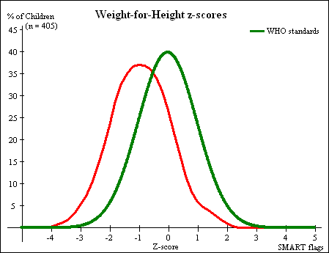

Table 18: Prevalence of stunting based on height-for-age z-scores and by sex- Bokolmanyo camp, Dollo Ado (March 2013)
 | All  n = 407 | Boys  n = 196 | Girls  n = 211
Prevalence of stunting  (<-2 z-score) | (49) 12.0 %  (9.2 - 15.6 95% C.I.) | (20) 10.2 %  (6.7 - 15.2 95% C.I.) | (29) 13.7 %  (9.7 - 19.0 95% C.I.)
Prevalence of moderate stunting  (<-2 z-score and >=-3 z-score) | (34) 8.4 %  (6.0 - 11.4 95% C.I.) | (11) 5.6 %  (3.2 - 9.8 95% C.I.) | (23) 10.9 %  (7.4 - 15.8 95% C.I.)
Prevalence of severe stunting  (<-3 z-score) | (15) 3.7 %  (2.2 - 6.0 95% C.I.) | (9) 4.6 %  (2.4 - 8.5 95% C.I.) | (6) 2.8 %  (1.3 - 6.1 95% C.I.)

Table 19: Prevalence of stunting by age based on height-for-age z-scores- Bokolmanyo camp, Dollo Ado (March 2013)
 |  | Severe stunting  (<-3 z-score) |  | Moderate stunting  (>= -3 and <-2 z-score ) |  | Normal  (> = -2 z score)
Age (mo) | Total no. | No. | % | No. | % | No. | %
6-17 | 80 | 6 | 7.5 | 6 | 7.5 | 68 | 85.0
18-29 | 94 | 7 | 7.4 | 12 | 12.8 | 75 | 79.8
30-41 | 79 | 0 | 0.0 | 8 | 10.1 | 71 | 89.9
42-53 | 105 | 1 | 1.0 | 8 | 7.6 | 96 | 91.4
54-59 | 49 | 1 | 2.0 | 0 | 0.0 | 48 | 98.0
Total | 407 | 15 | 3.7 | 34 | 8.4 | 358 | 88.0
Children in the age groups 6-17 and 18-29 months tend to be the most affected by stunting as compared to the other age groups.
Figure 8: Trends in the prevalence of stunting by age in children 6-59 months- Bokolmanyo camp, Dollo Ado (March 2013)
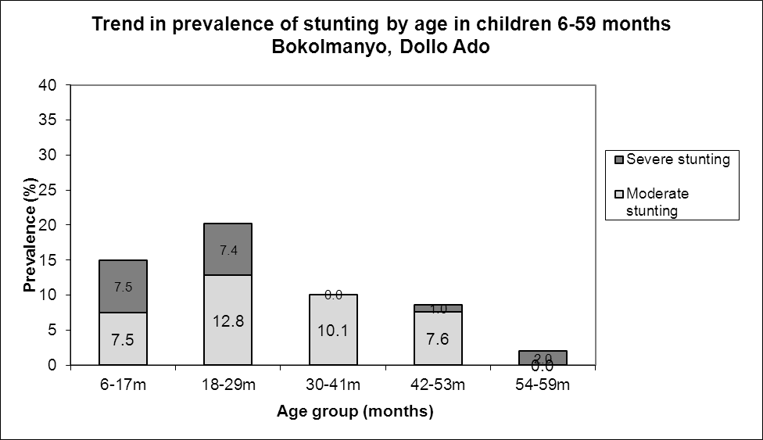

Table 20: Prevalence of underweight based on weight-for-age z-scores by sex- Bokolmanyo camp, Dollo Ado (March 2013)
 | All  n = 406 | Boys  n = 196 | Girls  n = 210
Prevalence of underweight  (<-2 z-score) | (57) 14.0 %  (11.0 - 17.8 95% C.I.) | (26) 13.3 %  (9.2 - 18.7 95% C.I.) | (31) 14.8 %  (10.6 - 20.2 95% C.I.)
Prevalence of moderate underweight  (<-2 z-score and >=-3 z-score) | (51) 12.6 %  (9.7 - 16.1 95% C.I.) | (22) 11.2 %  (7.5 - 16.4 95% C.I.) | (29) 13.8 %  (9.8 - 19.1 95% C.I.)
Prevalence of severe underweight  (<-3 z-score) | (6) 1.5 %  (0.7 - 3.2 95% C.I.) | (4) 2.0 %  (0.8 - 5.1 95% C.I.) | (2) 1.0 %  (0.3 - 3.4 95% C.I.)

Table 21: Mean z-scores, Design Effects and excluded subjects - Bokolmanyo camp, Dollo Ado (March 2013)

Indicator | n | Mean z-scores ± SD | Design Effect (z-score < -2) | z-scores not available* | z-scores out of range
Weight-for-Height | 405 | -0.92±0.99 | 1.00 | 1 | 5
Weight-for-Age | 406 | -1.07±0.87 | 1.00 | 0 | 5
Height-for-Age | 407 | -0.86±1.01 | 1.00 | 1 | 3

MUAC was used in the community for screening and admission to therapeutic and supplementary feeding programmes.

Table 22: Prevalence of MUAC malnutrition- Bokolmanyo camp, Dollo Ado (March 2013)
 | All  n = 410 | Boys  n = 198 | Girls  n = 212
Prevalence of MUAC  (< 125 mm and/or oedema) | (18) 4.4 %  (2.8 - 6.8 95% C.I.) | (7) 3.5 %  (1.7 - 7.1 95% C.I.) | (11) 5.2 %  (2.9 - 9.1 95% C.I.)
Prevalence of MUAC  (< 125 mm and >= 115 mm, no oedema) | (13) 3.2 %  (1.9 - 5.3 95% C.I.) | (5) 2.5 %  (1.1 - 5.8 95% C.I.) | (8) 3.8 %  (1.9 - 7.3 95% C.I.)
Prevalence of MUAC  (< 115 mm and/or oedema) | (5) 1.2 %  (0.5 - 2.8 95% C.I.) | (2) 1.0 %  (0.3 - 3.6 95% C.I.) | (3) 1.4 %  (0.5 - 4.1 95% C.I.)

The case load for the selective feeding programmes was estimated to aid in programme planning. The Bokolmanyo population used during the survey was 40703. Based on the survey results 23.3% children were found to be under 5 years (total of 9484) and hence a total of 8536 children were estimated to be between 6-59 months (assuming that 10% of under-5 are 0-5 months).

Table 23: Estimated number of malnourished children aged 6-59 months eligible to be enrolled in a selective feeding programme at the time of the survey (based on all admission criteria)- Bokolmanyo camp, Dollo Ado (March 2013)
 | Total/number | % (95% CI) | N (LCI-UCI)*
Eligible for therapeutic feeding programme** | 5/405 | 1.2 (0.5-2.9) | 102 (43-248)
Eligible for supplementary feeding programme** | 51/405 | 12.6 (9.7-16.2) | 1076 (828-1383)
*LCI=Lower Confidence Interval; UCI: Upper Confidence Interval
**WHZ flags excluded from analysis

Using the HIS data for week 11 there were 62 children enrolled in the therapeutic feeding program which was 0.7% of children 6-59 months while 372 were enrolled in the supplementary feeding program which was 4.4% of children 6-59 months.

Anaemia results

Table 24: Prevalence of anaemia and haemoglobin concentration in children 6-59 months of age - Bokolmanyo camp, Dollo Ado (March 2013)
Anaemia – Children 6-59 months | All  n = 409
Total Anaemia (Hb<11.0 g/dL) | (191) 46.7 %  (41.8-51.7 95% CI)
Mild Anaemia (Hb 10.0-10.9 g/dL) | (96) 23.5 %  (19.5-27.5 95% CI)
Moderate Anaemia (7.0-9.9 g/dL) | (92) 22.5 %  (18.6-26.9 95% CI)
Severe Anaemia (<7.0 g/dL) | (3) 0.7 %  (0.2-2.3 95% CI)
Mean Hb (g/dL) | 10.9 g/dL  (2.27SD)  [5.0 min,14.5 max]

Comparison with results from 2012 where the total anaemia was 50.2 %( 46.6-53.0 95%CI) shows no significant change in the anaemia prevalence among children 6-59 months (p>0.05).

Figure 9: Nutrition survey results (anaemia in children 6-59 months) since 2011- Bokolmanyo camp, Dollo Ado (March 2013)

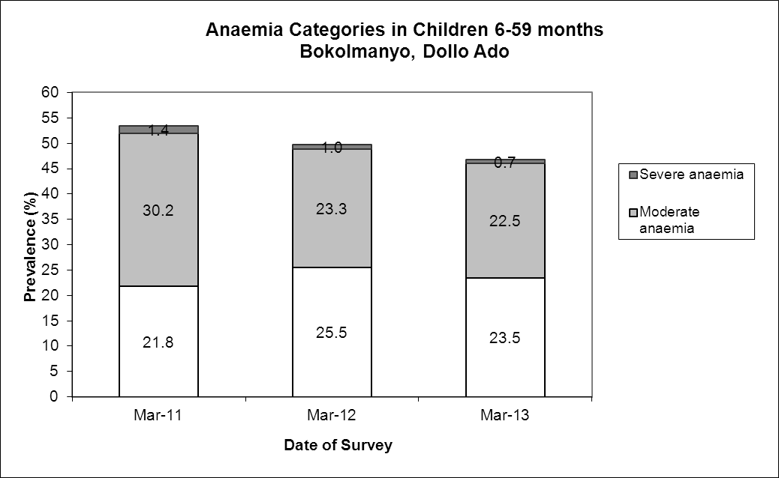

There was no significant increase in the mean haemoglobin concentration in children 6-59 months in 2013 compared to 2012(p> 0.05)

Figure 10: Mean haemoglobin concentration in children 6-59 months from 2011-2012 Bokolmanyo camp, Dollo Ado (March 2013)

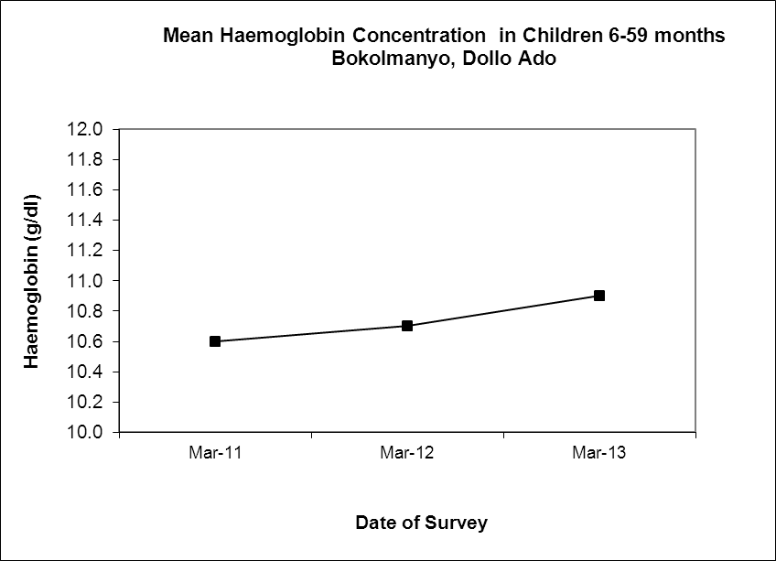

The 6-23 months age group had the highest prevalence of anaemia of 66.4%. Prevalence of anaemia declined with increasing age. These age trends are similar to those seen in 2012. Comparison with results from 2012 shows there was no significant decrease in ages 6-23months (p>0.05)

Table 25: Prevalence of anaemia by age- Bokolmanyo camp, Dollo Ado (March 2013)
 |  | Severe Anaemia  (<7.0 g/dL) |  | Moderate Anaemia  (7.0-9.9 g/dL) |  | Mild Anaemia (Hb 10.0-10.9 g/dL) |  | Total Anaemia (Hb<11g.0 g/dL) |  | Normal (Hb≥11.0 g/dL)
Age (mths) | Total no. | No. | %  (95% CI) | No. | %  (95% CI) | No. | %  (95% CI) | No. | %  (95% CI) | No. | %  (95% CI)
6-23 | 125 | 3 | 2.4  (0.5-6.9) | 46 | 36.8  (28.4-45.9) | 34 | 27.2  (19.6-35.9) | 83 | 66.4  (57.4-74.6) | 42 | 33.6  (25.4-42.6)
24-35 | 72 | 0 | 0 | 25 | 34.7  (23.9-46.9) | 21 | 29.2  (19.0-41.1) | 46 | 63.9  (51.7-74.9) | 26 | 36.1  (25.1-48.3)
36-59 | 212 | 0 | 0 | 21 | 9.9  (6.2-14.7) | 41 | 19.3  (14.3-25.3) | 62 | 29.2  (23.2-35.9) | 150 | 70.8  (64.1-76.8)
Total | 409 | 3 | 0.7  (0.2-2.3) | 92 | 22.5  (18.6-26.9) | 96 | 23.5  (19.5-27.9) | 191 | 46.7  (41.8-51.7) | 218 | 53.3  (41.8-51.7)

Programme coverage

Selective feeding programme**

Table 26: Nutrition treatment programme coverage based on all admission criteria (weight-for-height, MUAC, oedema) – Bokolmanyo camp, Dollo Ado (March 2013)
 | Number/total | % (95% C.I.)
Proportion of children aged 6-59 months with severe acute malnutrition currently enrolled in therapeutic feeding programme* | 3/7 | 42.9 (9.9-81.6)
Proportion of children aged 6-59 months with moderate acute malnutrition currently enrolled in supplementary feeding programme* | 16/56 | 28.6(17.3-42.2)
*WHZ flags excluded from analysis

Table 27: Nutrition treatment programme coverage based on MUAC and oedema only- Bokolmanyo camp, Dollo Ado (March 2013)
 | Number/total | % (95% CI)
Proportion of children aged 6-59 months with severe acute malnutrition currently enrolled in therapeutic feeding programme | 2/4 | 50 (6.8-93.2)
Proportion of children aged 6-59 months with moderate acute malnutrition currently enrolled in supplementary feeding programme | 5/13 | 38.5 (13.9-68.4)
**Selective feeding programme coverage results should be interpreted with caution due to small number of cases that were sampled during the survey.

Vaccination and supplementation programmes

Measles vaccination coverage

Table 28: Measles vaccination coverage for children aged 9-59 months (n= 510) - Bokolmanyo camp, Dollo Ado (March 2013)
 | Measles  (with card)  n=113 | Measles  (with card or confirmation from mother)  n=355
YES | 29.0 %  (24.6-33.8.0 95% CI) | 91.0 %  (87.7-93.7 95% CI)

Vitamin A supplementation coverage

Table 29: Vitamin A supplementation for children aged 6-59 months within past 6 months (n=540) - Bokolmanyo camp, Dollo Ado (March 2013)
 | Vitamin A capsule  (with card)  n=81 | Vitamin A capsule  (with card or confirmation from mother)  n=391
YES | 19.8 %  (16.1- 24.0 95% CI) | 95.4 %  92.7-97.1 95% CI)

Comparison with results from 2012 shows a significant increase in measles vaccination and vitamin A supplementation (within past six months) coverage among children 6-59 months (p<0.05).

Figure 11: Nutrition survey results (measles vaccination and vitamin A supplementation within past 6 months with card or recall) since 2011- Bokolmanyo camp, Dollo Ado (March 2013)
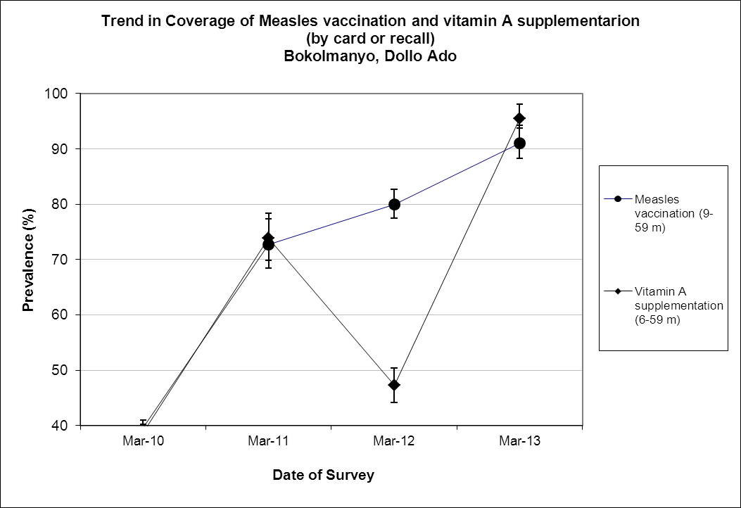

Deworming coverage

Table 30: Deworming for children aged 12-59 months within past 6 months (n=360) –Bokolmanyo camp, Dollo Ado (March 2013)

 | Deworming  (with card)  n=63 | Deworming  (with card or confirmation from mother)  n=353
YES | 17.5%  (13.8-21.9 95% CI) | 98.1 %  (95.9-99.1 95% CI)

Blanket supplementary feeding program (BSFP)

Blanket supplementary feding using CSB++ targeted all children 6-59 months from January 2013.

Table 31: BSFP programme for children aged 6-59 months- Bokolmanyo camp, Dollo Ado (March 2013)
 | Age | Number/total | % (95% CI)
Currently receiving CSB++ | 6-59 | 362/411 | 88.1  (84.5-91.0 95% CI

Morbidity and health seeking behaviour

Of children 6-59 months of age, 5.8 % (3.9-8.7 95% CI) had experienced diarrhoea two weeks prior to the survey date. Out of the 51 (12.4%) surveyed that was sick two weeks prior to the survey including diarroea, only 56.9% (42.2- 70.795% CI) of mothers sought help from the health services provided in the camp. Compared to 2012 the reported morbidity caseload (diarrhoea and other diseases) remained the same.

Table 32: Prevalence of diarrhoea and disease in children 6-59 months and health seeking behaviour among mothers of children 6-59 months
 | Number/total | % (95% CI)
Diarrhoea last two weeks (6-59 months) | 24/411 | 5.8 (3.9 – 8.7)
Children sick in the last two weeks (6-59 months) | 51/411 | 12.4 (9.5 – 16.1)
Proportion of mothers with sick children who sought assistance | 29/51 | 56.9(42.2 – 70.7)

CHILDREN 0-23 MONTHS- BOKOLMANYO CAMP, DOLLO ADO (MARCH 2013)

Table 33: Prevalence of Infant and Young Child Feeding Practices indicators- Bokolmanyo camp, Dollo Ado (March 2013)
Indicator | Age range | Number/total | Prevalence (%) | 95% CI
Children ever breastfed | 0-23 months | 167/172 | 97.1 | (93.3-99.0)
Timely initiation of breastfeeding | 0-23 months | 134/167 | 80.2 | (72.2-85.0)
Exclusive breastfeeding under 6 months | 0-5 months | 21/50 | 42.0 | (28.2-56.8)
Continued breastfeeding at 1 year | 12-15 months | 17/21 | 81.0 | (58.1-94.6)
Continued breastfeeding at 2 years | 20-23 months | 16/29 | 55.2 | (35.7-73.6)
Introduction of solid, semi-solid or soft foods | 6-8 months | 10/28 | 35.7 | (18.6-55.9)
Children bottle fed | 0-23 months | 36/172 | 20.9 | (15.1-27.8)
Consumption of iron rich or iron fortified foods | 6-23 months | 93/115 | 80.9 | (72.5-87.6)

The confidence intervals are an integral part of the results when analysing trends over the years. When IYCF indicators are collected in nutritional surveys, it is not feasible to achieve a large enough sample size for some of the indicators to be estimated as precisely as desired, especially for indicators covering a very narrow age range (e.g. 12-15 months, 6-8 months). Hence, trend analyses need to be interpreted with caution. Nevertheless, trend analyses are useful for assessing the situation and major differences seen from year to year should warrant further investigation.

Exclusive breastfeeding, timely introduction of semi-solid or soft foods improved compared to the 2012 survey but the consumption of iron-rich or ironfortified foods decreased. The rest of the indicators remained the same.

Figure 12: Nutrition survey results (key IYCF indicators) since 2012- Bokolmanyo camp, Dollo Ado (March 2013)
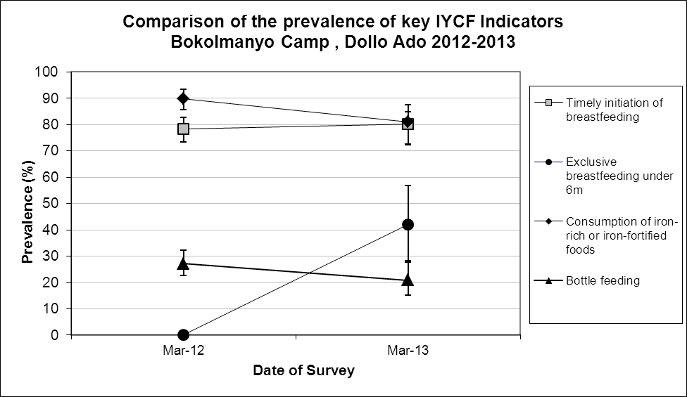

Prevalence of intake
Infant formula
Table 34: Infant formula intake in children aged 0-23 months
 | Number/total | % (95% CI)
Proportion of children aged 0-23 months who receive infant formula (fortified or non-fortified) | 19/171 | 11.1 (6.8-16.8)

Fortified blended foods
Table 35: CSB+ intake in children aged 6-23 months
 | Number/total | % (95% CI)
Proportion of children aged 6-23 months who receive FBF | 38/117 | 32.5 (24.1-41.8)

Table 36: CSB++ intake in children aged 6-23 months
 | Number/total | % (95% CI)
Proportion of children aged 6-23 months who receive FBF++ | 72/117 | 61.5 (52.1-70.4)

WOMEN 15-49 YEARS - BOKOLMANYO CAMP, DOLLO ADO (MARCH 2013)

Table 37: Demographic information- Bokolmanyo camp, Dollo Ado (March 2013)
Physiological status | Number/total | %
Non-Pregnant | 140/175 | 80.0
Pregnant | 35/175 | 20.0
Mean age (range) | 30.0 years (15-48)

Table 38: Prevalence of anaemia and haemoglobin concentration in non-pregnant women of reproductive age (15-49 years) - Bokolmanyo camp, Dollo Ado (March 2013)
Anaemia – Non-pregnant women of reproductive age 15-49 years | All  n = 138
Total Anaemia (<12.0 g/dL) | (47) 34.1%  (26.2-42.6 95% CI)
Mild Anaemia (11.0-11.9 g/dL) | (21) 15.2%  (9.7-22.3 95% CI)
Moderate Anaemia (8.0-10.9 g/dL) | (23) 16.7 %  (10.9-24.095% CI)
Severe Anaemia (<8.0 g/dL) | (3) 2.2%  (0.5-6.2 95% CI)
Mean Hb (g/dL) | 12.3g/dL  (1.57SD)  [7.3min, 16.2max]

Comparison with results from 2012 (28.0%) shows no statistically significant change in the prevalence of anaemia among non-pregnant women of reproductive age (p>0.05).

Figure 13: Anaemia categories in women of reproductive age from 2012 to 2013- Bokolmanyo camp, Dollo Ado (March 2013)
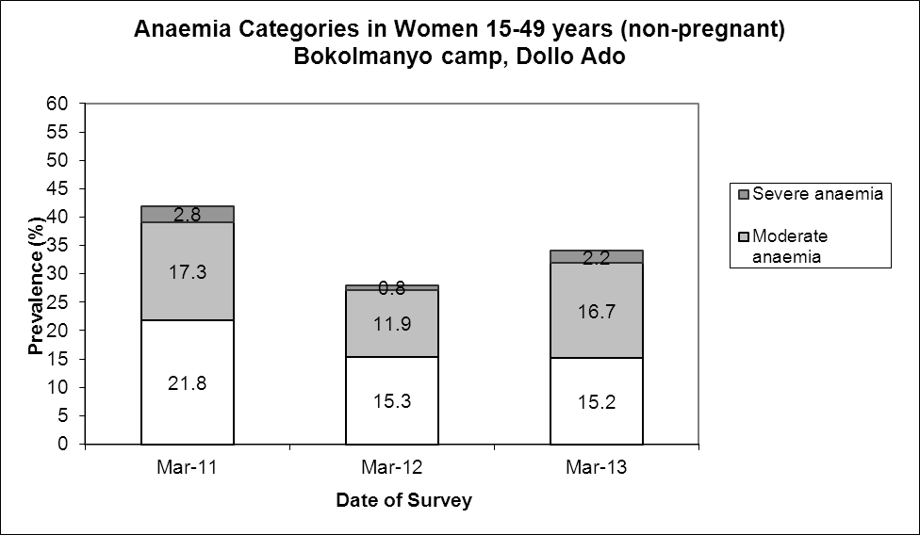

ANC enrolment and iron-folic acid supplementation coverage

Table 39: ANC enrolment and iron-folic acid pills coverage among pregnant women (15-49 years) - Bokolmanyo camp, Dollo Ado (March 2013)
 | Number/total | % (95% CI)
Currently enrolled in ANC programme | 30/34 | 88.2 (72.5-96.7)
Currently receiving iron-folic acid pills | 26/34 | 76.5 (58.8-89.3)

Table 40: Post-natal vitamin A supplementation among women (15-49 years) - Bokolmanyo camp, Dollo Ado (March 2013)
 | Number/total | % (95% CI)
Received vitamin A supplementation since delivery | 23/28 | 82.1 (63.1-93.9)

HOUSEHOLD-LEVEL INDICATORS- WATER, FOOD SECURITY AND MORTALITY- BOKOLMANYO CAMP, DOLLO ADO (MARCH 2013)

Table 41 shows the different indicators and the total number of households that were sampled for each household-level indicator. All households were considered whether or not they had eligible individuals for the individual-level measurements.
Table 41: Target sample size and actual number captured during the survey- Bokolmanyo camp, Dollo Ado (March 2013)
Indicator | Target  sample size | Household interviewed during the study | % of the target
Water | 193 | 183 | 94.8
Food security | 193 | 192 | 99.5
Mortality | 386 | 376 | 97.4

WATER- BOKOLMANYO CAMP, DOLLO ADO (MARCH 2013)

Table 42: Water Quantity: Amount of litres of water used per person per day-Bokolmanyo camp, Dollo Ado (March 2013)
Proportion of households that access: | Number/total | % (95% CI)
≥ 20 litres | 60/178 | 33.7(26.8-41.2)
15 – <20 litres | 35/178 | 19.7 (14.1-26.3)
<15 litres | 83/178 | 46.6(39.1-54.2)

The average water usage in lpppd: 18.3 lpppd

Table 43: Satisfaction with water supply- Bokolmanyo camp, Dollo Ado (March 2013)
 | Number/total | % (95% CI)
Proportion of households that say they are satisfied with the drinking water supply | 129/183 | 70.5(63.3-77.0)

22.4 (16.6-29.1 CI) of the surveyed household reported to not be satisfied with the water supply while a further 7.1% (3.8-11.8CI) reported to only be partially satisfied. The main reasons for the dissatisfaction were irregular supply (39.0%), long distance to the water point (24.4%); long waiting queues (17.1%), not enough water (12.2%), bad quality (4.9%) and due to bad taste (2.4%).

FOOD SECURITY- BOKOLMANYO, DOLLO ADO, (MARCH 2013)

Food distribution
Table 44: Ration card coverage- Bokolmanyo camp, Dollo Ado (March 2013)
 | Number/total | % (95% CI)
Proportion of households that received the general food ration | 192/192 | 100 (100-100)

The general food ration lasts at most 61.3 % of the intended theoretical duration of 30 days.

Table 45: Reported duration of general food ration 1- Bokolmanyo camp, Dollo Ado (March 2013)
Average number of days the food ration lasts (Standard deviation ) | Average duration (%) in relation to the theoretical duration of the ration
18.4 (4.67) | 61.3

The proportion of households reporting that their food ration lasted for 30 days was 3.1%.
80.7% of all the households reported that the general food ration received in the previously completed cycle had lasted less than 22.5 days (75% of cycle).

Table 46: Reported duration of general food ration 2 - Bokolmanyo camp, Dollo Ado (March 2013)
Number/total
(% (95% CI)
Proportion of households reporting that the food ration lasts the entire duration of the cycle | 6/192  3.1(1.2-6.7)
Proportion of households reporting that the food ration lasted:
≤75% of the cycle [0-22 days] | 155/192  80.7 (74.4-86.1)
>75% of the cycle [23-30 days] | 37/192  19.3(13.9-25.6)

Negative household coping strategies

The most common coping strategies used by households in Bokolmanyo camp was borrowing of cash, food or other items with/without interest and a reduction in the quantity and/or frequency of meals. 12.8% sent at least one child to work outside the household in order obtain cash or in-kind goods or services. A small proportion (3.1%) reportedlyengaged in risky or harmful activities

The proportion of households who reported that they did not use any of the coping strategies was 10.4%. This improved compared to the 2012 survey where the proportion was 3.5%; p<005.

Table 47: Coping strategies used by the surveyed population over the past month- Bokolmanyo camp, Dollo Ado (March 2013)
 | Number/total | % (95% CI)
Borrowed cash, food or other items with or without intrest | 140/192 | 72.9(66.0-79.1)
Sold any assets (furniture, seed stocks, tools, other NFI, livestock etc.) | 36/192 | 18.8(13.5-25.0)
Requested increase remittances or gifts as compared to normal | 8/192 | 4.2(1.8-8.0)
Reduced the quantity and/or frequency of meals | 96/192 | 50.0(42.7-57.3)
Begged | 36/156 | 18.8(13.5-25.0)
Engaged in potentially risky or harmful activities | 6/192 | 3.1(1.2-6.7)
Sent at least one child to work outside the household in order get cash or in-kind goods or services | 18/141 | 12.8(7.7-19.4)
Proportion of households reporting using none of the coping strategies over the past month | 20/192 | 10.4(6.5-15.6)

Household dietary diversity

The average household dietry diversity score was 5.7. There was no statistically significant change when compared with the average in 2012 of 3.3; p>0.05.

Table 48: Average Household Diet Diversity Score- Bokolmanyo camp, Dollo Ado (March 2013)
Average HDDS | Mean  (Standard deviation)
 | 5.7(1.4)

Fats and cereals (99.5%), sweets (86.5%) were the three most consumed food groups in Bokolmanyo camp, while white tubers (7.3%) fish/sea food (2.1%) and eggs (1.6%) were the least consumed.

Figure 14: Proportion of households consuming different food groups within last 24 hours- Bokolmanyo camp, Dollo Ado (March 2013)
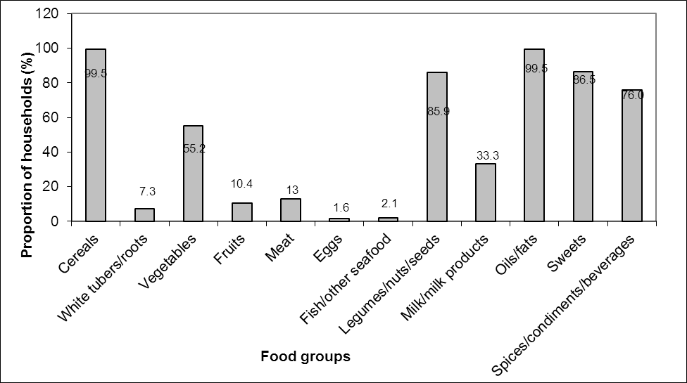

Reliance on the general food aid ration as the only source of food reduced in 2013 compared to 2012. In 2012, the proportion of households who consumed staples only from the food aid ration was 76.2% while the proportion of households where the diet consisted entirely of staples, pulses and oils/fat from food aid ration with no other food sources was 13.6%. These proportions were reduced significantly in 2013 to 38.5% and 1% respectively; p<0.05. The proportion of households not consuming any vegetables, fruits, meat, eggs, fish/sea-food, and milk/milk products also decreased form 71.3% to 34.9% which indicates that more households were consuming this food group. The consumption of CSB+ also improved from 57.4% in 2012 to 79.2% in 2013;p<0.05. It is worth noting that the survey data collection was carried out from the 9th to the 12th days of the distribution cycle which is immediately after the GFD distribution.

Table 49: Consumption of food aid commodities and micronutrient rich foods by households- Bokolmanyo camp, Dollo Ado (March 2013)
 | Number/total | % (95% CI)
Proportion of households where staples consumed are only from food aid ration (no other staples) | 74/192 | 38.5 (31.6-45.8)
Proportion of households where the diet consists entirely of staples, pulses and oils/fat from food aid ration (no other food sources) | 2/192 | 1.0(0.1-3.7)
Proportion of households not consuming any vegetables, fruits, meat, eggs, fish/seafood, and milk/milk products | 67/192 | 34.9(28.2-42.1)
Proportion of households consuming either a plant or animal source of vitamin A | 72/192 | 37.5(30.6-44.8)
Proportion of households consuming organ meat/flesh meat, or fish/seafood (food sources of haem iron) | 28/192 | 14.6(9.9-20.4)
Proportion of households consuming fortified blended foods | 152/192 | 79.2(72.7-84.7)

MORTALITY- BOKOLMANYO CAMP, DOLLO ADO (MARCH 2013)

Retrospective mortality data was collected over the past three months (100days). Demographic data was also derived from the mortality data as presented below.

Table 50: Demographic and retrospective mortality within camp- Bokolmanyo camp, Dollo Ado (March 2013)
Demographic data
Number of HH surveyed | 376
Average HH size | 5.4
% U5 | 23.3%
Retrospective mortality
Number of current HH residents | 2030
Total number U5 | 473
Number of people who joined HH / camp | 38
Total number U5 who joined HH / camp | 33
Number of people who left HH / camp | 76
Total number U5 who left HH / camp | 12
Number of births during recall | 27
Number of deaths during recall | 8
Total number U5 deaths during recall | 5
Crude Death Rate  (total deaths/10,000 people / day) | 0.39  (0.20-0.77 95% CI)
U5 Death Rate  (deaths in children under five/10,000 children under five / day) | 1.11  (0.47-2.57 95% CI)

RESULTS FROM MELKADIDA

INDIVIDUAL-LEVEL INDICATORS-CHILDREN 6-59 MONTHS, 0-23 MONTHS, AND WOMEN OF REPRODUCTIVE AGE 15-49 YEARS - MELKADIDA CAMP, DOLLO ADO (MARCH 2013)

Table 51 shows the different population groups and the total number of individuals who were sampled within each group.

Table 51: Target sample size and actual number captured during the survey Melkadida camp, Dollo Ado (March 2013)
Target group | Target  sample size | Subjects measured/interviewed during the survey | % of the target
Children 6-59 months | 341 | 378 | 110.9%
Children 0-23 months | 136 | 181 | 133.1%
Women 15-49 years | 189* | 182* | 96.3%
*Households

Anthropometric results (based on WHO Growth Standards 2006)

The coverage of age documentation was 20 % (children having an exact birth date). This means that the stunting and the underweight data should be interpreted with caution owing to the age unreliability

Table 52: Distribution of age and sex of sample-Melkadida camp, Dollo Ado (March 2013)
 | Boys |  | Girls |  | Total |  | Ratio
AGE (mo) | no. | % | no. | % | no. | % | Boy:girl
6-17 | 37 | 45.1 | 45 | 54.9 | 82 | 21.7 | 0.8
18-29 | 53 | 52.5 | 48 | 47.5 | 101 | 26.7 | 1.1
30-41 | 38 | 56.7 | 29 | 43.3 | 67 | 17.7 | 1.3
42-53 | 41 | 45.1 | 50 | 54.9 | 91 | 24.1 | 0.8
54-59 | 16 | 43.2 | 21 | 56.8 | 37 | 9.8 | 0.8
Total | 185 | 48.9 | 193 | 51.1 | 378 | 100.0 | 1.0

The overall sex ratio was 1.0 (sex ratio should be between 0.8-1.2), which confirms that both sexes were equally distributed.

Table 53: Prevalence of acute malnutrition based on weight-for-height z-scores (and/or oedema) and by sex- Melkadida camp, Dollo Ado (March 2013)
 | All  n = 378 | Boys  n = 185 | Girls  n = 193
Prevalence of global malnutrition  (<-2 z-score and/or oedema) | (64) 16.9 %  (13.5 - 21.0 95% C.I.) | (36) 19.5 %  (14.4 - 25.8 95% C.I.) | (28) 14.5 %  (10.2 - 20.2 95% C.I.)
Prevalence of moderate malnutrition  (<-2 z-score and >=-3 z-score, no oedema) | (58) 15.3 %  (12.1 - 19.3 95% C.I.) | (34) 18.4 %  (13.5 - 24.6 95% C.I.) | (24) 12.4 %  (8.5 - 17.8 95% C.I.)
Prevalence of severe malnutrition  (<-3 z-score and/or oedema) | (6) 1.6 %  (0.7 - 3.4 95% C.I.) | (2) 1.1 %  (0.3 - 3.9 95% C.I.) | (4) 2.1 %  (0.8 - 5.2 95% C.I.)
The prevalence of oedema is 0.0%

There was no difference between boys and girls in the prevalence of acute malnutrition.

Figure 15: Nutrition survey (GAM, SAM) results since 2011- Melkadida camp, Dollo Ado (March 2013)
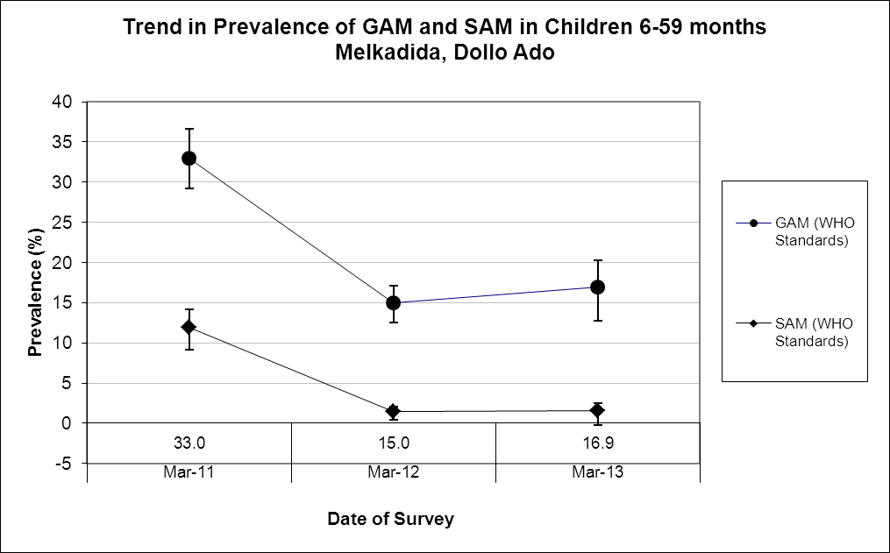

Comparison with results from 2012 shows no stastistically significant change in GAM and SAM among children 6-59 months (p>0.05).

Table 54: Prevalence of acute malnutrition by age, based on weight-for-height z-scores and/or oedema- Melkadida camp, Dollo Ado (March 2013)
 |  | Severe wasting  (<-3 z-score) |  | Moderate wasting  (>= -3 and <-2 z-score ) |  | Normal  (> = -2 z score) |  | Oedema
Age (mo) | Total no. | No. | % | No. | % | No. | % | No. | %
6-17 | 82 | 2 | 2.4 | 13 | 15.9 | 67 | 81.7 | 0 | 0.0
18-29 | 101 | 1 | 1.0 | 13 | 12.9 | 87 | 86.1 | 0 | 0.0
30-41 | 67 | 0 | 0.0 | 7 | 10.4 | 60 | 89.6 | 0 | 0.0
42-53 | 91 | 1 | 1.1 | 19 | 20.9 | 71 | 78.0 | 0 | 0.0
54-59 | 37 | 2 | 5.4 | 6 | 16.2 | 29 | 78.4 | 0 | 0.0
Total | 378 | 6 | 1.6 | 58 | 15.3 | 314 | 83.1 | 0 | 0.0

Figure 16: Trends in the prevalence of wasting by age in children 6-59 months- Melkadida camp, Dollo Ado (March 2013)
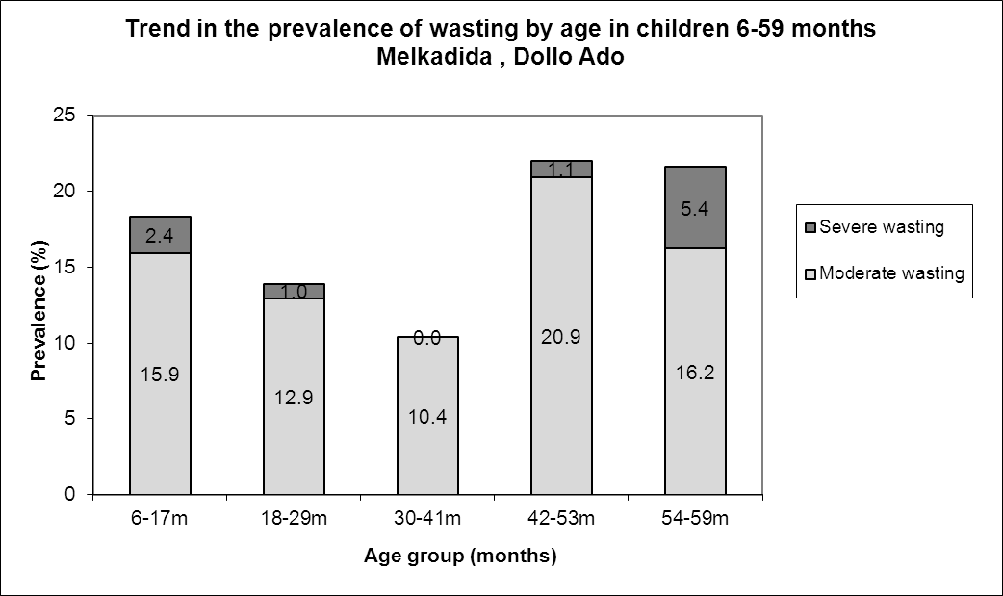

Table 55: Distribution of severe acute malnutrition and oedema based on weight-for-height z-scores- Melkadida camp, Dollo Ado (March 2013)
 | <-3 z-score* | >=-3 z-score
Oedema present | Marasmic kwashiorkor  No. 0  (0.0 %) | Kwashiorkor  No. 0  (0.0 %)
Oedema absent | Marasmic  No. 6  (1.6 %) | Not severely malnourished  No. 372  (98.4 %)
*Includes flags

The figure shows that the weight-for-height z-score distribution is shifted to the left, illustrating a poorer status than the international WHO Standard population of children aged 6-59 months.

Figure 17: Distribution of weight-for-height z-scores (based on WHO Growth Standards; the reference population is shown in green) of survey population compared to reference population-
Melkadida camp, Dollo Ado (March 2013)

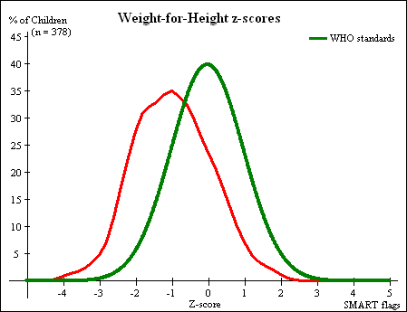

Table 56: Prevalence of stunting based on height-for-age z-scores and by sex- Melkadida camp, Dollo Ado (March 2013)
 | All  n = 376 | Boys  n = 183 | Girls  n = 193
Prevalence of stunting  (<-2 z-score) | (43) 11.4 %  (8.6 - 15.1 95% C.I.) | (27) 14.8 %  (10.3 - 20.6 95% C.I.) | (16) 8.3 %  (5.2 - 13.0 95% C.I.)
Prevalence of moderate stunting  (<-2 z-score and >=-3 z-score) | (36) 9.6 %  (7.0 - 13.0 95% C.I.) | (20) 10.9 %  (7.2 - 16.3 95% C.I.) | (16) 8.3 %  (5.2 - 13.0 95% C.I.)
Prevalence of severe stunting  (<-3 z-score) | (7) 1.9 %  (0.9 - 3.8 95% C.I.) | (7) 3.8 %  (1.9 - 7.7 95% C.I.) | (0) 0.0 %  (0.0 - 2.0 95% C.I.)

Table 57: Prevalence of stunting by age based on height-for-age z-scores- Melkadida camp, Dollo Ado (March 2013)
 |  | Severe stunting  (<-3 z-score) |  | Moderate stunting  (>= -3 and <-2 z-score ) |  | Normal  (> = -2 z score)
Age (mo) | Total no. | No. | % | No. | % | No. | %
6-17 | 81 | 1 | 1.2 | 11 | 13.6 | 69 | 85.2
18-29 | 100 | 4 | 4.0 | 14 | 14.0 | 82 | 82.0
30-41 | 67 | 1 | 1.5 | 4 | 6.0 | 62 | 92.5
42-53 | 91 | 1 | 1.1 | 6 | 6.6 | 84 | 92.3
54-59 | 37 | 0 | 0.0 | 1 | 2.7 | 36 | 97.3
Total | 376 | 7 | 1.9 | 36 | 9.6 | 333 | 88.6
Children in the age groups 6-17 and 18-29 months tend to be the least affected by stunting as compared to the other age groups.

Figure 18: Trends in the prevalence of stunting by age in children 6-59 months- Melkadida camp, Dollo Ado (March 2013)
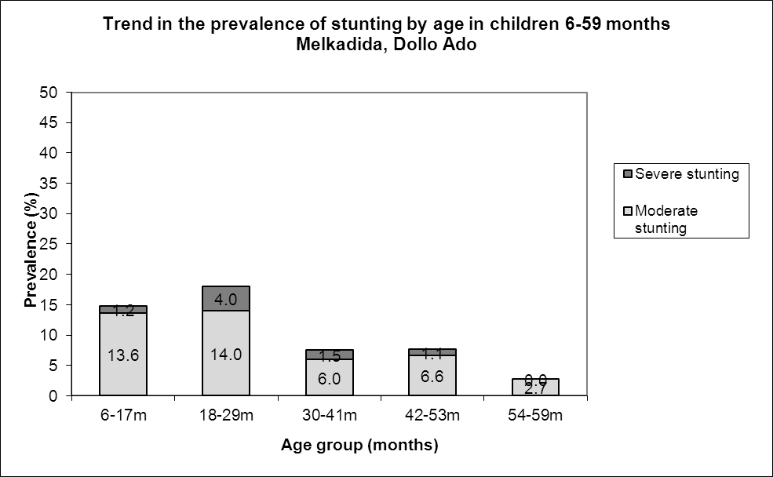

Table 58: Prevalence of underweight based on weight-for-age z-scores by sex- Melkadida camp, Dollo Ado (March 2013)
 | All  n = 377 | Boys  n = 184 | Girls  n = 193
Prevalence of underweight  (<-2 z-score) | (58) 15.4 %  (12.1 - 19.4 95% C.I.) | (37) 20.1 %  (15.0 - 26.5 95% C.I.) | (21) 10.9 %  (7.2 - 16.1 95% C.I.)
Prevalence of moderate underweight  (<-2 z-score and >=-3 z-score) | (53) 14.1 %  (10.9 - 17.9 95% C.I.) | (33) 17.9 %  (13.1 - 24.1 95% C.I.) | (20) 10.4 %  (6.8 - 15.5 95% C.I.)
Prevalence of severe underweight  (<-3 z-score) | (5) 1.3 %  (0.6 - 3.1 95% C.I.) | (4) 2.2 %  (0.8 - 5.5 95% C.I.) | (1) 0.5 %  (0.1 - 2.9 95% C.I.)

Table 59: Mean z-scores, Design Effects and excluded subjects - Melkadida camp, Dollo Ado (March 2013)
Indicator | n | Mean z-scores ± SD | Design Effect (z-score < -2) | z-scores not available* | z-scores out of range
Weight-for-Height | 378 | -0.97±1.05 | 1.00 | 0 | 0
Weight-for-Age | 377 | -1.20±0.84 | 1.00 | 0 | 1
Height-for-Age | 376 | -1.01±0.86 | 1.00 | 0 | 2
* contains for WHZ and WAZ the children with oedema.

MUAC was being used in the community for screening and admission to therapeutic and supplementary feeding programmes.

Table 60: Prevalence of MUAC malnutrition- Melkadida camp, Dollo Ado (March 2013)
 | All  n = 378 | Boys  n = 185 | Girls  n = 193
Prevalence of MUAC  (< 125 mm and/or oedema) | (15) 4.0 %  (2.4 - 6.4 95% C.I.) | (6) 3.2 %  (1.5 - 6.9 95% C.I.) | (9) 4.7 %  (2.5 - 8.6 95% C.I.)
Prevalence of MUAC  (< 125 mm and >= 115 mm, no oedema) | (15) 4.0 %  (2.4 - 6.4 95% C.I.) | (6) 3.2 %  (1.5 - 6.9 95% C.I.) | (9) 4.7 %  (2.5 - 8.6 95% C.I.)
Prevalence of MUAC  (< 115 mm and/or oedema) | (0) 0.0 % | (0) 0.0 % | (0) 0.0 %

The case load for the selective feeding programmes was estimated to aid in programme planning. The Melkadida population used during the survey was 42575. Based on the survey results 23.6% children were found to be under 5 years (total of 10048) and hence a total of 9043 children were estimated to be between 6-59 months (assuming that 10% of under-5 are 0-5 months).

Table 61: Estimated number of malnourished children aged 6-59 months eligible to be enrolled in a selective feeding programme at the time of the survey (based on all admission criteria)- Melkadida camp, Dollo Ado (March 2013)
 | Total/number | % (95% CI) | N (LCI-UCI)*
Eligible for therapeutic feeding programme** | 6/378 | 1.6 (0.7-3.4) | 145 (63-308)
Eligible for supplementary feeding programme** | 58/378 | 15.3(12.1-19.3) | 1384 (1094-1745)
*LCI=Lower Confidence Interval; UCI: Upper Confidence Interval
**WHZ flags excluded from analysis

Using the HIS data for week 11 there were 52 children enrolled in the therapeutic feeding program which was 0.6% of children 6-59 months while 360 were enrolled in the supplementary feeding program which was 4.0% of children 6-59 months.

Anaemia results

Table 62: Prevalence of anaemia and haemoglobin concentration in children 6-59 months of age - Melkadida camp, Dollo Ado (March 2013)
Anaemia – Children 6-59 months | All  n = 377
Total Anaemia (Hb<11.0 g/dL) | (180) 47.7 %  (47.1-57.4 95% CI)
Mild Anaemia (Hb 10.0-10.9 g/dL) | (93) 24.7 %  (20.5-29.4 95% CI)
Moderate Anaemia (7.0-9.9 g/dL) | (85) 22.5 %  (18.5-27.2 95% CI)
Severe Anaemia (<7.0 g/dL) | (2) 0.5 %  (0.1-2.1 95% CI)
Mean Hb (g/dL) | 10.8 g/dL  (1.37SD)  [6.1min,13.6 max]

Comparison with results from 2012 where the total anaemia was 39.0 % (35.8- 42.3 95%CI) shows a significant increase in anaemia among children 6-59 months (p<0.05).

Figure 19: Nutrition survey results (anaemia in children 6-59 months) since 2011- Melkadida camp, Dollo Ado (March 2013)
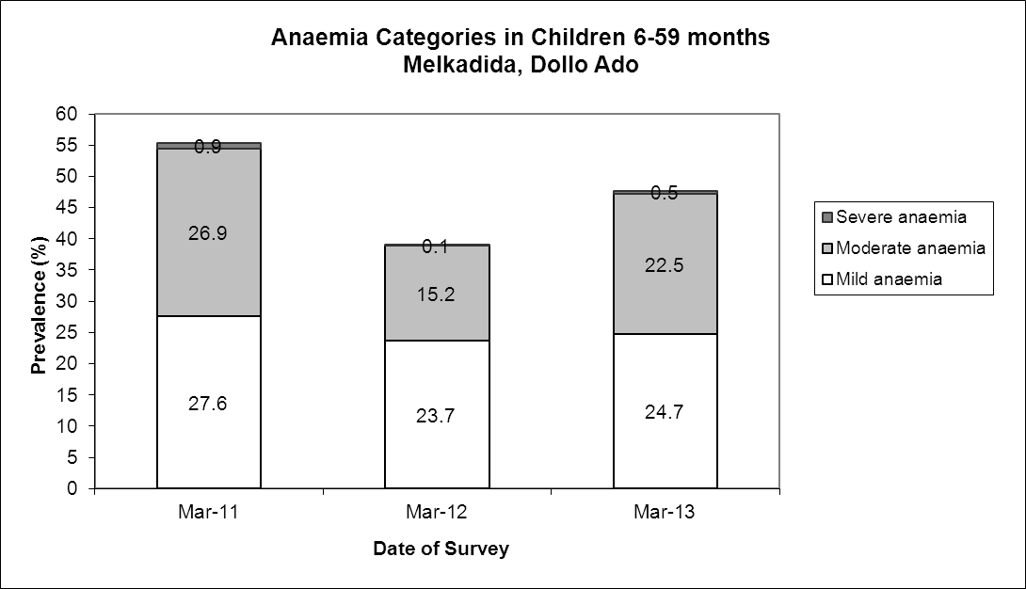

There was no statistically significant change in the mean haemoglobin concentration in children 6-59 months in 2013 compared to 2012(p> 0.05)

Figure 20: Mean haemoglobin concentration in children 6-59 months from 2011-2013 Melkadida camp, Dollo Ado
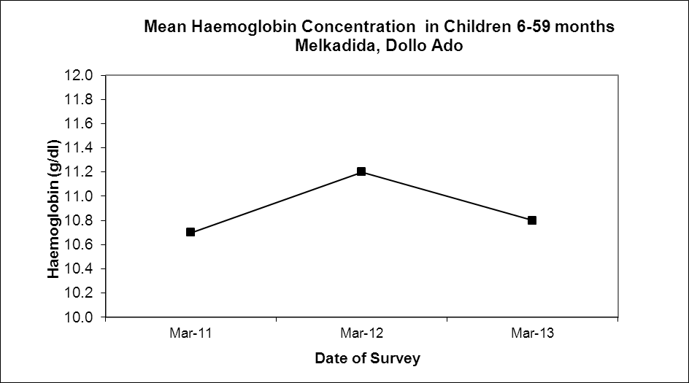

The 6-23 months age group had the highest prevalence of anaemia of 67.9%; prevalence of anaemia declined with increasing age. These age trends are similar to those seen in 2012. Comparison with results from 2012 shows there was no significant change in theprevalence of anaemia among children 6-23months (p>0.05).

Table 63: Prevalence of anaemia by age- Melkadida camp, Dollo Ado (March 2013)
 |  | Severe Anaemia  (<7.0 g/dL) |  | Moderate Anaemia  (7.0-9.9 g/dL) |  | Mild Anaemia (Hb 10.0-10.9 g/dL) |  | Total Anaemia (Hb<11g.0 g/dL) |  | Normal (Hb≥11.0 g/dL)
Age (mths) | Total no. | No. | %  (95% CI) | No. | %  (95% CI) | No. | %  (95% CI) | No. | %  (95% CI) | No. | %  (95% CI)
6-23 | 134 | 1 | 0.7  (0-4.1) | 51 | 38.1  (29.8-46.8) | 39 | 29.1  (21.6-37.6) | 91 | 67.9  (59.3-75.7) | 43 | 32.1  (24.3-40.7)
24-35 | 81 | 1 | 1.2  (0-6.7) | 22 | 27.5  (17.9-38.2) | 21 | 25.9  (16.8-36.9) | 44 | 54.3  (42.9-65.4) | 37 | 45.7  (34.6-57.1)
36-59 | 162 | 0 | 0 | 12 | 7.4  (3.9-12.6) | 33 | 20.4  (14.5-27.4) | 45 | 27.8  (21.0-35.3) | 117 | 72.2  (64.7-79.0)
Total | 377 | 2 | 0.5  (0.1-2.1) | 85 | 22.5  (18.5-27.2) | 93 | 24.7  (20.5-29.4) | 180 | 47.7  (42.6-52.9) | 197 | 52.3  (47.1-57.4)

Programme coverage

Selective feeding programme**

Table 64: Nutrition treatment programme coverage based on all admission criteria (weight-for-height, MUAC, oedema) - Melkadida camp, Dollo Ado (March 2013)
 | Number/total | % (95% C.I.)
Proportion of children aged 6-59 months with severe acute malnutrition currently enrolled in therapeutic feeding programme* | 0/3 | 0%
Proportion of children aged 6-59 months with moderate acute malnutrition currently enrolled in supplementary feeding programme* | 5/63 | 7.9(2.6-17.6)
*WHZ flags excluded from analysis

Table 65: Nutrition treatment programme coverage based on MUAC and oedema only- Melkadida camp, Dollo Ado (March 2013)
 | Number/total | % (95% CI)
Proportion of children aged 6-59 months with severe acute malnutrition currently enrolled in therapeutic feeding programme | 0/0 | 0%
Proportion of children aged 6-59 months with moderate acute malnutrition currently enrolled in supplementary feeding programme | 4/15 | 26.7(7.8-55.1)
**Selective feeding programme coverage results should be interpreted with caution due to small number of cases that were sampled during the survey.

Vaccination and supplementation programmes

Measles vaccination coverage

Table 66: Measles vaccination coverage for children aged 9-59 months (n= 510) - Melkadida camp, Dollo Ado (March 2013)
 | Measles  (with card)  n=57 | Measles  (with card or confirmation from mother)  n=342
YES | 16.0 %  (12.4-20.3 95% CI) | 95.8%  (93.0-97.5 95% CI)

Vitamin A supplementation coverage

Table 67: Vitamin A supplementation for children aged 6-59 months within past 6 months (n=540) - Melkadida camp, Dollo Ado (March 2013)
 | Vitamin A capsule  (with card)  n=59 | Vitamin A capsule  (with card or confirmation from mother)  n=348
YES | 15.6 %  (12.2- 19.8 95% CI) | 92.1 %  88.7-94.5 95% CI)

Comparison with results from 2012 shows a significant improvement in the coverage of the measles vaccination and vitamin A supplementation (within past six months) coverage among children 6-59 months (p<0.05).

Figure 21: Nutrition survey results (measles vaccination and vitamin A supplementation within past 6 months with card or recall) since 2011- Melkadida camp, Dollo Ado (March 2013)
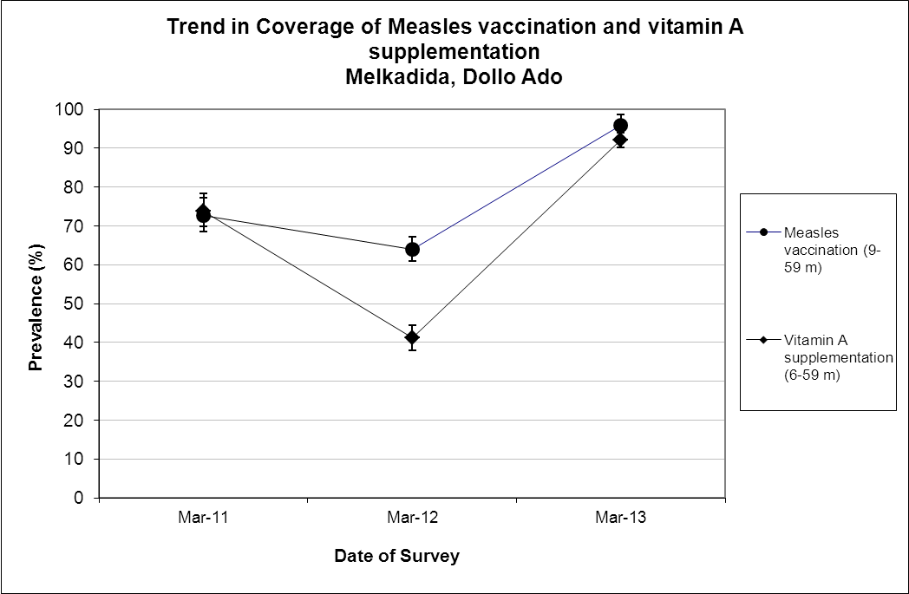

Deworming coverage

Table 68: Deworming for children aged 12-59 months within past 6 months (n=333) –Melkadida camp,Dollo Ado (March 2013)

 | Deworming  (with card)  n=54 | Deworming  (with card or confirmation from mother)  n=308
YES | 16.2 %  (12.5-20.7 95% CI) | 92.5%  (89.0-95.0 95% CI)

Blanket supplementary feeding program (BSFP)
Table 69: BSFP programme for children aged 6-59 months- Melkadida camp, Dollo Ado (March 2013)
 | Age | Number/total | % (95% CI)
Currently receiving CSB++ | 6-59 | 330/378 | 87.3  (83.5-90.5 95% CI

Morbidity and health seeking behaviour

Of children 6-59 months of age, 9.8% (CI 7.1 – 13.3) had experienced diarrhoea two weeks prior to the survey date. Out of the 75 surveyed that was sick two weeks prior to the survey, including diarrhoea, 74.3% (CI 62.8- 83.8) of mothers sought help from the health services provided in the camp. Compared to 2012 the reported morbidity caseload (diarrhoea and other diseases) went up significantly from 13.1% to 19.8% (p<0.05).

Table 70: Prevalence of diarrhoea and disease in children 6-59 months and health seeking behaviour among mothers of children 6-59 months
 | Number/total | % (95% CI)
Diarrhoea last two weeks (6-59 months) | 37/341 | 9.8(7.1 – 13.3)
Children sick in the last two weeks (6-59 months) | 75/378 | 19.8 (16.0 – 24.3)
Proportion of mothers with sick children who sought assistance | 55/74 | 74.3(62.8 – 83.8)

CHILDREN 0-23 MONTHS- MELKADIDA CAMP, DOLLO ADO (MARCH 2013)

Table 71: Prevalence of Infant and Young Child Feeding Practices indicators- Melkadida camp, Dollo Ado (Melkadida 2013)
Indicator | Age range | Number/total | Prevalence (%) | 95% CI
Children ever breastfed | 0-23 months | 180/181 | 99.4 | (97.0-100.0)
Timely initiation of breastfeeding | 0-23 months | 152/179 | 84.9 | (78.8-89.8)
Exclusive breastfeeding under 6 months | 0-5 months | 38/55 | 69.1 | (55.2-80.9)
Continued breastfeeding at 1 year | 12-15 months | 28/44 | 63.6 | (47.8-77.6)
Continued breastfeeding at 2 years | 20-23 months | 10/25 | 40.0 | (21.1-61.3)
Introduction of solid, semi-solid or soft foods | 6-8 months | 7/24 | 29.2 | (12.6-51.1)
Children bottle fed | 0-23 months | 23/181 | 12.7 | (8.2-18.5)
Consumption of iron rich or iron fortified foods | 6-23 months | 97/118 | 82.2 | (74.1-88.6)

The confidence intervals are an integral part of the results when analysing trends over the years. When IYCF indicators are collected in nutritional surveys, it is not feasible to achieve a large enough sample size for some of the indicators to be estimated as precisely as desired, especially for indicators covering a very narrow age range (e.g. 12-15 months, 6-8 months). Hence, trend analyses need to be interpreted with caution. Nevertheless, trend analyses are useful for assessing the situation and major differences seen from year to year should warrant further investigation.

Timely initiation of breastfeeding and exclusive breastfeeding improved compared to the 2012 survey but continuation of breastfeeding at one year reduced from 88.9% to 63.6%. The rest of the indicators remained the same; p>0.05.

Figure 22: Nutrition survey results (key IYCF indicators) since 2011- Melkadida camp, Dollo Ado (March 2013)

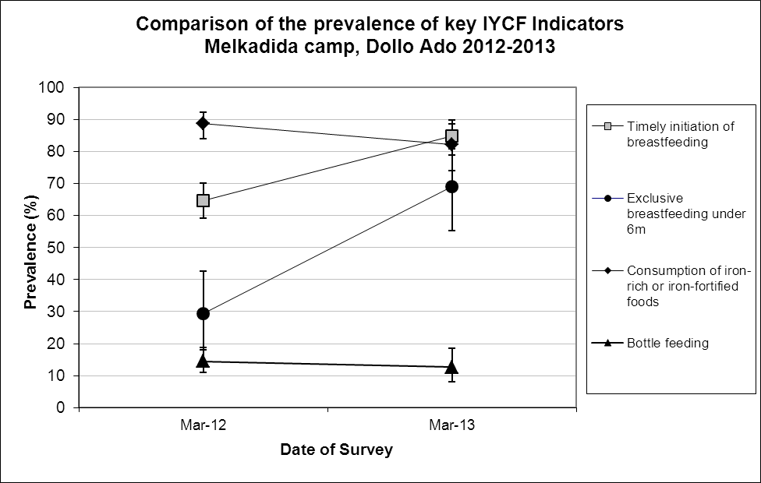

Prevalence of intake

Infant formula
Table 72: Infant formula intake in children aged 0-23 months
 | Number/total | % (95% CI)
Proportion of children aged 0-23 months who receive infant formula (fortified or non-fortified) | 28/181 | 15.5(10.5-21.6)

Fortified blended foods
Table 73: CSB+ intake in children aged 6-23 months
 | Number/total | % (95% CI)
Proportion of children aged 6-23 months who receive FBF | 36/119 | 30.3(22.2-39.3)

Table 74: CSB++ intake in children aged 6-23 months
 | Number/total | % (95% CI)
Proportion of children aged 6-23 months who receive FBF++ | 83/119 | 69.7(60.7-77.8)

WOMEN 15-49 YEARS - MELKADIDA CAMP, DOLLO ADO (MARCH 2013)

Table 75: Demographic information- Kobe camp, Dollo Ado (June 2012)
Physiological status | Number/total | %
Non-Pregnant | 97/137 | 70.8
Pregnant | 39/137 | 28.5
Mean age (range) | 29.7 years (15-45)

Table 76: Prevalence of anaemia and haemoglobin concentration in non-pregnant women of reproductive age (15-49 years) - Melkadida camp, Dollo Ado (March 2013)
Anaemia – Non-pregnant women of reproductive age 15-49 years | All  n = 97
Total Anaemia (<12.0 g/dL) | (23) 23.7%  (15.7-33.4 95% CI)
Mild Anaemia (11.0-11.9 g/dL) | (23) 13.4%  (7.3-21.8 95% CI)
Moderate Anaemia (8.0-10.9 g/dL) | (16) 8.2 %  (3.6-15.6 95% CI)
Severe Anaemia (<8.0 g/dL) | (1) 2.1%  (0-4.2 95% CI)
Mean Hb (g/dL) | 12.8g/dL  (1.57SD)  [6.6min, 16.3max]

Comparison with results from 2012 (24% 18.6-30.1 95% CI) shows no statistically significant change in anaemia among non-pregnant women of reproductive age (p>0.05).

Figure 23: Anaemia categories in women of reproductive age from 2011 to 2012- Melkadida camp, Dollo Ado (March 2013)
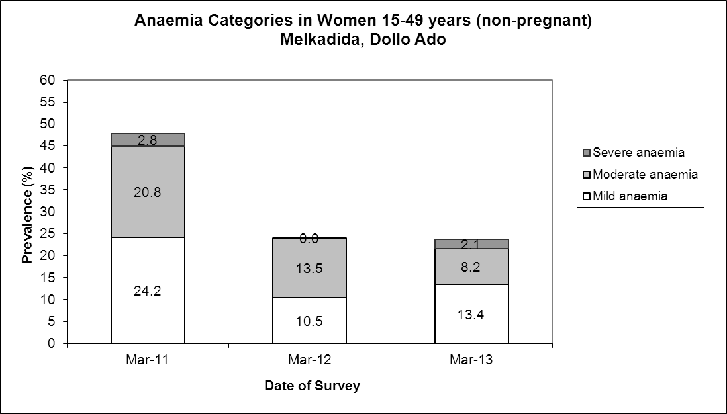

ANC enrolment and iron-folic acid supplementation coverage
Table 77: ANC enrolment and iron-folic acid pills coverage among pregnant women (15-49 years) - Melkadida camp, Dollo Ado (March 2013)
 | Number/total | % (95% CI)
Currently enrolled in ANC programme | 35/39 | 89.7 (75.8-97.1)
Currently receiving iron-folic acid pills | 29/39 | 74.4(57.9-87.0)

Table 78: Post-natal vitamin A supplementation among women (15-49 years) - Melkadida camp, Dollo Ado (March 2013)
 | Number/total | % (95% CI)
Received vitamin A supplementation since delivery | 30/32 | 93.8 (79.2-99.2)

HOUSEHOLD-LEVEL INDICATORS- WATER, FOOD SECURITY AND MORTALITY- MELKADIDA CAMP, DOLLO ADO (MARCH 2013)

Table 41 shows the different indicators and the total number of households who were sampled for each household-level indicator. All households were considered whether or not they had eligible individuals for the individual-level measurements.

Table 79: Target sample size and actual number captured during the survey- Melkadida camp, Dollo Ado (March 2013)
Indicator | Target  sample size | Household interviewed during the study | % of the target
Water | 189 | 179 | 94.7
Food security | 189 | 182 | 99.5
Mortality | 378 | 358 | 94.7

WATER- MELKADIDA CAMP, DOLLO ADO (MARCH 2013)

Table 80: Water Quantity: Amount of litres of water used per person per day-Melkadida camp, Dollo Ado (March 2013)
Proportion of households that access: | Number/total | % (95% CI)
≥ 20 litres | 67/174 | 38.5(31.2-46.2)
15 – <20 litres | 27/174 | 15.5 (10.5-21.8)
<15 litres | 80/174 | 46.0(38.4-53.7)

The average water usage in lpppd: 21.9 lpppd

Table 81: Satisfaction with water supply- Melkadida camp, Dollo Ado (March 2013)
 | Number/total | % (95% CI)
Proportion of households that say they are satisfied with the drinking water supply | 147/178 | 82.6 (76.2-87.8)

11.2% (7.0-16.8 CI) of the surveyed household reported to not be satisfied with the water supply while a further 6.2% (3.1-10.8 CI) reported to only be partially satisfied. The main reasons for the dissatisfaction were not enough water (35%); long waiting queues (25.0%); irregular supply (20.0%); long distance to the water point (15.0%); and bad quality(5 %).

FOOD SECURITY-MELKADIDA, DOLLO ADO (MARCH 2013)

Food distribution

Table 82: Ration card coverage- Melkadida camp, Dollo Ado (March 2013)
 | Number/total | % (95% CI)
Proportion of households that received the general food ration | 181/182 | 99.5 (97.0-100)
One household reported to not have received the general ration because they did not have a ration card.

The general food ration lasts at most 58.3 % of the intended theoretical duration of 30 days.

Table 83: Reported duration of general food ration 1- Melkadida camp, Dollo Ado (March 2013)
Average number of days the food ration lasts (Standard deviation ) | Average duration (%) in relation to the theoretical duration of the ration
17.6 (4.67) | 58.3

The proportion of households reporting that their food ration lasted for 30 days was 2.8%
87.2% of all the households reported that the general food ration received in the previously completed cycle had lasted less than 22.5 days (75% of cycle).

Table 84: Reported duration of general food ration 2 - Melkadida camp, Dollo Ado (March 2013)
Number/total
(% (95% CI)
Proportion of households reporting that the food ration lasts the entire duration of the cycle | 5/180  2.8(0.9-6.4)
Proportion of households reporting that the food ration lasted:
≤75% of the cycle [0-22 days] | 157/180  87.2 (81.4-91.7)
>75% of the cycle [23-30 days] | 23/180  12.8(8.3-18.6)

Negative household coping strategies

The most common coping strategies used by households in Melkadida camp were borrowing of cash, food or other items with/out interest and reducing the quantity and/or frequency of meals. This was the same in 2012. A small proportion (2.4%) reported to engage in risky or harmful activities and sending at least one child to work outside the household in order get cash or in-kind goods or services (2.4%).

The proportion of households reporting that they did not use any of the coping strategies was only 5.5%.

Table 85: Coping strategies used by the surveyed population over the past month- Melkadida camp, Dollo Ado (March 2013)
 | Number/total | % (95% CI)
Borrowed cash, food or other items with/out interest | 142/182 | 78.0(71.3-83.8)
Sold any assets (furniture, seed stocks, tools, other NFI, livestock etc.) | 25/182 | 13.7(9.1-19.6)
Requested increase remittances or gifts as compared to normal | 3/182 | 1.6(0.3-4.7)
Reduced the quantity and/or frequency of meals | 102/182 | 56.0(48.5-63.4)
Begged | 26/182 | 14.3(9.5-20.2)
Engaged in potentially risky or harmful activities | 4/182 | 2.2(0.6-5.5)
Sent at least one child to work outside the household in order get cash or in-kind goods or services | 3/124 | 2.4(0.5-6.9)
Proportion of households reporting using none of the coping strategies over the past month | 10/182 | 5.5(2.7-9.9)

Household dietary diversity

The average household diversity score was 6.1.This remained the same as that reported in 2012 with no statistically significant change.

Table 86: Average Household Diet Diversity Score- Melkadida camp, Dollo Ado (March 2013)
Average HDDS | Mean  (Standard deviation)
 | 6.1 (1.4)

Cereals and fats (99.4%), legumes (95%) condiments and beverages (87.8%) were the three most consumed food groups in Melkadida camp, while white tubers (13.3%), fish/sea food (1.1%) and eggs (1.1%) were the least consumed.

Figure 24: Proportion of households consuming different food groups within last 24 hours- Melkadida camp, Dollo Ado (March 2013)
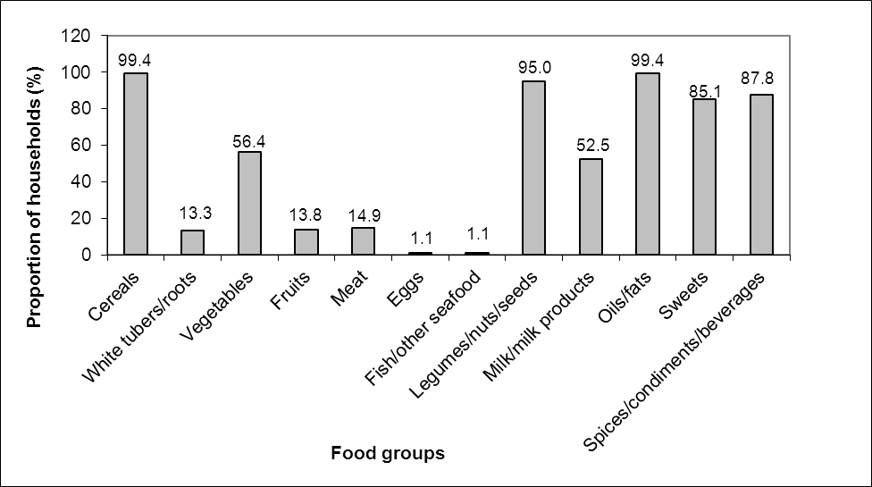

Reliance of the staples from the general food aid ration reduced in 2013 compared to 2012 from 76.7% to 51.4%.This was also the similar for the diet that consisted entirely of staples, pulses and oils/fat from food aid ration with no other food sources where in 2013 it was 0.6 and in 2012 it was 9.6%. The proportion of households not consuming any vegetables, fruits, meat, eggs, fish/sea-food, and milk/milk products decreased from 58.9% to 24.3% indicating that more households were consuming this food group. The consumption of CSB+ also improved from 34.2% in 2012 to 86.2% in 2013; p<0.05. It is worth noting that the survey data collection was carried out from the 12th to the 14th days of the distribution cycle which is immediately after the GFD distribution.

Table 87: Consumption of food aid commodities and micronutrient rich foods by households- Melkadida camp, Dollo Ado (March 2013)
 | Number/total | % (95% CI)
Proportion of households where staples consumed are only from food aid ration (no other staples) | 93/181 | 51.4 (43.9-58.9)
Proportion of households where the diet consists entirely of staples, pulses and oils/fat from food aid ration (no other food sources) | 1/181 | 0.6(0- 3.0)
Proportion of households not consuming any vegetables, fruits, meat, eggs, fish/seafood, and milk/milk products | 44/181 | 24.3(18.3-31.2)
Proportion of households consuming either a plant or animal source of vitamin A | 104/181 | 57.5(49.9-64.8)
Proportion of households consuming organ meat/flesh meat, or fish/seafood (food sources of haem iron) | 29/181 | 16.0(11.0-22.2)
Proportion of households consuming fortified blended foods | 156/181 | 86.2(80.3-90.9)

MORTALITY- MELKADIDA CAMP, DOLLO ADO (MARCH 2013)

Retrospective mortality data was collected over the past three months (104 days). Demographic data was also derived from the mortality data as presented below.

Table 88: Demographic and retrospective mortality within camp- Melkadida camp, Dollo Ado (March 2013)
Demographic data
Number of HH surveyed | 358
Average HH size | 5.0
% U5 | 23.6%
Retrospective mortality
Number of current HH residents | 1804
Total number U5 | 425
Number of people who joined HH / camp | 24
Total number U5 who joined HH / camp | 23
Number of people who left HH / camp | 98
Total number U5 who left HH / camp | 12
Number of births during recall | 22
Number of deaths during recall | 3
Total number U5 deaths during recall | 1
Crude Death Rate  (total deaths/10,000 people / day) | 0.16  (0.05-0.46 95% CI)
U5 Death Rate  (deaths in children under five/10,000 children under five / day) | 0.24  (0.04-1.32 95% CI)

RESULTS FROM KOBE

INDIVIDUAL-LEVEL INDICATORS-CHILDREN 6-59 MONTHS, 0-23 MONTHS, AND WOMEN OF REPRODUCTIVE AGE 15-49 YEARS-KOBE CAMP, DOLLO ADO (MARCH 2013)

Table 89 shows the different population groups and the total number of individuals who were sampled within each group.

Table 89: Target sample size and actual number captured during the survey Kobe camp, Dollo Ado (March 2013)
Target group | Target  sample size | Subjects measured/interviewed during the survey | % of the target
Children 6-59 months | 339 | 324 | 95.6%
Children 0-23 months | 136 | 164 | 120.6%
Women 15-49 years | 183* | 181* | 98.9%
*Households

Anthropometric results (based on WHO Growth Standards 2006)

The coverage of age documentation was 10% (children having an exact birth date). This means that the stunting and the underweight data should be interpreted with caution owing to the age unreliability

Table 90: Distribution of age and sex of sample-Kobe camp, Dollo Ado (March 2013)
 | Boys |  | Girls |  | Total |  | Ratio
AGE (mo) | no. | % | no. | % | no. | % | Boy: girl
6-17 | 32 | 49.2 | 33 | 50.8 | 65 | 19.9 | 1.0
18-29 | 40 | 47.1 | 45 | 52.9 | 85 | 26.0 | 0.9
30-41 | 30 | 58.8 | 21 | 41.2 | 51 | 15.6 | 1.4
42-53 | 44 | 46.8 | 50 | 53.2 | 94 | 28.7 | 0.9
54-59 | 19 | 59.4 | 13 | 40.6 | 32 | 9.8 | 1.5
Total | 165 | 50.5 | 162 | 49.5 | 327 | 100.0 | 1.0

The overall sex ratio was 1.0 (sex ratio should be between 0.8-1.2), which confirms that both sexes were equally distributed.

Table 91: Prevalence of acute malnutrition based on weight-for-height z-scores (and/or oedema) and by sex- Kobe camp, Dollo Ado (March 2013)
 | All  n = 324 | Boys  n = 164 | Girls  n = 160
Prevalence of global malnutrition  (<-2 z-score and/or oedema) | (55) 17.0 %  (13.3 - 21.4 95% C.I.) | (26) 15.9 %  (11.1 - 22.2 95% C.I.) | (29) 18.1 %  (12.9 - 24.8 95% C.I.)
Prevalence of moderate malnutrition  (<-2 z-score and >=-3 z-score, no oedema) | (46) 14.2 %  (10.8 - 18.4 95% C.I.) | (22) 13.4 %  (9.0 - 19.5 95% C.I.) | (24) 15.0 %  (10.3 - 21.3 95% C.I.)
Prevalence of severe malnutrition  (<-3 z-score and/or oedema) | (9) 2.8 %  (1.5 - 5.2 95% C.I.) | (4) 2.4 %  (1.0 - 6.1 95% C.I.) | (5) 3.1 %  (1.3 - 7.1 95% C.I.)
The prevalence of oedema is 0.0 %

There was no difference between boys and girls in the prevalence of acute malnutrition.

Figure 25: Nutrition survey (GAM, SAM) results since 2011- Kobe camp, Dollo Ado (March 2013)
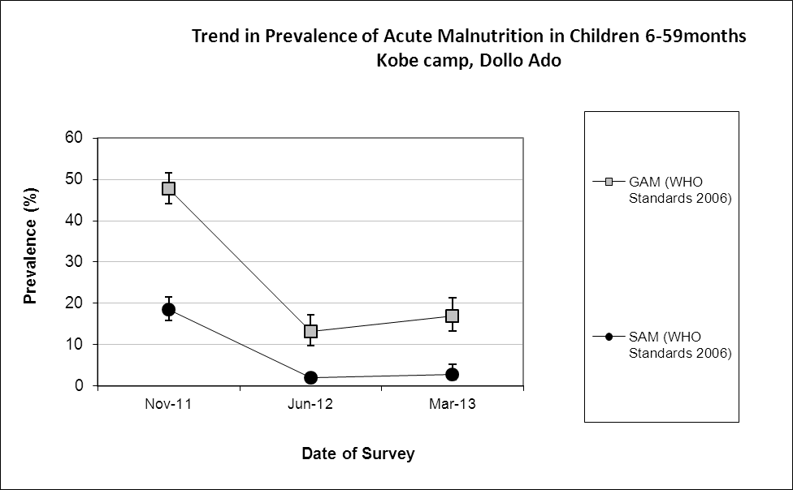

Comparison with results from 2012 shows no statistically significant change in GAM and SAM among children 6-59 months (p<0.05).

Table 92: Prevalence of acute malnutrition by age, based on weight-for-height z-scores and/or oedema- Kobe camp, Dollo Ado (March 2013)
 |  | Severe wasting  (<-3 z-score) |  | Moderate wasting  (>= -3 and <-2 z-score ) |  | Normal  (> = -2 z score) |  | Oedema
Age (mo) | Total no. | No. | % | No. | % | No. | % | No. | %
6-17 | 64 | 3 | 4.7 | 14 | 21.9 | 47 | 73.4 | 0 | 0.0
18-29 | 84 | 2 | 2.4 | 10 | 11.9 | 72 | 85.7 | 0 | 0.0
30-41 | 51 | 1 | 2.0 | 3 | 5.9 | 47 | 92.2 | 0 | 0.0
42-53 | 93 | 1 | 1.1 | 13 | 14.0 | 79 | 84.9 | 0 | 0.0
54-59 | 32 | 2 | 6.3 | 6 | 18.8 | 24 | 75.0 | 0 | 0.0
Total | 324 | 9 | 2.8 | 46 | 14.2 | 269 | 83.0 | 0 | 0.0

Figure 26: Trends in the prevalence of wasting by age in children 6-59 months- Kobe camp, Dollo Ado (March 2013)
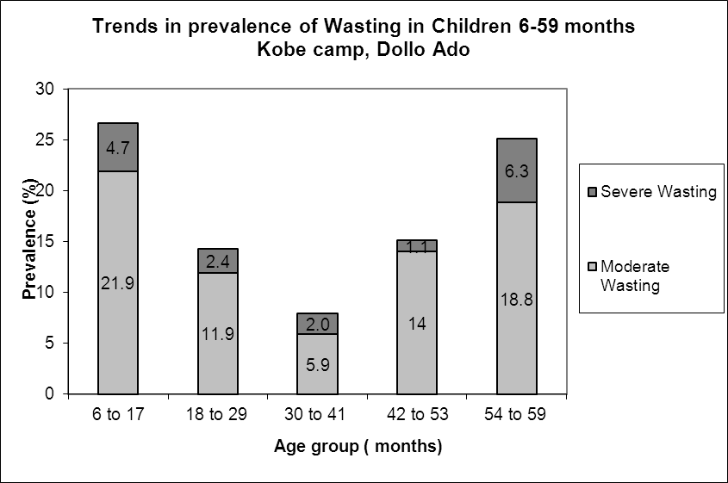

Children in age group 6-17 months and 54-59 tend to be most affected by wasting.

Table 93: Distribution of severe acute malnutrition and oedema based on weight-for-height z-scores- Kobe camp, Dollo Ado (March 2013)
 | <-3 z-score | >=-3 z-score
Oedema present | Marasmic kwashiorkor  No. 0  (0.0 %) | Kwashiorkor  No. 0  (0.0 %)
Oedema absent | Marasmic  No. 11  (3.4 %) | Not severely malnourished  No. 316  (96.6 %)

The figure shows that the weight-for-height z-score distribution is shifted to the left, illustrating a poorer status than the international WHO Standard population of children aged 6-59 months.

Figure 27: Distribution of weight-for-height z-scores (based on WHO Growth Standards; the reference population is shown in green) of survey population compared to reference population-
Kobe camp, Dollo Ado (March 2013)
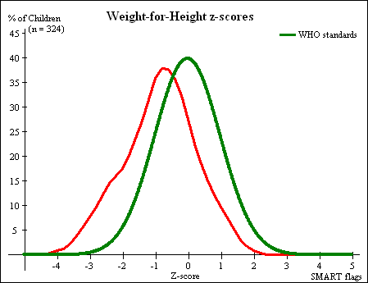

Table 94: Prevalence of stunting based on height-for-age z-scores and by sex- Kobe camp, Dollo Ado (March 2013)
 | All  n = 325 | Boys  n = 164 | Girls  n = 161
Prevalence of stunting  (<-2 z-score) | (21) 6.5 %  (4.3 - 9.7 95% C.I.) | (15) 9.1 %  (5.6 - 14.5 95% C.I.) | (6) 3.7 %  (1.7 - 7.9 95% C.I.)
Prevalence of moderate stunting  (<-2 z-score and >=-3 z-score) | (18) 5.5 %  (3.5 - 8.6 95% C.I.) | (14) 8.5 %  (5.2 - 13.8 95% C.I.) | (4) 2.5 %  (1.0 - 6.2 95% C.I.)
Prevalence of severe stunting  (<-3 z-score) | (3) 0.9 %  (0.3 - 2.7 95% C.I.) | (1) 0.6 %  (0.1 - 3.4 95% C.I.) | (2) 1.2 %  (0.3 - 4.4 95% C.I.)

Table 95: Prevalence of stunting by age based on height-for-age z-scores- Kobe camp, Dollo Ado (March 2013)
 |  | Severe stunting  (<-3 z-score) |  | Moderate stunting  (>= -3 and <-2 z-score ) |  | Normal  (> = -2 z score)
Age (mo) | Total no. | No. | % | No. | % | No. | %
6-17 | 64 | 1 | 1.6 | 7 | 10.9 | 56 | 87.5
18-29 | 85 | 2 | 2.4 | 6 | 7.1 | 77 | 90.6
30-41 | 51 | 0 | 0.0 | 1 | 2.0 | 50 | 98.0
42-53 | 93 | 0 | 0.0 | 4 | 4.3 | 89 | 95.7
54-59 | 32 | 0 | 0.0 | 0 | 0.0 | 32 | 100.0
Total | 325 | 3 | 0.9 | 18 | 5.5 | 304 | 93.5
Children in the age groups 6-17 and 18-29 months tend to be the most affected by stunting as compared to the other age groups.

Figure 28: Trends in the prevalence of stunting by age in children 6-59 months- Kobe camp, Dollo Ado (March 2013)
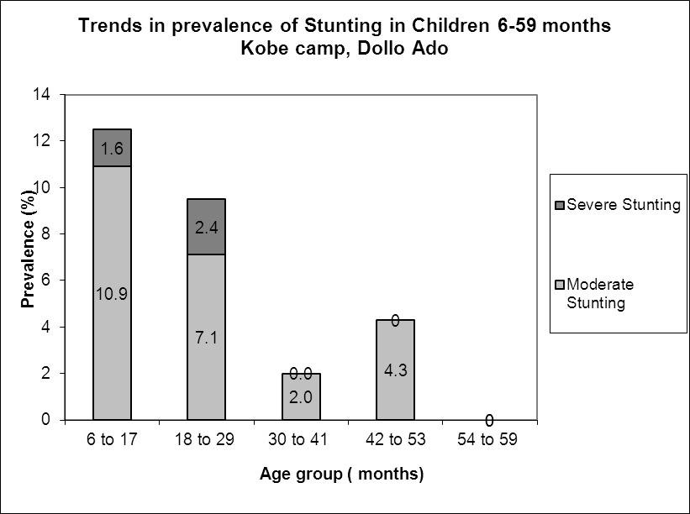

Table 96: Prevalence of underweight based on weight-for-age z-scores by sex- Kobe camp, Dollo Ado (March 2013)
 | All  n = 327 | Boys  n = 165 | Girls  n = 162
Prevalence of underweight  (<-2 z-score) | (47) 14.4 %  (11.0 - 18.6 95% C.I.) | (25) 15.2 %  (10.5 - 21.4 95% C.I.) | (22) 13.6 %  (9.1 - 19.7 95% C.I.)
Prevalence of moderate underweight  (<-2 z-score and >=-3 z-score) | (43) 13.1 %  (9.9 - 17.2 95% C.I.) | (24) 14.5 %  (10.0 - 20.7 95% C.I.) | (19) 11.7 %  (7.6 - 17.6 95% C.I.)
Prevalence of severe underweight  (<-3 z-score) | (4) 1.2 %  (0.5 - 3.1 95% C.I.) | (1) 0.6 %  (0.1 - 3.4 95% C.I.) | (3) 1.9 %  (0.6 - 5.3 95% C.I.)

Table 97: Mean z-scores, Design Effects and excluded subjects - Kobe camp, Dollo Ado (March 2013)
Indicator | n | Mean z-scores ± SD | Design Effect (z-score < -2) | z-scores not available* | z-scores out of range
Weight-for-Height | 324 | -0.86±1.09 | 1.00 | 0 | 3
Weight-for-Age | 327 | -1.06±0.85 | 1.00 | 0 | 0
Height-for-Age | 325 | -0.84±0.79 | 1.00 | 0 | 2
* contains for WHZ and WAZ the children with oedema.

MUAC was being used in the community for screening and admission to therapeutic and supplementary feeding programmes.

Table 98: Prevalence of MUAC malnutrition- Kobe camp, Dollo Ado (March 2013)
 | All  n = 327 | Boys  n = 165 | Girls  n = 162
Prevalence of MUAC  (< 125 mm and/or oedema) | (11) 3.4 %  (1.9 - 5.9 95% C.I.) | (4) 2.4 %  (0.9 - 6.1 95% C.I.) | (7) 4.3 %  (2.1 - 8.6 95% C.I.)
Prevalence of MUAC  (< 125 mm and >= 115 mm, no oedema) | (9) 2.8 %  (1.5 - 5.1 95% C.I.) | (4) 2.4 %  (0.9 - 6.1 95% C.I.) | (5) 3.1 %  (1.3 - 7.0 95% C.I.)
Prevalence of MUAC  (< 115 mm and/or oedema) | (2) 0.6 %  (0.2 - 2.2 95% C.I.) | (0) 0.0 %  (0.0 - 2.3 95% C.I.) | (2) 1.2 %  (0.3 - 4.4 95% C.I.)

The case load for the selective feeding programmes was estimated to aid in programme planning. The Kobe population used during the survey was 32,726. Based on the survey results 21.4% children were found to be under 5 years (total of 7,003) and hence a total of 6,303 children were estimated to be between 6-59 months (assuming that 10% of under-5 are 0-5 months).

Table 99: Estimated number of malnourished children aged 6-59 months eligible to be enrolled in a selective feeding programme at the time of the survey (based on all admission criteria)- Kobe camp, Dollo Ado (March 2013)
 | Total/number | % (95% CI) | N (LCI-UCI)*
Eligible for therapeutic feeding programme** | 9/324 | 2.8(1.5-5.2) | 176 (95-328)
Eligible for supplementary feeding programme** | 46/324 | 14.2(10.8-18.4) | 895 (681-1160)
*LCI=Lower Confidence Interval; UCI: Upper Confidence Interval
**WHZ flags excluded from analysis

Using the HIS data for week 11 there were 106 children enrolled in the therapeutic feeding program which was 1.7% of children 6-59 months while 547 were enrolled in the supplementary feeding program which was 8.7% of children 6-59 months.

Anaemia results

Table 100: Prevalence of anaemia and haemoglobin concentration in children 6-59 months of age - Kobe camp, Dollo Ado (March 2013)
Anaemia – Children 6-59 months | All  n = 326
Total Anaemia (Hb<11.0 g/dL) | (124) 38.0 %  (32.8-43.6 95% CI)
Mild Anaemia (Hb 10.0-10.9 g/dL) | (74) 22.7 %  (18.3-27.7 95% CI)
Moderate Anaemia (7.0-9.9 g/dL) | (49) 15.0 %  (11.4-19.5 95% CI)
Severe Anaemia (<7.0 g/dL) | (1) 0.3 %  (0-2.0 95% CI)
Mean Hb (g/dL) | 11.1 g/dL  (1.52 SD)  [6.9 min,13.7 max]

Comparison with results from 2012 where the total anaemia was 43.9% (39.7-48.3 95%CI) shows no significant change in the anaemia prevalence among children 6-59 months (p>0.05).

Figure 29: Nutrition survey results (anaemia in children 6-59 months) since 2011- Kobe camp, Dollo Ado (March 2013)
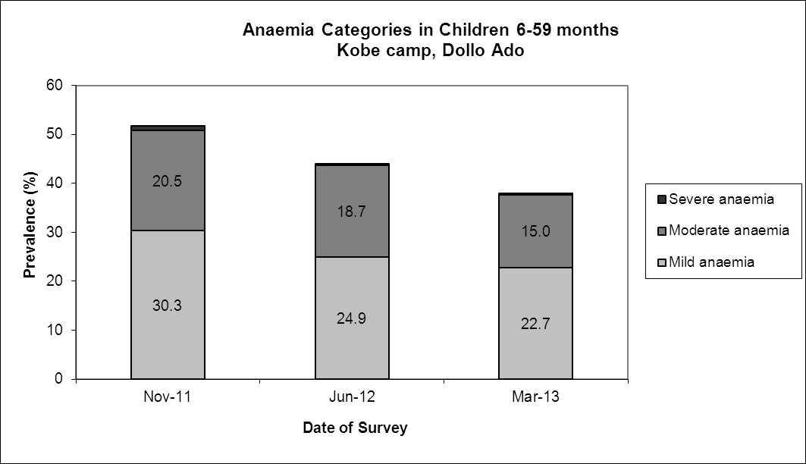

There was no significant increase in the mean haemoglobin concentration in children 6-59 months in 2013 compared to 2012(p> 0.05)

Figure 30: Mean haemoglobin concentration in children 6-59 months from 2011-2013 Kobe camp, Dollo Ado
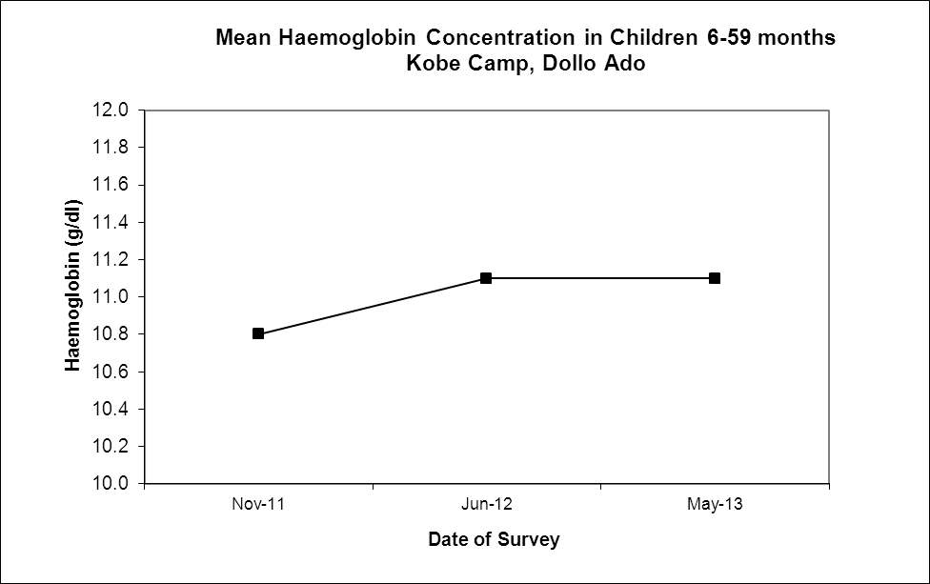

The 6-23 months age group had the highest prevalence of anaemia of 53.3%.The prevalence of anaemia declined with increasing age. These age trends are similar to those seen in 2012. Comparison with results from 2012 shows there was no significant decrease in the prevalence of anaemia among children 6-23months (p>0.05)

Table 101: Prevalence of anaemia by age- Kobe camp, Dollo Ado (March 2013)
 |  | Severe Anaemia  (<7.0 g/dL) |  | Moderate Anaemia  (7.0-9.9 g/dL) |  | Mild Anaemia (Hb 10.0-10.9 g/dL) |  | Total Anaemia (Hb<11g.0 g/dL) |  | Normal (Hb≥11.0 g/dL)
Age (mths) | Total no. | No. | %  (95% CI) | No. | %  (95% CI) | No. | %  (95% CI) | No. | %  (95% CI) | No. | %  (95% CI)
6-23 | 107 | 1 | 0.9  (0-5.1) | 32 | 29.9  (21.4-39.5) | 24 | 22.4  (14.9-31.5) | 57 | 53.3  (43.4-63.0) | 50 | 46.7  (37.0-56.6)
24-35 | 63 | 0 | 0 | 9 | 14.3  (6.7-25.4) | 22 | 34.9  (23.3-48.0) | 31 | 49.2  (36.4-62.1) | 32 | 50.8  (37.9-63.6)
36-59 | 155 | 0 | 0 | 8 | 5.2  (2.3-9.9) | 28 | 18.1  (12.4-25.0) | 36 | 23.2  (16.8-30.7) | 119 | 76.8  (69.3-83.2)
Total | 124 | 1 | 0.3  (0-2.0) | 49 | 15.0  (11.4-19.5) | 74 | 22.7  (18.3-27.7) | 124 | 38.0  (32.8-43.6) | 202 | 62.0  (56.5-67.3)

Programme coverage

Selective feeding programme**

Table 102: Nutrition treatment programme coverage based on all admission criteria (weight-for-height, MUAC, oedema) - Kobe camp, Dollo Ado (March 2013)
 | Number/total | % (95% C.I.)
Proportion of children aged 6-59 months with severe acute malnutrition currently enrolled in therapeutic feeding programme* | 2/9 | 22.2 (2.8-60.0)
Proportion of children aged 6-59 months with moderate acute malnutrition currently enrolled in supplementary feeding programme* | 5/50 | 10.0%(3.3-21.8)
*WHZ flags excluded from analysis

Table 103: Nutrition treatment programme coverage based on MUAC and oedema only- Kobe camp, Dollo Ado (March 2013)
 | Number/total | % (95% CI)
Proportion of children aged 6-59 months with severe acute malnutrition currently enrolled in therapeutic feeding programme | 1/1 | 100
Proportion of children aged 6-59 months with moderate acute malnutrition currently enrolled in supplementary feeding programme | 1/9 | 11.1 (0.3-48.2)
**Selective feeding programme coverage results should be interpreted with caution due to small number of cases that were sampled during the survey.

Vaccination and supplementation programmes

Measles vaccination coverage

Table 104: Measles vaccination coverage for children aged 9-59 months (n= 302) - Kobe camp, Dollo Ado (March 2013)
 | Measles  (with card)  n=23 | Measles  (with card or confirmation from mother)  n=286
YES | 7.6 %  (5.0-11.4 95% CI) | 94.7%  (91.4-96.8 95% CI)

Vitamin A supplementation coverage

Table 105: Vitamin A supplementation for children aged 6-59 months within past 6 months (n=328) - Kobe camp, Dollo Ado (March 2013)
 | Vitamin A capsule  (with card)  n=12 | Vitamin A capsule  (with card or confirmation from mother)  n=310
YES | 3.7 %  (2.0- 6.5 95% CI) | 94.5 %  91.3- 96.6 95% CI)

Comparison with results from 2012 shows a significant improvement in the coverage of measles vaccination and vitamin A supplementation (within past six months) coverage among children 6-59 months (p<0.05).

Figure 31: Nutrition survey results (measles vaccination and vitamin A supplementation within past 6 months with card or recall) since 2011- Kobe camp, Dollo Ado (March 2013)
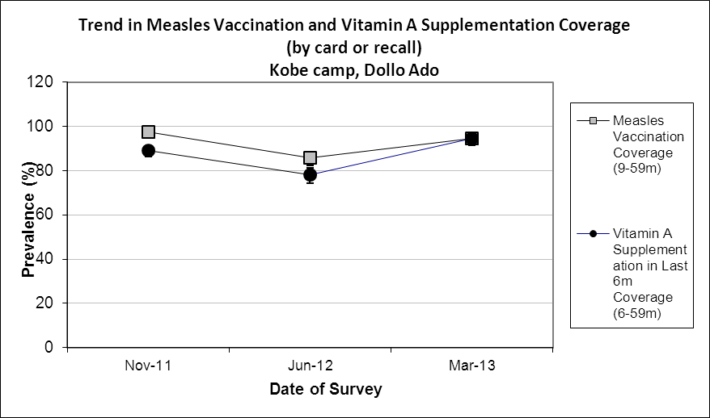

Deworming coverage

Table 106: Deworming for children aged 12-59 months within past 6 months (n=286) –Kobe camp,
Dollo Ado (March 2013)

 | Deworming  (with card)  n=4 | Deworming  (with card or confirmation from mother)  n=209
YES | 1.4 % | 94.4%  (91.1-96.8 95% CI)

Blanket supplementary feeding program (BSFP)

Table 107: BSFP programme for children aged 6-59 months- Kobe camp, Dollo Ado (March 2013)
 | Age | Number/total | % (95% CI)
Currently receiving CSB+/++ | 6-59 | 305/328 | 93.0(89.5-95.4 95% CI

Morbidity and health seeking behaviour

Of children 6-59 months of age, 8.5% (CI 5.8 – 12.2) had experienced diarrhoea two weeks prior to the survey date. Out of the 70 surveyed that was sick two weeks prior to the survey 72.9% (CI 17.1- 26.3) of mothers sought help from the health services provided in the camp which is an improvement compared to only 37.8% in 2012. Compared to 2012 the reported morbidity caseload (diarrhoea and other diseases) remained the same; (p>0.05).

Table 108: Prevalence of diarrhoea and disease in children 6-59 months and health seeking behaviour among mothers of children 6-59 months
 | Number/total | % (95% CI)
Diarrhoea last two weeks (6-59 months) | 28/328 | 8.5(5.8– 12.2)
Children sick in the last two weeks (6-59 months) | 70/328 | 21.3(17.1 – 26.3)
Proportion of mothers with sick children who sought assistance | 51/70 | 72.9(60.9 – 82.8)

CHILDREN 0-23 MONTHS- KOBE CAMP, DOLLO ADO (MARCH 2013)

Table 109: Prevalence of Infant and Young Child Feeding Practices indicators- Kobe camp, Dollo Ado (March 2013)
Indicator | Age range | Number/total | Prevalence (%) | 95% CI
Children ever breastfed | 0-23 months | 161/164 | 98.2 | (94.7-99.6)
Timely initiation of breastfeeding | 0-23 months | 141/161 | 87.6 | (81.5-92.2)
Exclusive breastfeeding under 6 months | 0-5 months | 47/61 | 77.0 | (64.5-86.8)
Continued breastfeeding at 1 year | 12-15 months | 6/14 | 42.9 | (17.7-71.1)
Continued breastfeeding at 2 years | 20-23 months | 5/18 | 27.8 | (9.7-53.5)
Introduction of solid, semi-solid or soft foods | 6-8 months | 5/27 | 18.5 | (6.3-38.1)
Children bottle fed | 0-23 months | 20/164 | 12.2 | (7.6-18.2)
Consumption of iron rich or iron fortified foods | 6-23 months | 78/101 | 77.2 | (67.8-85.0)

The confidence intervals are an integral part of the results when analysing trends over the years. When IYCF indicators are collected in nutritional surveys, it is not feasible to achieve a large enough sample size for some of the indicators to be estimated as precisely as desired, especially for indicators covering a very narrow age range (e.g. 12-15 months, 6-8 months). Hence, trend analyses need to be interpreted with caution. Nevertheless, trend analyses are useful for assessing the situation and major differences seen from year to year should warrant further investigation.

Timely initiation of breastfeeding, exclusive breastfeeding and bottle feeding improved compared to the 2012 surveys while all the other indicators remained the same with no statistically significant changes.

Figure 32: Nutrition survey results (key IYCF indicators) since 2011- Kobe camp, Dollo Ado (March 2013)
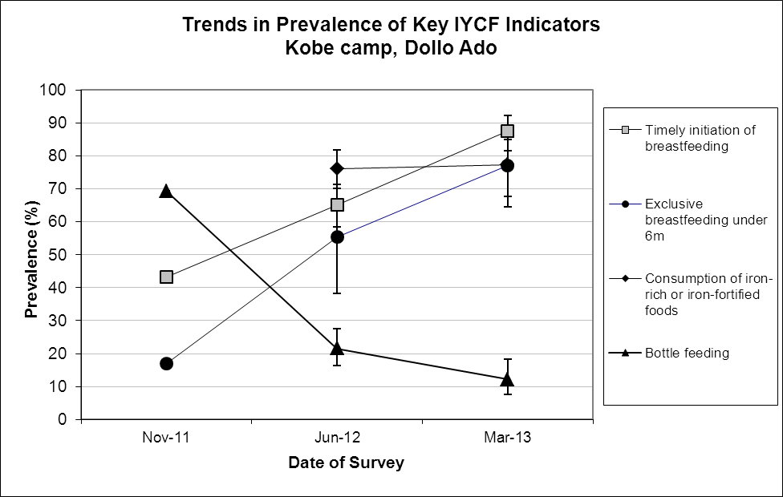

Prevalence of intake

Infant formula
Table 110: Infant formula intake in children aged 0-23 months
 | Number/total | % (95% CI)
Proportion of children aged 0-23 months who receive infant formula (fortified or non-fortified) | 23/102 | 22.5(14.9-31.9)

Fortified blended foods
Table 111: CSB+ intake in children aged 6-23 months
 | Number/total | % (95% CI)
Proportion of children aged 6-23 months who receive FBF | 22/101 | 21.8(14.2-31.1)

Table 112: CSB++ intake in children aged 6-23 months
 | Number/total | % (95% CI)
Proportion of children aged 6-23 months who receive FBF++ | 60/101 | 59.4(49.2-69.1)

WOMEN 15-49 YEARS - KOBE CAMP, DOLLO ADO (MARCH 2012)

Table 113: Demographic information- Kobe camp, Dollo Ado (March 2013)
Physiological status | Number/total | %
Non-Pregnant | 82/124 | 66.1
Pregnant | 42/124 | 33.9
Mean age (range) | 29.7 years (15-46)

Table 114: Prevalence of anaemia and haemoglobin concentration in non-pregnant women of reproductive age (15-49 years) - Kobe camp, Dollo Ado (March 2013)
Anaemia – Non-pregnant women of reproductive age 15-49 years | All  n = 82
Total Anaemia (<12.0 g/dL) | (30) 36.6%  (26.2-48.0 95% CI)
Mild Anaemia (11.0-11.9 g/dL) | (11) 13.4%  (6.9-22.7 95% CI)
Moderate Anaemia (8.0-10.9 g/dL) | (17) 20.7 %  (12.6-31.1 95% CI)
Severe Anaemia (<8.0 g/dL) | (2) 2.4%  (0.3- 8.5 95% CI)
Mean Hb (g/dL) | 12.1g/dL  (1.73SD)  [7.2 min, 15.5 max]

Comparison with results from 2011 [30.1% (23.2-39.7 95% CI)] shows no significant change in the anaemia prevalence among non-pregnant women of reproductive age (p>0.05).

Figure 33: Anaemia categories in women of reproductive age from 2011 to 2012- Kobe camp, Dollo Ado (March 2013)
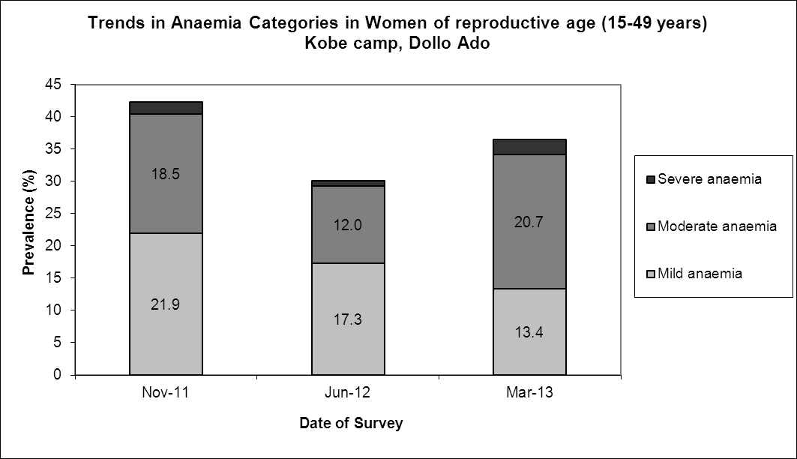

ANC enrolment and iron-folic acid supplementation coverage

Table 115: ANC enrolment and iron-folic acid pills coverage among pregnant women (15-49 years) - Kobe camp, Dollo Ado (March 2013)
 | Number/total | % (95% CI)
Currently enrolled in ANC programme | 36/40 | 90.0 (76.3-97.2)
Currently receiving iron-folic acid pills | 25/39 | 64.1 (47.2-78.8)

Table 116: Post-natal vitamin A supplementation among women (15-49 years) - Kobe camp, Dollo Ado (March 2013)
 | Number/total | % (95% CI)
Received vitamin A supplementation since delivery | 34/35 | 97.1 (85.1-99.9)

HOUSEHOLD-LEVEL INDICATORS-WATER, FOOD SECURITY AND MORTALITY- KOBE CAMP, DOLLO ADO (MARCH 2013)

Table 117 shows the different indicators and the total number of households who were sampled for each household-level indicator. All households were considered whether or not they had eligible individuals for the individual-level measurements.

Table 117: Target sample size and actual number captured during the survey- Kobe camp, Dollo Ado (March 2013)
Indicator | Target  sample size | Household interviewed during the study | % of the target
Water | 183 | 170 | 92.9
Food security | 183 | 181 | 98.9
Mortality | 366 | 360 | 98.4

WATER- KOBE CAMP, DOLLO ADO (MARCH 2013)
Table 118: Water Quantity: Amount of litres of water used per person per day- Kobe camp, Dollo Ado (March 2013)
Proportion of households that access: | Number/total | % (95% CI)
≥ 20 litres | 48/163 | 29.4(22.6-37.1)
15 – <20 litres | 28/163 | 17.2 (11.7-23.9)
<15 litres | 87/163 | 53.4(45.5  -54.2)

The average water usage in lpppd: 16.7 lpppd

Table 119: Satisfaction with water supply- Kobe camp, Dollo Ado (March 2013)
 | Number/total | % (95% CI)
Proportion of households that say they are satisfied with the drinking water supply | 120/170 | 70.6(63.1-77.3)

22.4% (16.3-29.4 CI) of the surveyed household reported to not be satisfied with the water supply while a further 7.1% (3.7-12.0 CI) reported to only be partially satisfied. The main reasons for the dissatisfaction were long distance to the water point (36.8%); long waiting queues (28.9%); irregular supply (18.4%), and not enough water (15.8%).

FOOD SECURITY-KOBE CAMP, DOLLO ADO (MARCH 2013)

Food distribution

Table 120: Ration card coverage- Kobe camp, Dollo Ado (March 2013)
 | Number/total | % (95% CI)
Proportion of households that received the general food ration | 181/181 | 100 (100-100)

The general food ration lasts at most 61.6 % of the intended theoretical duration of 30 days.

Table 121: Reported duration of general food ration 1- Kobe camp, Dollo Ado (March 2013)
Average number of days the food ration lasts (Standard deviation ) | Average duration (%) in relation to the theoretical duration of the ration
18.5 (4.8) | 61.6

The proportion of households reporting that their food ration lasted for 30 days was 6.1%

84.9% of all the households reported that the general food ration received in the previously completed cycle had lasted less than 22.5 days (75% of cycle).

Table 122: Reported duration of general food ration 2 - Kobe camp, Dollo Ado (March 2013)
Number/total
(% (95% CI)
Proportion of households reporting that the food ration lasts the entire duration of the cycle | 11/179  6.1(3.1-10.7)
Proportion of households reporting that the food ration lasted:
≤75% of the cycle [0-22 days] | 152/179  84.9 (78.8-89.8)
>75% of the cycle [23-30 days] | 27/179  15.1(10.2-21.2)

Negative household coping strategies

The most common coping strategies used by households in Kobe camp were borrowing of cash, food or other items with/out interest and reduction in the quantity and/or frequency of meals. A small proportion (5.8%) reported sending at least one child to work outside the household in order get cash or in-kind goods or service and (0.6%) engaged in risky or harmful activities.

The proportion of households reporting that they did not use any of the coping strategies was 6.1%.

Table 123: Coping strategies used by the surveyed population over the past month- Kobe camp, Dollo Ado (March 2013)
 | Number/total | % (95% CI)
Borrowed cash, food or other items with interest | 138/181 | 76.2(69.4-82.2)
Sold any assets (furniture, seed stocks, tools, other NFI, livestock etc.) | 37/181 | 20.4(14.8-27.1)
Requested increase remittances or gifts as compared to normal | 8/181 | 4.4(1.9-8.5)
Reduced the quantity and/or frequency of meals | 116/181 | 64.1(56.6-71.1)
Begged | 19/181 | 10.5(6.4-15.9)
Engaged in potentially risky or harmful activities | 1/181 | 0.6(0-3.0)
Sent at least one child to work outside the household in order get cash or in-kind goods or services | 8/137 | 5.8(2.6-11.2)
Proportion of households reporting using none of the coping strategies over the past month | 11/181 | 6.1(3.1-10.6)

Household dietary diversity

The average household diversity score was 6.2.There was no significant change in the household diversity score in 2013 compared with 2012; p>0.05.

Table 124: Average Household Diet Diversity Score- Kobe camp, Dollo Ado (March 2013)
Average HDDS | Mean  (Standard deviation)
 | 6.2 (1.5)

Fats (98.9%) spices/condiments/beverages (98.95) and cereals (98.3%) were the three most consumed food groups in Kobe camp, while white tubers (12.8%), meat(10.6%) and fish/sea food (2.8%) were the least consumed. None of the households reported to have eaten eggs in the last 24 hours.

Figure 34: Proportion of households consuming different food groups within last 24 hours- Kobe camp, Dollo Ado (March 2013)
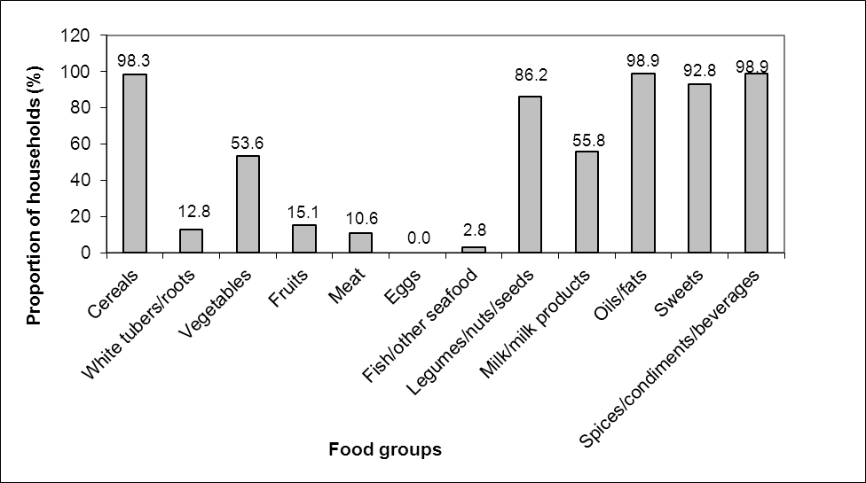

Reliance of a diet consisting entirely of staples, pulses and oils/fat from food aid ration remained the same in 2013 compared to 2012. This was also the same for proportion of households whose diet consisted entirely of general food aid staples. The proportion of households not consuming any vegetables, fruits, meat, eggs, fish/sea-food, and milk/milk products decreased from 43.5% to 26.8% indicating that more households were consuming this food group. The consumption of CSB+ also improved from 72.8 in 2012 to 86.5% in 2013; p<0.05. It is worth noting that the survey data collection was carried out from the 15th to the 18th days of the distribution cycle which is the middle of the GFD distribution cycle.
Table 125: Consumption of food aid commodities and micronutrient rich foods by households- Kobe camp, Dollo Ado (March 2013)
 | Number/total | % (95% CI)
Proportion of households where staples consumed are only from food aid ration (no other staples) | 118/179 | 65.9 (58.5-72.8)
Proportion of households where the diet consists entirely of staples, pulses and oils/fat from food aid ration (no other food sources) | 0/179 | 0
Proportion of households not consuming any vegetables, fruits, meat, eggs, fish/seafood, and milk/milk products | 48/179 | 26.8(20.5-33.9)
Proportion of households consuming either a plant or animal source of vitamin A | 105/179 | 58.7(51.1-66.0)
Proportion of households consuming organ meat/flesh meat, or fish/seafood (food sources of haem iron) | 23/179 | 12.8(8.3-91.7)
Proportion of households consuming fortified blended foods | 154/178 | 86.5(80.6-91.2)

MORTALITY- KOBE CAMP, DOLLO ADO (MARCH 2013)

Retrospective mortality data was collected over the past three months (108 days). Demographic data was also derived from the mortality data as presented below.

Table 126: Demographic and retrospective mortality within camp- Kobe camp, Dollo Ado (March 2013)
Demographic data
Number of HH surveyed | 360
Average HH size | 5.0
% U5 | 21.4%
Retrospective mortality
Number of current HH residents | 1809
Total number U5 | 387
Number of people who joined HH / camp | 35
Total number U5 who joined HH / camp | 29
Number of people who left HH / camp | 45
Total number U5 who left HH / camp | 7
Number of births during recall | 30
Number of deaths during recall | 2
Total number U5 deaths during recall | 1
Crude Death Rate  (total deaths/10,000 people / day) | 0.10  (0.03-0.37 95% CI)
U5 Death Rate  (deaths in children under five/10,000 children under five / day) | 0.26  (0.05-1.44 95% CI)

RESULTS FROM HILAWEYN

INDIVIDUAL-LEVEL INDICATORS-CHILDREN 6-59 MONTHS, 0-23 MONTHS, AND WOMEN OF REPRODUCTIVE AGE 15-49 YEARS-HILAWEYN CAMP, DOLLO ADO (MARCH 2013)

Table 127 shows the different population groups and the total number of individuals who were sampled within each group.

Table 127: Target sample size and actual number captured during the survey Hilaweyn camp, Dollo Ado (March 2013)
Target group | Target  sample size | Subjects measured/interviewed during the survey | % of the target
Children 6-59 months | 378 | 407 | 107.7%
Children 0-23 months | 151 | 203 | 134.4%
Women 15-49 years | 190* | 175* | 92.1%
*Households

Anthropometric results (based on WHO Growth Standards 2006)
The coverage of age documentation was 13 % (children having an exact birth date). This means that the stunting and the underweight data should be interpreted with caution owing to the age unreliability

Table 128: Distribution of age and sex of sample-Hilaweyn camp, Dollo Ado (March 2013)
 | Boys |  | Girls |  | Total |  | Ratio
AGE (mo) | no. | % | no. | % | no. | % | Boy: girl
6-17 | 57 | 55.9 | 45 | 44.1 | 102 | 25.0 | 1.3
18-29 | 56 | 54.9 | 46 | 45.1 | 102 | 25.0 | 1.2
30-41 | 34 | 48.6 | 36 | 51.4 | 70 | 17.2 | 0.9
42-53 | 51 | 53.1 | 45 | 46.9 | 96 | 23.5 | 1.1
54-59 | 25 | 65.8 | 13 | 34.2 | 38 | 9.3 | 1.9
Total | 223 | 54.7 | 185 | 45.3 | 408 | 100.0 | 1.2

The overall sex ratio was 1.2 (sex ratio should be between 0.8-1.2), which confirms that both sexes were equally distributed.

Table 129: Prevalence of acute malnutrition based on weight-for-height z-scores (and/or oedema) and by sex- Hilaweyn camp, Dollo Ado (March 2013)
 | All  n = 407 | Boys  n = 222 | Girls  n = 185
Prevalence of global malnutrition  (<-2 z-score and/or oedema) | (78) 19.2 %  (15.6 - 23.3 95% C.I.) | (51) 23.0 %  (17.9 - 28.9 95% C.I.) | (27) 14.6 %  (10.2 - 20.4 95% C.I.)
Prevalence of moderate malnutrition  (<-2 z-score and >=-3 z-score, no oedema) | (64) 15.7 %  (12.5 - 19.6 95% C.I.) | (43) 19.4 %  (14.7 - 25.1 95% C.I.) | (21) 11.4 %  (7.5 - 16.7 95% C.I.)
Prevalence of severe malnutrition  (<-3 z-score and/or oedema) | (14) 3.4 %  (2.1 - 5.7 95% C.I.) | (8) 3.6 %  (1.8 - 6.9 95% C.I.) | (6) 3.2 %  (1.5 - 6.9 95% C.I.)
The prevalence of oedema is 0.0 %

There was a significant difference between boys and girls in the prevalence of acute malnutrition with boys being more moderately malnourished than girls.

Figure 35: Nutrition survey (GAM, SAM) results since 2011- Hilaweyn camp, Dollo Ado (March 2013)
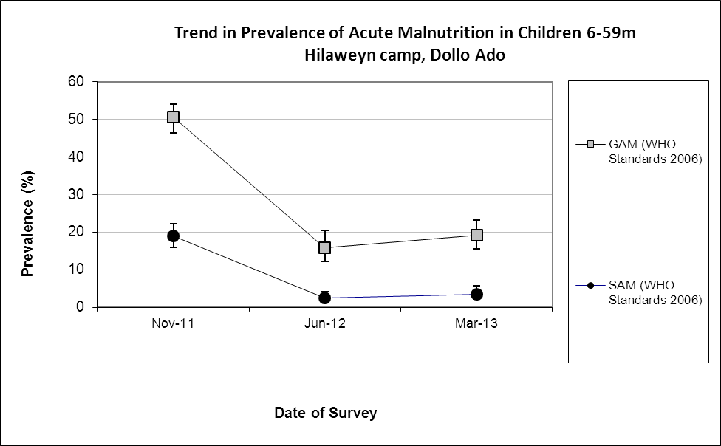

Comparison with results from 2012 shows no statistically significant change in GAM and SAM among children 6-59 months (p>0.05).

Table 130: Prevalence of acute malnutrition by age, based on weight-for-height z-scores and/or oedema- Hilaweyn camp, Dollo Ado (March 2013)
 |  | Severe wasting  (<-3 z-score) |  | Moderate wasting  (>= -3 and <-2 z-score ) |  | Normal  (> = -2 z score) |  | Oedema
Age (mo) | Total no. | No. | % | No. | % | No. | % | No. | %
6-17 | 101 | 9 | 8.9 | 29 | 28.7 | 63 | 62.4 | 0 | 0.0
18-29 | 102 | 1 | 1.0 | 17 | 16.7 | 84 | 82.4 | 0 | 0.0
30-41 | 70 | 0 | 0.0 | 5 | 7.1 | 65 | 92.9 | 0 | 0.0
42-53 | 96 | 3 | 3.1 | 8 | 8.3 | 85 | 88.5 | 0 | 0.0
54-59 | 38 | 1 | 2.6 | 5 | 13.2 | 32 | 84.2 | 0 | 0.0
Total | 407 | 14 | 3.4 | 64 | 15.7 | 329 | 80.8 | 0 | 0.0

Figure 36: Trends in the prevalence of wasting by age in children 6-59 months- Hilaweyn camp, Dollo Ado (March 2013)

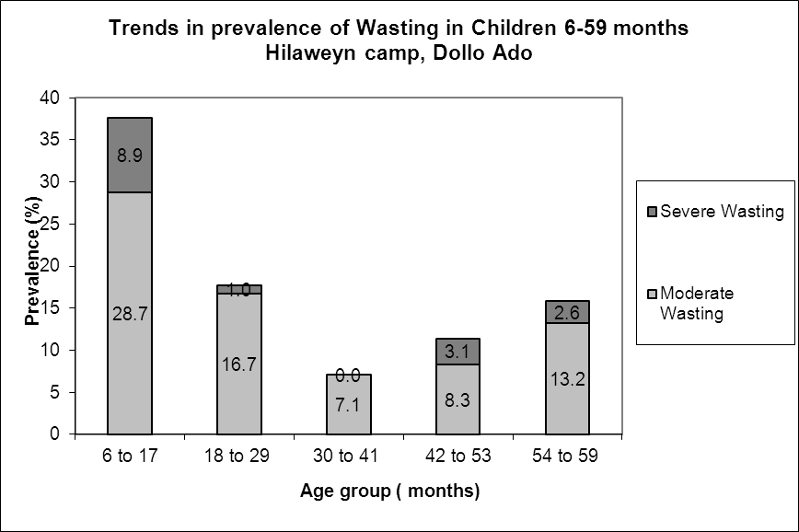

Table 131: Distribution of severe acute malnutrition and oedema based on weight-for-height z-scores- Hilaweyn camp, Dollo Ado (March 2013)
 | <-3 z-score | >=-3 z-score
Oedema present | Marasmic kwashiorkor  No. 0  (0.0 %) | Kwashiorkor  No. 0  (0.0 %)
Oedema absent | Marasmic  No. 15  (3.7 %) | Not severely malnourished  No. 393  (96.3 %)

The figure shows that the weight-for-height z-score distribution is shifted to the left, illustrating a poorer status than the international WHO Standard population of children aged 6-59 months.

Figure 37: Distribution of weight-for-height z-scores (based on WHO Growth Standards; the reference population is shown in green) of survey population compared to reference population-
Hilaweyn camp, Dollo Ado (March 2013)
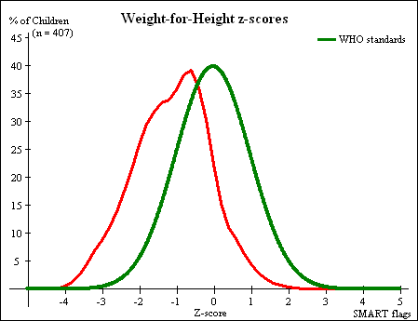

Table 132: Prevalence of stunting based on height-for-age z-scores and by sex- Hilaweyn camp, Dollo Ado (March 2013)
 | All  n = 404 | Boys  n = 222 | Girls  n = 182
Prevalence of stunting  (<-2 z-score) | (52) 12.9 %  (10.0 - 16.5 95% C.I.) | (35) 15.8 %  (11.6 - 21.1 95% C.I.) | (17) 9.3 %  (5.9 - 14.4 95% C.I.)
Prevalence of moderate stunting  (<-2 z-score and >=-3 z-score) | (42) 10.4 %  (7.8 - 13.8 95% C.I.) | (28) 12.6 %  (8.9 - 17.6 95% C.I.) | (14) 7.7 %  (4.6 - 12.5 95% C.I.)
Prevalence of severe stunting  (<-3 z-score) | (10) 2.5 %  (1.3 - 4.5 95% C.I.) | (7) 3.2 %  (1.5 - 6.4 95% C.I.) | (3) 1.6 %  (0.6 - 4.7 95% C.I.)

Table 133: Prevalence of stunting by age based on height-for-age z-scores- Hilaweyn camp, Dollo Ado (March 2013)
 |  | Severe stunting  (<-3 z-score) |  | Moderate stunting  (>= -3 and <-2 z-score ) |  | Normal  (> = -2 z score)
Age (mo) | Total no. | No. | % | No. | % | No. | %
6-17 | 100 | 3 | 3.0 | 18 | 18.0 | 79 | 79.0
18-29 | 101 | 7 | 6.9 | 9 | 8.9 | 85 | 84.2
30-41 | 69 | 0 | 0.0 | 5 | 7.2 | 64 | 92.8
42-53 | 96 | 0 | 0.0 | 10 | 10.4 | 86 | 89.6
54-59 | 38 | 0 | 0.0 | 0 | 0.0 | 38 | 100.0
Total | 404 | 10 | 2.5 | 42 | 10.4 | 352 | 87.1

Children in the age groups 6-17 and 18- 29 months tend to be the most affected by stunting as compared to the other age groups.

Figure 38: Trends in the prevalence of stunting by age in children 6-59 months- Hilaweyn camp, Dollo Ado (March 2013)
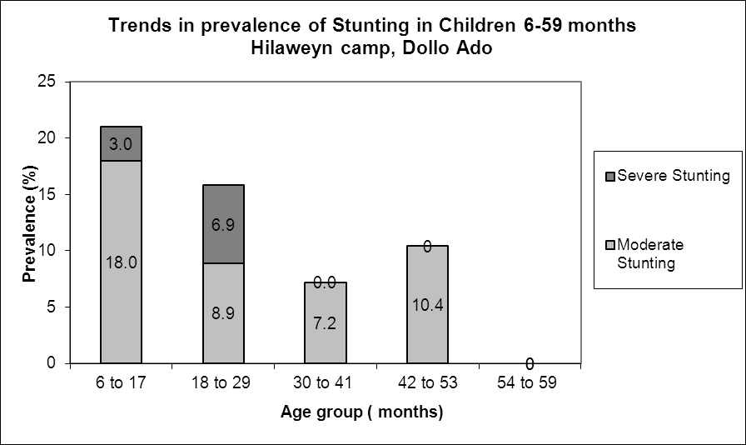

Table 134: Prevalence of underweight based on weight-for-age z-scores by sex- Hilaweyn camp, Dollo Ado (March 2013)
 | All  n = 407 | Boys  n = 222 | Girls  n = 185
Prevalence of underweight  (<-2 z-score) | (82) 20.1 %  (16.5 - 24.3 95% C.I.) | (54) 24.3 %  (19.1 - 30.4 95% C.I.) | (28) 15.1 %  (10.7 - 21.0 95% C.I.)
Prevalence of moderate underweight  (<-2 z-score and >=-3 z-score) | (65) 16.0 %  (12.7 - 19.8 95% C.I.) | (41) 18.5 %  (13.9 - 24.1 95% C.I.) | (24) 13.0 %  (8.9 - 18.6 95% C.I.)
Prevalence of severe underweight  (<-3 z-score) | (17) 4.2 %  (2.6 - 6.6 95% C.I.) | (13) 5.9 %  (3.5 - 9.8 95% C.I.) | (4) 2.2 %  (0.8 - 5.4 95% C.I.)

Table 135: Mean z-scores, Design Effects and excluded subjects - Hilaweyn camp, Dollo Ado (March 2013)
Indicator | n | Mean z-scores ± SD | Design Effect (z-score < -2) | z-scores not available* | z-scores out of range
Weight-for-Height | 407 | -1.11±1.00 | 1.00 | 0 | 1
Weight-for-Age | 407 | -1.37±0.87 | 1.00 | 0 | 1
Height-for-Age | 404 | -1.11±0.84 | 1.00 | 0 | 4

MUAC was being used in the community for screening and admission to therapeutic and supplementary feeding programmes.

Table 136: Prevalence of MUAC malnutrition- Hilaweyn camp, Dollo Ado (March 2013)
 | All  n = 408 | Boys  n = 223 | Girls  n = 185
Prevalence of MUAC  (< 125 mm and/or oedema) | (25) 6.1 %  (4.2 - 8.9 95% C.I.) | (15) 6.7 %  (4.1 - 10.8 95% C.I.) | (10) 5.4 %  (3.0 - 9.7 95% C.I.)
Prevalence of MUAC  (< 125 mm and >= 115 mm, no oedema) | (18) 4.4 %  (2.8 - 6.9 95% C.I.) | (10) 4.5 %  (2.5 - 8.1 95% C.I.) | (8) 4.3 %  (2.2 - 8.3 95% C.I.)
Prevalence of MUAC  (< 115 mm and/or oedema) | (7) 1.7 %  (0.8 - 3.5 95% C.I.) | (5) 2.2 %  (1.0 - 5.1 95% C.I.) | (2) 1.1 %  (0.3 - 3.9 95% C.I.)

The case load for the selective feeding programmes was estimated to aid in programme planning. The Hilaweyn population used during the survey was 32,075. Based on the survey results, 25.2% children were found to be under 5 years (total of 8,083 children) and hence a total of 7,275 children were estimated to be between 6-59 months (assuming that 10% of under-5 are 0-5 months).

Table 137: Estimated number of malnourished children aged 6-59 months eligible to be enrolled in a selective feeding programme at the time of the survey (based on all admission criteria)- Hilaweyn camp, Dollo Ado (March 2013)
 | Total/number | % (95% CI) | N (LCI-UCI)*
Eligible for therapeutic feeding programme** | 14/407 | 3.4(2.1-5.7) | 247 (152-415)
Eligible for supplementary feeding programme** | 64/407 | 15.7 (12.5-19.6) | 1142 (909-1426)
*LCI=Lower Confidence Interval; UCI: Upper Confidence Interval
**WHZ flags excluded from analysis

Using the HIS data for week 13 there were 126 children enrolled in the therapeutic feeding program which was 1.7% of children 6-59 months while 596 were enrolled in the supplementary feeding program which was 8.2% of children 6-59 months.

Anaemia results

Table 138: Prevalence of anaemia and haemoglobin concentration in children 6-59 months of age - Hilaweyn camp, Dollo Ado (March 2013)
Anaemia – Children 6-59 months | All  n = 394
Total Anaemia (Hb<11.0 g/dL) | (195) 49.5 %  (44.5-54.5 95% CI)
Mild Anaemia (Hb 10.0-10.9 g/dL) | (108) 27.4 %  (23.1-32.1 95% CI)
Moderate Anaemia (7.0-9.9 g/dL) | (84) 21.3 %  (17.4-25.8 95% CI)
Severe Anaemia (<7.0 g/dL) | (3) 0.8 %  (0.2-2.4 95% CI)
Mean Hb (g/dL) | 10.8 g/dL  (1.71 SD)  [5.7 min,14.0 max]
Comparison with results from 2012 shows no statistically significant change in the anaemia prevalence among children 6-59 months (p>0.05).

Figure 39: Nutrition survey results (anaemia in children 6-59 months) since 2011- Hilaweyn camp, Dollo Ado (March 2013)

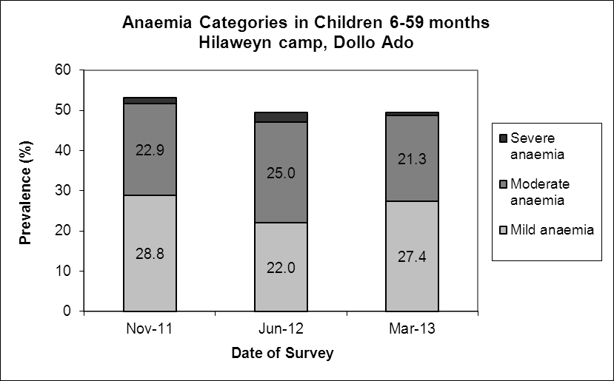

There was no significant decrease in the mean haemoglobin concentration in children 6-59 months in 2012 compared to 2011(p> 0.05)

Figure 40: Mean haemoglobin concentration in children 6-59 months from 2011-2013 Hilaweyn camp, Dollo Ado

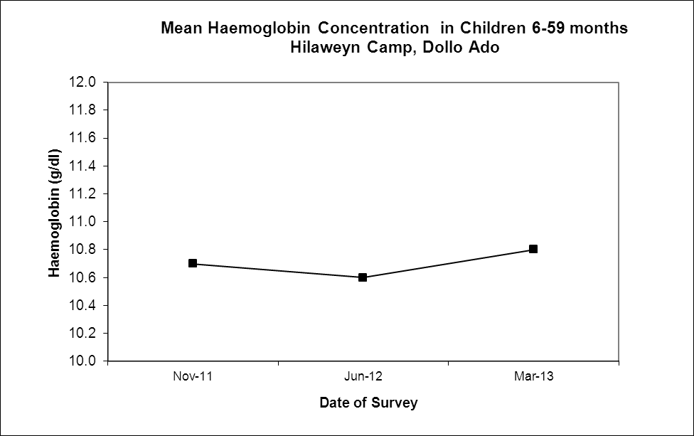

The 6-23 months age group had the highest prevalence of anaemia of 70.0%; prevalence of anaemia declined with increasing age. These age trends are similar to those seen in 2012.

Table 139: Prevalence of anaemia by age- Hilaweyn camp, Dollo Ado (March 2013)
 |  | Severe Anaemia  (<7.0 g/dL) |  | Moderate Anaemia  (7.0-9.9 g/dL) |  | Mild Anaemia (Hb 10.0-10.9 g/dL) |  | Total Anaemia (Hb<11g.0 g/dL) |  | Normal (Hb≥11.0 g/dL)
Age (mths) | Total no. | No. | %  (95% CI) | No. | %  (95% CI) | No. | %  (95% CI) | No. | %  (95% CI) | No. | %  (95% CI)
6-23 | 140 | 1 | 0.7  (0-3.9) | 57 | 40.7  (32.5-49.3) | 40 | 28.6  (21.3 - 36.8) | 98 | 70.0  (61.7-77.4) | 42 | 30.0  (22.6-38.3)
24-35 | 83 | 0 | 0 | 15 | 18.1  (10.5-28.0) | 25 | 30.1  (20.5-41.2) | 40 | 48.2  (37.1-59.4) | 43 | 51.8  (40.6-62.9)
36-59 | 171 | 2 | 1.2  (0.1-4.2) | 12 | 7.0  (3.7-11.9) | 43 | 25.1  (18.8-32.3) | 57 | 33.3  (26.3-40.9) | 114 | 66.7  (59.1-73.7)
Total | 394 | 3 | 0.8  (0.2-2.4) | 84 | 21.3  (17.4-25.8) | 108 | 27.4  (23.1-32.1) | 195 | 49.5  (44.5-54.5) | 199 | 50.5  (45.5-55.5)

Programme coverage

Selective feeding programme

Table 140: Nutrition treatment programme coverage based on all admission criteria (weight-for-height, MUAC, oedema) - Hilaweyn camp, Dollo Ado (March 2013)
 | Number/total | % (95% C.I.)
Proportion of children aged 6-59 months with severe acute malnutrition currently enrolled in therapeutic feeding programme* | 10/17 | 58.8 (32.9-81.6)
Proportion of children aged 6-59 months with moderate acute malnutrition currently enrolled in supplementary feeding programme* | 20/66 | 30.3 (19.6-42.9)
*WHZ flags excluded from analysis

Table 141: Nutrition treatment programme coverage based on MUAC and oedema only- Hilaweyn camp, Dollo Ado (March 2013)
 | Number/total | % (95% CI)
Proportion of children aged 6-59 months with severe acute malnutrition currently enrolled in therapeutic feeding programme | 6/7 | 85.7 (42.1-99.6)
Proportion of children aged 6-59 months with moderate acute malnutrition currently enrolled in supplementary feeding programme | 8/19 | 42.1 (20.3-66.5)
**Selective feeding programme coverage results should be interpreted with caution due to small number of cases that were sampled during the survey.

Vaccination and supplementation programmes

Measles vaccination coverage

Table 142: Measles vaccination coverage for children aged 9-59 months (n= 368) - Hilaweyn camp, Dollo Ado (March 2013)
 | Measles  (with card)  n=21 | Measles  (with card or confirmation from mother)  n=316
YES | 5.7 %  (3.7-8.7 95% CI) | 85.9 %  (81.9-89.395% CI)

Vitamin A supplementation coverage

Table 143: Vitamin A supplementation for children aged 6-59 months within past 6 months (n=408) - Hilaweyn camp, Dollo Ado (March 2013)
 | Vitamin A capsule  (with card)  n=24 | Vitamin A capsule  (with card or confirmation from mother)  n=354
YES | 5.9 %  (3.9-8.7 95% CI) | 86.8%  (83.1-89.9 95% CI)

Comparison with results from 2012 shows a significant improvement in the coverage of measles vaccination and vitamin A supplementation (within past six months) coverage with card or recall among children 6-59 months (p<0.05).

Figure 41: Nutrition survey results (measles vaccination and vitamin A supplementation within past 6 months with card or recall) since 2011- Hilaweyn camp, Dollo Ado (March 2013)

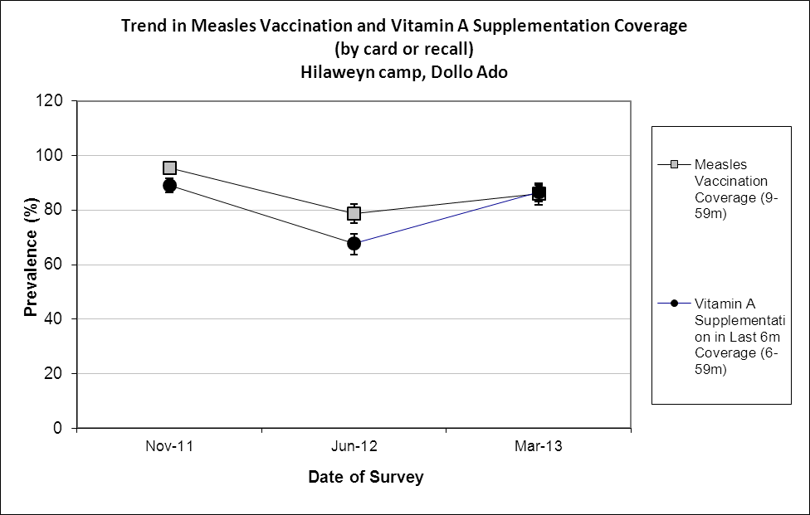

Deworming coverage

Table 144: Deworming for children aged 12-59 months within past 6 months (n=346) –Hilaweyn cam, Dollo Ado (March 2013)

 | Deworming  (with card)  n=16 | Deworming  (with card or confirmation from mother)  n=284
YES | 4.6 %  (2.8 -7.6 95% CI) | 75.3%  (77.6-86.0 95% CI)

Blanket supplementary feeding program (BSFP)
Table 145: BSFP programme for children aged 6-59 months- Hilaweyn camp, Dollo Ado (March 2013)
 | Age | Number/total | % (95% CI)
Currently receiving CSB++ | 6-59 | 367/408 | 90.0  (86.6-92.7 95% CI

Morbidity and health seeking behaviour

Of children 6-59 months of age, 15.7% (CI 12.4 – 19.7) had experienced diarrhoea two weeks prior to the survey date. Out of the 99 surveyed that was sick two weeks prior to the survey 58.6% of the mothers sought help from the health services provided in the camp which is an improvement compared to 2012 where only 32.0% sort help. Compared to 2012 the reported morbidity caseload (diarrhoea and other diseases remained the same; p>0.05).

Table 146: Prevalence of diarrhoea and disease in children 6-59 months and health seeking behaviour among mothers of children 6-59 months- Hilaweyn camp, Dollo Ado (March 2013)

 | Number/total | % (95% CI)
Diarrhoea last two weeks (6-59 months) | 64/408 | 15.7(12.4– 19.7)
Children sick in the last two weeks (6-59 months) | 99/408 | 24.3 (20.2– 28.8)
Proportion of mothers with sick children who sought assistance | 58/99 | 58.6(48.2 – 68.9)

CHILDREN 0-23 MONTHS- HILAWEYN CAMP, DOLLO ADO (MARCH 2013)

Table 147: Prevalence of Infant and Young Child Feeding Practices indicators- Hilaweyn camp, Dollo Ado (March 2013)
Indicator | Age range | Number/ total | Prevalence (%) | 95% CI
Children ever breastfed | 0-23 months | 181/202 | 89.6 | (84.5-93.4)
Timely initiation of breastfeeding | 0-23 months | 145/179 | 81.0 | (74.5-86.5)
Exclusive breastfeeding under 6 months | 0-5 months | 34/65 | 52.3 | (39.5-64.9)
Continued breastfeeding at 1 year | 12-15 months | 17/24 | 70.8 | (48.9-87.4)
Continued breastfeeding at 2 years | 20-23 months | 0/17 | 0 | 0
Introduction of solid, semi-solid or soft foods | 6-8 months | 15/38 | 39.5 | (24.0-56.6)
Children bottle fed | 0-23 months | 24/203 | 11.8 | (7.7-17.1)
Consumption of iron rich or iron fortified foods | 6-23 months | 128/136 | 94.1 | (88.7-97.4)

The confidence intervals are an integral part of the results when analysing trends over the years. When IYCF indicators are collected in nutritional surveys, it is not feasible to achieve a large enough sample size for some of the indicators to be estimated as precisely as desired, especially for indicators covering a very narrow age range (e.g. 12-15 months, 6-8 months). Hence, trend analyses need to be interpreted with caution. Nevertheless, trend analyses are useful for assessing the situation and major differences seen from year to year should warrant further investigation.

Timely introduction of solid, semisolid or soft foods and the consumption of iron rich or iron fortified foods improved compared to the 2012 survey. Continuation of breastfeeding at two years deteriorated while the rest of the indicators remained the same with no statistically significant change.

Figure 42: Trends in prevalence of key IYCF indicator Hilaweyn Camp-Dollo Ado
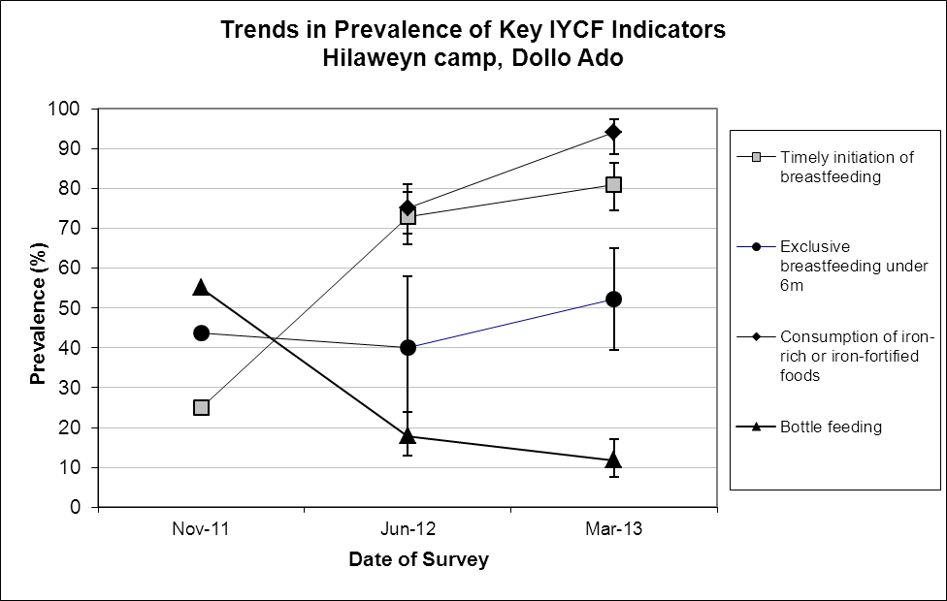

Prevalence of intake

Infant formula
Table 148: Infant formula intake in children aged 0-23 months
 | Number/total | % (95% CI)
Proportion of children aged 0-23 months who receive infant formula (fortified or non- fortified) | 43/203 | 21.2(15.8-27.5)

Fortified blended foods

Table 149: CSB+ intake in children aged 6-23 months
 | Number/total | % (95% CI)
Proportion of children aged 6-23 months who receive FBF | 48/136 | 35.3(27.3-43.9)

Table 150: CSB++ intake in children aged 6-23 months
 | Number/total | % (95% CI)
Proportion of children aged 6-23 months who receive FBF++ | 106/136 | 77.9(70.0-84.6)

WOMEN 15-49 YEARS - HILAWEYN CAMP, DOLLO ADO (MARCH 2013)

Table 151: Demographic information- Hilaweyn camp, Dollo Ado (March 2013)
Physiological status | Number/total | %
Non-Pregnant | 93/129 | 72.1
Pregnant | 35/129 | 27.1
Mean age (range) | 28.9 years (15-47)

Table 152: Prevalence of anaemia and haemoglobin concentration in non-pregnant women of reproductive age (15-49 years) - Hilaweyn camp, Dollo Ado (March 2013)
Anaemia – Non-pregnant women of reproductive age 15-49 years | All  n = 93
Total Anaemia (<12.0 g/dL) | (28) 29.8%  (20.8-40.1 95% CI)
Mild Anaemia (11.0-11.9 g/dL) | (19) 20.2%  (12.6-29.8 95% CI)
Moderate Anaemia (8.0-10.9 g/dL) | (8) 8.5 %  (3.7-16.7 95% CI)
Severe Anaemia (<8.0 g/dL) | (1) 1.1 %  (0-5.8 95% CI)
Mean Hb (g/dL) | 12.4g/dL  (1.47SD)  [7.7min, 15.2max]

Comparison with results from 2012 [24.5% (17.8-32.3 95% CI)] shows no significant change in anaemia among non-pregnant women of reproductive age (p<0.05).

Figure 43: Anaemia categories in women of reproductive age from 2011 to 2013- Hilaweyn camp, Dollo Ado (March 2013)
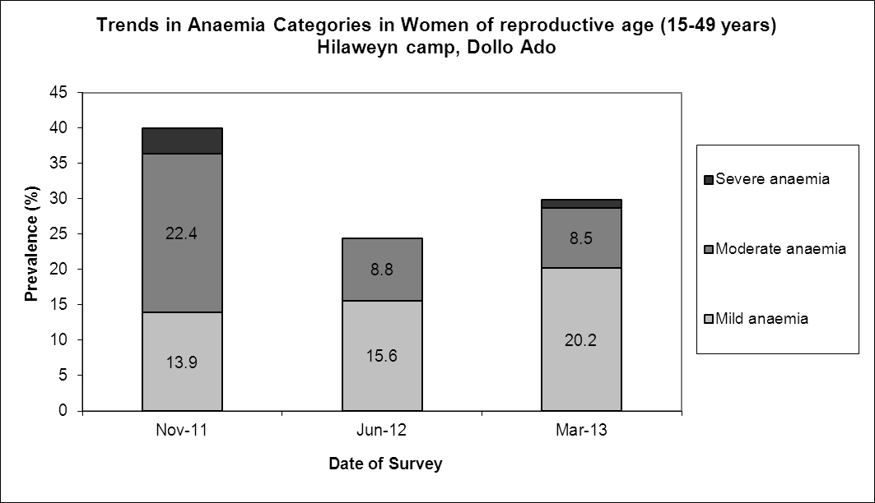

ANC enrolment and iron-folic acid supplementation coverage

Table 153: ANC enrolment and iron-folic acid pills coverage among pregnant women (15-49 years) - Hilaweyn camp, Dollo Ado (March 2013)
 | Number/total | % (95% CI)
Currently enrolled in ANC programme | 25/35 | 71.4 (53.7-85.4)
Currently receiving iron-folic acid pills | 18/35 | 51.4 (34.0-68.6)

Table 154: Post-natal vitamin A supplementation among women (15-49 years) - Hilaweyn camp, Dollo Ado (March 2013)
 | Number/total | % (95% CI)
Received vitamin A supplementation since delivery | 20/36 | 44.4 (38.1-72.1)

HOUSEHOLD-LEVEL INDICATORS- WATER, FOOD SECURITY AND MORTALITY- HILAWEYN CAMP, DOLLO ADO (MARCH 2013)

Table 155 shows the different indicators and the total number of households who were sampled for each household-level indicator. All households were considered whether or not they had eligible individuals for the individual-level measurements.

Table 155: Target sample size and actual number captured during the survey- Hilaweyn camp, Dollo Ado (March 2013)
Indicator | Target  sample size | Household interviewed during the study | % of the target
Water | 190 | 173 | 91.1
Food security | 190 | 175 | 92.1
Mortality | 380 | 364 | 95.8

WATER- HILAWEYN CAMP, DOLLO ADO, (MARCH 2013)
Table 156: Water Quantity: Amount of litres of water used per person per day- Hilaweyn camp, Dollo Ado (March 2013)
Proportion of households that access: | Number/total | % (95% CI)
≥ 20 litres | 65/173 | 37.6(30.3-45.2)
15 – <20 litres | 33/173 | 19.1 (13.5-25.7)
<15 litres | 75/173 | 43.4(35.9-51.1)

The average water usage in lpppd: 20.9 lpppd

Table 157: Satisfaction with water supply- Hilaweyn camp, Dollo Ado (March 2013)
 | Number/total | % (95% CI)
Proportion of households that say they are satisfied with the drinking water supply | 167/173 | 96.5 (92.6-98.7)

3.5 %( 1.3-7.4 CI) of the surveyed households were not satisfied with the water supply. The main reasons for the dissatisfaction were long waiting queues (50.0%); long distance to the water point (33.3.0%); and the water being too warm (16.7%).

FOOD SECURITY - HILAWEYN CAMP, DOLLO ADO, (MARCH 2013)

Food distribution

Table 158: Ration card coverage- Hilaweyn camp, Dollo Ado (March 2013)
 | Number/total | % (95% CI)
Proportion of households that received the general food ration | 175/175 | 100 (100-100)

The general food ration lasts at most 66.3 % of the intended theoretical duration of 30 days.

Table 159: Reported duration of general food ration 1- Hilaweyn camp, Dollo Ado (March 2013)
Average number of days the food ration lasts (Standard deviation ) | Average duration (%) in relation to the theoretical duration of the ration
19.9 (6.1) | 66.3

The proportion of households reporting that their food ration lasted for 30 days was 1.6%
More than 90% of all the households reported that the general food ration received in the previously completed cycle had lasted less than 22.5 days (75% of cycle).

Table 160: Reported duration of general food ration 2 - Hilaweyn camp, Dollo Ado (March 2013)
Number/total
(% (95% CI)
Proportion of households reporting that the food ration lasts the entire duration of the cycle | 27/174  15.5(10.5-21.8)
Proportion of households reporting that the food ration lasted:
≤75% of the cycle [0-22 days] | 122/174  70.1(62.7-76.8)
>75% of the cycle [23-30 days] | 52/174  29.9(23.2-37.3)

Negative household coping strategies

The most common coping strategies used by households in Hilaweyn camp were borrowing of cash, food or other items with/out interest and reduction in the quantity and/or frequency of meals. 7.5% of the households reported to engage in risky or harmful activities and sending at least one child to work outside the household in order get cash or in-kind goods or services (1.5%).

The proportion of households reporting that they did not use any of the coping strategies was 28.0 %.There was no statistically significant change in the proportion of households using negative coping strategies in 2013 compared to 2012

Table 161: Coping strategies used by the surveyed population over the past month- Hilaweyn camp, Dollo Ado (March 2013)
 | Number/total | % (95% CI)
Borrowed cash, food or other items with/out interest | 109/175 | 62.3(54.7-69.5)
Sold any assets (furniture, seed stocks, tools, other NFI, livestock etc.) | 17/175 | 9.7(5.8-15.1)
Requested increase remittances or gifts as compared to normal | 13/175 | 7.4(4.0-12.4)
Reduced the quantity and/or frequency of meals | 36/175 | 20.6(14.8-27.3)
Begged | 35/175 | 20.0(14.3-26.7)
Engaged in potentially risky or harmful activities | 13/174 | 7.5(4.0-12.4)
Sent at least one child to work outside the household in order get cash or in-kind goods or services | 2/132 | 1.5(0.2-5.4)
Proportion of households reporting using none of the coping strategies over the past month | 49/172 | 28.0(21.5-35.3)

Household dietary diversity

The average household diversity score was 5.9. This remained the same as that found in 2012(5.6); p>0.05

Table 162: Average Household Diet Diversity Score- Hilaweyn camp, Dollo Ado (March 2013)
Average HDDS | Mean  (Standard deviation)
 | 5.9 (1.8)

Cereals (98.9%), Fats (96.0%), and legumes (84%) were the three most consumed food groups in Hilaweyn camp while meat (6.9%), fish/seafood (5.7%), and eggs (2.9%), and were the least consumed.

Figure 44: Proportion of households consuming different food groups within last 24 hours- Hilaweyn camp, Dollo Ado (March 2013)
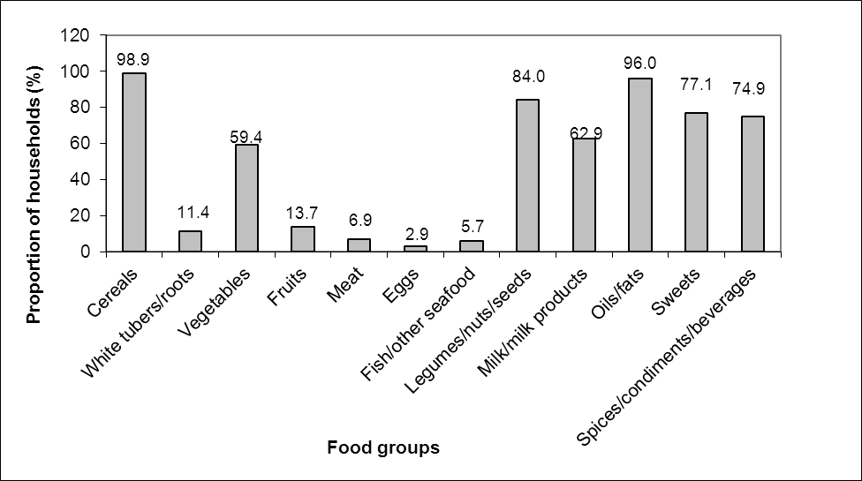

Reliance of the staples from the general food aid ration remained the same in 2013 compared to 2012.This was the same case for the diet that consisted entirely of staples, pulses and oils/fat from food aid ration with no other food sources. The proportion of households not consuming any vegetables, fruits, meat, eggs, fish/sea-food, and milk/milk products decreased from 34.7% to 18.4% indicating that more households were consuming this food group. The consumption of CSB+ also improved from 69.2% in 2012 to 84.5% in 2013; p<0.05. It is worth noting that the survey data collection was carried out from the 24th to the 26th days of the distribution cycle which is end the GFD distribution.

Table 163: Consumption of food aid commodities and micronutrient rich foods by households- Hilaweyn camp, Dollo Ado (March 2013)
 | Number/total | % (95% CI)
Proportion of households where staples consumed are only from food aid ration (no other staples) | 97/175 | 55.4 (47.7-62.9)
Proportion of households where the diet consists entirely of staples, pulses and oils/fat from food aid ration (no other food sources) | 9/175 | 5.2(2.4-9.6)
Proportion of households not consuming any vegetables, fruits, meat, eggs, fish/seafood, and milk/milk products | 32/174 | 18.4(12.9-25.0)
Proportion of households consuming either a plant or animal source of vitamin A | 117/175 | 66.7(59.4-73.8)
Proportion of households consuming organ meat/flesh meat, or fish/seafood (food sources of haem iron) | 21/175 | 12.1(7.6-17.9)
Proportion of households consuming fortified blended foods | 147/174 | 84.5(78.2-89.5)

MORTALITY- HILAWEYN CAMP, DOLLO ADO (MARCH 2013)
Retrospective mortality data was collected over the past three months (86 days). Demographic data was also derived from the mortality data as presented below.

Table 164: Demographic and retrospective mortality within camp- Hilaweyn camp, Dollo Ado (March 2013)
Demographic data
Number of HH surveyed | 364
Average HH size | 5.1
% U5 | 25.2 %
Retrospective mortality
Number of current HH residents | 1847
Total number U5 | 466
Number of people who joined HH / camp | 86
Total number U5 who joined HH / camp | 53
Number of people who left HH / camp | 93
Total number U5 who left HH / camp | 17
Number of births during recall | 42
Number of deaths during recall | 5
Total number U5 deaths during recall | 4
Crude Death Rate  (total deaths/10,000 people / day) | 0.32  (0.14-0.74 95% CI)
U5 Death Rate  (deaths in children under five/10,000 children under five / day) | 1.08  (0.42-2.76 95% CI)

RESULTS FROM BURAMINO

INDIVIDUAL-LEVEL INDICATORS-CHILDREN 6-59 MONTHS, 0-23 MONTHS, AND WOMEN OF REPRODUCTIVE AGE 15-49 YEARS-BURAMINO CAMP, DOLLO ADO (MARCH 2013)

Table 165 shows the different population groups and the total number of individuals who were sampled within each group.

Table 165: Target sample size and actual number captured during the survey Buramino camp, Dollo Ado (March 2013)
Target group | Target  sample size | Subjects measured/interviewed during the survey | % of the target
Children 6-59 months | 341 | 474 | 139%
Children 0-23 months | 136 | 241 | 177.2%
Women 15-49 years | 230* | 208* | 90.4%
*Household

New arrivals in Buramino camp for less than three months represented 4% of the population

Anthropometric results (based on WHO Growth Standards 2006)

The coverage of age documentation was 6% (children having an exact birth date). This means that the stunting and the underweight data should be interpreted with caution owing to the age unreliability

Table 166: Distribution of age and sex of sample-Buramino camp, Dollo Ado (March 2013)
 | Boys |  | Girls |  | Total |  | Ratio
AGE (mo) | no. | % | no. | % | no. | % | Boy:girl
6-17 | 53 | 49.1 | 55 | 50.9 | 108 | 22.8 | 1.0
18-29 | 63 | 47.4 | 70 | 52.6 | 133 | 28.1 | 0.9
30-41 | 43 | 51.8 | 40 | 48.2 | 83 | 17.5 | 1.1
42-53 | 48 | 44.9 | 59 | 55.1 | 107 | 22.6 | 0.8
54-59 | 25 | 58.1 | 18 | 41.9 | 43 | 9.1 | 1.4
Total | 232 | 48.9 | 242 | 51.1 | 474 | 100.0 | 1.0

The overall sex ratio was 1.0 (sex ratio should be between 0.8-1.2), which confirms that both sexes were equally distributed.

Table 167: Prevalence of acute malnutrition based on weight-for-height z-scores (and/or oedema) and by sex- Buramino camp, Dollo Ado (March 2013)
 | All  n = 474 | Boys  n = 232 | Girls  n = 242
Prevalence of global malnutrition  (<-2 z-score and/or oedema) | (93) 19.6 %  (16.3 - 23.4 95% C.I.) | (63) 27.2 %  (21.8 - 33.2 95% C.I.) | (30) 12.4 %  (8.8 - 17.1 95% C.I.)
Prevalence of moderate malnutrition  (<-2 z-score and >=-3 z-score, no oedema) | (71) 15.0 %  (12.0 - 18.5 95% C.I.) | (49) 21.1 %  (16.4 - 26.8 95% C.I.) | (22) 9.1 %  (6.1 - 13.4 95% C.I.)
Prevalence of severe malnutrition  (<-3 z-score and/or oedema) | (22) 4.6 %  (3.1 - 6.9 95% C.I.) | (14) 6.0 %  (3.6 - 9.9 95% C.I.) | (8) 3.3 %  (1.7 - 6.4 95% C.I.)
The prevalence of oedema is 0.0 %
There was a difference between boys and girls in the prevalence of acute malnutrition with boys being more moderately malnourished.

Table 168: Prevalence of acute malnutrition based on weight-for-height z-scores (and/or oedema) and by Arrival- Buramino camp, Dollo Ado (March 2013)
 | All  n = 474 | Arrival <3 months  n = 19 | Arrival >3months  n=455
Prevalence of global malnutrition  (<-2 z-score and/or oedema) | (93) 19.6 %  (16.3 - 23.4 95% C.I.) | (5) 26.3 %  (9.1 – 51.2 95% C.I.) | (88) 19.3 %  (15.9 – 23.3 95% C.I.)
Prevalence of moderate malnutrition  (<-2 z-score and >=-3 z-score, no oedema) | (71) 15.0 %  (12.0 - 18.5 95% C.I.) | (5) 26.3 %  (9.1 – 51.2 95% C.I.) | (66) 14.5 %  (11.5 – 18.2 95% C.I.)
Prevalence of severe malnutrition  (<-3 z-score and/or oedema) | (22) 4.6 %  (3.1 - 6.9 95% C.I.) | 0 | (22) 4.8%  (3.1 – 7.3 95% C.I.)

There was no statistically significant difference between arrivals who came in the last three months and those that came before that in the prevalence of acute malnutrition among children 6-59 months in Buramino; p>0.05.This should however be interpreted with caution due to the small sample size of the new arrivals.

Figure 45: Nutrition survey (GAM, SAM) results since 2012- Buramino camp, Dollo Ado (March 2013)
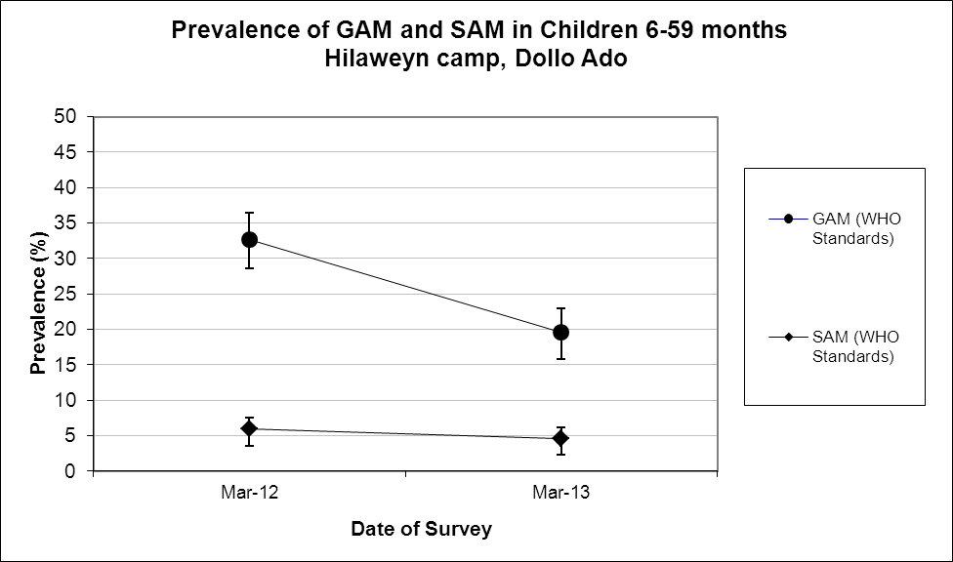

Comparison with results from 2012 shows a significant decrease in GAM among children 6-59 months (p<0.05) with less chidren being moderately malnourished. There was no significant change in the prevalence SAM

Table 169: Prevalence of acute malnutrition by age, based on weight-for-height z-scores and/or oedema- Buramino camp, Dollo Ado (March 2013)
 |  | Severe wasting  (<-3 z-score) |  | Moderate wasting  (>= -3 and <-2 z-score ) |  | Normal  (> = -2 z score) |  | Oedema
Age (mo) | Total no. | No. | % | No. | % | No. | % | No. | %
6-17 | 108 | 5 | 4.6 | 25 | 23.1 | 78 | 72.2 | 0 | 0.0
18-29 | 133 | 4 | 3.0 | 12 | 9.0 | 117 | 88.0 | 0 | 0.0
30-41 | 83 | 3 | 3.6 | 12 | 14.5 | 68 | 81.9 | 0 | 0.0
42-53 | 107 | 5 | 4.7 | 15 | 14.0 | 87 | 81.3 | 0 | 0.0
54-59 | 43 | 5 | 11.6 | 7 | 16.3 | 31 | 72.1 | 0 | 0.0
Total | 474 | 22 | 4.6 | 71 | 15.0 | 381 | 80.4 | 0 | 0.0

Figure 46: Trends in the prevalence of wasting by age in children 6-59 months- Buramaino camp, Dollo Ado (March 2013)

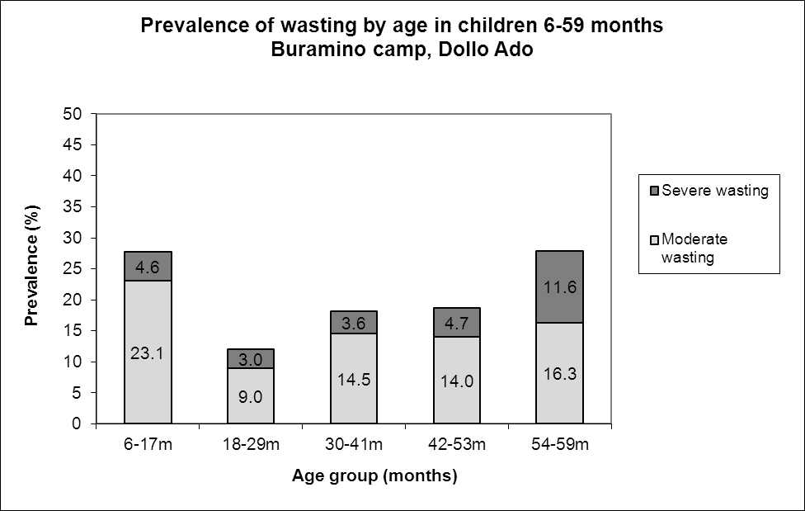

Children in age group 6-17 months and 54-59 tend to be most affected by wasting.

Table 170: Distribution of severe acute malnutrition and oedema based on weight-for-height z-scores- Buramino camp, Dollo Ado (March 2013)
 | <-3 z-score | >=-3 z-score
Oedema present | Marasmic kwashiorkor  No. 0  (0.0 %) | Kwashiorkor  No. 0  (0.0 %)
Oedema absent | Marasmic  No. 22  (4.6 %) | Not severely malnourished  No. 452  (95.4 %)

The figure shows that the weight-for-height z-score distribution is shifted to the left, illustrating a poorer status than the international WHO Standard population of children aged 6-59 months.

Figure 47: Distribution of weight-for-height z-scores (based on WHO Growth Standards; the reference population is shown in green) of survey population compared to reference population-
Buramino camp, Dollo Ado (March 2013)
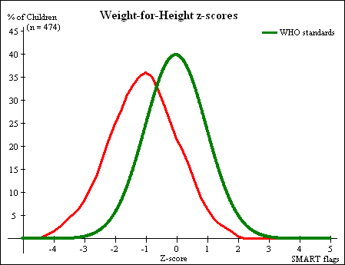

Table 171: Prevalence of stunting based on height-for-age z-scores and by sex- Buramino camp, Dollo Ado (March 2013)
 | All  n = 469 | Boys  n = 228 | Girls  n = 241
Prevalence of stunting  (<-2 z-score) | (56) 11.9 %  (9.3 - 15.2 95% C.I.) | (34) 14.9 %  (10.9 - 20.1 95% C.I.) | (22) 9.1 %  (6.1 - 13.4 95% C.I.)
Prevalence of moderate stunting  (<-2 z-score and >=-3 z-score) | (46) 9.8 %  (7.4 - 12.8 95% C.I.) | (26) 11.4 %  (7.9 - 16.2 95% C.I.) | (20) 8.3 %  (5.4 - 12.5 95% C.I.)
Prevalence of severe stunting  (<-3 z-score) | (10) 2.1 %  (1.2 - 3.9 95% C.I.) | (8) 3.5 %  (1.8 - 6.8 95% C.I.) | (2) 0.8 %  (0.2 - 3.0 95% C.I.)

Table 172: Prevalence of stunting by age based on height-for-age z-scores- Buramino camp, Dollo Ado (March 2013)
 |  | Severe stunting  (<-3 z-score) |  | Moderate stunting  (>= -3 and <-2 z-score ) |  | Normal  (> = -2 z score)
Age (mo) | Total no. | No. | % | No. | % | No. | %
6-17 | 105 | 6 | 5.7 | 11 | 10.5 | 88 | 83.8
18-29 | 131 | 3 | 2.3 | 19 | 14.5 | 109 | 83.2
30-41 | 83 | 1 | 1.2 | 7 | 8.4 | 75 | 90.4
42-53 | 107 | 0 | 0.0 | 9 | 8.4 | 98 | 91.6
54-59 | 43 | 0 | 0.0 | 0 | 0.0 | 43 | 100.0
Total | 469 | 10 | 2.1 | 46 | 9.8 | 413 | 88.1
Children in the age groups 6-17 and 18-29 months tend to be the most affected by stunting as compared to the other age groups.

Figure 48: Trends in the prevalence of stunting by age in children 6-59 months- Buramino camp, Dollo Ado (March 2013)

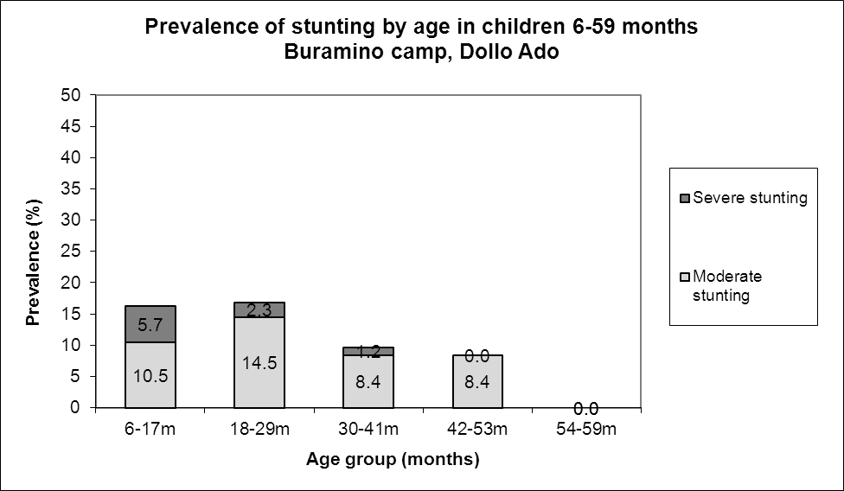

Table 173: Prevalence of underweight based on weight-for-age z-scores by sex- Buramino camp, Dollo Ado (March 2013)
 | All  n = 473 | Boys  n = 231 | Girls  n = 242
Prevalence of underweight  (<-2 z-score) | (103) 21.8 %  (18.3 - 25.7 95% C.I.) | (65) 28.1 %  (22.7 - 34.3 95% C.I.) | (38) 15.7 %  (11.7 - 20.8 95% C.I.)
Prevalence of moderate underweight  (<-2 z-score and >=-3 z-score) | (84) 17.8 %  (14.6 - 21.5 95% C.I.) | (53) 22.9 %  (18.0 - 28.8 95% C.I.) | (31) 12.8 %  (9.2 - 17.6 95% C.I.)
Prevalence of severe underweight  (<-3 z-score) | (19) 4.0 %  (2.6 - 6.2 95% C.I.) | (12) 5.2 %  (3.0 - 8.9 95% C.I.) | (7) 2.9 %  (1.4 - 5.8 95% C.I.)

Table 174: Mean z-scores, Design Effects and excluded subjects - Buramino camp, Dollo Ado (March 2013)
Indicator | n | Mean z-scores ± SD | Design Effect (z-score < -2) | z-scores not available* | z-scores out of range
Weight-for-Height | 474 | -1.08±1.09 | 1.00 | 0 | 0
Weight-for-Age | 473 | -1.33±0.93 | 1.00 | 0 | 1
Height-for-Age | 469 | -1.04±0.88 | 1.00 | 0 | 5

MUAC was being used in the community for screening and admission to therapeutic and supplementary feeding programmes.

Table 175: Prevalence of MUAC malnutrition- Buramino camp, Dollo Ado (March 2013)
 | All  n = 474 | Boys  n = 232 | Girls  n = 242
Prevalence of MUAC  (< 125 mm and/or oedema) | (22) 4.6 %  (3.1 - 6.9 95% C.I.) | (12) 5.2 %  (3.0 - 8.8 95% C.I.) | (10) 4.1 %  (2.3 - 7.4 95% C.I.)
Prevalence of MUAC  (< 125 mm and >= 115 mm, no oedema) | (13) 2.7 %  (1.6 - 4.6 95% C.I.) | (8) 3.4 %  (1.8 - 6.7 95% C.I.) | (5) 2.1 %  (0.9 - 4.7 95% C.I.)
Prevalence of MUAC  (< 115 mm and/or oedema) | (9) 1.9 %  (1.0 - 3.6 95% C.I.) | (4) 1.7 %  (0.7 - 4.3 95% C.I.) | (5) 2.1 %  (0.9 - 4.7 95% C.I.)

The case load for the selective feeding programmes was estimated to aid in programme planning. The Buramino population used during the survey was 36,228. Based on the survey results 26.3% children were found to be under 5 years (total of 9,528) and hence a total of 8,575 children were estimated to be between 6-59 months (assuming that 10% of under-5 are 0-5 months).

Table 176: Estimated number of malnourished children aged 6-59 months eligible to be enrolled in a selective feeding programme at the time of the survey (based on all admission criteria)- Buramino camp, Dollo Ado (March 2013)
 | Total/number | % (95% CI) | N (LCI-UCI)*
Eligible for therapeutic feeding programme** | 22/474 | 4.6 (3.1-6.9) | 395 (266-592)
Eligible for supplementary feeding programme** | 71/474 | 15.0(12.0-18.5) | 1286(1029-1586)
*LCI=Lower Confidence Interval; UCI: Upper Confidence Interval
**WHZ flags excluded from analysis

Using the HIS data for week 13 there were 70 children enrolled in the therapeutic feeding program which was 0.8% of children 6-59 months while 579 were enrolled in the supplementary feeding program which was 6.8% of children 6-59 months.

Anaemia results

Table 177: Prevalence of anaemia and haemoglobin concentration in children 6-59 months of age - Buramino camp, Dollo Ado (March 2013)
Anaemia – Children 6-59 months | All  n = 471
Total Anaemia (Hb<11.0 g/dL) | (273) 58.0 %  (53.4-62.4 95% CI)
Mild Anaemia (Hb 10.0-10.9 g/dL) | (138) 29.3 %  (25.3-33.7 95% CI)
Moderate Anaemia (7.0-9.9 g/dL) | (132) 28.0 %  (24.1-32.4 95% CI)
Severe Anaemia (<7.0 g/dL) | (3) 0.6 %  (0.2-2.0 95% CI)
Mean Hb (g/dL) | 10.6 g/dL  (1.36 SD)  [4.5 min,14.2 max]

Comparison with results from 2012 where the total anaemia was 54.5 %( 50.2-58.7 95%CI) shows no significant change in the anaemia prevalence among children 6-59 months (p>0.05).

Figure 49: Nutrition survey results (anaemia in children 6-59 months) since 2011- Buramino camp, Dollo Ado (March 2013)
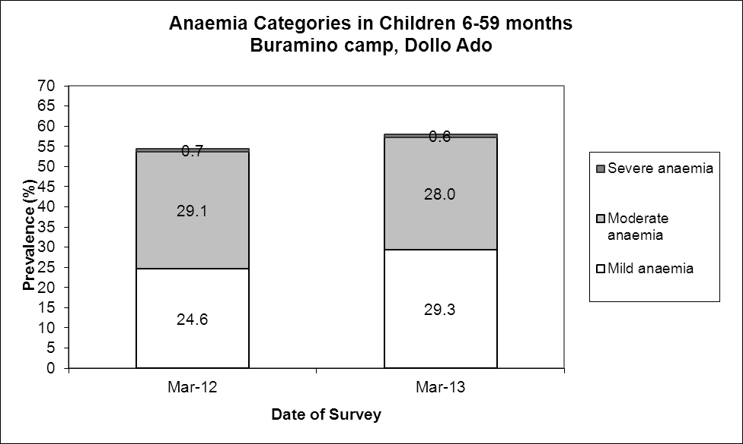

The mean haemoglobin concentration in children 6-59 months in remained the same in 2013 compared to 2013.

Figure 50: Mean haemoglobin concentration in children 6-59 months from 2011-2012 Buramino camp, Dollo Ado (March 2013)

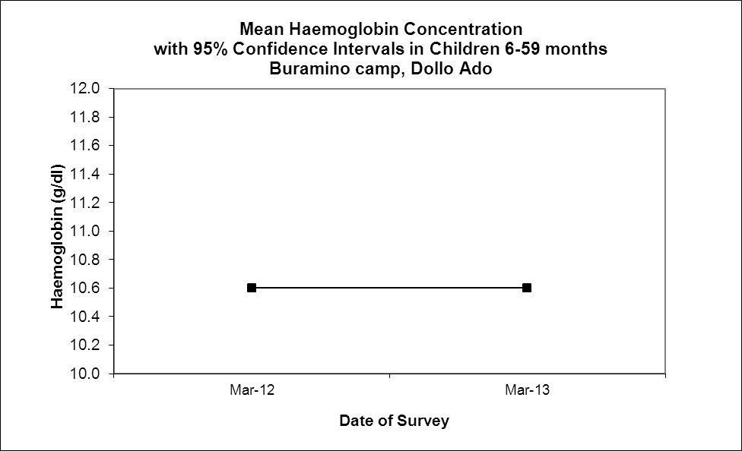

The 6-23 months age group had the highest prevalence of anaemia of 75.8%. The prevalence of anaemia declined with increasing age. These age trends are similar to those seen in 2012.

Table 178: Prevalence of anaemia by age- Buramino camp, Dollo Ado (March 2013)
 |  | Severe Anaemia  (<7.0 g/dL) |  | Moderate Anaemia  (7.0-9.9 g/dL) |  | Mild Anaemia (Hb 10.0-10.9 g/dL) |  | Total Anaemia (Hb<11g.0 g/dL) |  | Normal (Hb≥11.0 g/dL)
Age (mths) | Total no. | No. | %  (95% CI) | No. | %  (95% CI) | No. | %  (95% CI) | No. | %  (95% CI) | No. | %  (95% CI)
6-23 | 178 | 0 | 0 | 68 | 38.2  (31.0-45.8) | 67 | 37.6  (30.5-45.2) | 135 | 75.8  (68.9-81.9) | 43 | 24.2  (18.1-31.1)
24-35 | 97 | 0 | 0 | 30 | 30.9  (21.9-41,1) | 23 | 23.7  (15.7-33.4) | 53 | 54.6  (44.2-64.8) | 44 | 45.4  (35.2-64.8)
36-59 | 239 | 3 | 1.5  (0.3-4.4) | 34 | 17.3  (12.3-23.4) | 48 | 24.5  (18.6-31.1) | 85 | 43.4  (36.3-50.6) | 111 | 56.6  (49.4-63.7)
Total | 471 | 3 | 0.6  (0.2-2.0) | 132 | 28.0  (24.1-32.4) | 138 | 29.3  (25.3-33.7) | 273 | 58.0  (53.4-62.4) | 198 | 42.0  (37.6-46.6)

Programme coverage

Selective feeding programme**

Table 179: Nutrition treatment programme coverage based on all admission criteria (weight-for-height, MUAC, oedema) - Buramino camp, Dollo Ado (March 2013)
 | Number/total | % (95% C.I.)
Proportion of children aged 6-59 months with severe acute malnutrition currently enrolled in therapeutic feeding programme* | 12/29 | 41.4(23.5-61.1)
Proportion of children aged 6-59 months with moderate acute malnutrition currently enrolled in supplementary feeding programme* | 24/73 | 32.9(22.3-44.9)
*WHZ flags excluded from analysis

Note that 13.8% (4/29) of the children meeting the admission criteria for therapeutic care were enrolled in the targeted supplementary feeding program while 17.8% (13/73) of the children meeting the admission criteria for TSFP were enrolled in the therapeutic feeding program.

Table 180: Nutrition treatment programme coverage based on MUAC and oedema only- Buramino camp, Dollo Ado (March 2013)
 | Number/total | % (95% CI)
Proportion of children aged 6-59 months with severe acute malnutrition currently enrolled in therapeutic feeding programme | 1/9 | 100
Proportion of children aged 6-59 months with moderate acute malnutrition currently enrolled in supplementary feeding programme | 3/13 | 23.1(5.0-53.8)
**Selective feeding programme coverage results should be interpreted with caution due to small number of cases that were sampled during the survey.

Note that 38.5% (5/13) of the children meeting the MUAC admission criteria for TSFP were enrolled in the therapeutic feeding program

Vaccination and supplementation programmes

Measles vaccination coverage

Table 181: Measles vaccination coverage for children aged 9-59 months (n= 444) - Buramino camp, Dollo Ado (March 2013)
 | Measles  (with card)  n=3 | Measles  (with card or confirmation from mother)  n=355
YES | 0.7 %  (0.2-2.1 95% CI) | 80.0%  (75.9-83.5 95% CI)

Vitamin A supplementation coverage

Table 182: Vitamin A supplementation for children aged 6-59 months within past 6 months (n=474) - Buramino camp, Dollo Ado (March 2013)
 | Vitamin A capsule  (with card)  n=3 | Vitamin A capsule  (with card or confirmation from mother)  n=422
YES | 0.6 %  (0.2- 2.0 95% CI) | 89.0 %  85.8-91.6 95% CI)

Comparison with results from 2012 shows a significant improvement in the coverage of measles vaccination and vitamin A supplementation (within past six months) among children 6-59 months (p<0.05).

Figure 51: Nutrition survey results (measles vaccination and vitamin A supplementation within past 6 months with card or recall) since 2012- Buramino camp, Dollo Ado (March 2013)
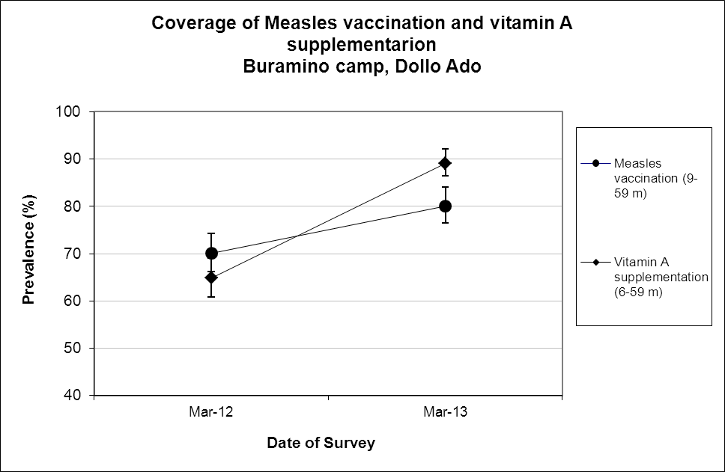

Deworming coverage

Table 183: Deworming for children aged 12-59 months within past 6 months (n=411) –Buramino camp, Dollo Ado (March 2013)

 | Deworming  (with card)  n=1 | Deworming  (with card or confirmation from mother)  n=343
YES | 0.2%  (0-1.6 95% CI) | 83.5%  (79.4-86.8 95% CI)

Blanket supplementary feeding program (BSFP)

Table 184: BSFP programme for children aged 6-59 months- Buramino camp, Dollo Ado (March 2013)
 | Age | Number/total | % (95% CI)
Currently receiving CSB+/++ | 6-59 | 416/474 | 87.8  (84.4-90.5 95% CI

Morbidity and health seeking behaviour

Of children 6-59 months of age, 13.3% (CI 10.4 – 16.8) had experienced diarrhoea two weeks prior to the survey date. Out of the 93 surveyed that was sick two weeks prior to the survey 74.2% (CI 64.1- 82.7) of mothers sought help from the health services provided in the camp. Compared to 2012 the reported morbidity caseload (diarrhoea and other diseases) remained the same (p>0.05).

Table 185: Prevalence of diarrhoea and disease in children 6-59 months and health seeking behaviour among mothers of children 6-59 months
 | Number/total | % (95% CI)
Diarrhoea last two weeks (6-59 months) | 63/474 | 13.3(10.4 – 16.8)
Children sick in the last two weeks (6-59 months) | 93/474 | 19.6 (16.2 – 23.5)
Proportion of mothers with sick children who sought assistance | 69/93 | 74.2(64.1– 82.7)

CHILDREN 0-23 MONTHS- BURAMINO CAMP, DOLLO ADO (MARCH 2013)

Table 186: Prevalence of Infant and Young Child Feeding Practices indicators- Buramino camp, Dollo Ado (March 2013)
Indicator | Age range | Number/total | Prevalence (%) | 95% CI
Children ever breastfed | 0-23 months | 240/241 | 99.6 | (97.7-100.0)
Timely initiation of breastfeeding | 0-23 months | 189/240 | 78.8 | (73.0-83.7)
Exclusive breastfeeding under 6 months | 0-5 months | 27/72 | 37.5 | (26.4-49.7)
Continued breastfeeding at 1 year | 12-15 months | 17/30 | 56.7 | (37.4-74.5)
Continued breastfeeding at 2 years | 20-23 months | 8/43 | 18.6 | (8.4-33.4)
Timely introduction of solid, semi-solid or soft foods | 6-8 months | 16/29 | 44.8 | (26.4-64.3)
Children bottle fed | 0-23 months | 15/241 | 6.2 | (3.5-10.1)
Consumption of iron rich or iron fortified foods | 6-23 months | 160/165 | 97.0 | (93.1-99)

The confidence intervals are an integral part of the results when analysing trends over the years. When IYCF indicators are collected in nutritional surveys, it is not feasible to achieve a large enough sample size for some of the indicators to be estimated as precisely as desired, especially for indicators covering a very narrow age range (e.g. 12-15 months, 6-8 months). Hence, trend analyses need to be interpreted with caution. Nevertheless, trend analyses are useful for assessing the situation and major differences seen from year to year should warrant further investigation.

Exclusive breastfeeding, introduction of solid, semi-solid or soft foods, consumption of iron rich or iron fortified foods and bottle feeding improved compared to the 2012 survey but continuation of breastfeeding at one year and two years decreased from 82.1% and 47.6% respectively. Timely initiation of breastfeeding remained the same with no statistically significant change.

Figure 52: Nutrition survey results (key IYCF indicators) since 2011- Buramino camp, Dollo Ado (March 2013)
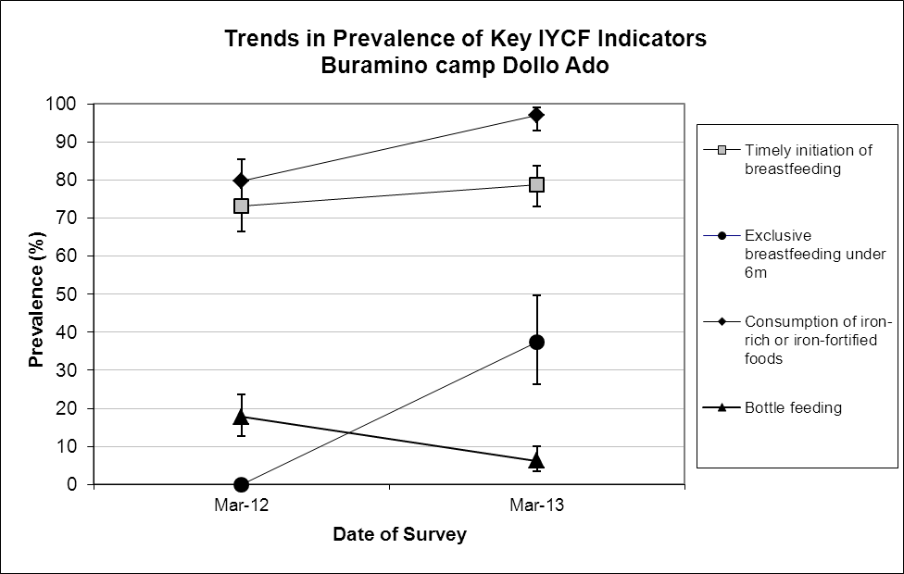

Prevalence of intake

Infant formula
Table 187: Infant formula intake in children aged 0-23 months
 | Number/total | % (95% CI)
Proportion of children aged 0-23 months who receive infant formula (fortified or non-fortified) | 40/240 | 16.7(12.2-22.0)

Fortified blended foods

Table 188: CSB+ intake in children aged 6-23 months
 | Number/total | % (95% CI)
Proportion of children aged 6-23 months who receive FBF | 37/169 | 21.9(15.9-28.9)

Table 189: CSB++ intake in children aged 6-23 months
 | Number/total | % (95% CI)
Proportion of children aged 6-23 months who receive FBF++ | 129/168 | 76.8(69.7-82.9)

WOMEN 15-49 YEARS - BURAMINO CAMP, DOLLO ADO (MARCH 2013)

Table 190: Demographic information- Buramino camp, Dollo Ado (March 2013)
Physiological status | Number/total | %
Non-Pregnant | 128/176 | 72.7
Pregnant | 47/176 | 26.7
Mean age (range) | 29.2 years (15-46)

Table 191: Prevalence of anaemia and haemoglobin concentration in non-pregnant women of reproductive age (15-49 years) – Buramino camp, Dollo Ado (March 2013)
Anaemia – Non-pregnant women of reproductive age 15-49 years | All  n = 127
Total Anaemia (<12.0 g/dL) | (61) 48.0%  (39.1-57.1 95% CI)
Mild Anaemia (11.0-11.9 g/dL) | (28) 22.0%  (15.2-30.3 95% CI)
Moderate Anaemia (8.0-10.9 g/dL) | (31) 24.4%  (17.2-32.8 95% CI)
Severe Anaemia (<8.0 g/dL) | (2) 1.6%  (0-2-5.6 95% CI)
Mean Hb (g/dL) | 11.8g/dL  (1.55 SD)  [6.2 min, 15.7max]

Comparison with results from 2012 [48.3% (40.0-56.7 95% CI)] showed no statistically significant change in the prevalence of anaemia among non-pregnant women of reproductive age (p>0.05).

Figure 53: Anaemia categories in women of reproductive age from 2011 to 2012- Buramino camp, Dollo Ado (March 2013)
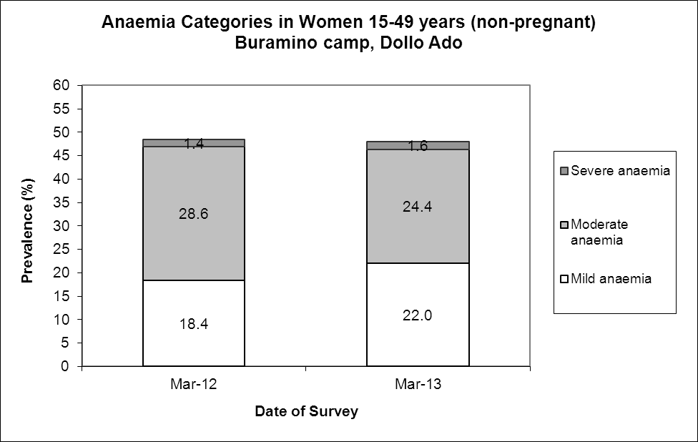

ANC enrolment and iron-folic acid supplementation coverage
Table 192: ANC enrolment and iron-folic acid pills coverage among pregnant women (15-49 years) – Buramino camp, Dollo Ado (March 2013)
 | Number/total | % (95% CI)
Currently enrolled in ANC programme | 33/47 | 70.2 (55.1-82.7)
Currently receiving iron-folic acid pills | 31/47 | 66.0 (50.7-79.1)

Table 193: Post-natal vitamin A supplementation among women (15-49 years) - Buramino camp, Dollo Ado (March 2013)
 | Number/total | % (95% CI)
Received vitamin A supplementation since delivery | 32/34 | 94.1 (80.3-99.0)

HOUSEHOLD-LEVEL INDICATORS- WATER, FOOD SECURITY AND MORTALITY- BURAMINO CAMP, DOLLO ADO (MARCH 2013)

Table 194 shows the different indicators and the total number of households who were sampled for each household-level indicator. All households were considered whether or not they had eligible individuals for the individual-level measurements.

Table 194: Target sample size and actual number captured during the survey- Buramino camp, Dollo Ado (March 2013)
Indicator | Target  sample size | Household interviewed during the study | % of the target
Water | 230 | 212 | 92.2
Food security | 230 | 208 | 90.4
Mortality | 461 | 416 | 90.2

WATER- BURAMINO CAMP, DOLLO ADO (MARCH 2013)

Table 195: Water Quantity: Amount of litres of water used per person per day- Buramino camp, Dollo Ado (March 2013)
Proportion of households that access: | Number/total | % (95% CI)
≥ 20 litres | 104/209 | 49.8 (42.8-56.7)
15 – <20 litres | 40/209 | 19.1 (14.0-25.1)
<15 litres | 65/209 | 31.1(24.9-37.9)

The average water usage in lppd: 21.7 lpppd

Table 196: Satisfaction with water supply- Buramino camp, Dollo Ado (March 2013)
 | Number/total | % (95% CI)
Proportion of households that say they are satisfied with the drinking water supply | 173/212 | 81.6 (75.7-86.6)

14.2% (9.8-19.6 CI) of the surveyed household reported to not be satisfied with the water supply while a further 4.2% (2.0-7.9 CI) reported to only be partially satisfied. The main reasons for the dissatisfaction were long distance to the water point (60.0%); irregular supply (23.3%), long waiting queues (10.0%) and not enough water (6.7%).

FOOD SECURITY - BURAMINO CAMP, DOLLO ADO (MARCH 2013)

Food distribution

Table 197: Ration card coverage- Buramino camp, Dollo Ado (March 2013)
 | Number/total | % (95% CI)
Proportion of households that received the general food ration | 207/207 | 100 (100-100)

The general food ration lasts at most 61.7 % of the intended theoretical duration of 30 days.

Table 198: Reported duration of general food ration 1- Buramino camp, Dollo Ado (March 2013)
Average number of days the food ration lasts (Standard deviation ) | Average duration (%) in relation to the theoretical duration of the ration
18.5 (5.63) | 61.7

The proportion of households reporting that their food ration lasted for 30 days was 7.3%
77.7% of all the households reported that the general food ration received in the previously completed cycle had lasted less than 22.5 days (75% of cycle).

Table 199: Reported duration of general food ration 2 - Buramino camp, Dollo Ado (March 2013)
Number/total
(% (95% CI)
Proportion of households reporting that the food ration lasts the entire duration of the cycle | 15/206  7.3(4.1-11.7)
Proportion of households reporting that the food ration lasted:
≤75% of the cycle [0-22 days] | 160/206  77.7 (71.4-83.2)
>75% of the cycle [23-30 days] | 46/206  22.3(16.8-28.6)

Negative household coping strategies

The most common coping strategies used by households in Buramino camp were borrowing of cash, food or other items with or with/out interest, begging, and reduction in the quantity and/or frequency of meals. The proportion of households that reported to engage in potentially risky or harmful activities was 11.7%. 7.8% of household having children 5-14 years old reported sending at least one child to work outside the household in order get cash or in-kind goods or services.

The proportion of households reporting that they did not use any of the coping strategies was 12.6%. There was no statistically significant change in this proportion compared to the 2012 results.

Table 200: Coping strategies used by the surveyed population over the past month- Buramino camp, Dollo Ado (March 2013)
 | Number/total | % (95% CI)
Proportion of households reporting using the following coping strategies over the past month*
Borrowed cash, food or other items with/out interest | 158/206 | 76.7(70.3-82.3)
Sold any assets (furniture, seed stocks, tools, other NFI, livestock etc.) | 27/206 | 13.1(8.8-18.5)
Requested increase remittances or gifts as compared to normal | 24/206 | 11.7(7.6-18.6)
Reduced the quantity and/or frequency of meals | 49/206 | 23.8(18.1-30.2)
Begged | 50/206 | 24.3(18.6-30.7)
Engaged in potentially risky or harmful activities | 24/206 | 11.7(7.6-16.8)
Sent at least one child to work outside the household in order get cash or in-kind goods or services | 11/141 | 7.8(4.0-13.5)
Proportion of households reporting using none of the coping strategies over the past month | 26/206 | 12.6(8.4-19.9)

Household dietary diversity

The average household diversity score was 5.9. This remained the same as that in 2012 with no significant statistical change; p>0.05.

Table 201: Average Household Diet Diversity Score- Buramino camp, Dollo Ado (March 2013)
Average HDDS | Mean  (Standard deviation)
 | 5.9 (1.9)

Cereals (98.1%), Legumes/nuts/seeds (89.4%), and Oil/Fats (82.6%) were the three most consumed food groups in Buramino camp, while meat (8.2%), fish/sea food (3.4%), and eggs (1.9%) were the least consumed.
Figure 54: Proportion of households consuming different food groups within last 24 hours- Buramino camp, Dollo Ado (March 2013)
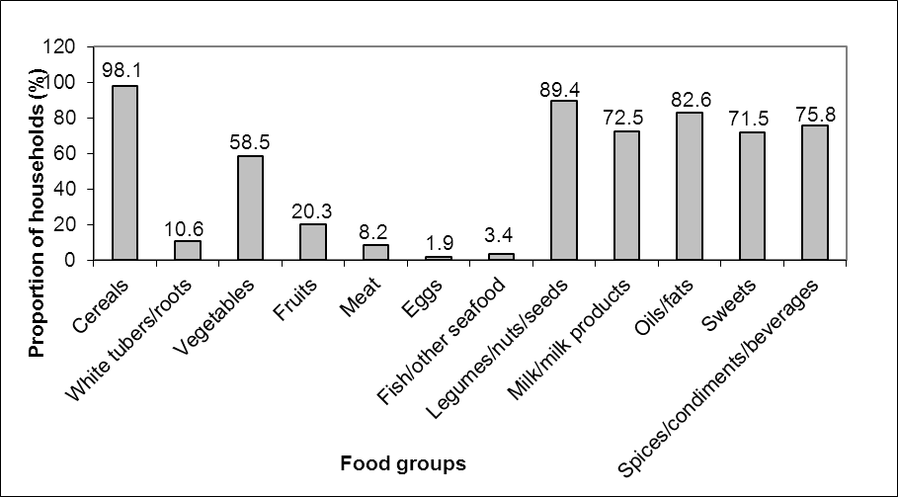
Reliance of the staples from the general food aid ration only reduced in 2013 compared to 2012 from 78.8% to 36.7% while that of a diet that consisted entirely of staples, pulses and oils/fat from food aid ration with no other food sources remained the same; p>0.05. The proportion of households not consuming any vegetables, fruits, meat, eggs, fish/sea-food, and milk/milk products decreased from 54.2% to 19.1% indicating that more households were consuming this food group. The consumption of CSB+ also improved from 37.1% in 2012 to 82.1% in 2013; p<0.05. It is worth noting that the survey data collection was carried out from the 27th to the 29th days of the distribution cycle which is the end of the GFD distribution cycle.
Table 202: Consumption of food aid commodities and micronutrient rich foods by households- Buramino camp, Dollo Ado (March 2013)
 | Number/total | % (95% CI)
Proportion of households where staples consumed are only from food aid ration (no other staples) | 76/207 | 36.7 (30.1-43.7)
Proportion of households where the diet consists entirely of staples, pulses and oils/fat from food aid ration (no other food sources) | 11/204 | 5.4 (2.7-9.4)
Proportion of households not consuming any vegetables, fruits, meat, eggs, fish/seafood, and milk/milk products | 39/204 | 19.1(14.0-25.2)
Proportion of households consuming either a plant or animal source of vitamin A | 155/207 | 74.9 (68.4-80.6)
Proportion of households consuming organ meat/flesh meat, or fish/seafood (food sources of haem iron) | 23/204 | 11.3 (7.3-16.4)
Proportion of households consuming fortified blended foods | 170/207 | 76.2 (67.0-87.1)

MORTALITY- BURAMINO CAMP, DOLLO ADO (MARCH 2013)

Retrospective mortality data was collected over the past three months (89 days). Demographic data was also derived from the mortality data as presented below.

Table 203: Demographic and retrospective mortality within camp- Buramino camp, Dollo Ado (March 2013)
Demographic data
Number of HH surveyed | 416
Average HH size | 4.9
% U5 | 26.3%
Retrospective mortality
Number of current HH residents | 2035
Total number U5 | 535
Number of people who joined HH / camp | 126
Total number U5 who joined HH / camp | 64
Number of people who left HH / camp | 129
Total number U5 who left HH / camp | 26
Number of births during recall | 30
Number of deaths during recall | 1
Total number U5 deaths during recall | 1
Crude Death Rate  (total deaths/10,000 people / day) | 0.05  (0.01-0.27 95% CI)
U5 Death Rate  (deaths in children under five/10,000 children under five / day) | 0.19  (0.03-1.08 95% CI)

LIMITATIONS

- Poor quality of age data for children U5: There was no age documentation among children 6-59 months in both camps. Due to this limitation, and although an event calendar was used by the surveyors to ascertain age, stunting results are to be interpreted with caution because z-scores for height-for-age require accurate ages to within two weeks (CDC/WFP: A manual: Measuring and Interpreting Mortality and Malnutrition, 2005).

- Selective feeding programme coverage for young children: Selective feeding programme coverage results should be interpreted with caution due to the small number of cases that were sampled during the survey. In addition, although surveyors had sachets of Plumpy’Nut® and Plumpy’Sup® to show to the respondents, admission to selective feeding programme was assessed by recall and hence it is possible that some children included in a selective programme were not detected because the caregiver misunderstood the question or that some children being admitted in the SFP were mixed with children admitted in the OTP and vice versa. This was the same case for BSFP coverage.

- Programme coverage for women: The coverage of ANC enrolment of and iron-folic acid supplementation to pregnant women, and the coverage of vitamin A supplementation to post-natal women should be interpreted with caution due to the small number of beneficiaries that were sampled during the survey.

DISCUSSION

Nutritional status of young children and mortality

The prevalence of global acute malnutrition (GAM) in Bokolmanyo, Melkadida, Kobe and Hilaweyn; Dollo Ado camps remained the same in 2013 compared to 2012 with the slight increase in the prevalence being statistically insignificant. In Buramino camp however the global acute malnutrition decreased significantly from 32.7% (28.9 -36.8 95% CI) to 19.6 (16.3-23.4 95% CI); p<0.05. The prevalence of acute malnutrition in all camps, except Bokolmanyo, was above the WHO emergency threshold of 15%. The Bokolmanyo upper confidence interval was also above the WHO threshold of 15% which indicates a critical nutrition situation in all camps.

The prevalence of severe acute malnutrition (SAM) followed the same pattern and remained unchanged with no statistically significant change in Bokolmanyo, Melkadida, Kobe and Hilaweyn camps in 2013 compared to 2012. In Buramino there was a significant decrease in the severe acute malnutrition prevalence from 5.9% (4.2-8.2 95% CI) to 4.6% (3.1-6.9 95% CI); p<0.05 in 2013 compared to 2012.

Crude mortality and under five mortality rates remained within the acceptable standard of <1 death per 10,000 persons per day and <2 deaths per 10,000 persons per day respectively in all camps. The rates tend to be lower in 2013 compared to 2012 but there was no statistically significant change in crude mortality across all the camps. This was similar for under five mortality rates with the exception of Melkadida and Kobe camps which had significant reduction;p<0.05.The under five mortality rate in Melkadida in 2012 was 1.20(0.67-2.14 95% CI) while in 2013 it was 0.24 (0.04-1.32). In Kobe the under five mortality rate was 1.56 (0.72-3.33 95% CI) while in 2013 it was 0.26 (0.05-1.44 95% CI). The survey mortality rate results were similar to those collected in the UNCHR health information.

As demonstrated by the Buramino survey, children aged 6-59 months tend to be much more malnourished in the first three months upon arrival in the camp (a new arrival is defined as being in the camp for <3 months as per UNHCR). The GAM prevalence among the new arrival was 26.3% (9.1-51.2 95% CI) while that among children whose household had arrived earlier was 19.3%. The new arrivals represented 4% of the sample of children 6-59 months.On exclusion from the overall GAM analysis the results revealed no major differences (p>0.05) in overall GAM prevalence which suggests that the new arrivals did not necessarily skew the overall GAM results in the camps.

Stunting refers to a deficit in height relative to age due to a long-term process of linear growth retardation. It has long been proposed as a measure of chronic under nutrition or ill health, but may also be attributed to certain micronutrient deficiencies such as Vitamin A, zinc, calcium or folate.The prevalence of global stunting among children 6-59 months in 2013 was within the acceptable range of <20% in all camps. Given that the coverage of age documentation was found to be low across all the camps with a range of 6 to 25% stunting results need to be interpreted with caution.

Morbidity and Health seeking behaviour

The surveys collected data on diarrhoea which is closely linked to nutritional status. This was based on caregivers’ recall. A range of 5.8 % to 15.7% of the surveyed children was found to have suffered from one or more episodes of diarrhoea in the two weeks prior to the survey among children aged 6-59 in the Dollo Ado camps. Diarrhoea is associated with insufficient quality water and poor hygiene practices and was reported as the top morbidity in the UNHCR health information system (March 2012 to March 2013) accounting for 13.3% of all the morbidities among children under five years. The interactions of nutrition and infection are cyclic with each exacerbating the other. Diarrhoea is a preventable disease and ways of ensuring this should continue to be strengthened.

The proportion of children 6-59 months that were reported to have been sick two weeks prior to the survey date ranged from 19.6% in Buramnio to 24.3% in Hilaweyn. This remained the same compared to 2012 in the exception of Melkadida where the proportion increased from 13.1% to 19.8%. The health seeking behaviour among those that reported to have been sick in the last two weeks ranged from 56.9% in Bokolmanyo to 74.3% in Melkadida. In Kobe and Hilaweyn where there was comparative health seeking behaviour data the practice had improved greatly in 2013 compared to 2012. To reduce the morbidity caseload there is the need for a sustained and expanded service to cater for the existing population and the new arrivals. Top morbidities should also be given special attention.

Programme coverage in young children

Selective feeding programme

It should be noted that selective feeding programme coverage results should be interpreted with caution due to the small numbers that were sampled during the survey. The TFP and SFP coverage results based on all admission criteria were found to be low (ranging between (0% - 58.8%) in all camps. The TFP coverage results based MUAC only criteria was above 85% in all camps except Bokolmanyo where it was 50% while that of SFP ranged from 11.1% to 42.1%. It is worth noting that the coverage calculation did not account for children who were found to be enrolled but in a different program from that which they met the admission criteria of. The latter ranged from 5.4% to 38.5 for the various programs and criteria. This could be attributed to the mixed criteria used for admission and also the discharge criteria the chidren have to meet before being transferred to the next phase. Despite this, except for the TFP MUAC coverage the rest of the coverage indicators were well below the 90% target for coverage in a camp setting. The screening procedures should be reviewed to ensure the community outreach workers are using the MUAC tapes correctly for the SFP screening especially in Melkadida and Kobe where the SFP MUAC coverage was very low <35% (chidren found in the program irrespective of the kind). From the assessment of MUAC versus WHZ z scores a high percentage of the older age groups with -2 z-scores were not captured by the MUAC screening criteria. This is also indicated by the low proportion of children identified with MUAC <125 mm in comparison to the prorportion identified with -2 WHZ z-scores. Of intrest also is the fact that among the smaller age group (6-17 months) there are some children that meet the MUAC criteria but do not meet the respective WHZ score criteria. In this light, the mixed criteria for admission should be ensured by using MUAC or WHZ scores to capture the children missed by either MUAC or the WHZ scores. It is also proposed that at the blanket supplementary feeding centres the MUAC screening cut off for the at risk category be reviewed to a range of 125 to 145mm among the older age groups (24-59months). For all children found to be at risk (125 -135mm) for the 6-23months and (125-145mm) for the 24-59 months a second stage weight for height z-score would thereafter be taken. Any children found to meet the admission criteria using the WHZ scores under this category would be enrolled into the appropriate program. From the November 2012 Dollo Ado MUAC screening 1424 out of the 1818 children admitted were identified through the second stage weight for height measurement in the absence of which these children would not have been admitted. In addition to the above as the MUAC results from this survey showed a high proportion of children at risk of malnutrition ranging from 13.2% to 20.3% the MUAC screening at the community level should be raised to a cut off of <135mm in all camps.

Measles vaccination and vitamin A supplementation

The coverage for measles vaccination and vitamin A supplementation was found to have improved significantly in all camps (ranging from 80%-95.8%). Effort put towards improvement in the coverage was one of the key action points from the 2012 surveys in terms of pipeline management and the cold chain management. To further ensure that all the camps reach the target of ≥95% and ≥90% for measles vaccination and vitamin A supplementation respectively, sustained gains must be maintained and the health implementing partner taking over the ordering and the pipeline management including transportation of vaccines to the camps must be strengthened. This can be facilitated through technical support, support supervision and the expansion of vaccination outposts. As these results were based on both card and recall there is also need to improve the coverage of cards for reliability and for monitoring.

Anaemia in young children and women
The prevalence of total anaemia in children aged 6-59 months was 46.7%, 47.7%, 38.0%, 46.5%, and 58.0% in Bokolmanyo, Melkadida, Kobe, Hilaweyn, and Buramino camps respectively. According to WHO classification of public health significance, the level of total anaemia exceeded 40% indicating a high public health significance in all refugee’ camps of Dollo Ado (taking into consideration the upper limit of the confidence interval in Kobe). The prevalence of total anaemia remained the same in 2013 compared to 2012 with no statistically significant change except in Melkadida camp which had a significant increase in the total anaemia among 6-59 months from 39.7% (35.8-42.3 95%CI) in 2012 to 47.7%(47.1-57.4 95%CI) in 2013; p-value<0.005. Reasons attributing to the raise should be investigated and averted.

The prevalence of anaemia among children 6-23 months also remained the same compared to the results in 2012. The levels remained high with a range of 53.3% in Kobe (lowest) and 75.8% (highest) in Buramino. The prevalence of anaemia declined with increasing age, as seen also in the 2012 and 2011 surveys. The prevalence of anaemia among the younger age groups (6-23 and 24-35 months) was above 40% in all camps while the prevalence of anaemia among the 36-59 months age group was below 40% but above 20% apart from Buramino where the prevalence was 43.4%. This highlights the need to look into additional interventions targeted at the 6- 36 months age group to reduce the anaemia levels.

The prevalence of total anaemia in non-pregnant women of reproductive age (15-49 years) in the camps ranged from 23.7% in Melkadida to 48.0% in Buramino. This indicates that anaemia is classified as of medium public health significance in Bokolmanyo, Melkadida, Kobe, and Hilaweyn camps while it is of high public health significance in Buramino. There is need for continued efforts to reduce anaemia to the acceptable level of below 20%. Comparing the prevalence in 2013 with that in 2012, the difference was insignificant in all camps (p-value>0.05).

Of note is that the prevalence of total anaemia among children 6-59 months and women in Buramino did not decrease as expected,when taking into consideration previous trends of the other camps that showed a significant reduction of anaemia prevalence in the first follow up surveys.

In Dollo ado the population depends on food aid which limits the micronutrient intake to the general ration and the blanket supplementary feeding provision. The general ration lacks animal protein, fresh fruits and vegetables thus the bioavailability and absorption of micronutrients might not be optimum. There are high rates of infection with intestinal worms among the top five morbidities in the camp according to the UNHCR health information system. Other limiting factors include sub standard antenatal coverage, closely spaced and frequent pregnancies due to low contraceptive use and poor infant and young child feeding practices. All these factors should be explored to facilitate the reduction of anaemia.

Programme coverage in women

During pregnancy and lactation, women’s nutritional needs for energy, protein and micronutrients significantly increase. Pregnant women require an additional 285 kcals/day, and lactating women require an additional 500 kcals/day. Both pregnant and lactating women also have an increased need for micronutrients. The consequences of poor nutritional status and inadequate nutritional intake for women during pregnancy and lactation not only directly affects the women’s health status but may have a negative impact on infant birth-weight and early development. In Dollo Ado all pregnant women enrolled in the ANC and lactating women until the child is six months are provided with complementary feeding to meet the additional requirements of pregnancy and lactation. Routine iron and folate supplementation is also provided at the antenatal clinics (ANC). The supplementary ration provided include a pre-mix of CSB+ (200g), oil (25 g) and sugar (20 g) as a take-home ration.

The proportion of surveyed pregnant women who were enrolled in the ANC (with card and recall) at the time of the survey ranged from 70.2% (in Buramino) to 90% (in Kobe). The coverage of iron/folate supplementation for pregnant women ranged from 51.4% (in Hilaweyn) to 76.5% (in Bokolmanyo). Compared to the 2012 coverage there was a significant increase in ANC enrolment in Bokolmanyo, Melkadida, and Kobe (p<0.05) camps while the increase in Hilaweyn and Buramino was not significant (p>0.05). The iron/folate coverage improved significantly in Bokolmanyo and Melkadida while the improvement was insignificant in Kobe, Hilaweyn and Buramino (p>0.05). The coverage of post-natal vitamin A supplementation based on card and recall was 82.1%, 93.8%, 97.1%, 44.4%, and 94.1% in Bokolmanyo, Melkadida, Kobe, Hilaweyn, and Buramino respectively. While improvements have been noted in the ANC and PNC coverage in most camps there is need to sustain the efforts and strengthen the services in the camps with less than 90% coverage. Complementary feeding and screening for malnutrition should also be continued in all camps

Infant and young child feeding practices

The infant and young child nutrition indicators in Dollo Ado improved in 2013 compared to 2012. Despite the improvement most indicators still remain poor which indicates the need for sustained and expanded programming in this area.

Most of the children in all camps were breast fed (a range of 89.6% to 99.6%) which indicates that breastfeeding is a practice well accepted by the refugee community. Timely initiation of breastfeeding was the highest of the core IYCF indicators. The prevalence figures were 80.2% (72.2-85.0 95% CI), 84.9% (78.8-89.8), 87.6% (81.5-92.2), 81.0% (74.5-86.5) and 78.8% (73.0-83.7) in Bokolmanyo, Melkadida, Kobe, Hilaweyn and Buramino respectively. Timely initiation of breastfeeding improved significantly, Melkadida and Kobe. In Hilaweyn and Buramino the increase was not significant.

The prevalence of exclusive breast feeding in children 0-5 months improved in all camps and ranged from 37.5% to 77.0%. Continued breastfeeding at 1 and 2 years remained the same or decreased in all camps thus there is a need to review the messages in place in this regard and adapt them to the context. Breastfeeding reduces infant morbidity and mortality from diarrhoea and respiratory infections. The benefits of breastfeeding increase with exclusiveness of breastfeeding. Babies who are breastfed are generally healthier and achieve optimal growth and development compared to those who are fed on formula milk. Increasing awareness and support to lactating mothers must continue being provided and include birth spacing which is one of the probable reasons for the short duration of continued breast feeding. Timely introduction of solid, semi-solid or soft foods improved but still remained below 45% in all camps.

The proportion of children aged 0-23 months who were bottle fed decreased compared to the 2012 results however ranged from 11.1% to 22.5%. Bottle feeding and giving a baby breast milk substitutes such as infant formula or animal milk can threaten the baby’s health and survival. Babies who do not receive breast milk do not receive protection from illnesses provided by the mother’s antibodies and other components that are gainedfrom her milk. These babies are more likely to experience diarrhoea and respiratory and ear infections. Diarrhoea and respiratory infections, such as pneumonia, can be deadly in babies and young children and continue to be top morbidities in Dollo camps. Efforts to reduce the proportion of children being bottle fed should be continued.

The proportion of children 6-23 months who consumed iron rich or iron fortified food 24 hours prior to the survey day ranged from 77.2% to 97%. Children need iron-rich foods to protect their physical and mental abilities and to prevent anaemia.

Of all proven preventive health and nutrition interventions, IYCF has the single greatest potential impact on child survival. Therefore, reduction of child mortality can be reached only when nutrition in early childhood and IYCF specifically are highly prioritized. The 2003 landmark Lancet Child Survival Series ranked the top 15 preventative child survival interventions for their effectiveness in preventing under-five mortality. Exclusive breastfeeding up to six months of age and breastfeeding up to 12 months was ranked number one, with complementary feeding starting at six months number three. These two interventions alone were estimated to prevent almost one-fifth of under-five mortality in developing countries

To further improve IYCF in Dollo Ado refugee camps prevention interventions then demand a multidimensional and comprehensive approach. There is a strategy in place which is adapted to the Dollo Ado context and its implementation should be followed through.

Food security

There was no break in the general food pipeline from March 2012 to March 2013 and the amount of kilocalories supplied per person per day met the FAO recommended 2100 Kcal. WFP provided the same ration type from January to June 2012 which consisted of wheat grain as the only staple grain. In July 2012 through to March 2013 the ration changed to included rice a preferred grain by the refugees as part of the staple. The ration consists of wheat grain, pulses, rice, vegetable oil, CSB+, sugar and oil.
All the households surveyed had ration cards (except one) and had received the general food ration in the last cycle prior to the survey. However this did not translate to utilization as shown by the average duration the general food ration lasted which ranged from 17.5 to19.9 days out of the 30 days cycle. Only 3.1% to 15.5% of the households surveyed reported that the food ration had lasted for at least 30 days while more than 70.1% to 87.2% of all the households in the camps reported that food ration from the cycle prior to the survey had lasted less than three-quarters of the expected duration. Borrowing of food/cash/other items with/out interest and reduced quantity or frequency of meals was reported as the most common negative coping strategies in the camps. Less than a quarter of the households in all camps reported using none of the negative coping strategies which indicates that the rest of the households were under significant stress to meet their food needs. This is similar to the findings in the monthly food monitoring reports in Dollo refugee camps. The reports suggest the reason the general food ration did not last was because of the sale to: buy other preferred foods, buy core relief items (CRIs), cover milling cost of approximately 3- 4 birr per kg of wheat, buy medicine and firewood. Livelihood options around the unmet food needs should be increased and expanded. Unmet needs like timely replacement of CRIs, medicine supplies should be looked into to reduce this gap.

Household dietary diversity score, which is a reflection of the average number of different food groups consumed at household level was used to estimate the extent of food access at household level. This indicator was found to be at an average of 5.7, 6.1, and 6.2, in Bokolmanyo, Melkadida and Kobe while in Hilaweyn and Buramino it was 5.9. This was out of the 12 food groups used for measuring household dietary diversity. More than one third of the households in all camps did not consume vegetables, fruits, meat, eggs, fish/seafood and milk/milk products the day prior to the survey. The proportion of households consuming fortified blended foods increased significantly in all camps (>75%). Fortified blended foods are distributed through the general ration, targeted supplementary programmes and the blanket distribution and form an important source of micronutrients. A diversified diet has been associated with better outcome indicators such as haemoglobin status, nutrition status and birth weight.

Food assistance continues to be the main source of food for the Dollo Ado Refugees thus there is a need to continue the 100% general food ration . The food distribution system in place should continue to be improved to address identified gaps which include, among others, limited distribution chutes, lack of scooping materials and long waiting time during distributions.Provision of suitable energy for cooking food remains an enormous challenge with wide spread cutting of trees in and around refugee camps. To avoid further environmental degradation there is a need to provide regular alternative energy sources.

Water supply and consumption

Poor water, sanitation and hygiene have serious consequences for health and nutritional status, especially among the most vulnerable population groups. At the time of the survey, there had been no general distribution of soap for the previous two months. As much as there are other adhoc small scale soap distribution mechanisms in the camps, a lack of soap in the general distribution could be a contributing factor to the diarrhoea caseload reported by caregivers during the two weeks preceding the surveys. Lack of soap negatively impacts on key hygiene practices like hand washing at critical times. This is a programme implementation issue that needs to be rapidly resolved.
Per capita water consumption has improved considerably in all camps in Dollo Ado but continued improvement is required. Per capita water consumption in Melkadida, Hilaweyn and Buramino had reached UNHCR standards (20 litres per person per day) while in Bokolmanyo and Kobe it was 18.3 and 16.7 litres per person per day (still low but more than SPHERE standards of 15 litres per person per day). Over half of the refugee population in all camps except Kobe received 15 litres per person per day or more. 33.7%, 38.5%, 29.4%, 37.6% and 49.8% of the households in Bokolmanyo, Melkadida, Kobe, Hilaweyn and Buramino respectively were found to have access to 20 litres per person per day or more which represents approximately a third of the population in the camp. This results show that there are still some equity issues in water consumption distribution that require attention.
The level of satisfaction on water supply services varied from camp to camp. Hilaweyn reported the highest level of satisfaction (96%) while Kobe reported the lowest (70%). This represents a gradual improvement in level of services and stabilisation in water system performance. Whereas the target is to meet 100% level of satisfaction, the level of satisfaction is considered acceptable. Reasons for the dissatisfaction were: long distances from the water points, irregular supply, long queues and insufficient water supply.
Water supply in Dollo Ado camps has improved at various folds. To date, three of the five camps are served by permanent water systems. Buramino and Hilaweyn are supplied by temporary water systems that remain unpredictable, expensive and give rise to equity issues across all camps that require rapidresolutions. Households close to the water taps consume more water than those further from the water collection points. There is a need to improve refugees’ household water collection and storage capacity as there is not a systematic distribution of containers across all camps and this affects water consumption. Furthermore, there have been reports of some breakdown in communication among IPs and the refugee community in regard to water supply schedules. Discussions among the various stakeholders have led to an agreement for the need for refugees to participate in matters regarding water supply and use more. The land/ property rights issues that dictate the use of local owners for pumping water who in turn decide the period of pumping consequently determines the quantity of water supplied to the camps. Negotiations to ensure that adequate water is pumped are thus a continuous process.

CONCLUSION

The persistent at or above the emergency threshold prevalence of global acute malnutrition in Dollo Ado camps indicates a fragile nutrition situation with possible further deterioration if not analyzed critically and interventions put in place in the various sectors urgently. After birth, a child‘s ability to achieve the standards in growth is determined by the adequacy of dietary intake (which depends on infant and young child feeding and care practices and food security), as well as exposure to disease. Under-nutrition and infection are intertwined in a synergistic vicious cycle. Therefore, support to quality child feeding practices (breastfeeding and complementary feeding) and improvement of household food security, together with disease prevention and control programmes, are the most effective interventions that can significantly reduce stunting and acute malnutrition during the first two years of life and onwards into adult life.

The persistent food insecurity in southern Somalia, combined with a continued state of generalized conflict in most parts of the country, continues to provoke refugee outflows into Dollo Ado camps with an average of 2966 individuals received per month in 2012. Towards the end of 2012 and into the first quarter of 2013 there was a notable increase as compared to the same time in 2012. In the absence of a camp for the influx relocation, the new arrivals in 2013 continue to be relocated in the existing camps. This contributes negatively to the nutrition stability of the established camps due to the dynamics of increased needs and sharing of resources among the old and new arrivals including access to services (longer waiting time), shelter, exploitation of natural resources such as firewood etc.
Refugees are mainly dependent on the general food ration with no or little access to additional sources of food/income. Sale of the general food ration and nutrition products to cater for the other basic needs is often reported thus the need to increase sustainable livelihood options to meet the other basic needs (preferred foods, clothes, shelter repairs, non-food items replacement, fuel for cooking, transport) continues to be a gap.
With the mix above the camps continue to function in an emergency mode despite the current interventions in place. Moreover the multi dynamic nature of the causes of malnutrition requires other sectors including food, health, shelter, livelihoods, protection, latrines and water points to function optimally tosustain the current gains and to reduce the malnutrition burden. There is also need to; review the current health and nutrition services for gaps that require strengthening,sustenance of thecurrent services; capacity building for expanded activities in line with new arrival numbers and an emergency response plan in case of a majorinflux. Focus on preventative nutrition activities to build the capacity of caretakers to improve caring practices should also be continued though health education and the full implementation of the IYCF and the anaemia Dollo Ado strategies.

Recommendations and Priorities

Nutrition related

- Strengthen and continue to provide all the components of the community management of malnutrition in all camps (including the efficacy of the community outreach screening) to ensure maximum coverage is attained. (UNHCR, UNICEF,WFP,ARRA,IPs)

- Ensure community screening referral for all 6-59 months children identified with a MUAC less than 125mm get enrolled into the management of acute malnutrition programs through community outreach follow up at household level. Children with a MUAC ≥125mm should be referred to the blanket supplementary feeding for enrollment and growth monitoring. (ARRA,IPs)

- Conduct the two step MUAC and WHZ scores (for children with MUAC at risk) screening monthly at the BSFP sites in all camps to ensure both high MUAC and WHZ score coverage.(IPs)

- WFP to continue the blanket supplementary feeding programme for children 6-59 months using a fortified blended food or lipid based supplement until the prevalence of malnutrition decreases to the acceptable level of <10%. Awareness and sensitization for proper use of the supplementary foods for the target group should also be continued.

- WFP to continue complementary feeding for all pregnant and lactating women with children less than six months using corn soya blend, sugar and oil premix.

- UNHCR,UNICEF, WFP, ARRA and partners to implement the Dollo Ado specific anaemia and IYCF strategy with packaged set of interventions targeting children under two years of age and pregnant and non-pregnant women of reproductive age to reduce anemia and improve caring practices.

- Ensure regular monitoring, quartely joint monitoring and yearly program perfomance evaluations in all camps to assess performance progress and formulate recommendations for any identified gaps. (UNHCR,WFP,UNICEF, ARRA, IPs)

- Undertake annual joint nutrition surveys in all camps to analyze trends and facilitate program impact evaluation. Integrate the use of computerized data collection to decrease data entry time and data check with the increased number of annual surveys in five camps within the same time frame. (UNHCR, ARRA, WFP, UNICEF and IPs)

Food security related

- WFP to continue the 100% general food ration provision in all camps.

- WFP, UNHCR and ARRA to ensure that all camps have at least one permanent distribution site, with two distribution chutes that allow for a proper distribution flow including dissemination of key messages on the utilization of the GFD at the household level.

- UNHCR to urgently provide scooping materials to all camps to facilitate accurate ration provision.

- Continue routine food basket monitoring on site and post distribution monitoring with monthly and quarterly reports in all camps to ensure that refugees receive their entitlement and problems are addressed in a timely manner (UNHCR, ARRA and WFP).

- Expand the coverage of sustainable food security and livelihood solutions in the refugee context in all camps to complement the general food distribution (UNHCR, WFP, ARRA and IPs).

Health related

- Maintain and strengthen the provision of comprehensive community based primary health programme for refugee and host populations in Dollo Ado. (UNHCR, ARRA and IPs)

- Decentralise health services and establish refugee health committee to cater for the increasing camp population. (UNHCR, ARRA, Partners)

- Develop a strategy to ensure a periodic de-worming (5-10 years, adolescents and adults) campaign of at least two times in the year for refugees and host population, to curb the high morbidity caseload with intestinal worms. This can include a school health programme with a provision for de-worming and hygiene promotion to the 5-10 years and adolescents. ( Woreda, UNHCR, ARRA, IPs)

- UNICEF, ARRA and UNHCR to ensure procurement, delivery, and coldchain management of vaccines is maintained and strengthened to facilitate efficient routine vaccinations at the health centres in all camps.

WASH related

- To curb water inequity issues, it is necessary to ensure systematic distribution of water storage/collection facilities, ensure optimal performance of the water systems and an enhanced back up system. This is a critical need and should be prioritized urgently. (UNHCR,UNICEF, WASH IPs)

Other recommendations gathered from secondary data as an inter-displinary approach to ensuring optimum food and nutrition security

Environment and livelihoods

- Develop, fund and implement a coordinated alternative fuel strategy for the refugees (including, as appropriate, firewood purchased from the local community, fuel-efficient stoves, kerosene stoves, heat-saving devices). (UNHCR)

Shelter

- Preposition emergency shelter stock for new arrivals to ensure that the length of stay at the reception centre is kept to a maximum of 3 days. The length of stay in the communal shelter should be limited to a maximum of one week. This should be followed up by the provision of a family emergency shelter for a maximum of three months and finally to a transitional shelter as a more sustainable shelter solution. (UNHCR)

Non- food items

- Regularly provide core relief items as per set standards/guidelines and increase transparency by providing refugees information on their entitlements to core relief items including their replacement period (UNHCR)

Education

- The Education sector should be used as an essential avenue to facilitate cross-sectoral message dissemination. The education sector to coordinate the development of key messages for each sector. These messages and practices should then be consistently passed throughout the camp. (UNHCR,UNICEF,ARRA,IPs)

Appendix 1: Names of contributors

Data collection teams
 | Enumerators | Organisation
1 | Tesfaye Kassa | ARRA
2 | Bedasa Abera | ARRA
3 | Kadar SH/Ahmed | ARRA
4 | Hussen Tesema | ARRA
5 | Hasaaen Bulo Ahmed | ARRA
6 | Befikadu Bekele | ARRA
7 | Habtamu Tesfaye | ARRA
8 | Mohamednur Bana | ARRA
9 | Dajane Imara Jara | ARRA
10 | Kassaye Zebdewos | ARRA
11 | Mezanur Tilahun | ARRA
12 | Anwar Abdi Nour | ARRA
13 | Nothan Omar Abdulahhi | SCI
14 | Ibrahim Abdi Mohamed | SCI
15 | Feisal Mohamed Abdulahi | SCI
16 | Abukar Mohammed Hassen | SCI
17 | Isak Aliye Ibrahim | SCI
18 | Sahara Hassan Ibrahim | SCI
19 | Abdurazak Abdulle Aden | SCI
20 | Mohamed Sabdow Aden | SCI
21 | Ibrahim Mahmed Abdi | SCI
22 | Mohamed Moalim Isack | SCI
23 | Qatra Ali Noor | SCI
24 | Mekonene Bekele | IMC
25 | Sahra Moalim Abdullahi | IMC
26 | Bishara Hassan Mohamed | IMC
27 | Habtamu Moges | IMC
28 | Mohamed Abdirahman | IMC
29 | Kadar Ali Abdi | IMC
30 | Katima Sherif Osman | IMC
31 | Abdikadir Moh’ed Hussein | IMC
32 | Hassan Mahamad Abdulahi | IMC
33 | Hassan Ibrahim Ashir | IMC
34 | Abdikadir Mohamed Haji | IMC
35 | Mohammed Kahin Abdi | IMC
36 | Abdirisaq Shide Ali | IMC
37 | Hassan Mohamed Abdinoor | IMC
38 | Mohamed Ugas Adan | ACF
39 | Abdiwali Hassan | ACF
40 | Adan Muktar Moh'd | ACF
41 | Mohamed Abdikadir Mohamed | ACF
42 | Farhiya Ali Omar | ACF
43 | Abdullahi Aden Osman | ACF
44 | Fardousa Issack Osman | ACF
45 | Maryan Ibrahim Omar | ACF
46 | Shimelis Itzazu | ACF
47 | Omar Suleiman | ACF
48 | Yimer Mohammed Yassen | GOAL
49 | Issa Hussein Sheikh | GOAL
50 | Ugas Ibrahim Mohamed | GOAL
51 | Halima Molu Balambel | GOAL
52 | Alemayehu Gezahegn Shiferaw | GOAL
53 | Tadech Gebita Umer | GOAL
54 | Henok Legesse Kasa | GOAL
55 | Temir Mohammed Yimam | GOAL
56 | Aden Guhad Ali | GOAL
57 | Habiba Abdi Subane | GOAL
58 | Farah Abdi Hassan | GOAL
59 | Mohamed Muhumed Ahmed | GOAL
60 | Zehara Abdou Mohammed | GOAL
61 | Hussein Abdi Bulle | GOAL
 | Data Entry clerk
62 | Hiwot Fiseha | GOAL

Survey coordination and Supervision
Terry Theuri (Nutrition Officer, UNHCR Dollo Ado)
Dr. Mohammed Diaaeldin Omer (Health and Nutrition Specialist, UNICEF, Dollo Ado
Daniel Hadgu (Roving nutrition manager, IMC, Dollo Ado)
Barbara Tembo (Nutritionist, WFP, Addis Ababa)
Abdirahman Yusuf Shil (Nutrition focal point, WFP, Dollo Ado)
Zamzam Adow Mohamed (Nutritionist, UNICEF, Dollo Ado
Sisaye Fujaga (Zonal Health Coordinator, ARRA, Dollo Ado)
Yonas Zewdie (Health officer, ARRA, Hilaweyn, Dollo Ado)
Amdework Yehualawork (ARRA Zonal nutrition officer, Dollo Ado)
Mohamed Bishar (CMAM coordinator; Save the children international, Bokolmanyo)
Abubeker Abdu Ese (IMC, Dollo Ado)
Seleshi Abebe (IMC, Kobe)
Gammada Safayi (SCI; Addis Ababa)
Ali Hassan Maalim (Nutrition manager_community mobilisation, ACF, Dollo Ado)
Ahmed Mohamed Abdulahi (Senior Commnutity nutrition officer, GOAL, Buramino)
Abdulahhi Mohamed Haji (Community nutrition officer, GOAL, Buramino)
Afera Asmerom (Survey coordinator, GOAL, Addis Ababa)
Shiferaw Tadesse Ashgre (Survey coordinator, GOAL, Addis Ababa)

Data analysis and report compilation
Terry Theuri (Nutrition Officer, UNHCR Dollo Ado)
Dr. Mohammed Diaaeldin Omer (Health and Nutrition Specialist, UNICEF, Dollo Ado)

Funding
UNHCR provided funding for the survey while additional staffing and logistical support was received from ARRA, WFP, UNICEF, SC-I, IMC, ACF and GOAL.

Appendix 2: Summary of overall quality of anthropometric data (weight-for-height data)

Bokolmanyo

Overall data quality

Criteria Flags* Unit Excel. Good Accept Problematic Score

Missing/Flagged data Incl % 0-2.5 >2.5-5.0 >5.0-10 >10
(% of in-range subjects) 0 5 10 20 0 (1.2 %)
Overall Sex ratio Incl p >0.1 >0.05 >0.001 <0.000
(Significant chi square) 0 2 4 10 0 (p=0.521)
Overall Age distrib Incl p >0.1 >0.05 >0.001 <0.000
(Significant chi square) 0 2 4 10 0 (p=0.174)
Dig pref score - weight Incl # 0-5 5-10 10-20 > 20
0 2 4 10 0 (5)
Dig pref score - height Incl # 0-5 5-10 10-20 > 20
0 2 4 10 2 (8)
Standard Dev WHZ Excl SD <1.1 <1.15 <1.20 >1.20
0 2 6 20 0 (0.99)
Skewness WHZ Excl # <±1.0 <±2.0 <±3.0 >±3.0
0 1 3 5 0 (0.10)
Kurtosis WHZ Excl # <±1.0 <±2.0 <±3.0 >±3.0
0 1 3 5 0 (-0.10)
Poisson dist WHZ-2 Excl p >0.05 >0.01 >0.001 <0.000
0 1 3 5 0 (p=)
Timing Excl Not determined yet
0 1 3 5
OVERALL SCORE WHZ = 0-5 5-10 10-15 >15 2 %

At the moment the overall score of this survey is 2 %, this is excellent.

Melkadida

Overall data quality

Criteria Flags* Unit Excel. Good Accept Problematic Score

Missing/Flagged data Incl % 0-2.5 >2.5-5.0 >5.0-10 >10
(% of in-range subjects) 0 5 10 20 0 (0.0 %)
Overall Sex ratio Incl p >0.1 >0.05 >0.001 <0.000
(Significant chi square) 0 2 4 10 0 (p=0.681)
Overall Age distrib Incl p >0.1 >0.05 >0.001 <0.000
(Significant chi square) 0 2 4 10 0 (p=0.108)
Dig pref score - weight Incl # 0-5 5-10 10-20 > 20
0 2 4 10 0 (4)
Dig pref score - height Incl # 0-5 5-10 10-20 > 20
0 2 4 10 2 (8)
Standard Dev WHZ Excl SD <1.1 <1.15 <1.20 >1.20
0 2 6 20 0 (1.05)
Skewness WHZ Excl # <±1.0 <±2.0 <±3.0 >±3.0
0 1 3 5 0 (0.11)
Kurtosis WHZ Excl # <±1.0 <±2.0 <±3.0 >±3.0
0 1 3 5 0 (-0.17)
Poisson dist WHZ-2 Excl p >0.05 >0.01 >0.001 <0.000
0 1 3 5 0 (p=)
Timing Excl Not determined yet
0 1 3 5
OVERALL SCORE WHZ = 0-5 5-10 10-15 >15 2 %

At the moment the overall score of this survey is 2 %, this is excellent.

Kobe

Overall data quality

Criteria Flags* Unit Excel. Good Accept Problematic Score

Missing/Flagged data Incl % 0-2.5 >2.5-5.0 >5.0-10 >10
(% of in-range subjects) 0 5 10 20 0 (0.9 %)
Overall Sex ratio Incl p >0.1 >0.05 >0.001 <0.000
(Significant chi square) 0 2 4 10 0 (p=0.868)
Overall Age distrib Incl p >0.1 >0.05 >0.001 <0.000
(Significant chi square) 0 2 4 10 4 (p=0.002)
Dig pref score - weight Incl # 0-5 5-10 10-20 > 20
0 2 4 10 0 (5)
Dig pref score - height Incl # 0-5 5-10 10-20 > 20
0 2 4 10 2 (8)
Standard Dev WHZ Excl SD <1.1 <1.15 <1.20 >1.20
0 2 6 20 0 (1.09)
Skewness WHZ Excl # <±1.0 <±2.0 <±3.0 >±3.0
0 1 3 5 0 (-0.18)
Kurtosis WHZ Excl # <±1.0 <±2.0 <±3.0 >±3.0
0 1 3 5 0 (-0.23)
Poisson dist WHZ-2 Excl p >0.05 >0.01 >0.001 <0.000
0 1 3 5 0 (p=)
Timing Excl Not determined yet
0 1 3 5
OVERALL SCORE WHZ = 0-5 5-10 10-15 >15 6 %

At the moment the overall score of this survey is 6 %, this is good.

Hilaweyn

Overall data quality

Criteria Flags* Unit Excel. Good Accept Problematic Score

Missing/Flagged data Incl % 0-2.5 >2.5-5.0 >5.0-10 >10
(% of in-range subjects) 0 5 10 20 0 (0.2 %)
Overall Sex ratio Incl p >0.1 >0.05 >0.001 <0.000
(Significant chi square) 0 2 4 10 2 (p=0.060)
Overall Age distrib Incl p >0.1 >0.05 >0.001 <0.000
(Significant chi square) 0 2 4 10 0 (p=0.123)
Dig pref score - weight Incl # 0-5 5-10 10-20 > 20
0 2 4 10 0 (2)
Dig pref score - height Incl # 0-5 5-10 10-20 > 20
0 2 4 10 0 (4)
Standard Dev WHZ Excl SD <1.1 <1.15 <1.20 >1.20
0 2 6 20 0 (1.00)
Skewness WHZ Excl # <±1.0 <±2.0 <±3.0 >±3.0
0 1 3 5 0 (-0.07)
Kurtosis WHZ Excl # <±1.0 <±2.0 <±3.0 >±3.0
0 1 3 5 0 (-0.21)
Poisson dist WHZ-2 Excl p >0.05 >0.01 >0.001 <0.000
0 1 3 5 0 (p=)
Timing Excl Not determined yet
0 1 3 5
OVERALL SCORE WHZ = 0-5 5-10 10-15 >15 2 %

At the moment the overall score of this survey is 2 %, this is excellent.

Buramino

Overall data quality

Criteria Flags* Unit Excel. Good Accept Problematic Score

Missing/Flagged data Incl % 0-2.5 >2.5-5.0 >5.0-10 >10
(% of in-range subjects) 0 5 10 20 0 (0.0 %)
Overall Sex ratio Incl p >0.1 >0.05 >0.001 <0.000
(Significant chi square) 0 2 4 10 0 (p=0.646)
Overall Age distrib Incl p >0.1 >0.05 >0.001 <0.000
(Significant chi square) 0 2 4 10 4 (p=0.019)
Dig pref score - weight Incl # 0-5 5-10 10-20 > 20
0 2 4 10 0 (3)
Dig pref score - height Incl # 0-5 5-10 10-20 > 20
0 2 4 10 0 (4)
Standard Dev WHZ Excl SD <1.1 <1.15 <1.20 >1.20
0 2 6 20 0 (1.09)
Skewness WHZ Excl # <±1.0 <±2.0 <±3.0 >±3.0
0 1 3 5 0 (-0.06)
Kurtosis WHZ Excl # <±1.0 <±2.0 <±3.0 >±3.0
0 1 3 5 0 (-0.21)
Poisson dist WHZ-2 Excl p >0.05 >0.01 >0.001 <0.000
0 1 3 5 0 (p=)
Timing Excl Not determined yet
0 1 3 5
OVERALL SCORE WHZ = 0-5 5-10 10-15 >15 4 %

At the moment the overall score of this survey is 4 %, this is excellent.

Appendix 3:Nutrition Surveys Questionnaires March 2013

Greeting and Reading of Rights

This statement is to be read to the head of the household or, if they are absent, another adult member of the house before the interview. Define a household as a group of people who live together and routinely eat out of same pot. Define head of household as member of the family who manages the family resources and is the final decision maker in the house.

Hello, my name is _____________ and I work with [organization/institution]. We would like to invite your household to participate in a survey that is looking at the nutrition and health status of people living in this camp.

UNHCR and other IPs working in the nutrition and health sectors are sponsoring this nutrition survey

Taking part in this survey is totally your choice. You can decide to not participate or stop taking part at any time and for any reason. If you stop being in this survey it will not have any negative effects on how you or your household is treated or what aid you receive.

If you agree to participate, I will ask you some questions about your family. We will then measure the arm circumference, weight and height of children who are older than 6 months up to 5 years. In addition to these assessments we will also test a small amount of blood from the finger of the children and women to see if they have anaemia.

Before we start to ask you any questions or take any measurements, we will ask you to give your verbal consent. Be assured that any information that you will provide will be kept strictly confidential.

You can ask me any questions that you have about this survey before you decide whether to participate.

Thank you

Mortality Questionnaire (One questionnaire / HH)
Da Date of interview (dd/mm/yyyy) | Camp | Block Number
|___|___|/|___|___|/2013 |  | |___|___|
HH Number | Team Number | Consent
|___|___|___| | |___|___| | YI___| N|___|

# | COL1 | COL2 |  | COL3 |  | COL4 | COL5 | COL6
 | name | Sex  M/F |  | age if ≥5 yrs  unit: years |  | age if < 5 yrs  unit: months | born between end of deyr and today  (Y/N) | joined household between end of deyr and today (Y/N)
- LIST ALL MEMBERS WHO ARE CURRENTLY LIVING IN THISHOUSEHOLD AND ROUTINELY EAT FROM THE SAME POT
01
02
03
04
05
06
13
- DID ANY MEMBERS OF THE HOUSEHOLD LEAVE BETWEEN END OF DEYR AND TODAY? IF SO LIST THEM
01
02
03
04
05
- DID ANY MEMBERS OF THE HOUSEHOLD DIE BETWEEN END OF DEYR AND TODAY? IF SO LIST THEM
01
02
03
MORTALITY SUMMARY (for supervisor only)
 |  |  |  |  | TOTAL |  | UNDER 5
- Members present now |  |  | A. COL 1
- Joined household between end of DEYR and today |  |  | A. COL 6
- Members that left the household between end of DEYR and today |  |  | B. COL 1
- Births between end of DEYR and today |  |  | A, B. COL 5
5. Deaths between end of DEYR and today |  |  | C. COL 1
NB:
- Household members are defined as members who are living together in the camp and who are eating routinely from the same cooking pot
- Members of the household present now are the members who slept in the household last night. Members of the household who slept here last night but who are away today to the market/elsewhere and will return before the end of the day should be listed here also.
- A child who was born and dead during the recall period is counted as a death only when entering data in ENA (SMART Version 1, April 2006).

Questionnaire for WOMEN 15-49 YEARS (every other HH)
This questionnaire is to be administered to all women aged between 15 and 49 years IN THE SELECTED HH
Date (dd/mm/yyyy) |  |  |  |  | Camp |  |  |  | Block Number
|___|___|/|___|___|/2013
 |  |  |  |  | Team Number
W1 | W2 | W3 | W4 | W5 | W6 | W7 | W8 | W9 |  | *W10 | W11
Woman ID | HH | Consent given  1=yes  2=no  3=absent | Age (years) | Did you give birth in the last 6 months?  1=yes(go to W6)  2=no (go to W7)  8=unk (go to W7) | Did you receive a vitamin A capsule after delivery? (SHOW CAPSULE)  1=yes card  2=yes recall  3=no  8=unk | Are you pregnant? (Wax Maad Leedahay)  1=yes(go to W8 and W9)  2=no (go to HB)  8=unk (go to HB) | Are you currently enrolled in the ANC?  1=yes  2=no | Are you currently receiving iron-folate tablets? (SHOW PILL)  1=yes  2=no  8=unk |  | Hb  (g/dL)  (FOR NON PREGNANT WOMEN ONLY) | Woman referred for anaemia  1=yes  2=no
1
2
3
4
5
6
7
8
9
10
11
12
13
14
15
16
17
18
*W10: REFER TO CLINIC FOR SEVERE ANAEMIA IF HB <8.0 G/DL UNK=UNKNOWN
Questionnaire for CHILDREN 6-59 MONTHS (every HH)
This questionnaire is to be administered to all caretakers of a child that lives with them and is between 6-59 months of age

Date (dd/mm/yyyy) |  |  |  |  |  |  |  | Camp |  |  |  |  |  |  |  | Block Number
|___|___|/|___|___|/2013
 |  |  |  |  |  |  |  | Team Number
 |  |  |  |  |  |  |  | |___|___|
C1 | C2 |  | C3 | C4 | C5 | C6 | C7 |  | C8 | C9 | C10 | C11 | C12 | C13 | C14 | C15 | C16 | C17 | C18 | C19
Child  No | HH No | Name | Did you arrive in the camp in the last 3 months (since 1st January 2013 to date)  1=yes  2=no | Sex  (m/f) | Birthdate*  dd/mm/yyyy | Age** (months) | Weight (kg) |  | Height (cm)  ±0.1cm | Oedema ***  (y/n) | MUAC *** (cm) | Is child enrolled in a nutrition programme?  1=TFP(SC/OTP)  2=TSFP  3=None | Is this child enrolled into BSFP?  1=Yes  2=No | Measles  1=Yes card  2=Yes recall  3=No or don’t Know | Vit. A in past 6 months  (SHOW CAPSULE)  1=Yes card  2=Yes recall  3=No or don’t Know | Deworming in past 6months (SHOW TABLET)  1=Yes card  2=Yes recall  3=No or don’t Know | Has [name] had diarrhoea in the last two weeks, including today? #  1=yes  2=no  8=unk | Has [name] had other sickness in the last two weeks, including today?  1=yes  2=no  8=unk | If yes to C16 and/or C17, did the child visit a health facility?  1=yes  2=no  8=unk | Hb  (g/dL)  REFER CHILDREN WITH <7G/DL
1
2
3
4
5
6
7
8
9
10
11
*Record from EPI/health card/age documentation if available. Leave blank if no valid age documentation. **Estimate using event calendar and recall if age documentation not available. #Diarrhoea:3 or more loose stools within
24hrs ***C9 & C10: REFER TO CLINIC FOR MALNUTRITION IF NOT ALREADY ENROLED IN SFP / OTP IF OEDEMA=Y OR MUAC < 12.5CM; C19:REFER IF HB IS<7 G/DL

Infant and young child feeding questionnaire (1 questionnaire per child 0-23 months)
Date (dd/mm/yyyy) |  | Camp |  |  | Block Number
|___|___|/|___|___|/2013 |  |  |  |  | |___|___|
HH Number |  | Team Number |  |  | Child Number
|___|___|___| |  | |___|___| |  |  | |___|___|
 | QUESTION |  | ANSWER CODES
SECTION 1
 | Sex |  |  | Male 1  Female 2 |  | ___
 | Birthdate (Taariikh dhalasho)  RECORD FROM AGE DOCUMENTATION.  LEAVE BLANK IF NO VALID AGE DOCUMENTATION. |  |  | Day/Month/Year… ___ ___ / ___ ___ / ___ ___ ___ ___
 | Child’s age in months  (Da’da bilo ahaan)  ESTIMATE USING EVENT CALENDAR AND RECALL IF AGE DOCUMENTATION NOT AVAILABLE |  |  | ___ ___
 | Has [NAME] ever been breastfed?  Ilmahan mala naas nuujiyay waligii |  |  | Yes 1  No 2  DK 8 |  | ___  IF ANSWER IS 2 or 8 GO TO Q7
 | How long after birth did you first put [NAME] to the breast?  Markuu ilmuhu dhashay muddo goormaad ku duwday naaska |  |  | Less than one hour 1  Between 1 and 23 hours 2  More than 24 hours 3  DK 8 |  | ___
 | Was [NAME] breastfed yesterday during the day or at night?  Ilaa shalay iyo xalay ma siisay naas |  |  | Yes 1  No 2  DK 8 |  | ___
SECTION 2
7. | Now I would like to ask you about liquids that [NAME] may have had yesterday during the day and at night. I am interested in whether your child had the item even if it was combined with other foods.  Yesterday, during the day or at night, did [NAME] receive any of the following?  illaa shalay ilmaha ma siisay wax ka mid ah waxyaalaha hoos ku qoran ? |  | ASK ABOUT EVERY LIQUID. IF ITEM WAS GIVEN, CIRCLE ‘1’. IF ITEM WAS NOT GIVEN, CIRCLE ‘2’. IF CAREGIVER DOESN’T KNOW, CIRCLE ‘8’. EVERY LINE MUST HAVE A CODE.
 | 7A: Plain water for example (Biyo caadiah ama biyo madow) |  | Yes No DK  7A………………..………………………………1 2 8
 | 7B: Infant formula for example (Nan, mamix, choice, S26, Sahha,caanaha ilmaha, sida mamix-caanah dasada yar) |  | 7B………………..………………………………1 2 8
 | 7C: Milk other than breast milk, such as tinned, powdered, or fresh animal milk for example (Caanaha naaska marka lagareebo,sida ookale,canaha daasada ama qardaasyada,caano xoolo) |  | 7C………………..………………………………1 2 8
 | 7D: Juice or juice drinks: (Sharaab sida cambe liin iwm) |  | 7D………………..………………………………1 2 8
 | 7E: Clear broth:(fuud/maraq xoolo) |  | 7E………………..………………………………1 2 8
 | 7F:Sour milk or yogurt for example (Caano fadhi ama gadhood, suusac iwm |  | 7F………………..………………………………1 2 8
 | 7G: Thin porridge for example (Boorash khafiif ah) |  | 7G………………..………………………………1 2 8
 | 7H: Tea or coffee with milk (Shaah ama bun caano leh iwm) |  | 7H………………..………………………………1 2 8
 | 7I: Any other water-based liquids Sodas, other sweet drinks, herbal infusion, gripe water, clear tea with no milk, black coffee, ritual fluids (biges, bun, casmale, biyo tiira,soda) |  | 7I………………..………………………………1 2 8
8. | Yesterday, during the day or at night, did [NAME] eat solid or semi-solid (soft, mushy) food? For example  (illaa shalay ilmaha ma siisay cunta la tumay ama cunta yar adag ama cunta adag) |  | Yes 1  No 2  DK 8 |  |  | |___|
SECTION 3
9. | Did [NAME] drink anything from a bottle with a nipple yesterday during the day or at night?  (Cunuga makucabay masaasad, duuda am dalo ib leh) |  | Yes 1  No 2  DK 8 |  |  | |___|
SECTION 4
10. | Is child aged 6-23 months? (Cunuga majiraa 6-23 bilood)  REFER TO Q2 |  | Yes 1  No 2 |  |  | |___|  IF ANSWER IS 2 STOP NOW
11. | Now I would like to ask you about some particular foods [NAME] may eat. I am interested in whether your child had the item even if it was combined with other foods.  Yesterday, during the day or at night, did [NAME] consume any of the following?  (Imika waxaan doonayaa in aan kuwareysto cuntooyiin qaas ah oo cunuga uu cunay ama gooni ha u cuno ama rashiin kujiro shaygan) |  | ASK ABOUT EVERY ITEM. IF ITEM WAS GIVEN, CIRCLE ‘1’. IF ITEM WAS NOT GIVEN, CIRCLE ‘2’. IF CAREGIVER DOESN’T KNOW, CIRCLE ‘8’. EVERY LINE MUST HAVE A CODE.
 | 11A. Flesh foods like hilib, kaluun, digaag, beer, /wadna, kilyo iwm |  | Yes No DK  11A………………..………………………………1 2 8
 | 11B. CSB+ |  | 11B………………..………………………………1 2 8
 | 11C. CSB++/Super cereal +(SHOW SACHET) |  | 11C……………….……………………………….1 2 8
 | 11D. Plumpy’Nut® (SHOW SACHET) |  | 11D……………..………...……………………..1 2 8
 | 11E. Plumpy’Sup® (SHOW SACHET) |  | 11E………………..……………………………….1 2 8
 | 11G. Infant formula: for example Nan, mamix, choice, anchor, S26(caano boodhe, sahha) |  | 11G……...………..………………………………1 2 8
 | 11H. List any iron fortified solid, semi-solid or soft foods designed specifically for infants and young children available in the local setting that are different than distributed commodities.(Serifam , Cerelac) |  | 11H…………...…..……………………………..1 2 8

Food Security questionnaire (1 questionnaire per every other household)
Date (dd/mm/yyyy) |  |  |  | Camp |  |  | Block Number
|___|___|/|___|___|/2013 |  |  |  |  |  |  | |___|___|
HH Number |  |  |  | Team Number
|___|___|___| |  |  |  | |___|___|
No |  |  | QUESTION |  | ANSWER CODES
SECTION 1
 | Does your family receive general food ration distributed by ARRA?  Reerku mahelaa rashiinka ey bixiso hayada ARRA? |  |  |  |  | Yes 1  No 2 |  | |___|  IF ANSWER IS 1 GO TO Q3
 | Why do you not receive the general food ration?  Waa maxaay sababta uu reerka u qaadanin rashiinka lagabixiyo xarada? |  |  |  |  | No ration card 1  Lost card 2  Traded card 3  Not registered but eligible 4  Not eligible (not in targeting criteria) 5  Other 6 |  | |___|
 | How many days did the food from the general ration from the [insert] cycle of [insert] month last?  (Imisa cisho ayuu raashinka bishu idin gaadhsiiya(qor inta maalmood) hadday tahay 30 cisho u wareeg S5) |  |  |  |  | Number of Dates _______ _________  IF ANSWER IS > or =30 days GO TO Q5 |  | |___|___|
 | What is the main reason the general ration did not last until the next distribution?  (haddi cuntadu inikufilneen 30 casho maxaa sabaabay) |  |  |  |  | Amount given is not adequate 1  Part of food sold to buy other items 2  Food sold for milling cost 3  Food sold to pay debt 4  New arrival family 5  Gave to livestock 6  Shared the food with kins 7  Others 8 |  | |___|
 | In the last month, have you or anyone in your household borrowed cash, food or other items with or without interest?  (Bishii lasoodaafay qof qooyska kamid ah masoodensaday lacag, ama raashin ama wax kale oo an riba lahayn) |  |  |  |  | Yes 1  No 2  Don’t Know……………………………………….8 |  | |___|
 | In the last month, have you or anyone in your household sold any assets that you would not have normally sold (furniture, seed stocks, tools, other NFI, livestock etc.)?  (Bishii lasoodaafay qof qooyska kamid ah ma iibiyay alaabta guriga, harurka, qalabka, iyo xoolo, iwm) |  |  |  |  | Yes 1  No 2  Don’t Know……………………………………….8 |  | |___|
 | In the last month, have you or anyone in your household been requested increased remittances or gifts as compared to normal?  (Bishii lasoodaafay qof qooyska ah madalbaday in loo soo xawilo lacag dheerad ah ama deeq ka badan intii hore) |  |  |  |  | Yes 1  No 2  Don’t Know……………………………………….8 |  | |___|
 | In the last month, have you or anyone in your household reduced the quantity and/or frequency of meals?  (Bishii lasoodaafay qof qooyska ah ma dhimay qiyaasta rashiinka guriga lagakariyo ama madimay waqtiyaha raashiinka lacuna guriga) |  |  |  |  | Yes 1  No 2  Don’t Know……………………………………….8 |  | |___|
 | In the last month, have you or anyone in your household begged?  Bishii lasoodaafay qof qooyska ah maraasaday caawitan ama masw baryotamay) |  |  |  |  | Yes 1  No 2  Don’t Know……………………………………….8 |  | |___|
 | In the last month, have you or anyone in your household engaged in: killing of wild animals, cutting of big trees and selling, stealing, cross boarder smuggling, charcoal burning or any other risky or harmful activities  Bishii lasoodaafay qof qooyska ah maka qeeyb qaatay waxyaala sida cidoodka oo la ugaarto, dhirta oo laguro, kutoroban iwm) |  |  |  |  | Yes 1  No 2  Don’t Know……………………………………….8 |  | |___|
 | Do you have one or more children 5-14 years of age currently living in the household?  Qooyska ma leeyahay cunug da’disa 5-14 sano ama kayar? |  |  |  |  | Yes 1  No 2 |  | |___|  IF ANSWER IS 2 GO TO SECTION 2
 | In the last month, have you or anyone in your household sent your child or children 5-14 years to work outside the household in order to get income (cash or in-kind)?  Bishii lasoodaafay qof qooyska ah ma u diray cunug 5-14 in uu kasoo shaqeeeyo meel ka baxsan guriga sifa uu dahqaale guriga u keeno) |  |  |  |  | Yes 1  No 2  Don’t Know……………………………………….8 |  | |___|
SECTION 2
13. |  | Now I would like to ask you about the types of foods that you or anyone else in your household ate yesterday during the day and at night.  I am interested in whether you or anyone else in your household had the item even if it was combined with other foods.  (Fadlan qeex cunnooyinka ee shalay reerku cunay maalinimadii. Ka bilow cuntada u horraysa) |  |  |  | READ THE LIST OF FOODS AND DO NOT PROBE. RECORD (1) IN THE BOX IF ANYONE IN THE HOUSEHOLD ATE THE FOOD IN QUESTION, OR (0) IN THE BOX IF NO ONE IN THE HOUSEHOLD ATE THE FOOD.
 |  | 1A. Cereals from own food aid ration: wheat ,rice or any foods made from these (Canjeero, Cambuulo, Baris; rooti,Iyo boorash) |  |  |  | 1A……..…………………………………………… |___|
 |  | 1B. Cereals purchased, exchanged ,home-grown ,gift and not from own food ration: wheat ,rice, pasta, bread, porridge ( Baris, Basto, Rooti, Iyo boorash )  1C. Fortified blended foods: CSB+, CSB++ or any other food made from these. |  |  |  | 1B………………..………………………………… |___|  1C………………..………………………………… |___|
 |  | 2. White roots and tubers: Any green bananas, plantains, white potatoes, white yam, white cassava, or other foods made from roots (moos ceyriin,  baradho) |  |  |  | 2…………………………………………………… |___|
 |  | 3A. Vitamin A rich vegetables and tubers: Any carrot, pumpkin, squash, or sweet potato that are orange inside + other locally available vitamin A rich vegetables (e.g. red sweet pepper) (qumbe, karoot) |  |  |  | 3A………………………………………………… |___|
 |  | 3B. Dark green leafy vegetables: Any dark green leafy vegetables, including wild forms + locally available vitamin A rich leaves such as amaranth, arugula, cassava leaves, kale, spinach (Caleen cagaaran sida kosta gooman cagaar iwm). |  |  |  | 3B………………………………………………… |___|
 |  | 3C. Other vegetables: Any other vegetables (e.g. bamboo shoots, cabbage, green pepper, tomato, onion, eggplant, zucchini) + other locally available vegetables (tamata, basal, cabash, basbas cagaar. Ton) |  |  |  | 3C…..….………………………………………… |___|
 |  | 4A. Vitamin A rich fruits: Any mango (ripe, fresh and dried), ripe papaya, and 100% fruit juice made from these + other locally available vitamin A rich fruits (canbo kartay, cambe,, papaya,qara) |  |  |  | 4A………………………………………………… |___|
 |  | 4B. Other fruits: Any other fruits such as apple, avocados, banana, coconut flesh, lemon, , including wild fruits and 100% fruit juice made from these(ananas, tufax, afkadho, moos, liin- iwm) |  |  |  | 4B………………………………………………… |___|
 |  | 5A. Organ meat: ber, kilyo, wadna iwm |  |  |  | 5A………………………………………………… |___|
 |  | 5B. Flesh meats: hilib xoola sida ari, lo’ geel, ida, digaag ama hilib cidood |  |  |  | 5B………………………………………………… |___|
 |  | 6. Eggs: bet/ukun noc kasta |  |  |  | 6…………………………………………………… |___|
 |  | 7. Fish and seafood: kaluun, kaluun laqalajijay,, tuna/kaluunka gasacadaha, iwm |  |  |  | 7…………………………………………………… |___|
 |  | 8A. Legumes, nuts and seeds from own food aid ration: Misir/Digir |  |  |  | 8A………………………………………………… |___|
 |  | 8B. Legumes, nuts and seeds purchased, exchanged, home-grown, gift and not from own food aid ration: Any dried peas, lentils, nuts, seeds or foods made from these (Misir, sida digir marawe, digir soomali, |  |  |  | 8B………………………………………………… |___|
 |  | 9. Milk and milk products: Any milk, infant formula, cheese, yogurt or other milk products (caano dhamaan, cano fadhi, garoor) |  |  |  | 9…………………………………………………… |___|
 |  | 10A. Oils and fats from own food aid ration: Vegetable oil (saliida lagabixiyo xarada –sida saliid cadeey) |  |  |  | 10A………………………………………………… |___|
 |  | 10B. Oils and fats purchased, exchanged , home-grown, gift and not from own food ration  Oil, fats, ghee or butter added to food or used for cooking (saliida xarada aan lagabixinin-sida macsaro, sixin, subag iwm.) |  |  |  | 10B………………………………………………… |___|
 |  | 11. Sweets: sugar, honey, sweetened soda or sweetened juice drinks, sugary foods such as chocolates, candies, cookies, sweet biscuits and cakes (macmacaanka (sokor, malab, soda, cabitaan lamacaaneyay, nacnac, buskut, doolsha halwa) |  |  |  | 11…………………………………………………... |___|
 |  | 12. Spices, condiments, beverages: (filfil madoow, cusba,heel, basbaas, shah, bun .)Any spices (black pepper, salt), condiments (soy sauce, hot sauce), coffee, tea, alcoholic beverages |  |  |  | 12…………………………………………………... |___|

Wash questionnaire (1 Questionnaire per every other Household)
Date (dd/mm/yyyy) |  |  | Camp |  | Block Number
|___|___|/|___|___|/2013
HH |___|___|___| |  |  |  |  | Team Number |_ __|___|
No | QUESTION |  |  | ANSWER CODES
SECTION WS1
WS1 | How many people are currently living in this household? |  |  | |___|___|
WS3 | Are you satisfied with the water supply?  THIS RELATES TO THE DRINKING WATER SUPPLY |  |  | Yes 1  No 2  Partially 3  Don’t know 8 |  |  |  |  | |___|  IF ANSWER IS 1, 3 OR 8 GO TO WS9
WS4 | What is the main reason you are not satisfied with the water supply?  DO NOT READ THE ANSWERS  SELECT ONE ONLY |  |  | Not enough 01  Long waiting queue 02  Long distance 03  Irregular supply 04  Bad taste 05  Water too warm 06  Bad quality 07  Have to pay 08  Other (specify) 96  Don’t know 98
SECTION WS2
Observation Based Questions (done after the initial questions to ensure the flow of the interview is not broken )
No |  | OBSERVATION / QUESTION |  | ANSWER
WS9 |  | CALCULATE THE TOTAL AMOUNT OF WATER USED BY THE HOUSEHOLD PER DAY  THIS RELATES TO ALL SOURCES OF WATER (DRINKING WATER AND NON-DRINKING WATER SOURCES)  IF HOUSEHOLD BORROWED CONTAINERS TO COLLECT WATER OR DID NOT COLLECT WATER YESTERDAY, LEAVE BLANK |  | Please show me the containers you used yesterday for collecting water  ASSIGN A NUMBER TO EACH CONTAINER |  | Capacity in litres | Number of journeys made with each container | Total litres  SUPERVISOR TO COMPLETE  HAND CACLULATION
 |  |  |  | Total litres used by household

Appendix 4: Result Tables for NCHS growth reference 1977

Table Prevalence of acute malnutrition based on weight-for-height z-scores (and/or oedema) and by sex – NCHS growth reference 1977
 |  | Bokolmanyo Melkadida Kobe | Hilaweyn | Buramino
All | n | 408 378 325 | 408 | 474
Prevalence of global acute malnutrition | (n) % | (58)14.2% (67) 17.7 % (50) 15.4 % | (78) 19.1 % | (93) 19.6 %
(<-2 z-scores and/or oedema) | (95% CI) | (11.2-17.9 95% C.I) (14.2 - 21.9 95% C.I) (11.9 - 19.7 95% C.I) | (15.6 - 23.2 95% C.I) | (16.3 - 23.4 95% C.I)
Prevalence of moderate acute malnutrition | (n) % | (56) 13.7 % (63) 16.7 % (45) 13.8 % | (75) 18.4 % | (86) 18.1 %
(<-2 and ≥-3 z-scores, no oedema) | (95% CI) | (10.7 - 17.4 95% C.I) (13.2 - 20.8 9 95% C.I) (10.5 - 18.0 95% C.I) | (14.9 - 22.4 95% C.I) | (14.9 - 21.9 95% C.I) )
Prevalence of severe acute malnutrition | (n) % | (2) 0.5 % (4) 1.1 % (5) 1.5 % | (3) 0.7 % | (7) 1.5 %
(<-3 z-score and/or oedema | (95% CI) | (0.1 - 1.8 95% C.I) (0.4 - 2.7 95% C.I) (0.7 - 3.6 95% C.I) | (0.3 - 2.1 95% C.I) | (0.7 - 3.0 95% C.I)
Oedema prevalence | n | 0.0 0.0 0.0 | 0.0 | 0.0
Boys | n | 197 185 164 | 223 | 232
Prevalence of global acute malnutrition | (n) % | (28) 14.2 % (36) 19.5 % (22) 13.4 % | (51) 22.9 % | (61) 26.3 %
(<-2 z-scores and/or oedema) | (95% CI) | (10.0 - 19.8 95% C.I) (14.4 - 25.8 95% C.I) (9.0 - 19.5 95% C.I) | (17.8 - 28.8 95% C.I) | (21.0 - 32.3 95% C.I)
Prevalence of moderate acute malnutrition | (n) % | (27) 13.7 % (35) 18.9 % (20) 12.2 % | (49) 22.0 % | (55) 23.7 %
(<-2 and ≥-3 z-scores, no oedema) | (95% CI) | (9.6 - 19.2 95% C.I) (13.9 - 25.2 95% C.I) (8.0 - 18.195% C.I) | (17.0 - 27.9 95% C.I) | (18.7 - 29.6 95% C.I)
Prevalence of severe acute malnutrition | n) % | (1) 0.5 % (1) 0.5 % (2) 1.2 % | (2) 0.9 % | (6) 2.6 %
(<-3 z-score and/or oedema | (95% CI) | (0.1 - 2.8 95% C.I) (0.1 - 3.0 95% C.I) (0.3 - 4.3 95% C.I) | (0.2 - 3.2 95% C.I) | (1.2 - 5.5 95% C.I)
Girls | n | 211 193 161 | 185 | 242
Prevalence of global acute malnutrition | (n) % | (30) 14.2 % (31) 16.1 % (28) 17.4 % | (27) 14.6 % | (32) 13.2 %
(<-2 z-scores and/or oedema) | (95% CI) | (10.1 - 19.6 95% C.I) (11.6 - 21.9 95% C.I) (12.3 - 24.0 95% C.I) | (10.2 - 20.4 95% C.I) | (9.5 - 18.1 95% C.I)
Prevalence of moderate acute malnutrition | (n) % | (29) 13.7 % (28) 14.5 % (25) 15.5 % | (26) 14.1 % | (31) 12.8 %
(<-2 and ≥-3 z-scores, no oedema) | (95% CI) | (9.7 - 19.0 95% C.I) (10.2 - 20.2 95% C.I) (10.7 - 21.9 95% C.I) | (9.8 - 19.8 95% C.I) | (9.2 - 17.6 95% C.I)
Prevalence of severe acute malnutrition | (n) % | (1) 0.5 % (3) 1.6 % (3) 1.9 % | (1) 0.5 % | (1) 0.4 %
(<-3 z-score and/or oedema | (95% CI) | (0.1 - 2.6 95% C.I) (0.5 - 4.5 95% C.I) (0.6 - 5.3 95% C.I) | (0.1 - 3.0 95% C.I) | (0.1 - 2.3 95% C.I)

Table Prevalence of stunting based on height-for-age z-scores and by sex – NCHS growth reference 1977
 |  |  | Bokolmanyo Melkadida Kobe |  | Hilaweyn Buramino
All | n |  | 407 376 326 |  | 404 472
Prevalence of stunting | (n) % |  | (33) 8.1 % (31) 8.2 % (13) 4.0 % |  | (42) 10.4 % (40) 8.5 %
(<-2 z-scores) | (95% CI) |  | (5.8 - 11.2 95% C.I) (5.9 - 11.5 95% C.I.) (2.3 - 6.7 95% C.I.) |  | (7.8 - 13.8 95% C.I.) (6.3 - 11.3 95%C.I.)
Prevalence of moderate stunting | (n) % |  | (25) 6.1 % (26) 6.9 % (10) 3.1 % |  | (39) 9.7 % (29) 6.1 %
(<-2 and ≥-3 z-scores) | (95% CI) |  | (4.2 - 8.9 95% C.I) (4.8 - 9.9 95% C.I.) (1.7 - 5.6 95% C.I.) |  | (7.1 - 12.9 95% C.I.) (4.3 - 8.7 95%C.I.)
Prevalence of severe stunting | (n) % |  | (8) 2.0 % (5) 1.3 % (3) 0.9 % |  | (3) 0.7 % (11) 2.3 %
(<-3 z-score) | (95% CI) |  | (1.0 - 3.8 95% C.I) (0.6 - 3.1 95% C.I.) (0.3 - 2.7 95% C.I.) |  | (0.3 - 2.2 95% C.I.) (1.3 - 4.1 95% C.I.)
Boys | n |  | 196 183 223 |  | 222 231
Prevalence of stunting | (n) % |  | (13) 6.6 % (19) 10.4 % (8) 4.9 % |  | (26) 11.7 % (27) 11.7 %
(<-2 z-scores) | (95% CI) |  | (3.9 - 11.0 95% C.I.) (6.7 - 15.6 95% C.I.) (2.5 - 9.3 95% C.I.) |  | (8.1 - 16.6 95% C.I.) (8.2 - 16.5 95%C.I.)
Prevalence of moderate stunting | (n) % |  | (10) 5.1 % (14) 7.7 % (7) 4.3 % |  | (24) 10.8 % (18) 7.8 %
(<-2 and ≥-3 z-scores) | (95% CI) |  | (2.8 - 9.1 95% C.I.) (4.6 - 12.4 95% C.I.) (2.1 - 8.5 95% C.I.) |  | (7.4 - 15.6 95% C.I.) (5.0 - 12.0 95%C.I.)
Prevalence of severe stunting | (n) % |  | (3) 1.5 % (5) 2.7 % (1) 0.6 % |  | (2) 0.9 % (9) 3.9 %
(<-3 z-score) | (95% CI) |  | (0.5 - 4.4 95% C.I.) (1.2 - 6.2 95% C.I.) (0.1 - 3.4 95% C.I.) |  | (0.2 - 3.2 95% C.I.) (2.1 - 7.2 95% C.I.)
Girls | n |  | 211 193 162 |  | 182 241
Prevalence of stunting | (n) % |  | (20) 9.5 % (12) 6.2 % (5) 3.1 % |  | (16) 8.8 % (13) 5.4 %
(<-2 z-scores) | (95% CI) |  | (6.2 - 14.2 95% C.I.) (3.6 - 10.6 95% C.I.) (1.3 - 7.0 95% C.I.) |  | (5.5 - 13.8 95% C.I.) (3.2 - 9.0 95%C.I.)
Prevalence of moderate stunting | (n) % |  | (15) 7.1 % (12) 6.2 % (3) 1.9 % |  | (15) 8.2 % (11) 4.6 %
(<-2 and≥³-3 z-scores) | (95% CI) |  | (4.4 - 11.4 95% C.I.) (3.6 - 10.6 95% C.I.) (0.6 - 5.3 95% C.I.) |  | (5.1 - 13.2 95% C.I.) (2.6 - 8.0 95%C.I.)
Prevalence of severe stunting | (n) % |  | (5) 2.4 % (0) 0.0 % (2) 1.2 % |  | (1) 0.5 % (2) 0.8 %
(<-3 z-score) | (95% CI) |  | (1.0 - 5.4 95% C.I.) (0.0 - 2.0 95% C.I.) (0.3 - 4.4 95% C.I.) |  | (0.1 - 3.0 95% C.I.) (0.2 - 3.0 95% C.I.)

Table Prevalence of underweight based on weight-for-age z-scores by sex –NCHS growth reference 1977

 |  |  | Bokolmanyo Melkadida Kobe |  | Hilaweyn |  | Buramino
All | n |  | 409 378 327 |  | 408 |  | 474
Prevalence of underweight | (n) % |  | (84) 20.5 % (92) 24.3 % (58) 17.7 % |  | (114) 27.9 % |  | (141) 29.7 %
(<-2 z-scores) | (95% CI) |  | (16.9 - 24.7 95%C.I.) (20.3 - 28.9 95%C.I.) (14.0 - 22.2 95%C.I) |  | (23.8 - 32.5 98%C.I) |  | (25.8 - 34.0 95%
Prevalence of moderate underweight | (n) % |  | (77) 18.8 % (84) 22.2 % (52) 15.9 % |  | (95) 23.3 % |  | (119) 25.1 %
(<-2 and ≥-3 z-scores) | (95% CI) |  | (15.3 - 22.9 95% C.I.) (18.3 - 26.7 95%C.I) (12.3 - 20.3 95% C.I) |  | (19.4 - 27.6 95%C.I) |  | (21.4 - 29.2 95%
Prevalence of severe underweight | (n) % |  | (7) 1.7 % (8) 2.1 % (6) 1.8 % |  | (19) 4.7 % |  | (22) 4.6 %
(<-3 z-score) | (95% CI) |  | (0.8 - 3.5 95% C.I.) (1.1 - 4.1 95% C.I.) (0.8 - 3.9 95% C.I) |  | (3.0 - 7.2 95% C.I.) |  | (3.1 - 6.9 95%C.I)
Boys | n |  | 198 185 165 |  | 223 |  | 232
Prevalence of underweight | (n) % |  | (33) 16.7 % (50) 27.0 % (31) 18.8 % |  | (73) 32.7 % |  | (88) 37.9 %
(<-2 z-scores) | (95% CI) |  | (12.1 - 22.5 95%C.I.) (21.1 - 33.8 95%C.I.) (13.6 - 25.4 95%C.I) |  | (26.9 - 39.1 95%C.I) |  | (31.9 - 44.3 95%
Prevalence of moderate underweight | (n) % |  | (28) 14.1 % (45) 24.3 % (29) 17.6 % |  | (60) 26.9 % |  | (73) 31.5 %
(<-2 and ≥-3 z-scores) | (95% CI) |  | (10.0 - 19.7 95% C.I.) (18.7 - 31.0 95% C.I.) (12.5 - 24.1 95%CI) |  | (21.5 - 33.1 95%C.I) |  | (25.8 - 37.7 95%
Prevalence of severe underweight | (n) % |  | (5) 2.5 % (5) 2.7 % (2) 1.2 % |  | (13) 5.8 % |  | (15) 6.5 %
(<-3 z-score) | (95% CI) |  | (1.1 - 5.8 95% C.I.) (1.2 - 6.2 95% C.I.) (0.3 - 4.3 95% C.I.) |  | (3.4 - 9.7 95% C.I.) |  | (4.0 - 10.4 95%
Girls | n |  | 211 193 162 |  | 185 |  | 242
Prevalence of underweight | (n) % |  | (51) 24.2 % (42) 21.8 % (27) 16.7 % |  | (41) 22.2 % |  | (53) 21.9 %
(<-2 z-scores) | (95% CI) |  | (18.9 - 30.4 95% C.I.) (16.5 - 28.1 95% C.I) (11.7 - 23.2 95%C.I.) |  | (16.8 - 28.7 95% C.I) |  | (17.2 - 27.5 95%
Prevalence of moderate underweight | (n) % |  | (49) 23.2 % (39) 20.2 % (23) 14.2 % |  | (35) 18.9 % |  | (46) 19.0 %
(<-2 and ≥-3 z-scores) | (95% CI) |  | (18.0 - 29.4 95% C.I) (15.1 - 26.4 95% C.I) (9.7 - 20.4 95%C.I) |  | (13.9 - 25.2 95% C.I) |  | (14.6 - 24.4 95%
Prevalence of severe underweight | (n) % |  | (2) 0.9 % (3) 1.6 % (4) 2.5 % |  | (6) 3.2 % |  | (7) 2.9 %
(<-3 z-score) | (95% CI) |  | (0.3 - 3.4 95% C.I.) (0.5 - 4.5 95% C.I.) (1.0 - 6.2 95% C.I.) |  | (1.5 - 6.9 95% C.I.) |  | (1.4 - 5.8 95%C.I)

Table Mean z-score values (NCHS Reference 1977) in children aged 6-59 months, design effects and included and excluded subjects

Indicator | Camp | Total | Mean |  | z-scores | z-scores
 |  |  | z-scores ± S.D. |  | not available | out of range
 | Bokolmanyo | 408 | -1.06±0.86 |  | 1 | 2
 | Melkadida | 378 | -1.13±0.90 |  | 0 | 0
Weight-for-Height | Kobe | 325 | -1.02±0.95 |  | 0 | 2
 | Hilaweyn | 408 | -1.22±0.82 |  | 0 | 0
 | Buramino | 474 | -1.21±0.89 |  | 0 | 0
 | Bokolmanyo | 407 | -0.68±0.97 |  | 1 | 3
 | Melkadida | 376 | -0.83±0.81 |  | 0 | 2
Height-for-Age | Kobe | 326 | -0.66±0.77 |  | 0 | 1
 | Hilaweyn | 404 | -0.93±0.79 |  | 0 | 4
 | Buramino | 472 | -0.89±0.84 |  | 0 | 2
 | Bokolmanyo | 409 | -1.30±0.89 |  | 0 | 2
 | Melkadida | 378 | -1.44±0.84 |  | 0 | 0
 | Kobe | 326 | -1.27±0.84 |  | 0 | 0
Weight-for-Age | Hilaweyn | 408 | -1.57±0.81 |  | 0 | 0
 | Buramino | 474 | -1.55±0.87 |  | 0 | 0

Appendix 5: Event calendar for Dollo Ado nutrition surveys 2013
Seasons | Religious Holidays | Local Event (in camp of surrounding villages) | Somali Calendar | Month / year | Age (m) | Height Range
End of Jiilal |  |  | Malmadone | March 2013 | 0
Mid of Jiilal |  |  | Mowlid | February 2013 | 1  1
Beginning of Jililal | Mowlid celebration |  | Safar | January 2013 | 2
End of Deyr |  |  | Zako | December 2012 | 3
Mid of Deyr |  |  | Arafa | November 2012 | 4
Beginning of Deyr | Eid Al Adha |  | Sidatal | October 2012 | 5
End of Xagaa |  |  | Soon fur | September 2012 | 6 | 65-70 cm
Mid of Xagaa | Eid Alfitr | Ramadhan | Soon /Ramadhan | August 2012 | 7 | 65-70 cm
Beginning of Xagaa | Beginning of Ramadhan |  | Shaba'an | July 2012 | 8 | 71-76 cm
End of Gu' |  | Refugee Day | Rajab | June 2012 | 9 | 71-76 cm
Mid of Gu' |  |  | Jamadul akhir | May 2012 | 10 | 71-76 cm
Beginning ogf Gu' |  |  | Jamadul awal | April 2012 | 11 | 71-76 cm
End of Jiilal |  |  | Malmadone | March 2012 | 12 | 71-76 cm
Mid of Jiilal | Mowlid celebration |  | Mowlid | February 2012 | 13 | 77-80 cm
Beginning of Jililal |  |  | Safar | January 2012 | 14 | 77-80 cm
End of Deyr |  |  | Zako | December 2011 | 15 | 77-80 cm
Mid of Deyr |  |  | Arafa | November 2011 | 16 | 77-80 cm
Beginning of Deyr |  |  | Sidatal | October 2011 | 17 | 77-80 cm
End of Xagaa |  |  | Soon fur | September 2011 | 18 | 77-80 cm
Mid of Xagaa | Ramadhan  (30/08/2011) End of ramadhan |  | Soon /Ramadhan | August 2011 | 19 | 77-80 cm
Beginning of Xagaa |  |  | Shaba'an | July 2011 | 20 | 81-86 cm
End of Gu' |  | Refugee Day / Moon eclipse | Rajab | June 2011 | 21 | 81-86 cm
Mid of Gu' |  |  | Jamadul akhir | May 2011 | 22 | 81-86 cm
Beginning of Gu' |  |  | Jamadul awal | April 2011 | 23 | 81-86 cm
End of Jiilal |  |  | Malmadone | March 2011 | 24 | 81-86 cm
Mid of Jiilal | Mowlid celebration |  | Mowlid | February 2011 | 25 | 87-90 cm
Beginning of Jililal |  |  | Safar | January 2011 | 26 | 87-90 cm
End of Deyr |  |  | Zako | December 2010 | 27 | 87-90 cm
Mid of Deyr |  |  | Arafa | November 2010 | 28 | 87-90 cm
Beginning of Deyr |  |  | Sidatal | October 2010 | 29 | 87-90 cm
End of Xagaa | End of Ramadan (09/09/2010) |  | Soon fur | September 2010 | 30 | 87-90 cm
Mid of Xagaa | Beginning Ramadan |  | Soon /Ramadhan | August 2010 | 31 | 87-90 cm
Beginning of Xagaa |  |  | Shaba'an | July 2010 | 32 | 87-90 cm
End of Gu' |  | Refugee Day | Rajab | June 2010 | 33 | 87-90 cm
Mid of Gu' |  |  | Jamadul akhir | May 2010 | 34 | 87-90 cm
Beginning ogf Gu' |  |  | Jamadul awal | April 2010 | 35 | 87-90 cm
End of Jiilal | Mowlid celebration |  | Malmadone | March 2010 | 36 | 87-90 cm
Mid of Jiilal |  |  | Mowlid | February 2010 | 37 | 91-99 cm
Beginning of Jililal |  |  | Safar | January 2010 | 38 | 91-99 cm
End of Deyr |  |  | Zako | December 2009 | 39 | 91-99 cm
Mid of Deyr |  |  | Arafa | November 2009 | 40 | 91-99 cm
Beginning of Deyr |  | Mental Health day | Sidatal | October 2009 | 41 | 91-99 cm
End of Xagaa | End Ramadan |  | Soon fur | September 2009 | 42 | 91-99 cm
Mid of Xagaa | Beginning Ramadan |  | Soon /Ramadhan | August 2009 | 43 | 91-99 cm
Beginning of Xagaa |  |  | Shaba'an | July 2009 | 44 | 91-99 cm
End of Gu' |  | Refugee day | Rajab | June 2009 | 45 | 91-99 cm
Mid of Gu' |  |  | Jamadul akhir | May 2009 | 46 | 91-99 cm
Beginning ogf Gu' |  | Madobadki Bisha moon eclipse | Jamadul awal | April 2009 | 47 | 91-99 cm
End of Jiilal | Mowlid celebration |  | Malmadone | March 2009 | 48 | 91-99 cm
Mid of Jiilal |  |  | Mowlid | February 2009 | 49 | 100-110 cm
Beginning of Jililal |  |  | Safar | January 2009 | 50 | 100-110 cm
End of Deyr |  |  | Zako | December 2008 | 51 | 100-110 cm
Mid of Deyr |  |  | Arafa | November 2008 | 52 | 100-110 cm
Beginning of Deyr |  |  | Sidatal | October 2008 | 53 | 100-110 cm
End of Xagaa | End Ramadan (30/09/08) |  | Soon fur | September 2008 | 54 | 100-110 cm
Mid of Xagaa | Beginning Ramadan |  | Soon /Ramadhan | August 2008 | 55 | 100-110 cm
Beginning of Xagaa |  |  | Shaba'an | July 2008 | 56 | 100-110 cm
End of Gu' |  | Refugee day | Rajab | June 2008 | 57 | 100-110 cm
Mid of Gu' |  |  | Jamadul akhir | May 2008 | 58 | 100-110 cm
Beginning ogf Gu' | Mowlid celebration |  | Jamadul awal | April 2008 | 59 | 100-110 cm

Appendix 6 - Map of the Dollo Ado camps

There were no cases found to be severely malnourished using MUAC
Based on the NutVal 3.0 calculator
Since the U5 population is <10,000 in all camps, the sample size calculation is corrected to account for a small population size.
An empty tent or shelter was considered as abandoned and excluded from the nutrition survey if no one was present in that tent for the last one month.
The ‘precision’ of the estimate is measured by a statistical term known as the confidence interval (C.I.). This reflects the error introduced by the sampling method and the sample size. Confidence intervals are usually assoC.I.ated with a probability of 95 per cent, which is equivalent to saying that if the survey is done 100 times the true population value will be within the range of the confidence interval 95 times out of 100.
Planned duration of 30 days
The ‘precision’ of the estimate is measured by a statistical term known as the confidence interval (C.I.). This reflects the error introduced by the sampling method and the sample size. Confidence intervals are usually assoC.I.ated with a probability of 95 per cent, which is equivalent to saying that if the survey is done 100 times the true population value will be within the range of the confidence interval 95 times out of 100.
Planned duration of 30 days
The ‘precision’ of the estimate is measured by a statistical term known as the confidence interval (C.I.). This reflects the error introduced by the sampling method and the sample size. Confidence intervals are usually assoC.I.ated with a probability of 95 per cent, which is equivalent to saying that if the survey is done 100 times the true population value will be within the range of the confidence interval 95 times out of 100.
Planned duration of 30 days
The ‘precision’ of the estimate is measured by a statistical term known as the confidence interval (C.I.). This reflects the error introduced by the sampling method and the sample size. Confidence intervals are usually associated with a probability of 95 per cent, which is equivalent to saying that if the survey is done 100 times the true population value will be within the range of the confidence interval 95 times out of 100.
Planned duration of 30 days
The ‘precision’ of the estimate is measured by a statistical term known as the confidence interval (C.I.). This reflects the error introduced by the sampling method and the sample size. Confidence intervals are usually assoC.I.ated with a probability of 95 per cent, which is equivalent to saying that if the survey is done 100 times the true population value will be within the range of the confidence interval 95 times out of 100.
Planned duration of 30 days
Allen LH. Nutritional influences on linear growth: a general review, Eur J Clin Nutr 1994; 48:S75-S89.
UNHCR health information systems
http://www.factsforlifeglobal.org/resources/factsforlife-en-full.pdf
WFP monthly field monitoring reports January to March 2013
Guidelines for measuring household and individual dietary diversity FAO 2011
UNHCR AGDM report , December 2012
UNHCR WASH monitoring reports

