Anaemia quality assurance logsheet

Model quality assurance logsheet

HemoCue machine number | Date (dd/mm/yyyy) | When was microcuvette container opened  dd/mm/yyyy) | Visual inspection completed (Yes/No) | Hemocue machine cleaned |  | Microcuvette holder cleaned (Yes/Not needed) | Results from Analysis of Quality Control Samples (Eurotrol) |  |  |  |  |  | Error codes |  | Comments
 |  |  |  | External cleaning by wiping with a damp cloth  (Yes/Not needed) | Internal with cleaning spatula (Yes/Not needed) | Microcuvette holder cleaned (Yes/Not needed) | Eurotrol Low |  | Eurotrol Normal |  | Eurotrol High |  | Yes/No | Code | Comments
 |  |  |  |  |  |  | Acceptable range | Value | Acceptable range | Value | Acceptable range | Value | Yes/No | Code | Comments

Information on Eurotrol solutions: To perform a functional control of the complete HemoCue Hb 301 system (analyzer, microcuvette and operator), Eurotrol Hb 301 Control (bovine based material) solutions should be used. The control material is available in three different levels and comes in 2 dropper bottles of 1.0 mL each: i) Low: ~8.0 g/dL (80 g/L); ii) Normal: ~12.0 g/dL (120 g/L); and iii) High: ~16.0 g/dL (160 g/L). If stored unopened in a refrigerator at temperature between 2-8 °C (35-46 °F), the solutions can be stored for up to 1 year from the date of manufacture. After opening the vials they are stable for 14 days when properly recapped and stored at room temperature (15-30 °C) or for 30 days if stored in a refrigerator at 2-8 °C.

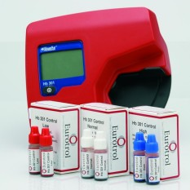
Eurotrol solution for HemoCue Hb 301 Analyser

